**Parameter**

Workdir

Input

Genome

**Alignment Results**

Alignment rate ---- samtools

**DNA methylation level**

+

-

Count ….

**DNA methylation distribution on genome**

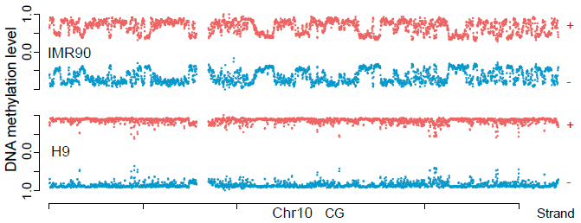

**DNA methylation distribution on function elements**

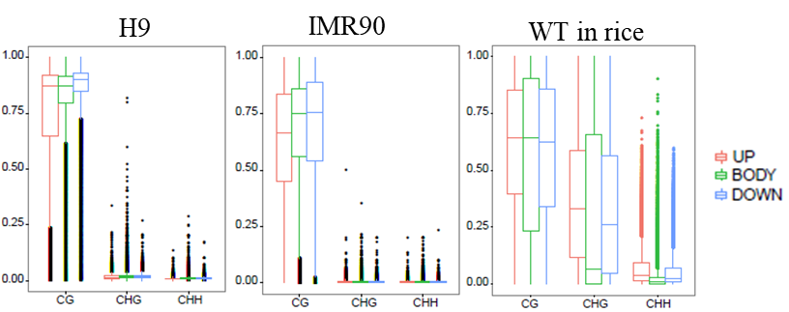

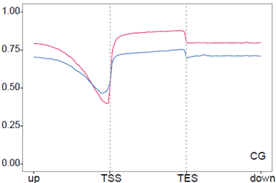

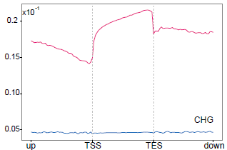

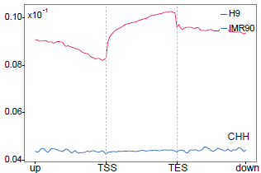

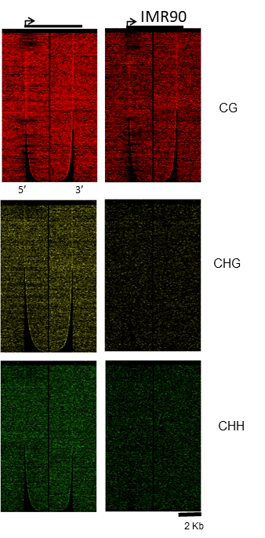

**DNA methylation distribution with function elements density**

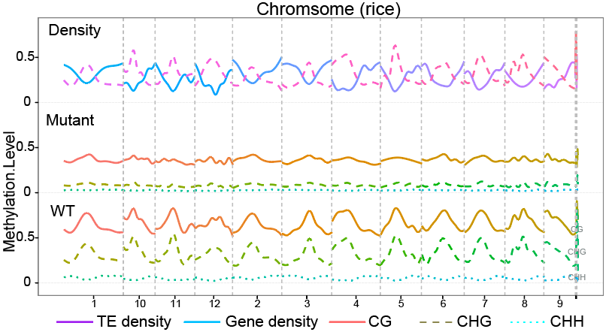

**Differential methylation**

DMC

DMR

DMP

DMB

DMC annotation:

