Introduction to ROS - Group project

Autonomous Drones

**Due 02.08.22**

# Coding:

1. Unity simulation environment
2. ROS simulation bridging
3. Controller
4. State machine
5. Perception pipeline
6. Path planner
7. Trajectory planner (obstacles avoidance) 2D (3D bonus)

# Documentation:

* Description of each node and its function
* Indicates external code
* Indicates who is responsible for which parts
* ROS graph
* Plots of results
* Bibliography

# Presentations:

* ~~Intro. 5min 28.06.22~~
* ~~Intermediate 12.07.22~~
* ~~Final. 02.08.22~~

# References:

Fast-Planner: <https://github.com/HKUST-Aerial-Robotics/Fast-Planner>

CCO-Voxel: <https://github.com/sudarshan-s-harithas/CCO-VOXEL>

Explore Strategy:

[http://wiki.ros.org/frontier_exploration](https://wx.qq.com/cgi-bin/mmwebwx-bin/webwxcheckurl?requrl=http%3A%2F%2Fwiki.ros.org%2Ffrontier_exploration&skey=%40crypt_346dcf81_ebc6c7e1ac6e020c5d5203c886f0a3a8&deviceid=e347647986350123&pass_ticket=PV5ry1dexuS8pEZgwO3zlwrchX%252FpEAihnkod9A3rZiewq6A6NGVEnSiHaOVPjDBJ&opcode=2&scene=1&username=@4456497aa4da987c7ad48150e232c7b85af8d9852d5189d5a77d8d62e6518376)

[http://wiki.ros.org/explore_lite](https://wx.qq.com/cgi-bin/mmwebwx-bin/webwxcheckurl?requrl=http%3A%2F%2Fwiki.ros.org%2Fexplore_lite&skey=%40crypt_346dcf81_ebc6c7e1ac6e020c5d5203c886f0a3a8&deviceid=e347647986350123&pass_ticket=PV5ry1dexuS8pEZgwO3zlwrchX%252FpEAihnkod9A3rZiewq6A6NGVEnSiHaOVPjDBJ&opcode=2&scene=1&username=@4456497aa4da987c7ad48150e232c7b85af8d9852d5189d5a77d8d62e6518376)

[http://wiki.ros.org/explore](https://wx.qq.com/cgi-bin/mmwebwx-bin/webwxcheckurl?requrl=http%3A%2F%2Fwiki.ros.org%2Fexplore&skey=%40crypt_346dcf81_ebc6c7e1ac6e020c5d5203c886f0a3a8&deviceid=e347647986350123&pass_ticket=PV5ry1dexuS8pEZgwO3zlwrchX%252FpEAihnkod9A3rZiewq6A6NGVEnSiHaOVPjDBJ&opcode=2&scene=1&username=@4456497aa4da987c7ad48150e232c7b85af8d9852d5189d5a77d8d62e6518376)

[http://wiki.ros.org/rrt_exploration](https://wx.qq.com/cgi-bin/mmwebwx-bin/webwxcheckurl?requrl=http%3A%2F%2Fwiki.ros.org%2Frrt_exploration&skey=%40crypt_346dcf81_ebc6c7e1ac6e020c5d5203c886f0a3a8&deviceid=e347647986350123&pass_ticket=PV5ry1dexuS8pEZgwO3zlwrchX%252FpEAihnkod9A3rZiewq6A6NGVEnSiHaOVPjDBJ&opcode=2&scene=1&username=@4456497aa4da987c7ad48150e232c7b85af8d9852d5189d5a77d8d62e6518376)

**Team Member:**

* Haoxuan Li
* Jingkun Feng*
* Tao Zhou
* Xuhui Li*
* Yinghan Huang

*: no fixplatz yet

**Proposed Approach:**

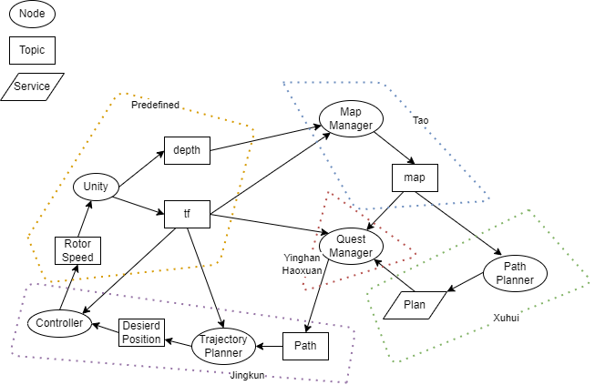

**Timeline:**

| Week | map | quest | path | control |
| --- | --- | --- | --- | --- |
| 1 | Literature review  Familiarize ourselves with provided codes | | | |
| 2 | Prototype  Integrate | scan the boundary  Integrate | 2D path planning  Integrate | Prototype  Integrate |
| 3 | Add service(API) | Scan whole map | Improvement | Parameter tuning |
| 4 | Improve performance | Improve coop and 3D | 3D path planning | Improvement |
| 5 | Documentation | Documentation | Documentation | Documentation |

**Pending Questions:**

* Can cameras on the drone be rotated? no
* How do two drones work?
* What is the difference between trajectory and path? -> Trajectory can be considered as a time-dependent path.
* Should the drones move to a goal position after generating the map? If yes, does it count in time? No
* Minimum height of the map? 5m
* Provide source of Unity project? Yes

Additional Hints:

* Make the ports parameters