Path Generation Guide

This is the guide on how to use the Matlab code provided to generate paths for all pairs of nodes in a given network topology.

February 25, 2014

1. Code Organization

The code structure is as below:

./k_path_gen/all_path_gen.m

/dijkstra.m

/gen_k_shortest_path.m

/kShortestPath.m

/main.m

/topo_info/path/ring_9_path.txt

/topo_info/topo_csv/ring_9.csv

* Root Directory: k_path_gen
* Core source code: dijkstra.m, gen_k_shortest_path.m, kShortestPath.m

The core source codes are available from the link below:

<http://www.mathworks.com/matlabcentral/fileexchange/32513-k-shortest-path-yens-algorithm>

* Code to generate paths for every pair of nodes in the network: all_path_gen.m
* Program wrapper: main.m
* Topo_info: a directory that stores the topology information and path files that will be generated. It has two subdirectories:
  + topo_csv: Stores the csv files that represents the network connectivity information. In general, a csv file shows an n-by-n matrix, where n represents the number of nodes in a network. If node i is connected with node j, then the value of (i, j) in the matrix is 1 (or the weight of the link i-j), otherwise, it is “inf”, which means infinite. You will see several csv files corresponding to specific topologies under the topo_csv directory.
  + path: Stores the files that stores the path information. You will find the sample path files under this directory that match the topology csv files under topo_csv directory.

1. Running the code

* Pre-request:
* Unzip the path_gen_matlab.zip file.
* Start Matlab and set the default folder as path_gen_matlab

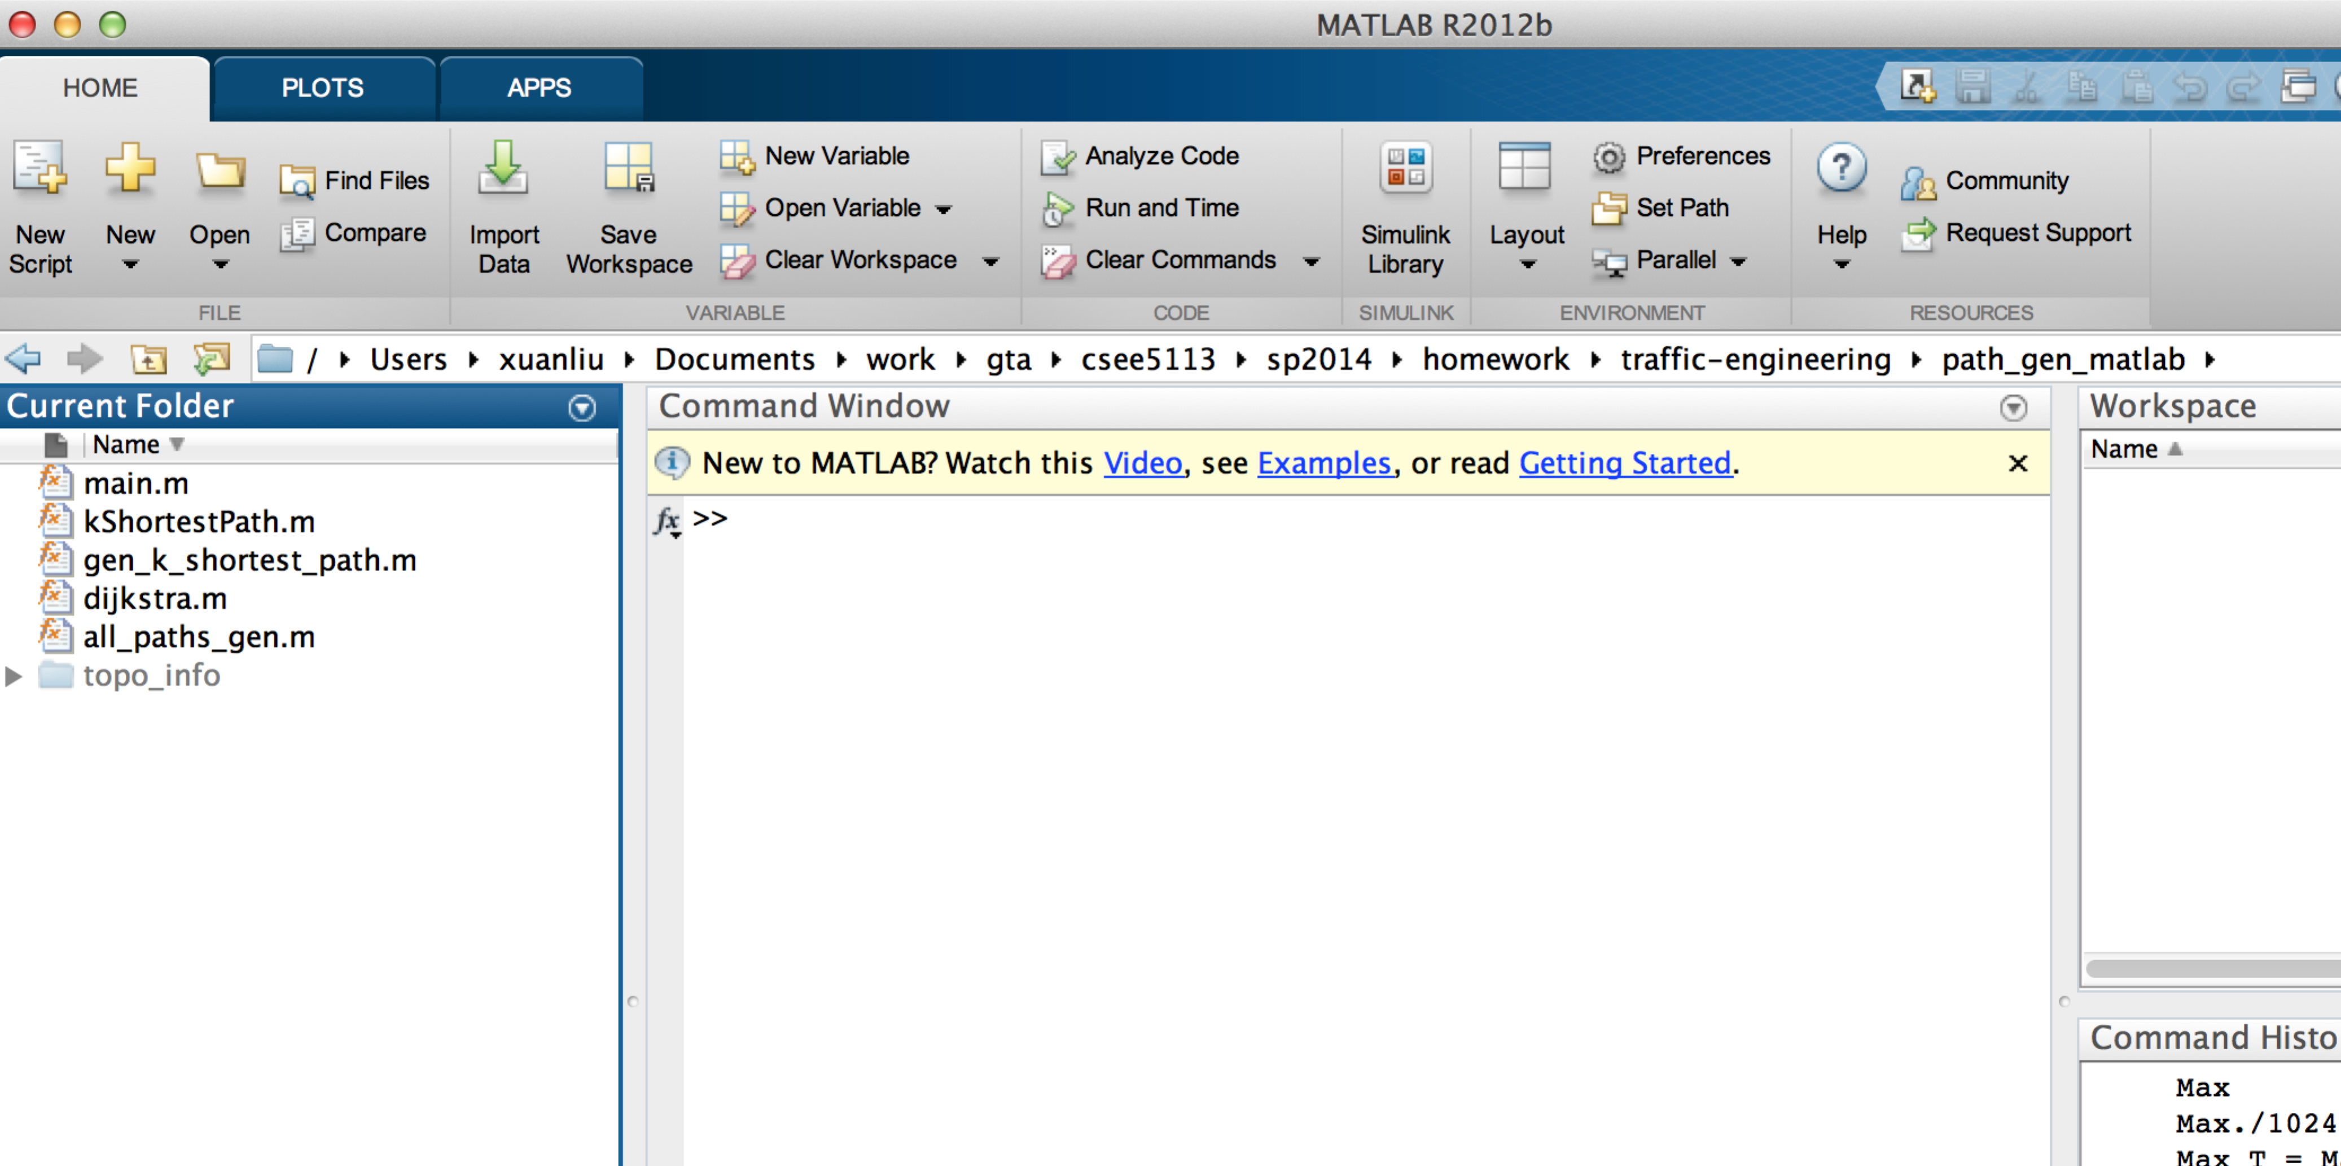

* The csv file containing the adjacent matrix, which presents the connectivity information of a existing network
  + You can use any program language to create this csv file
  + Put the csv file under: ./path_gen_matlab/topo_info/topo_csv/
* Run the main function
  + main(csv_file, path_file, number_of_paths)
  + Example:



1. Sample Files:
   1. topo_csv file for a 4-node ring topology

inf,1,inf,1

1,inf,1,inf

inf,1,inf,1

1,inf,1,inf

* 1. path_file for a 4-node ring topology, since this is ring topology, each node pair has two paths at most

4 nodes

Path # 1: 3 4 : 3_4 : x_1_1

Path # 2: 3 4 : 3_2_1_4 : x_1_2

Path # 1: 2 4 : 2_1_4 : x_2_1

Path # 2: 2 4 : 2_3_4 : x_2_2

Path # 1: 2 3 : 2_3 : x_3_1

Path # 2: 2 3 : 2_1_4_3 : x_3_2

Path # 1: 1 4 : 1_4 : x_4_1

Path # 2: 1 4 : 1_2_3_4 : x_4_2

Path # 1: 1 3 : 1_2_3 : x_5_1

Path # 2: 1 3 : 1_4_3 : x_5_2

Path # 1: 1 2 : 1_2 : x_6_1

Path # 2: 1 2 : 1_4_3_2 : x_6_2

Note: x_i_j: the flow variable for the jth path of demand pair i

a1_a2_...a­n: the path including nodes a1, a2, …, an, where a1 is the source node, and an is the destination node.