Fashion and wearable sports

Name: Zecong Zhou

Directory：
Abstract.......................................................................................2
Keywords.....................................................................................2
Introduction................................................................................3
The revolution and development of sports fashion....................3
1.1Early stage: Functionality first................................................3
1.2Mid-20th century: Sportswear enters popular fashion.........4
1.3The end of the 20th century:the intersection of street
culture and sports fashion..........................................................5
1.4The 21st century: the rise of high-tech materials and smart wearables....................................................................................7
Conclusion...................................................................................7
References..................................................................................9
Abstracts:
In recent years, the combination of fashion and wearables is rapidly changing the direction of the global fashion and sports industries. With advances in technology and diversifying consumer needs, sports fashion is an evolving field.Since the mid-20th century, sportswear has become popular among the general public. And today, with the introduction of smart devices and innovative materials, sports fashion is no longer just about functionality, but is a way for people to improve the quality of their lives and their sense of aesthetics, and is gradually becoming a symbol of personal style. The intersection of fashion and technology in the sports industry has led to innovations that improve performance, safety and style. From smartwatches and fitness trackers to sportswear embedded with sensors, wearable devices are gradually becoming an important part of sports fashion, fulfilling the multiple demands of functionality, comfort and aesthetics. This paper will explore the historical evolution of the combination of sport and fashion, analyse the application of wearables in contemporary fashion, and look forward to the future development trend of this field to provide more valuable references for the combination of fashion and sport.

Keywords: Fashion, sports, wearable devices,high-tech materials, multi-functional fashion

Introduction：
The combination of sports and fashion is not a new concept, but has been developing for decades. Since the beginning of the 20th century, sportswear has been gradually accepted by the public for its practicality and comfort. With the increase in health awareness and the public's pursuit of a sporting lifestyle, sportswear has gradually entered the mainstream fashion field.In the 1980s, with the global rise of brands such as Nike and Adidas, the design concept of sportswear began to change, focusing not only on functionality but also on fashion sense (Smith, 2017). Based on this, sportswear gradually evolved into one of the key elements of street culture, and the rise of this sports fashion trend has directly influenced the direction of the modern fashion industry.Since the late 20th century, there have been attempts to use clothing as a medium to provide technological functionality to enhance human capabilities in the closest possible proximity to the human body, resulting in a multi-functional fashion product.(J. Human Comput,2009)

In modern society, with the rise of wearable devices, the integration of technology and fashion has further promoted the transformation of sports fashion.In recent times, the fusion of technology and fashion has further fuelled the transformation of sports fashion with the rise of wearable devices. Consumers are not only looking for comfortable and functional apparel, but also expect smart technology to be incorporated in these apparels. In recent years, wearable devices have demonstrated their market potential through a number of well-known products including smartwatches or chest straps (International Data Corporation, 2020).Wearables such as smartwatches and fitness trackers have become one of the core product lines of many sports brands. Such products are capable of monitoring health data as well as having an aesthetically pleasing design, making them an integral part of consumers' daily lives (Johnson, 2020). Not only athletes and fitness enthusiasts, but also ordinary consumers are seeking wearable devices that are both technologically advanced and fashionable, and this expanding demand is fuelling the rapid convergence and development of fashion and wearables.

In addition, the driving force behind innovation in sportswear is usually the consumer, who is hungry for new features, new gadgets and greater safety when playing sport and is willing to spend a fortune on sportswear. So the financial benefits are huge and the drive for innovation is impressive. In 2012, the sportswear industry grew "1.5 times faster than general consumer spending" (Fuzz et al., 2014). It is therefore important to take this factor into account at the same time when considering the future of the sportswear industry.

1.The revolution and development of sports fashion
1.1Early stage: Functionality first
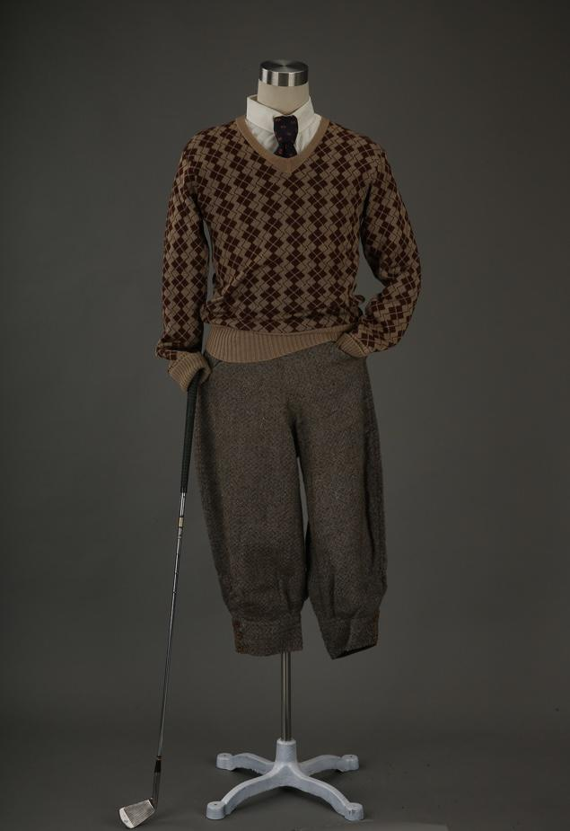
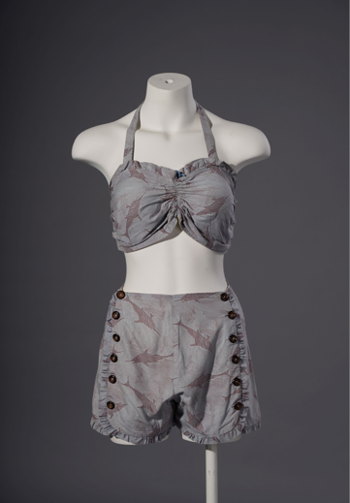
The origins of sport have been traced back to ancient times. However, over the past few thousand years, there have been very few historical records of what was worn in sports, and the general public has only been able to learn about it from scattered portraits and descriptive texts. The concept of sportswear was not born together with sports. Sportswear (activewear) was first introduced in Britain in the 19th century, and it was initially a reflection of the leisure lifestyle of upper-class men, such as horse-riding, hunting, golf and other sports. As society developed and more women became involved in these outdoor activities, the cumbersome long dresses could no longer be adapted and activewear garments designed specifically for sports began to appear. (The China Silk Museum, 2023)In the early 20th century, when sportswear was designed primarily for functionality. The initial purpose of sportswear was to meet the practical needs of athletes when competing and exercising, rather than fashion considerations. For example, professional clothing for sports such as tennis, football and athletics was usually loose, breathable and comfortable to ensure that athletes were not restricted in their performance. At this point, clothing design emphasises the durability of the material and its adaptability to the particular sport, rather than the aesthetic expression of the style and design.(Simon,2017)
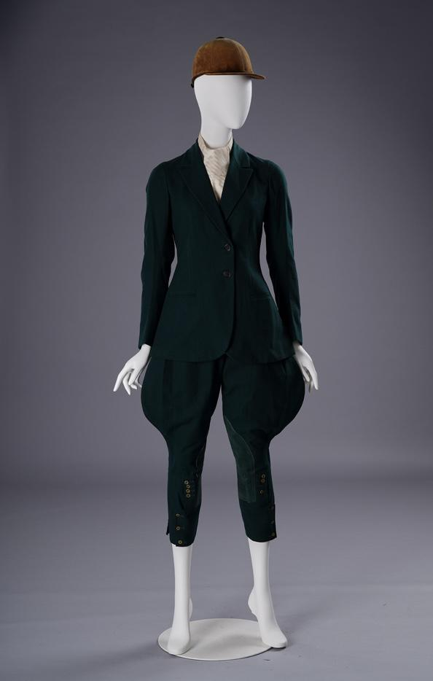

Figure1 Figure2 Figure3

1.2 Mid-20th century: Sportswear enters popular fashion
However, this changed in the first decades of the twentieth century, when sportswear design moved away from general fashion design because of its practical function and tended to clearly differentiate between different sports with a uniform appearance. For example, aesthetic sportswear gradually entered the scene, with colours and patterns used to differentiate between players and teams attracting the attention of spectators. It is also becoming common to see sportswear introduced into the catwalks of leading fashion brands.In the 1920s, when women began to enter the labour market and the public sphere at an unprecedented rate, Chanel, inspired by men's sportswear fabrics (polo shirts and tweed, used for shooting and riding suits), created a revolutionary new wardrobe for the New Woman of the 1920s. Among her track and field innovations were flared trousers (inspired by sailors), one-piece sweatshirts, and, most iconic of all, two-piece tweed suits. (Mette Bielefeldt Bruun, 2016)By the mid-20th century, sportswear gradually came into public life and became a fashion symbol. After World War II, the global economy recovered and health and outdoor activities became a popular trend, fuelling the popularity of sportswear.Images of Hollywood stars such as Marilyn Monroe wearing sportswear in the 1950s made sportswear not just confined to the stadium, but also a form of casual fashion (Moorhead, 2019). Iconic sports fashion products of the period included tennis skirts, gym shorts and canvas shoes, which gradually moved from the realm of sport to everyday wear.


Figure4 Figure5-6
1.3 The end of the 20th century: the intersection of street culture and sports fashion

The 1980s was an important turning point in the development of sports fashion. With the pursuit of healthy living and the emergence of fitness instructional videos, people began to pay attention to the fashion trend of sportswear. The videos of Jane Fonda, the "mother of fitness", are also considered a textbook for sportswear fashion, and she drove the popularity of skinny jumpsuits, bottoms, leggings and elasticated headbands. Skinny jumpsuits are also triggering a comeback of bright colours, stripes and polka dot patterns. (Saxony Dudbridge, 2015) At the same time, major fashion brands have been launching sports-appropriate clothing, and sweatpants and matching sweatshirts have become a must-have item at every women's and men's show, with Chloé, Gucci, Bottega Veneta, Christopher Kane, Vetements, Designers such as Ami and Astrid Anderson have skilfully incorporated sportswear. (Thompson, 2016)

In addition, along with the rise of street culture and the popularity of hip-hop culture, it has made sportswear a unique fashion expression. Brands such as Nike and Adidas began to collaborate with hip-hop musicians and street sports (such as skateboarding and street dance) to launch a range of sports shoes and apparel with iconic designs. For example, Nike's Air Jordan line of basketball shoes debuted in 1985, which not only exemplified innovation in sports shoes but also became a symbol of street culture (Packer, 2020).Shawn Stussy, the founder of renowned streetwear brand Stussy, grew up in Laguna Beach, California and showed his passion for surfing by dedicating himself to making surfboards from the age of 13. He founded his own brand in Laguna Beach, California in the 80's, starting out with surfing and making customised boards, and then printing his own graffiti on his T-shirts, which unexpectedly gained a good response. Starting with surfing and making custom surfboards, Stussy began by printing its own graffiti on T-shirts, which was an unexpected success, and has since evolved from a small surf brand to a potential streetwear label. (Haiquan Tango, 2023)

At the same time, sportswear has become an important tool for musicians and teenagers to express their individuality. For example, Run-D.M.C.'s song "My Adidas" made Adidas' Superstar trainers a global pop culture icon. By merging with pop culture, sports brands have not only expanded their markets, but have also succeeded in transforming sportswear into a symbol of popular fashion.
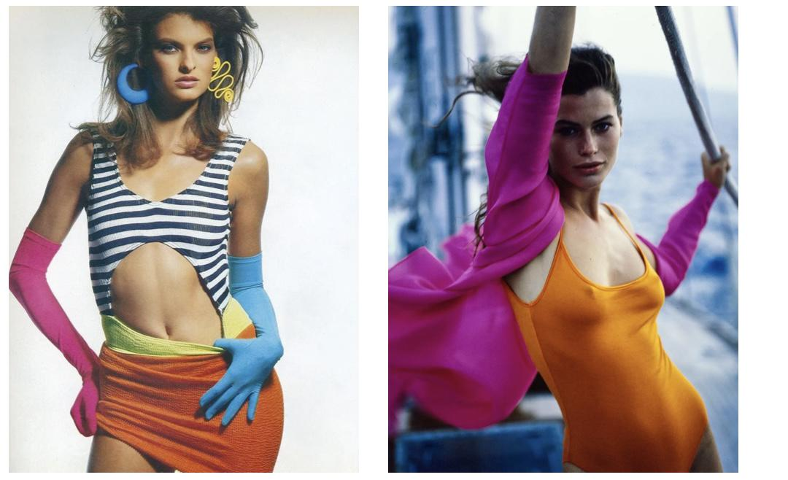
Figure7-8 Figure9

1.4 The 21st century: the rise of high-tech materials and smart wearables

Entering the 21st century, sports fashion has stepped into a brand new stage. The popularity of healthy lifestyles and technological advances have made sportswear not only more specialised in terms of function, but also innovative in terms of aesthetics. One of the most representative changes is the application of high-tech materials. For example, brands such as Under Armour have taken the lead in launching high-performance sportswear such as quick-drying, anti-bacterial and UV protection, bringing more technological elements to sports fashion (Davis, 2021).

At the same time, smart wearables are beginning to take centre stage. products such as the Apple Watch and Fitbit have become iconic for sports fashion, not only in terms of the functionality they offer for exercise and health monitoring, but also in terms of the fashion design they incorporate. The latest Apple Watch Hermès offering builds on the collaborative foundation of iconic design and craftsmanship with a range of vibrantly coloured luxury textiles. The launch of such devices signalled a shift in sports fashion from singular apparel design to a deeper fusion of technology and fashion, driving cross-border innovation across the industry (Johnson, 2020).

Moreover, the introduction of 3D printing technology has also brought new possibilities to sports fashion. For instance, Adidas has launched Futurecraft 4D shoes, which use 3D printing technology to create the soles and provide consumers with more personalised products through data-driven design. These technological breakthroughs have not only enhanced the functionality of sports fashion, but also promoted the diversity and uniqueness of its designs.
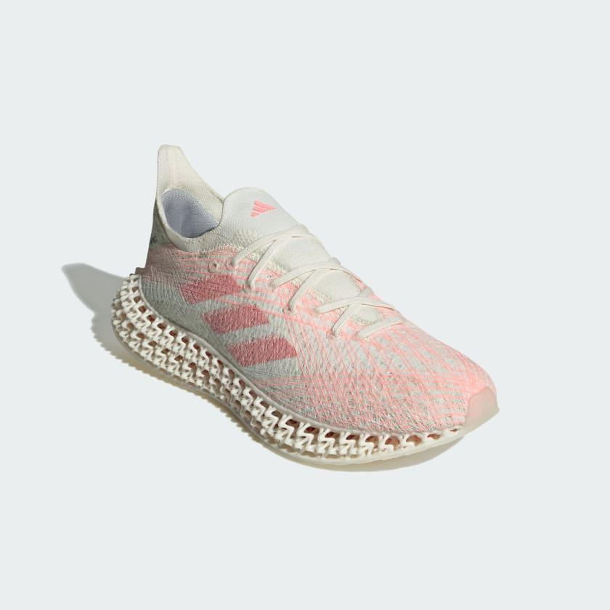
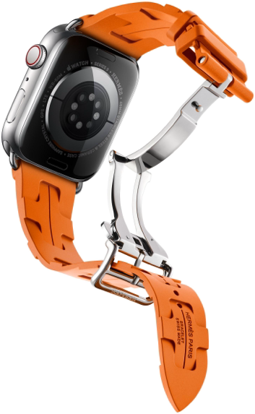

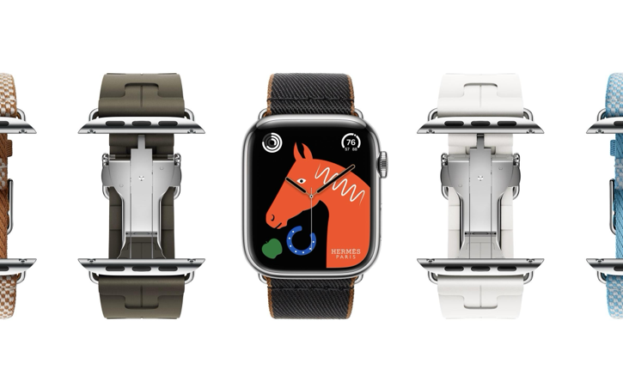

Figure10 Figure11-12

Recently, outdoor sports brand ARC'TERYX launched a wearable external power device, which is designed to empower alpine sports enthusiasts and help improve alpine performance. It is a motorised sports aid created by the Advanced Concepts Team at ARC'TERYX and SKIP. The device uses a motor in the knee area, together with a set of sensors and a computer module, to anticipate the user's movements and provide assistance accordingly. The system integrates perfectly with the ARC'TERYX Beginning Bird Gamma softshell mountaineering trousers, providing a comfortable fit for everyday wear. The MO/GO™ Exoskeleton Softshell Pants are the world's first wearable exo-power designed specifically for the outdoors and took four years to develop. It is named after the Mountain Goat, which is known for its ability to climb on magnificent cliffs. Compact and lightweight, weighing only 3kg, and simple to manoeuvre, MO/GO can be worn without placing a noticeable strain on the legs. The exoskeleton softshell trousers provide half the strength assistance to the legs when going up a mountain, and support to the knees when going down. When worn, the exoskeleton allows the user to feel 14kg lighter, allowing even consumers with leg injuries to do some hiking or mountaineering, and allowing the wearer to tackle the climb in a way they never have before. (Yuri Cheng, 2024)

But the price of such a versatile and stylish product is naturally high. MO/GO is currently available for pre-order at $4,500, and will go on sale at the end of 2025, when the price will be adjusted to $5,000. Starting in the second half of 2024 in Canada and parts of the United States, Skip and ARC'TERYX will be offering advanced rentals for $80 for eight hours.

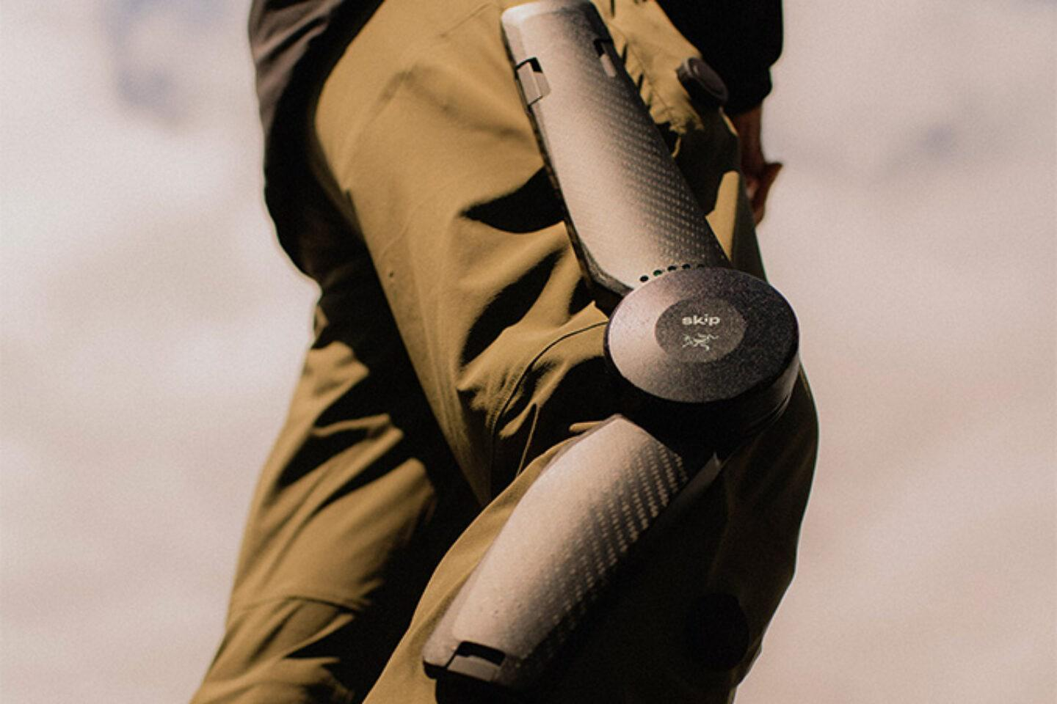
Figure13-14
Conclusion：
The combination of fashion and sports has enhanced the design aesthetics and functionality of sportswear while bringing a higher quality of life experience to the public. Through the application of high-tech materials and smart wearable devices, sports fashion is no longer limited to functional needs, but has become part of everyday life. This combination gives sportswear a double advantage: the ability to fulfil the needs of athletic performance while visually displaying a sense of individuality and style.

However, while wearable devices bring convenience and innovation, they also face a number of challenges. Many smart devices are more expensive, making them unaffordable for certain consumers, which to some extent limits the market's widespread popularity. Secondly, due to the special materials of smart devices and high-tech sportswear, their changing and maintenance are also more complicated than traditional clothing. For example, sportswear with embedded sensors require special care when washing, which increases the difficulty for users (Johnson, 2020). Despite these problems, the combination of fashion and sport undoubtedly has a promising future.

With the continuous advancement of technology and the gradual decline in production costs, future smart wearables and sportswear will become more accessible and cover a wider range of consumer groups. In addition, sports fashion will continue to innovate in functionality and aesthetics, bringing a more convenient, healthy and personalised lifestyle to modern society.

Reference
•Cheung, M. L. et al.(2019). Examining consumers' adoption of wearable healthcare technology: The role of health attributes. International Journal of Environmental Research and Public Health, 16(13).，2257
•China National Silk Museum (2023).［Online］Available at:
https://www.chinasilkmuseum.com/yz/info_18.aspx?itemid=31164［Accessed 08 Sep 2023］
•D’Orazio, D. (2012).Nike+ Basketball and Training Sneakers Track Your Game, Push You to Compete with others.［Online］
Available at:https://www.theverge.com/2012/2/22/2816583/nike-plus-basketball-training-shoes-app［Accessed 23 Feb 2012］
•Fuzz, F. K. , et al. (2014). Routledge Handbook of Sports Technology and Engineering . London: Routledge.
•Gepperth, J.,(2012).Smart Things: wearables & clothing. Advances in Media Technology
Technische Universität München Institute for Media Technology, München,:C. H. Beck,p 41-48
•Hanlon, M.(2004).Our Clothes Are Getting Smarter New Atlas.［Online］Available at: https://newatlas.com/go/1586/［Accessed 04 Jun 2004］
•International Electrotechnical Commission. (2019). SMB/6937/R strategic business plan: wearable electronic devices and technologies.
[Online] Available at:https://assets.iec.ch/public/misfiles/ sbp/124.pdf
•International Data Corporation. (2020). Worldwide quarterly wearable device tracker: IDC Media Center. [Online]
Available at: https://www.idc.com/tracker/showproductinfo. jsp?containerId=IDC_P31315
•Ji, Y. G., & Lee, K. (2009). Standardization for smart clothing technology. In
G. Cho (Ed.), Smart clothing: Technology and applications.America.CRC
Press,p:59-87.
•Johnson, L. (2020). Wearable Technology: Merging Fashion with Functionality. International Journal of Fashion Design, 15(1), p.22-35.
•Kelly, N. (2016). The WEAR scale: Development of a measure of the social acceptability of a wearable device [Doctoral dissertation, Iowa State University]. California:fIowa State University Digital RepositorCalif,p2864-2871.
•Lee, H.S. &Lee, J.J.(2018). A study on the development of the functional convergence fashion prototype applied the Low-tech-Focused on the convergence between fashion and electronic technology J. Korean Soc. Costume,(68)2,p98-115.
•Mette Bielefeldt Bruun & Michael A. Langkjær.(2016).Sportswear: Between Fashion, Innovation and Sustainability,8(2),p181-188
•Rothenberg, B.(2016).“For Some at Wimbledon, Nike’s Dress Just Doesn’t Do It.” New York Times , June 29. ［Online］Available at:
http://www.nytimes.com/2016/06/29/sports/tennis/nike-wimbledon-premier-slam-dress.html?_r=0
［Accessed July 14, 2016. ］
•Smith, J. (2017). The Evolution of Sports Fashion: From Function to Fashion. Fashion Studies Journal, 22(4),p 45-60.
•Saxony Dudbridge，“History of Fashion 1980s – 1990s”，(2015)［Online］Available at:
https://www.catwalkyourself.com/fashion-history/1980s-1990s/
•Haiquan Tang,(2023).The History of Street Fashion - Case Study.［Online］Available at:
https://www.d2cbrand.com/?p=6455［Accessed Sep 5，2023］
•Wang, W.et al.(2018).Interactive technology embedded in fashion emotional design
Interact. Technol. 30(3),p:302-319
•Yoon, S.I. &Kang, H.S.(2013).The type and development of hybrid fashion’s convergence–focused on convergence of 21st century technology and design.38(2),p:299-308
•"10 things you didn't know about Stussy."(2024).［Online］Available at:
https://www.isneakers171.com/blog/posts/10-things-you-didnt-know-about-stussy［Accessed 06 Aug 2024］

•Figure1-3：China National Silk Museum 2023
https://www.chinasilkmuseum.com/yz/info_18.aspx?itemid=31164
•Figure4-6https://www.pinterest.com/
•Figure7-8：https://www.vogue.com/

•Figure9：https://www.isneakers171.com/blog/posts/10-things-you-didnt-know-about-stussy
•Figure10：https://www.adidas.com/us/4d
•Figure11-12：https://www.apple.com/apple-watch-hermes/
•Figure13-14：
https://www.googleadservices.com/pagead/aclk?sa=L&ai=DChcSEwiyz7zs4qOIAxU0tVoFHZ7rKR4YABAAGgJ2dQ&ae=2&co=1&gclid=CjwKCAjwxNW2BhAkEiwA24Cm9CyT6EM2EDIpbcLRlgtxpL_-s5p8FbWVm_5aXPVNP0A0AAfGQO-7ERoCFgYQAvD_BwE&ohost=www.google.com&cid=CAESVuD2ohWG_tLuzCvp_NtZLZkLYE0rYNdU0NsOafDwOiXMVUlLIQWRHt8zcaK2kOnNTqQDFcPNT9cLaWieGV33Eu2E_iB2KhCmxVv-VeKxNW-iP3VQgoQS&sig=AOD64_1Dt8V3yuye4r97u_2kUQmotcGIwg&q&adurl&ved=2ahUKEwi9_rjs4qOIAxVsRDABHSltAcIQ0Qx6BAgeEAE

