CREATE (:operator {name: 'operator'});

CREATE (: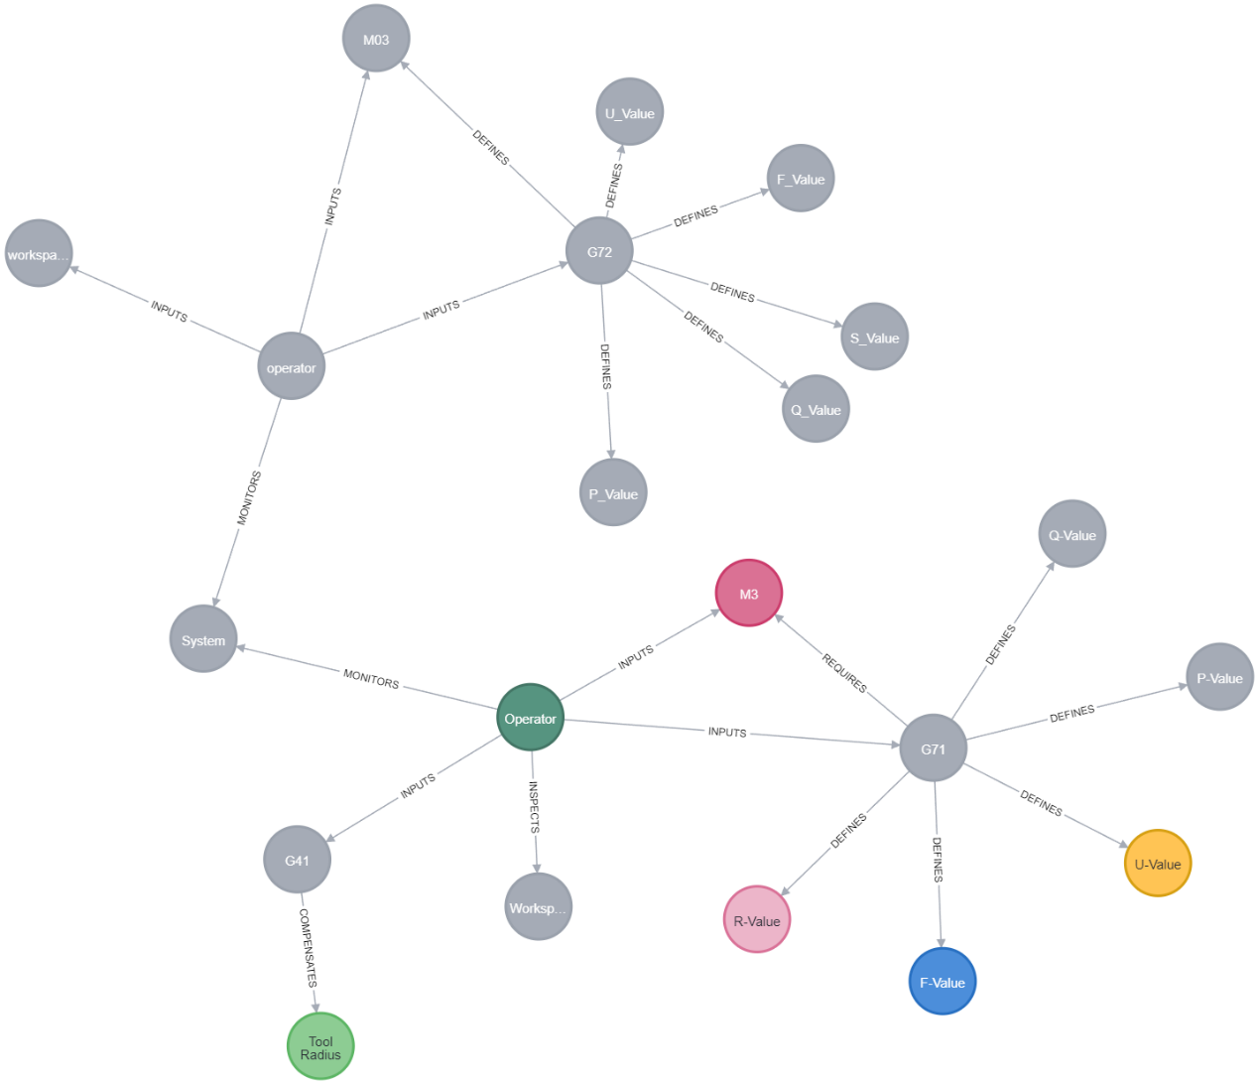 {name: 'workspace'});

CREATE (:s_Value {name: 'S_Value'});

CREATE (:f_Value {name: 'F_Value'});

CREATE (:u_Value {name: 'U_Value'});

CREATE (:p_Value {name: 'P_Value'});

CREATE (:q_Value {name: 'Q_Value'});

CREATE (:m3 {name: 'M03'});

// 创建节点

CREATE (:Operator {name: 'Operator'});

CREATE (:System {name: 'System'});

CREATE (:Workspace {name: 'Workspace'});

CREATE (:G41 {name: 'G41'});

CREATE (:G71 {name: 'G71'});

CREATE (:Tool_Radius {name: 'Tool Radius'});

CREATE (:R_Value {name: 'R-Value'});

CREATE (:F_Value {name: 'F-Value'});

CREATE (:U_Value {name: 'U-Value'});

CREATE (:M3 {name: 'M3'});

// 创建 Operator 的关系

MATCH (o:Operator), (w:Workspace), (s:System), (g41:G41), (g71:G71), (m3:M3)

CREATE (o)-[:INSPECTS]->(w),

(o)-[:MONITORS]->(s),

(o)-[:INPUTS]->(g41),

(o)-[:INPUTS]->(g71),

(o)-[:INPUTS]->(m3);

// 创建 G41 与 Tool Radius 的关系

MATCH (g41:G41), (tr:Tool_Radius)

CREATE (g41)-[:COMPENSATES]->(tr);

// 创建 G71 与 R-Value、F-Value、U-Value 的关系

MATCH (g71:G71), (r:R_Value), (f:F_Value), (u:U_Value)

CREATE (g71)-[:DEFINES]->(r),

(g71)-[:DEFINES]->(f),

(g71)-[:DEFINES]->(u);

// 创建 G71 与 M3 的关系

MATCH (g71:G71), (m3:M3)

CREATE (g71)-[:REQUIRES]->(m3);

match (n:G72{name:"G72"}), (m:s_Value{name:"S_Value"})

create(n)-[r:DEFINES]·->(m) return n.name,type(r),m.name