University of Macau
CISC7204 Data Science and Data Visualization
Course Code: CISC7204
Course Title: Data Science and Data Visualization
Coursework Item: Assignment 02 - Revised Project Proposal (Pair Work)

Price Without Yield
How the rent-price gap in Hong Kong's private housing diverged by flat size, 1993 to 2026

Student Name: ZHOU ZHIFAN | YOU YUQI
Student ID: MC651611 | MC65223
25 October 2026

1. Project Title and Guiding Question
Project title: Price Without Yield: How the rent-price gap in Hong Kong's private housing diverged by flat size, 1993 to 2026.
Guiding question: In Hong Kong's private domestic housing market, how far has the price index moved away from the rental index between 1993 and 2026, and has that divergence behaved differently for small flats (class A, under 40 m²) than for large flats (class E, 160 m² and above)?
The question is testable with data that already exists. The Rating and Valuation Department publishes a price index and a rental index for identical dwelling classes over the same period and on the same base year, so the two series can be divided directly without assuming that any particular flat is matched across time.

1.1 What this revision changes
Three things distinguish this pair proposal from the preliminary proposal submitted in Assignment 01.
- The deliverable set is wider. Assignment 02 supplied the dashboard capability, so the revised plan adds an interactive Plotly and Dash application alongside the static figure, which is retained because an argument carried in a document has to be printable.
- The commitment is now explicit. Assignment 01 was read and submitted individually by both members; this is the joint plan that both will execute, and Section 9 states who owns what.
- Every deliverable in Section 5 is now written as an artefact a third party can check, with exactly one owner. The preliminary plan described steps; this plan describes outputs.

2. Purpose

2.1 Outcomes
This project connects to the course learning outcomes on data acquisition, exploratory analysis and statistical communication. It works from a genuine government data source rather than a pre-cleaned teaching file, which means handling a published spreadsheet layout, a non-obvious unit convention and a documented suppression rule. Beyond the course, the question sits inside a live public debate in Hong Kong about housing affordability, and the skills it exercises transfer directly to market analysis and policy work.

2.2 Skills
- Retrieving and validating an open dataset from an official statistical agency.
- Reshaping a wide workbook that uses merged cells into a tidy monthly time series.
- Constructing a derived indicator and stating precisely what it does and does not measure.
- Designing one figure that separates a long-run trend from a recent divergence.
- Building an interactive dashboard with callbacks, and deciding what should and should not be interactive.
- Writing an interpretation that keeps description, inference and causal claim apart.

2.3 Knowledge
- How price indices, rental indices and base years work, and why the ratio of two indices carries meaning while their absolute values do not.
- How a housing market can correct through falling prices without any correction in rents.
- The difference between an index-based measure and a simple average of transactions.
- Hong Kong's flat-size classification, classes A to E, and why publishing by class matters.
- The difference between a static figure, which fixes an argument, and a dashboard, which invites exploration.

3. Region and Domain Category
Region: Hong Kong SAR, China, covering the whole territory, because both source series are published territory-wide.
Domain category: Residential real estate, specifically the private domestic (non-subsidised) housing market, segmented by unit floor area.

4. Data Sources
Both datasets come from the Rating and Valuation Department (RVD) of the HKSAR Government. They are free, require no registration, and share the same class definitions and the same base year of 1999 = 100, which is what makes a direct comparison between them valid.
Dataset | What it contains | File and format
Private Domestic Price Indices by Class (Territory-wide) | Monthly index of transaction prices, January 1993 to July 2026, for classes A to E plus three aggregates; 403 monthly observations | his_data_4.xls (289 KB); monthly, quarterly and annual sheets
Private Domestic Rental Indices by Class (Territory-wide) | The same structure over the same period, for rents rather than prices | his_data_3.xls (277 KB); same three sheets

Direct links to the two datasets: price index (https://www.rvd.gov.hk/doc/en/statistics/his_data_4.xls) | rental index (https://www.rvd.gov.hk/doc/en/statistics/his_data_3.xls)
Class definitions used by the publisher: A. under 40 m², B. 40 to 69.9 m², C. 70 to 99.9 m², D. 100 to 159.9 m², E. 160 m² and above.
Two publisher caveats that this analysis respects: sales of new units (primary sales) are excluded from the indices, and any month with fewer than 20 transactions is suppressed, which explains isolated gaps in the thinner class E series. Figures for the most recent month are provisional.

5. Tasks
The work runs in six steps. Each step names the deliverable it produces and the owner accountable for it.
1. Acquire the data. Download both workbooks from the RVD site and confirm that they cover the same months. Deliverable: both files held locally plus a coverage check confirming 403 matching months. Owner: ZHOU.
2. Parse the published layout. The workbooks use merged cells for the year and for the class headings, so the data cannot be read with a simple header setting. Reshape them into a tidy monthly frame. Deliverable: a loader function returning one row per month and one column per class, tested on two sampled years. Owner: ZHOU.
3. Build the indicator. Merge the two frames and compute the price-to-rent ratio for every class. Deliverable: a summary table of peak month, peak value and latest value per class. Owner: ZHOU.
4. Produce the static figure. Build the two-panel figure described in Section 7. Deliverable: one figure at print resolution, with units, a stated base year, an annotated peak and a source line. Owner: YOU.
5. Build the interactive dashboard. Wrap the same analysis in a Plotly and Dash application with two controls - a flat-size class selector and a date-range selector - and one linked view showing the ratio together with its price and rent components. Deliverable: a runnable application directory plus a short note stating which quantities are interactive and which are deliberately fixed. Owner: YOU.
6. Interpret and write up. State what the artefacts show and separate that from what they cannot show. Deliverable: the justification in Section 7, the limitations note below it, and a one-page reading guide for the dashboard. Owner: drafted by YOU, checked by ZHOU.
Requirements to be fulfilled: the two source workbooks must be the official published editions; the ratio must be computed on the published indices rather than on re-derived averages; provisional figures must be flagged; every number quoted in the written output must be reproducible from the notebook; and any claim about causality must be marked as untested.

6. Criteria for Success
A successful deliverable has six characteristics.
1. Reproducible from source. A reader with the two links can regenerate every number, the figure and the dashboard, with no manual step in between.
2. Correctly scoped. The ratio is described as a relative measure of the price-rent relationship, never as a rental yield, and the arbitrary index base is stated.
3. Segmented, not aggregated. The result is reported by flat class, because the territory-wide number conceals the interesting variation.
4. Visually self-explanatory. The figure carries units, a stated base year, an annotated peak and a source line, so a reader need not read the surrounding text to read the axes.
5. Interactive for a reason. The dashboard exposes exactly the two choices that change the reading of the data - which class, and which window - and keeps everything else fixed.
6. Honest about limits. Suppressed observations, provisional figures and the absence of causal identification are stated rather than omitted.
How these will be evidenced. The primary evidence is the final figure and the dashboard, together with a checklist built from the six characteristics above. Each item maps to a specific element of the artefacts: reproducibility to the accompanying notebook, scoping and segmentation to the ratio table, visual clarity to the annotated axes, purposeful interactivity to the dashboard control note, and honesty about limits to the limitations note. A checklist is preferred over a rubric because these criteria are pass-or-fail properties of an artefact rather than gradations of quality.

7. Visualisation and Justification
The figure answers the research question in two moves. Panel A plots the price-to-rent ratio for all five size classes from January 1993 to July 2026, with the market-wide peak annotated. Because both indices share a base year and the same class definitions, each line is directly readable: a value of 1.0 means prices stand at their 1999 relationship with rents, and 2.0 means the same unit costs twice as much relative to what it can be let for. The ratio oscillates between roughly 0.8 and 1.3 through the 1990s and 2000s, climbs almost continuously to a territory-wide peak of 2.22 in March 2021, and then falls to 1.55, a level last seen in early 2013. Plotting all five classes on one axis rather than a single aggregate is what makes the divergence visible. At the 2021 peak the classes were bunched within 0.35 ratio points of one another; by July 2026 they range from 1.53 for small flats to 1.91 for large ones.
Panel B isolates the mechanism by decomposing the change from the 2019 average to July 2026 into a price component and a rent component for each class. The two bars point in opposite directions. Prices fall between 8.7 per cent and 19.8 per cent, while rents rise between 3.7 per cent and 7.5 per cent for every class except the largest. The compression of the ratio is therefore a capital-value correction, not a rental-market correction. The correction is also strongly size-dependent: the smallest flats lost 19.8 per cent of their index value while gaining 3.7 per cent in rent, whereas class E lost 8.8 per cent of value and saw rents essentially flat. Read together, the two panels answer the guiding question: the rent-price gap has narrowed since 2021, and the price correction behind it was roughly twice as deep on the smallest flats as on the largest. One qualification the figure makes visible is that the ordering of the classes never reversed. Large flats carried the highest ratio before the correction and still do afterwards, with the distance between the two ends widening from 0.21 ratio points at the 2021 peak to 0.38 in July 2026.
The dashboard adds a third move that a printed figure cannot make. Because the guiding question turns on two choices, which flat size and which window to compare, the dashboard exposes exactly those and holds the rest fixed: a reader who doubts that the 2021 peak is territory-wide can select class E alone and see the gap left by the suppressed months, and a reader who doubts that the recent correction is a price story can switch the same chart to its two components.
Figure 1. Price-to-rent ratio by flat size class in Hong Kong's private domestic housing, January 1993 to July 2026, with the post-2019 change decomposed into a price and a rent component.
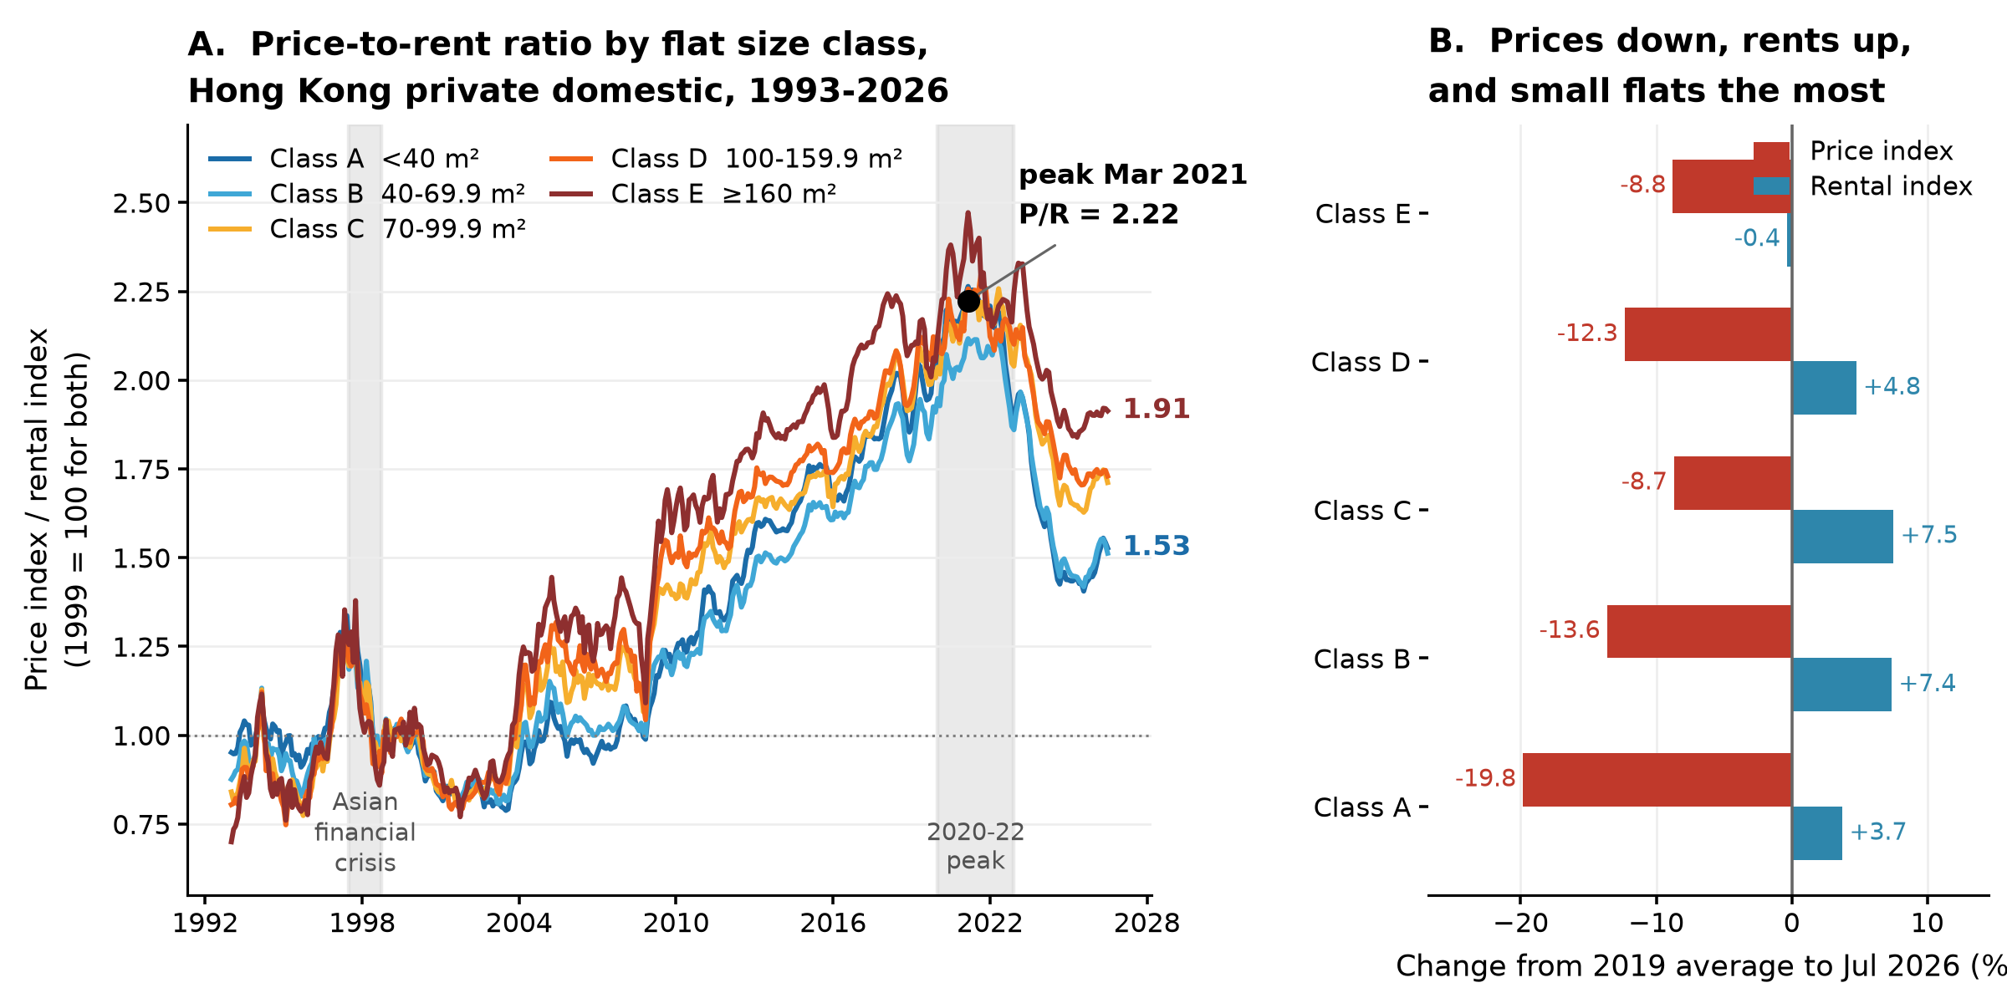
Source: Rating and Valuation Department, HKSAR Government. Both indices use 1999 = 100. Primary sales are excluded and the July 2026 figures are provisional.

8. Limitations and Next Steps
The analysis has three limits worth stating plainly. The ratio is a relative measure built on two indices that share a base year, so it cannot be converted into a rental yield. The RVD series are class aggregates, so they say nothing about location, age or building quality. And the comparison is descriptive: nothing in this design identifies why prices and rents moved apart.
Three next steps follow: converting the ratio into an actual gross yield needs the average price and rent per square metre that the same department publishes, testing the divergence formally needs a structural break test around 2021, and a cross-market comparison against Macau DSEC statistics would show whether the pattern here is local or regional.

9. Collaboration
Assignment 02 is pair work and the two members are ZHOU ZHIFAN and YOU YUQI. The division below is the plan both members have agreed to and will follow.
Division of work. ZHOU ZHIFAN owns the data strand, covering Steps 1 to 3: acquiring and validating the two RVD workbooks, parsing the published layout into a tidy monthly frame, and building the price-to-rent indicator. YOU YUQI owns the output strand, covering Steps 4 and 5: producing the static figure, building the Plotly and Dash dashboard, and checking every quoted number back to the analysis. Step 6 is drafted by YOU and checked by ZHOU. Both members read the finished proposal against the six criteria in Section 6 before either copy is submitted.
Ground rules. Four ground rules are adopted. Every number in the written output must be traceable to the analysis notebook, and no figure enters the document otherwise. Where the published series is incomplete, the limitation is stated rather than silently worked around. Disagreements about what the data shows are settled by re-running the analysis, not by argument. Neither copy is submitted until both members have read the final version in full.
Role (held by) | What the role covers for this project
Project coordinator (ZHOU ZHIFAN) | Fixes the sequence of the six tasks and the cut-off date for each, and makes the final call when two options compete.
Project scribe (ZHOU ZHIFAN) | Records decisions as they are taken and keeps terminology, quoted numbers and the figure caption consistent across both copies of the proposal.
Project progress tracker (YOU YUQI) | Checks each deliverable in Section 5 against its stated definition of done, and raises slippage while there is still time to absorb it.
Project liaison (YOU YUQI) | Single point of contact with the instructor for questions and submission, so the brief is not interpreted twice.

10. Data Sources and References
Rating and Valuation Department, HKSAR Government. Private Domestic Price Indices by Class (Territory-wide), 1999 = 100. https://www.rvd.gov.hk/doc/en/statistics/his_data_4.xls
Rating and Valuation Department, HKSAR Government. Private Domestic Rental Indices by Class (Territory-wide), 1999 = 100. https://www.rvd.gov.hk/doc/en/statistics/his_data_3.xls
Rating and Valuation Department, HKSAR Government. Property Market Statistics, index landing page and technical notes. https://www.rvd.gov.hk/en/publications/property_market_statistics.html

