University of Macau
CISC7204 Data Science and Data Visualization
Course Code: CISC7204
Course Title: Data Science and Data Visualization
Coursework Item: Assignment 02 - Revised Project Proposal (Pair Work)

Price Without Yield
How the rent-price gap in Hong Kong's private housing diverged by flat size, 1993 to 2026
Pair Number: 07
Student Name: ZHOU ZHIFAN | YOU YUQI
Student ID: MC651611 | MC65223
25 October 2026

1. Project Title and Guiding Question
Project title: Price Without Yield: How the rent-price gap in Hong Kong's private housing diverged by flat size, 1993 to 2026.
Guiding question: In Hong Kong's private domestic housing market, how far has the price index moved away from the rental index between 1993 and 2026, and has that divergence behaved differently for small flats (class A, under 40 m²) than for large flats (class E, 160 m² and above)?
The question is testable with data that already exists. The Rating and Valuation Department publishes a price index and a rental index for identical dwelling classes over the same period and on the same base year, so the two series can be divided directly without assuming that any particular flat is matched across time.
Hong Kong is a useful case because the same official classification is published monthly for more than three decades. Dividing the price index by the rental index gives a price-to-rent ratio — the gap in the title — where a rising value means prices are pulling away from rents. The gap matters to two audiences: households choosing between buying and renting, and policymakers deciding whether prices or rents carry the adjustment. Flat size is the split that makes the question tractable, because small units and large units serve different buyers and have moved apart since 2019.

1.1 What this revision changes
Three changes distinguish this pair proposal from the preliminary proposal submitted in Assignment 01.
- The deliverable set is wider. The revised plan adds an interactive Plotly and Dash application alongside the static figure, which is retained for the written argument.
- The commitment is now explicit. Assignment 01 was individual work; this is the joint plan both members will execute, and Section 9 states who owns what.
- Every step in Section 5 names one accountable owner and, where relevant, a reviewer. The preliminary plan described activities; this plan commits to outputs.

2. Purpose

2.1 Outcomes
This project connects to the course learning outcomes on data acquisition, exploratory analysis and statistical communication. It uses a genuine government data source rather than a pre-cleaned teaching file, which requires handling a published spreadsheet layout, an index base that is easy to misread and a documented suppression rule. The project also addresses a live housing-affordability question, and it produces a portfolio piece for roles in data analysis, property research or public policy, where the core skill is defending a number back to its source.

2.2 Skills
- Retrieving and validating an open dataset from an official statistical agency.
- Reshaping a wide workbook that uses merged cells into a tidy monthly time series.
- Constructing a derived indicator and stating precisely what it does and does not measure.
- Designing one figure that separates a long-run trend from a recent divergence.
- Building an interactive dashboard with callbacks and deciding what should be interactive.
- Writing an interpretation that keeps description, inference and causal claims apart.
- Explaining a chart and an interactive view to a non-specialist reader.

2.3 Knowledge
- How price indices, rental indices and base years work, and why the ratio of two indices carries meaning while their absolute values do not.
- How a housing market can correct through falling prices without any correction in rents.
- The difference between an index-based measure and a simple average of transactions.
- Hong Kong's flat-size classification, classes A to E, and why publishing by class matters.
- The difference between a static figure, which fixes an argument, and a dashboard, which invites exploration.
- Why rebasing an index changes its levels but not the direction of a ratio.

3. Region and Domain Category
Region: Hong Kong SAR, China, covering the whole territory, because both source series are published territory-wide.
Domain category: Residential real estate, specifically the private domestic (non-subsidised) housing market, segmented by unit floor area.

4. Data Sources
Both datasets come from the Rating and Valuation Department (RVD) of the HKSAR Government. They are free, require no registration, and share the same class definitions and the same base year of 1999 = 100, which makes a direct comparison between them valid.
Dataset | What it contains | File and format
Private Domestic Price Indices by Class (Territory-wide) | Monthly index of transaction prices, January 1993 to August 2026, for classes A to E plus three aggregates; 404 monthly periods; no missing class-month values in this vintage. | his_data_4.xls; monthly, quarterly and annual sheets
Private Domestic Rental Indices by Class (Territory-wide) | The same structure over the same period, for rents rather than prices | his_data_3.xls; same three sheets

Direct links to the two datasets: price index (his_data_4.xls) | rental index (his_data_3.xls)
Both workbooks were downloaded on 25 October 2026 and stored unchanged. The monthly sheets cover January 1993 to August 2026 (404 months); the quarterly and annual sheets reach back to 1979 but are not used because the ratio needs monthly resolution. Each sheet has one row per month and eight series: classes A-E, A,B&C, D&E, and All, all indexed to 1999 = 100. The year is stored once per block as a merged cell and is forward-filled, and an asterisk marks provisional months. SHA-256 checksums for both files are recorded in data/README.md.
Class definitions used by the publisher: A. under 40 m², B. 40 to 69.9 m², C. 70 to 99.9 m², D. 100 to 159.9 m², E. 160 m² and above.
Publisher caveats: sales of new units (primary sales) are excluded from the indices; any month with fewer than 20 transactions is suppressed, although no such cells occur in the monthly A-E series and no class-month is missing in this vintage; and June-August 2026 are provisional.

5. Tasks
The work runs in six steps. Each step names the deliverable it produces and the owner accountable for it.
1. Acquire the data. Download both workbooks from the RVD site, confirm that they cover the same months, and record their SHA-256 checksums. Deliverable: both files held locally plus a coverage check confirming 404 matching monthly periods. Owner: ZHOU.
2. Parse the published layout. The workbooks use merged cells for the year and class headings, so the data cannot be read with a simple header setting. Reshape them into a tidy monthly frame. Deliverable: a loader function returning one row per month and one column per class, tested on two sampled years. Owner: ZHOU.
3. Build the indicator. Merge the two frames and compute the price-to-rent ratio for every class. Deliverable: a summary table of peak month, peak value and latest value per class. Owner: ZHOU.
4. Produce the static figure. Build the two-panel figure described in Section 7. Deliverable: one figure at print resolution, with units, a stated base year, an annotated peak and a source line. Owner: YOU.
5. Build the interactive dashboard. Wrap the analysis in a Plotly and Dash application with a flat-size selector and a date-range selector, and a linked view showing the ratio with its price and rent components. Deliverable: a runnable application directory plus a note stating which quantities are interactive and which are fixed. Owner: YOU.
6. Interpret and write up. State what the artefacts show and separate that from what they cannot show. Deliverable: the justification in Section 7, the limitations note, and a one-page reading guide for the dashboard. Owner: YOU; reviewer: ZHOU.
Sequencing. Steps 2 and 3 depend on Step 1; Step 4 depends on the Step 3 output; Step 5 reuses the same output; Step 6 is written last because it quotes numbers from Steps 3 to 5.
Guides and worksheets. The analysis follows the course notebook template for figure conventions and reproducibility. The RVD technical notes supply the class definitions and the suppression rule, and the index landing page is the reference for base years. No separate worksheet is required; the checklist in Section 6 doubles as the review worksheet.
Requirements to be fulfilled: the two source workbooks must be the official published editions; the ratio must be computed on the published indices rather than on re-derived averages; provisional figures must be flagged; the notebook must run end-to-end in a clean environment; the dashboard must start with one documented command; every number quoted in the written output must be reproducible from the notebook; and any claim about causality must be marked as untested.

6. Criteria for Success
A successful deliverable has six characteristics. The table below is the rubric we will use: each row is marked Met, Partly met or Not met, and nothing is submitted until all six are Met.
# | Characteristic | What 'Met' looks like | Evidence in the submission | Mark
1 | Reproducible from source | A reader with the two links and the submitted project folder can regenerate every number, the figure and the dashboard by following the README. | Notebook, requirements.txt, data/README.md and README run order | ☐
2 | Correctly scoped | The ratio is described as a relative measure of the price-rent relationship, never as a rental yield; the 1999 base is stated wherever the ratio appears. | Sections 1, 4 and 7; figure axis label | ☐
3 | Segmented, not aggregated | Every substantive result is reported by class A to E; the territory-wide series is used only as context. | Figure 1, Panel A; ratio summary table | ☐
4 | Visually self-explanatory | Units, base year, peak annotation and source line are on the figure, which stays readable in print at A4 size. | Figure 1; print proof | ☐
5 | Interactive for a reason | The dashboard exposes class and comparison window, links the ratio to its price and rent components, and states which controls are fixed. | Dash application; control note | ☐
6 | Honest about limits | Thin class E coverage, provisional months and the absence of causal identification are stated, not worked around. | Section 8; figure caption | ☐
Review process. Each row is checked by the member who did not produce the artefact: ZHOU checks the figure, dashboard and interpretation, and YOU checks the notebook, ratio table and data handling. A row marked Partly met is fixed and re-checked before submission; the Mark column records that second-reader check.

7. Visualisation and Justification
The draft figure answers the research question in two moves. Panel A plots the price-to-rent ratio for all five size classes from January 1993 to August 2026, with the territory-wide peak annotated. Because both indices share a base year and the same class definitions, each line is comparable: a value of 1.0 means prices and rents have moved by the same proportion since 1999, and 2.0 means prices have moved twice as far from their 1999 level as rents. The ratio stays between roughly 0.8 and 1.3 through the 1990s and 2000s, climbs to a territory-wide peak of 2.22 in March 2021, falls to a 2025 trough of 1.45, and has since rebounded to 1.52 in August 2026. At the 2021 peak the five classes spanned only 0.21 ratio points; by August 2026 they span 0.38, from 1.50 for small flats to 1.88 for large flats.
Panel B decomposes the change from the 2019 average to August 2026 into price and rent components; 2019 is the pre-peak baseline. The bars show that the ratio narrowed because prices fell in every class while rents rose in every class, and the compression is largest for small flats, where the price fall was deepest. The smallest flats lost 20.1 per cent of their index value while gaining 5.3 per cent in rent, whereas class E lost 8.4 per cent of value with rent up 2.1 per cent. The ordering of the classes did not reverse: large flats had the highest ratio before the correction and still have it afterwards, with the gap between the two ends widening from 0.21 ratio points at the 2021 peak to 0.38 in August 2026.
Figure 1. Price-to-rent ratio by flat-size class in Hong Kong, January 1993 to August 2026, with the post-2019 change decomposed into price and rent components.
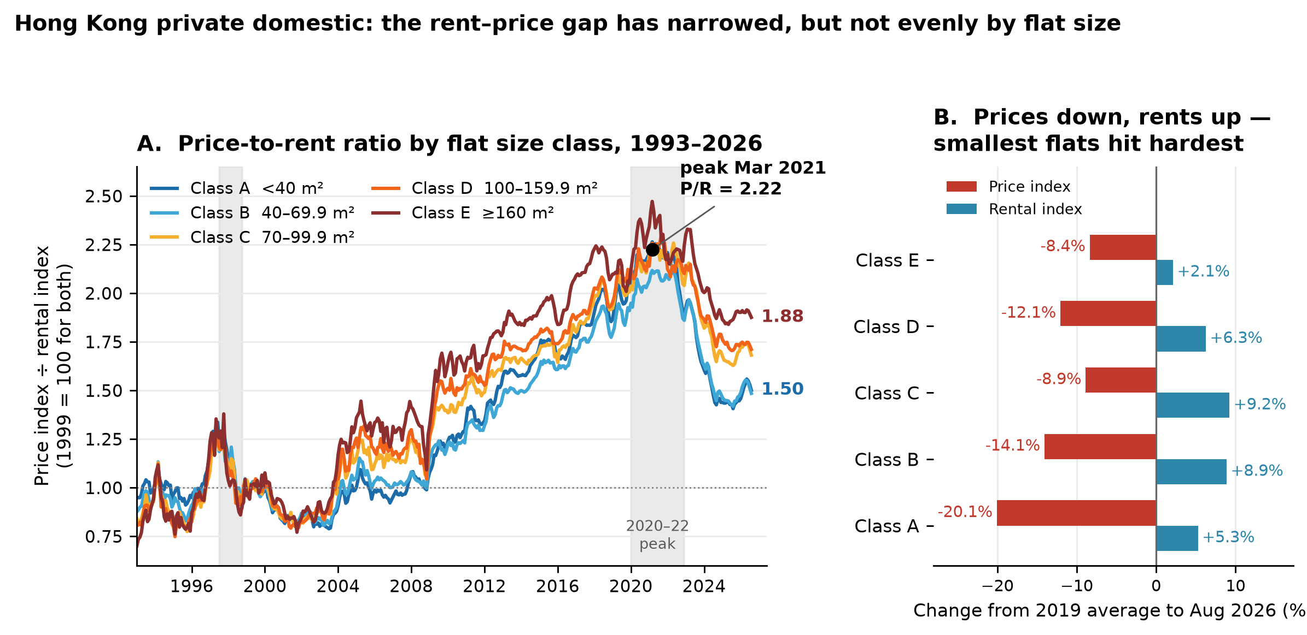
Source: Rating and Valuation Department, HKSAR Government. Both indices use 1999 = 100. Primary sales are excluded and the June-August 2026 figures are provisional.
Read together, the two panels answer the guiding question at the level it was asked: they measure how far prices moved from rents and show which side of the market did the moving.
The dashboard will add an exploratory view that a printed figure cannot provide. A reader can select one flat-size class and a comparison window, then switch the same chart to its price and rent components. This makes the provisional months visible and lets a reader test whether the recent narrowing is driven mainly by the price series. The printed figure carries the argument; the dashboard lets a sceptical reader check it.

8. Limitations and Next Steps
The analysis has three limits. The ratio is a relative measure built on two indices that share a base year, so it cannot be converted into a rental yield. The RVD series are class aggregates and say nothing about location, age or building quality; class E covers the fewest transactions, so its monthly values are the most volatile. The comparison is descriptive, and the design does not identify why prices and rents moved apart.
Three next steps follow: converting the ratio into an actual gross yield needs the average price and rent per square metre that the same department publishes; testing the divergence formally needs a structural-break test around 2021; and a comparison with Macau DSEC statistics would show whether the pattern is local or regional.

9. Collaboration
Assignment 02 is pair work. The two members are ZHOU ZHIFAN and YOU YUQI. The division below is the plan both members will follow.
Division of work. ZHOU ZHIFAN owns the data strand, covering Steps 1 to 3: acquiring and validating the two RVD workbooks, parsing the published layout into a tidy monthly frame, and building the price-to-rent indicator. YOU YUQI owns the output strand, covering Steps 4 and 5: producing the static figure, building the Plotly and Dash dashboard, and checking every quoted number against the analysis. Step 6 is drafted by YOU and checked by ZHOU. Both members read the finished proposal against the six criteria in Section 6 before submission. Ownership means accountability, not exclusivity: both members can run every step, and either can cover the other's work if needed.
Ground rules. Every number in the written output must be traceable to the analysis notebook. Where the published series is incomplete, the limitation is stated rather than silently worked around. Disagreements about the data are settled by re-running the analysis. Neither member submits until both have read the final version. We hold a 30-minute check-in each week, keep one shared folder with dated versions, and reply to each other within one working day.
Role (held by) | What the role covers for this project
Project coordinator (ZHOU ZHIFAN) | Sets the sequence and deadline for the six tasks and makes the final call when two options compete.
Project scribe (YOU YUQI) | Records decisions and keeps terminology, quoted numbers and the figure caption consistent.
Project progress tracker (YOU YUQI) | Checks each deliverable in Section 5 against its definition of done and raises slippage while there is time to respond.
Project liaison (ZHOU ZHIFAN) | Acts as the single point of contact with the instructor for questions and submission.

10. Data Sources and References
Rating and Valuation Department, HKSAR Government. Private Domestic Price Indices by Class (Territory-wide), 1999 = 100. Open price-index workbook
Rating and Valuation Department, HKSAR Government. Private Domestic Rental Indices by Class (Territory-wide), 1999 = 100. Open rental-index workbook
Rating and Valuation Department, HKSAR Government. Property Market Statistics, index landing page and technical notes. Open technical notes
All web sources were accessed on 25 October 2026. The two RVD workbooks are openly available and require no registration; the analysis uses the 25 October 2026 vintage.
Software. The analysis uses Python 3 with pandas, Plotly and Dash; exact versions are pinned in requirements.txt.

