Sobel-Guided Attention for Pix2Pix-Based Cross-Scene Single Image Reflection Removal : A Case Study on Museum Artifact Recognition
¹Zi-Xian Zhuang (莊子賢), ^{1,*}Jiann-Shu Lee (李建樹)
¹ Department of Computer Science and Information Engineering, National University of Tainan, Tainan City, Taiwan
E-mail: s11159030@gm2.nutn.edu.tw

Abstract

The fundamental bottleneck of supervised single image reflection removal (SIRR) is that real-world scenes rarely allow pixel-aligned 'with/without reflection' paired data. This prevents models from being trained directly on the target scene. Motivated by cross-scene generalization, we propose a Sobel-Guided Attention (SGA) module integrated into the Pix2Pix architecture, enabling a model trained on public SIRR datasets to transfer to unseen scenes without fine-tuning. SGA uses fixed Sobel kernels to extract per-channel edge gradient magnitudes that drive CBAM-style channel-and-spatial dual-branch attention. Because the kernels are fixed, their computation does not depend on the training data's scene distribution, which provides a structural basis for cross-scene transfer. We validate this on museum artifact reflection removal, a real scenario where exhibits are immovable and glass enclosures are hard to dismantle, making paired data entirely unobtainable at scale. Experiments show SGA enables successful generalization to museum artifacts, raising downstream YOLOv8 recognition accuracy from 92.7% to 94.5% and demonstrating a measurable, if modest, practical benefit of cross-scene reflection removal.
Keywords: Single image reflection removal, cross-scene generalization, Sobel structural prior, conditional generative adversarial network, Pix2Pix.

1. Introduction

Single image reflection removal (SIRR) is a persistently studied problem in computer vision, with applications spanning museum exhibit photography, automotive windshield imaging, and other real-world settings. Existing supervised deep-learning methods, however, face a fundamental training dilemma: they require pixel-aligned 'with/without reflection' paired images, which are nearly impossible to obtain at scale in most real deployments. Static aligned pairs remain out of reach whether due to the high glass-replacement and lighting-control costs of factory glass inspection, or the continuously changing ambient light of automotive scenes. This is a recognized limitation in current SIRR research: without datasets that comprehensively cover diverse real-world reflective surfaces and lighting conditions, model evaluation remains unreliable when deployed to new scenes [1].
Museum artifact reflection removal is a representative instance. Exhibits sit behind glass enclosures and cannot be moved, and ambient lighting is dictated by exhibition design and cannot be adjusted, so paired data are virtually unobtainable. Yet the application demand is real: when visitors photograph exhibits with smartphones, glass reflections markedly reduce AI recognition accuracy. In our experiments, YOLOv8 [2] reached only 92.7% accuracy on reflection-laden images. The museum setting thus offers an ideal case study with quantifiable downstream metrics for validating cross-scene SIRR generalization.
The core research question of this paper is whether a model trained on public SIRR datasets can be deployed directly to entirely unseen target scenes without fine-tuning. The key insight is that if a model's feature representations are scene-agnostic, the reflection removal it learns should transfer across scenes naturally. Two gradient properties motivate our design: the SIRR literature widely treats the low-gradient nature of reflection layers as a common prior [6][8], while object edges produce high-gradient responses from material discontinuity, a basic edge cause recognized across the edge-detection literature [31]. Building on this and on prior Sobel- and attention-guided designs (detailed in §2.3), we propose a Sobel-Guided Attention (SGA) module that performs edge-aware feature recalibration before the first encoder block of the Pix2Pix U-Net generator, letting the network distinguish 'exhibit structure' from 'reflection interference' at the pixel level.
The main contributions of this paper are as follows:
(1) We propose the SGA module, which uses fixed Sobel edge gradients to guide CBAM-style channel-and-spatial dual-branch attention. Because the Sobel kernels are fixed, SGA provides a structural prior for Pix2Pix reflection removal without adding any trainable parameters.
(2) We adopt a 'train on public SIRR datasets, deploy directly to the target scene' framework to study how fixed structural priors affect cross-scene SIRR generalization, offering a viable methodological path for real-world applications where paired data are hard to obtain.
(3) We conduct a museum artifact case study, training on public SIRR datasets and applying across scenes to museum images, with quantitative validation via YOLOv8 recognition accuracy (92.7% to 94.5%).

2. Related Work

2.1. Single Image Reflection Removal

SIRR research has evolved from optimization-based methods to deep learning. Fan et al. [6] introduced edge information into SIRR with CEILNet (CNN-based edge prediction followed by transmission recovery), a key predecessor of our SGA module. Li et al. [7] proposed IBCLN, which iteratively refines transmission and reflection layers and provides a densely annotated paired dataset used in our training set. Chi et al. [5] noted that downsampling-induced information loss increases decoder restoration difficulty, echoing our motivation for injecting edge attention before the encoder (§3.1); Dong et al. [8] showed the value of explicit spatial location cues via a reflection probability map.
Recent methods advance in different directions — DURRNet [9] via algorithm unrolling, PromptRR [10] via diffusion-driven Transformers at higher inference cost — but cross-scene generalization remains the core challenge this paper targets.

2.2. Image-to-Image Translation and Conditional Generative Adversarial Networks

Generative adversarial networks [11][15] learn data distributions via adversarial training, providing a powerful framework for image synthesis. Mirza and Osindero's cGAN [12] added condition vectors to learn deterministic mappings, the foundation of Pix2Pix; Isola et al. [13] instantiated this as Pix2Pix, establishing the effectiveness of paired supervision in image restoration (architecture detailed in §3).
CycleGAN [14] removes the paired-data requirement via cycle-consistency loss, but comparative experiments show Pix2Pix still outperforms it when sufficient paired data are available. We therefore train Pix2Pix on public paired SIRR datasets and deploy cross-scene, relying on existing paired data rather than requiring any in the target scene.

2.3. Attention Mechanisms

Hu et al. [16] proposed SENet, re-weighting channel features via global pooling and establishing channel attention in CNNs. Woo et al. [4] extended this with CBAM, combining channel and spatial attention to outperform SENet. Our SGA's dual-branch design derives directly from CBAM, but replaces purely learned statistics with fixed Sobel gradients as the driving signal — independent of the training data's scene distribution.
Lu et al. [3] applied Sobel-guided multi-scale attention to medical image segmentation, improving boundary precision despite a sizeable medical-to-natural domain gap; this single-domain success inspired us to extend the same principle to cross-scene validation. Combining global context modeling with channel calibration also outperforms either alone [17][18], further supporting our dual-branch design.

2.4. Edge-Guided Image Processing

Using edge information to guide image restoration is a mature paradigm. Xie and Tu [19] showed via holistically nested edge detection that edge features at different levels carry complementary structural information. Ji et al. [20] decoupled texture and semantic features via gradient supervision, inspiring our gradient-guided feature refinement.
Sharp U-Net [21] inserts sharpening kernels before skip connections to reduce the semantic gap between encoder and decoder features, similar to our injection of Sobel guidance before the encoder. Li and Liu [22] showed that gradient-guided design also applies in MRI super-resolution.
3. Proposed Method

3.1. Overall Architecture

This method uses Pix2Pix [13] as the backbone, with the SGA module inserted before the first encoder block of the U-Net generator (Fig. 1; full pipeline detailed in the caption). SGA is placed at the very front rather than in a middle layer for two reasons: reflection interference already exists at the pixel level, so downsampling before remediation risks losing structural detail [5]; and middle-layer features may already carry semantic cues specific to the training data's scenes, which could hinder cross-scene transfer.

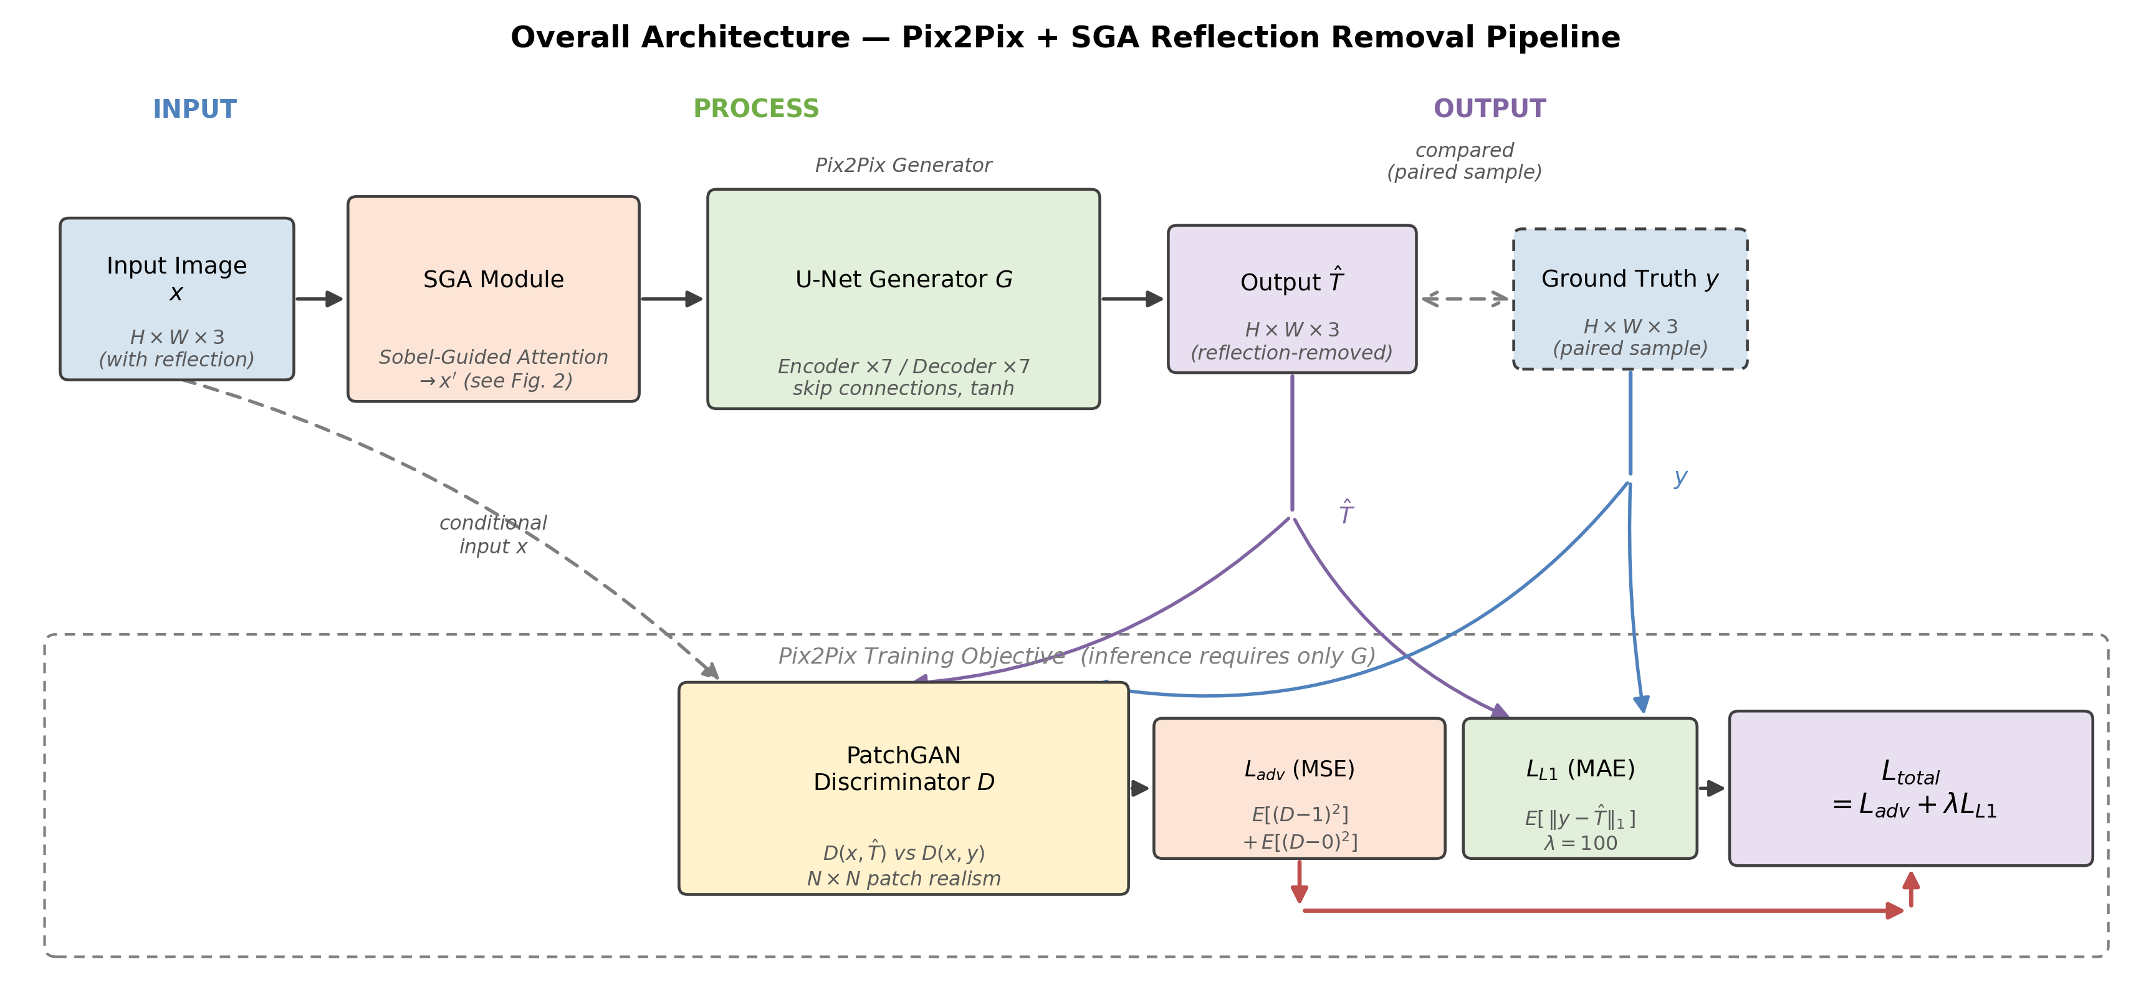
Fig. 1. Overall architecture diagram. The input image x (with reflection) is recalibrated by the SGA module (structure detailed in Fig. 2) to x', then mapped by the U-Net generator G to the reflection-free output T̂. During training, the PatchGAN discriminator D compares (x, T̂) with (x, y) to compute the adversarial loss Ladv, and T̂ is compared with ground truth y to compute LL1, combined as Ltotal = Ladv + λ·LL1 (λ = 100); during inference, only the generator G is required.

3.2. Sobel-Guided Attention Module (SGA)

The SGA module accepts the raw input image x ∈ R(H×W×3) and outputs a recalibrated feature map x' of the same dimensions. It runs in three sequential stages: Sobel feature extraction, channel attention, and spatial attention. All of these computations use fixed parameters and introduce no additional trainable parameters, so the attention-guidance signal's behavior is fixed by construction and does not change with training.

3.2.1. Sobel Feature Extraction
Fixed 3×3 Sobel horizontal convolution kernel Kx and vertical convolution kernel Ky are applied separately to each of the three input image channels (R, G, B) to compute gradient components:
$$G_{x,c}=x_{c}*K_{x},G_{y,c}=x_{c}*K_{y},c∈\{R,G,B\}$$
where Kx and Ky are defined as follows:
$$K_{x}=\left[\begin{matrix}-1 & 0 & +1 \\ -2 & 0 & +2 \\ -1 & 0 & +1\end{matrix}\right],K_{y}=\left[\begin{matrix}-1 & -2 & -1 \\ 0 & 0 & 0 \\ +1 & +2 & +1\end{matrix}\right]$$
The gradient magnitude is defined as:
$$M_{c}=\sqrt{G_{x,c}^{2}+G_{y,c}^{2}}$$
This yields the Sobel feature map S ∈ R(H×W×3), capturing the per-channel edge intensity distribution. As noted in §1, reflection regions show low gradients [6][8] while object edges show high gradients [31]. S therefore captures the gradient difference between 'object structure' and 'reflection interference', which is the basis for SGA's attention design.

3.2.2. Channel Attention Branch
Global average pooling is applied to the Sobel feature map S to obtain a channel descriptor v ∈ R3. Channel attention weights are then generated via a 1×1 convolution and Sigmoid activation:
$$w_{c}=sigmoid\left({Conv}_{1×1}\left(GAP(S)\right)\right)$$
The channel-recalibrated feature map is Xc = x ⊙ wc, where ⊙ denotes element-wise multiplication broadcast along the spatial dimensions. This adaptively adjusts the R, G, B contribution ratios by the relative importance of each channel's edge intensity, giving higher weight to edge-rich channels.

3.2.3. Spatial Attention Branch
Average pooling (AvgPool) and max pooling (MaxPool) are applied separately to the channel-recalibrated feature map Xc along the channel dimension. The two results are concatenated and passed through a 7×7 convolution with Sigmoid activation to generate a spatial attention map:
$$w_{s}=sigmoid\left({Conv}_{7×7}\left(\left[AvgPool(X_{c});MaxPool(X_{c})\right]\right)\right)$$
The final output of the SGA module is:
$$x^{'}=x⊙w_{c}⊙w_{s}$$
This dual-branch design strengthens edge-rich feature regions along both channel and spatial dimensions, while blurry, diffuse reflection regions are suppressed by their weak Sobel response. Because both wc and ws are driven by fixed Sobel gradients, their computation does not depend on scene content — this is why we expect stable attention behavior across the cross-scene deployment we tested.

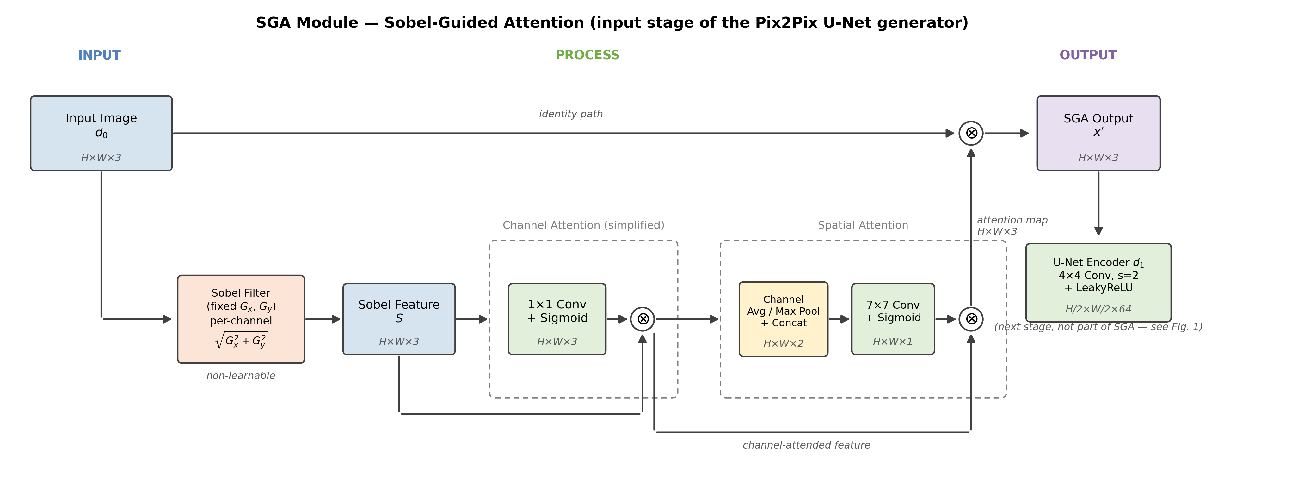
Fig. 2. Detailed structure of the SGA module. Sobel features are sequentially recalibrated by channel attention (1×1 convolution) and spatial attention (7×7 convolution), then element-wise multiplied with the original input and fed into the first encoder block of the U-Net.

3.3. U-Net Generator Architecture

The SGA module is followed by the standard Pix2Pix U-Net generator [13][23]. The encoder consists of 7 downsampling blocks and the decoder consists of 7 upsampling blocks, connected via skip connections that pass encoder feature maps at corresponding resolutions to preserve spatial details. The final layer outputs pixel values to [-1, 1] via tanh activation. All input and output images are normalized to [-1, 1] range via xnorm = x / 127.5 - 1.

3.4. PatchGAN Discriminator

The PatchGAN discriminator [13] judges overlapping N×N patches rather than the whole image, focusing on high-frequency local texture — well suited to reflection removal since it mainly affects local regions. Our discriminator consists of 4 convolutional layers plus a 1×1 output layer.

3.5. Loss Function

The training objective combines adversarial loss with pixel reconstruction loss:
$$L_{total}=L_{adv}+λ·L_{L1}$$
The adversarial loss Ladv uses mean squared error:
$$L_{adv}=E\left[‖D(G(x))-1‖^{2}\right]+E\left[‖D(y)-0‖^{2}\right]$$
The L1 pixel reconstruction loss spatially constrains the difference between the generated image and the ground-truth reflection-free image:
$$L_{L1}=E\left[‖y-G(x)‖_{1}\right]$$
The weight coefficient λ = 100 heavily favors the L1 term, ensuring pixel-level structural accuracy while the adversarial loss supplements perceptual realism. This configuration is consistent with the original Pix2Pix settings [13].

3.6. Training Configuration

Input and output images are uniformly resized to 256×256 pixels. The Adam optimizer is used with a learning rate of 5e-5, training for 500 epochs with a batch size of 8. Data augmentation employs random horizontal flipping applied synchronously to input-output pairs to maintain correct pixel correspondence.

4. Experiments

4.1. Experimental Design

Our model is trained entirely on public SIRR datasets, without any target-scene images. After training, it is deployed directly to the museum scene to evaluate reflection removal in this 'never-seen target domain'.

4.1.1. Training Dataset (Public SIRR Datasets)
The training data integrates four public SIRR datasets — SIR² [24], IBCLN [7], ERRNET [25], and RFC [26] — together covering diverse real-scene reflection types, materials, lighting conditions, and flash-assisted pairs.
The four datasets are merged and randomly split, with 80% as the training set (1951 pairs) and 20% as the test set (491 pairs). Splitting uses random sampling rather than dataset-based partitioning, ensuring that training and test sets have similar distributions of reflection types, scene diversity, and lighting conditions.

Fig. 3. Sample examples from the training dataset (left: Original, source image with reflection; right: Generated, corresponding model output). The scenes involve ordinary architecture and vegetation, completely unrelated to museum artifacts, directly illustrating that the training data and evaluation scenes come from unrelated sources.

4.1.2. Case Study: Museum Collection Evaluation Set
Museum artifact reflection removal is our chosen cross-scene case, selected because target-scene paired data are entirely unobtainable yet downstream recognition accuracy is readily quantifiable. The evaluation set contains 699 reflection-laden museum artifact images spanning 7 categories — ceramics, metal artifacts, and 3D sculptures — none used in training; lacking reflection-free ground truth, they serve only to validate the cross-scene downstream benefit rather than PSNR/SSIM/LPIPS.

4.2. Evaluation Metrics

This paper adopts a two-tier evaluation strategy:
(1) Image restoration metrics (on the public SIRR test set): PSNR, SSIM [27], LPIPS [28];
(2) Cross-scene downstream benefit (museum evaluation set): YOLOv8 [2] exhibit classification accuracy. Together, these two tiers quantify in-distribution restoration quality and target-domain practical benefit.

4.3. Ablation Study: Contribution of SGA to Generalization

To verify SGA's effectiveness, we compare two configurations on the public SIRR test set: (a) baseline Pix2Pix (no attention module); (b) Pix2Pix+SGA (ours). Quantitative results are shown in Table 1.

Table 1. Ablation experiment results on the public SIRR test set (491 pairs).
Method | PSNR (dB) ↑ | SSIM ↑ | LPIPS ↓
Baseline Pix2Pix [13] | 23.896 | 0.8706 | 0.1630
Pix2Pix + SGA (Ours) | 22.682 | 0.8192 | 0.2178

Table 1 shows that adding SGA yields PSNR (22.682 dB) and SSIM (0.8192) slightly below baseline Pix2Pix (23.896 dB / 0.8706), while LPIPS (0.2178) is higher than baseline (0.1630). This does not necessarily indicate degraded reflection removal — it is a common trait of GAN-based methods under perception-oriented optimization. Blau and Michaeli [29] proved a fundamental perception-distortion trade-off, where higher perceptual quality tends to lower PSNR/SSIM. Ledig et al. [30] confirmed the same pattern in super-resolution, where minimizing MSE encourages pixel-wise averaging that looks overly smooth. Our Pix2Pix L1 loss [13] shares this mechanism, and SGA's adversarial training pushes the model toward the perceptual boundary, so some drop in PSNR/SSIM is expected.
A breakdown by reflection severity clarifies this pattern further. Using the per-pixel difference between each reflection image and its paired ground truth as a proxy for reflection severity, we split the 491 test pairs into quartiles. The PSNR gap between Pix2Pix+SGA and Baseline narrows sharply with increasing severity: from −2.494 dB in the lightest quartile, to −1.249 dB, to −0.475 dB in the third quartile — an overall five-fold narrowing — before ticking back up slightly to −0.650 dB in the heaviest quartile. SSIM shows the same direction but more weakly (−0.057 to −0.045), while LPIPS shows essentially no such trend (+0.056 to +0.053 across quartiles). Consistent with this, the average PSNR gap (−1.214 dB) is driven disproportionately by a tail of cases. The worst-performing 20% of images account for a −3.743 dB gap, while the remaining 80% average only −0.583 dB (median gap: −0.799 dB, also below the mean), and 59% of this worst-performing tail overlaps with the lightest-reflection quartile. We interpret this as evidence that SGA's fixed structural prior contributes least on images where reflection is already mild and the baseline reconstructs accurately without help, while its relative disadvantage shrinks substantially on more severely reflective cases — closer to the deployment scenarios this paper targets. This pattern is clearest for PSNR, weaker for SSIM, and not observed for LPIPS, so it should be read as a partial, metric-specific explanation rather than a complete account of the gap.
We additionally tested whether limited input resolution (256×256) is the primary driver of the reconstruction gap by training a 512×512 variant (SGA-512, 360 epochs). Results showed only marginal PSNR/SSIM improvement (+0.14 dB / +0.02) and no LPIPS improvement (LPIPS increased from 0.217 to 0.238), while requiring a halved batch size (8→4) due to VRAM constraints. This suggests input resolution is not the primary bottleneck behind the observed gap, and we did not pursue this direction further given the increased training cost relative to the marginal benefit.

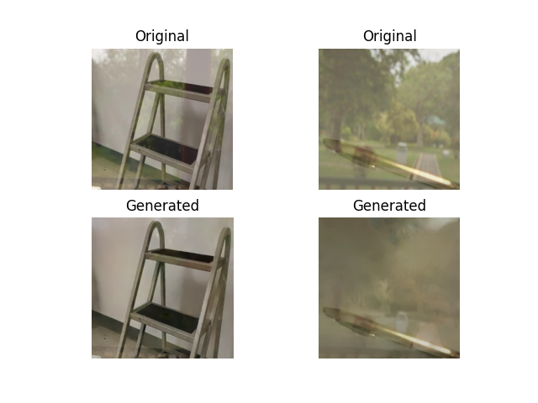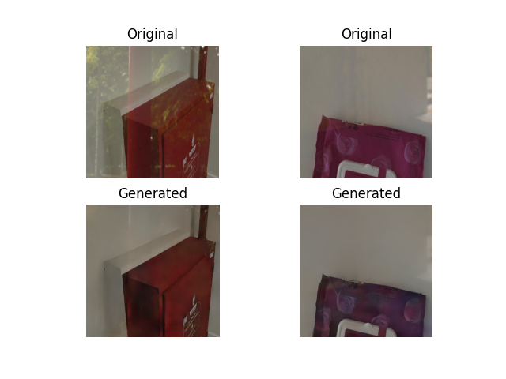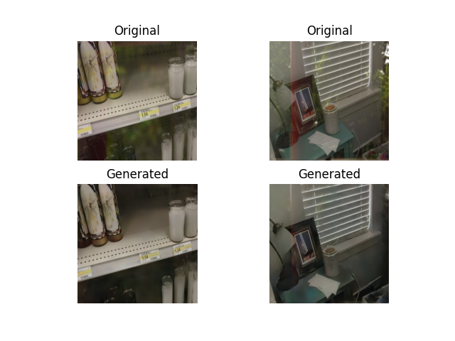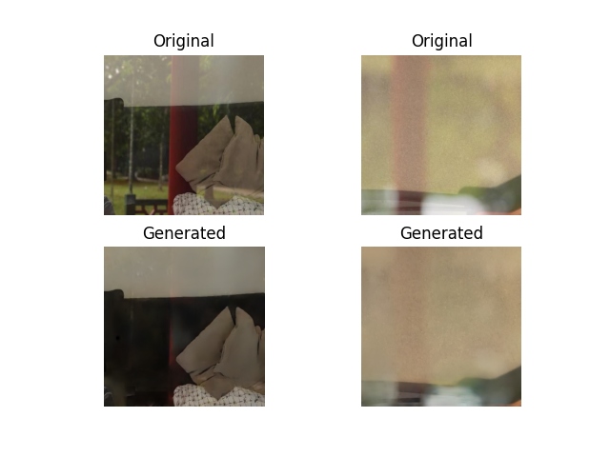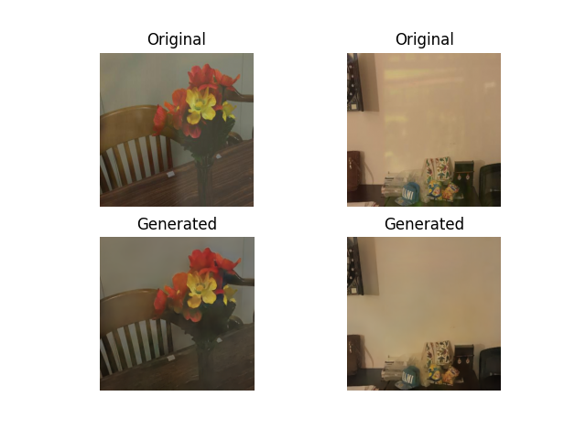
Fig. 4. Examples of reflection removal on the training dataset (Original/Generated comparison), showing visibly reduced reflection and genuine removal capability in-domain; see Table 1 and the Perception-Distortion discussion above for quantitative context.

4.4. Visual Comparison and Attention Map Analysis

Fig. 5 compares museum artifacts across three conditions: the original reflection-laden image, Baseline Pix2Pix, and Pix2Pix+SGA. Baseline removal also attempts to suppress reflections, but its effect is limited, with visible residual glare and a noticeable drop in overall resolution and detail. In contrast, reflection regions are markedly weakened once SGA is added, with object structure better preserved. This provides qualitative evidence consistent with the Sobel prior's edge-aware attention transferring to the museum scene.
Fig. 6 visualizes the Sobel gradient magnitude that drives SGA's attention. High gradients concentrate on exhibit edges and material details, while diffuse reflection areas show clearly lower gradients — suggesting that SGA's attention continues to emphasize object structure over reflection regions in the museum domain.

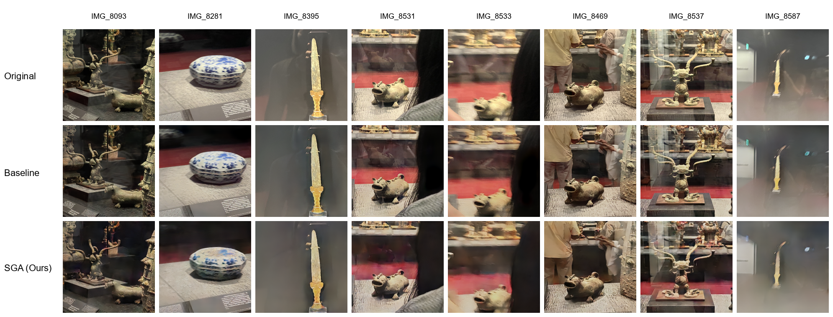
Fig. 5. Cross-scene visual comparison on museum collection items.

Top: originals with reflection (Original); middle: Baseline Pix2Pix results; bottom: Pix2Pix+SGA results (Ours).

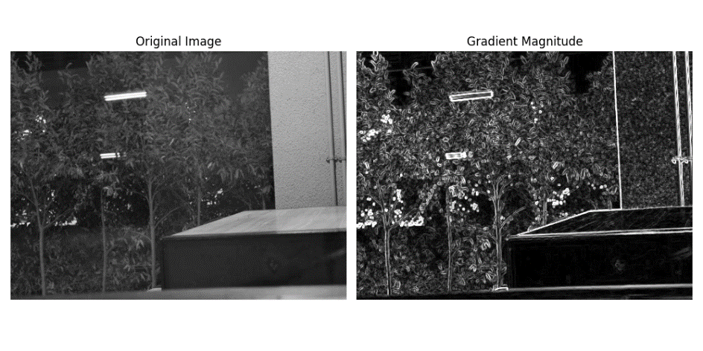
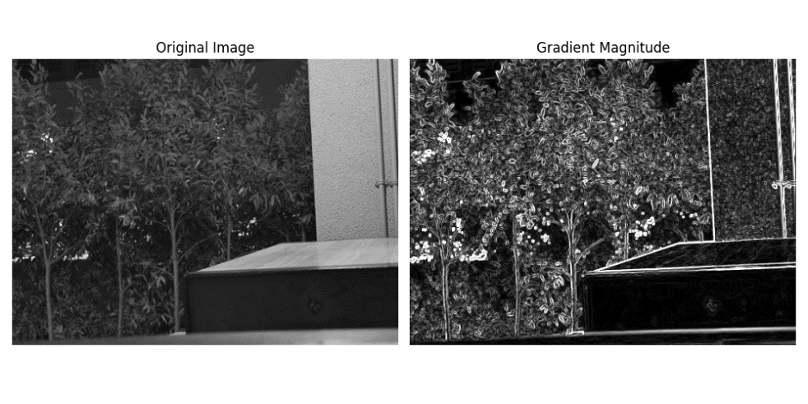
Fig. 6. Sobel gradient magnitude (left: original; right: magnitude). Top: with reflection, high gradients appear only at the boundary; bottom: without reflection, gradients concentrate on structural edges — the basis for SGA's attention signal.
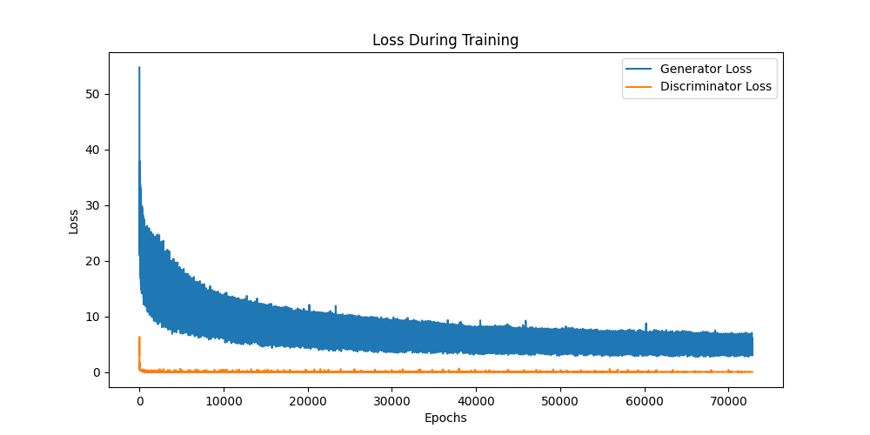
Fig. 7. Training loss curves (blue: Generator loss; orange: Discriminator loss; x-axis: iterations).

4.6. Cross-Scene Downstream Validation

Fig. 8 shows YOLOv8 detection boxes and confidence values for the same exhibit images before and after reflection removal, demonstrating its direct gain on downstream recognition.
Quantitatively, YOLOv8 reached 92.7% accuracy on the original reflection-containing images in the museum evaluation set (40 of 699 unrecognized). After Pix2Pix+SGA, 10 of these 40 (25%) became recognized, raising overall accuracy to 94.5% (+1.8 pp).
The overall accuracy improvement (+1.8 pp) is relatively modest, attributed primarily to two constraining factors:
(1) The correctable base is inherently small — the 40 of 699 failures (5.7%) cap the theoretical gain at 5.7 pp even if all were recovered.
(2) The recognition model already achieves a high 92.7% baseline, inherently limiting the room for improvement and making reflection removal's marginal contribution hard to surface in the overall metric.
For comparison, we further applied Baseline Pix2Pix (without SGA) to the museum images before downstream recognition. Baseline removal not only fails to cleanly eliminate glass reflections, but also markedly reduces resolution and blurs the structural and material details of the artifacts (e.g., smeared object contours). As a result, even a detector retrained on baseline-removed images mostly fails to recognize them reliably, producing missed detections, misclassifications, or only low-confidence outputs. We attribute this to the following mechanism: downstream recognition relies primarily on the structural contours and edges of the artifacts as discriminative cues. Baseline Pix2Pix lacks a structural prior, so it indiscriminately smooths high-frequency edges and textures while suppressing reflections, consistent with the L1/adversarial over-smoothing discussed in §4.3. This contour blurring erases discriminative features, so the detector can no longer recognize the objects. This result, in turn, supports the motivation for our fixed Sobel edge prior, which guides attention to preserve object structure during reflection removal.
Table 2. Cross-scene downstream recognition accuracy (museum evaluation set, 699 images, 7 exhibit categories).
Condition | Accuracy (%) | Description
Original image (with reflection) | 92.7 | 40 of 699 not recognized
Pix2Pix + SGA (Ours) | 94.5 | +1.8 pp; 10 of 40 (25%) recovered

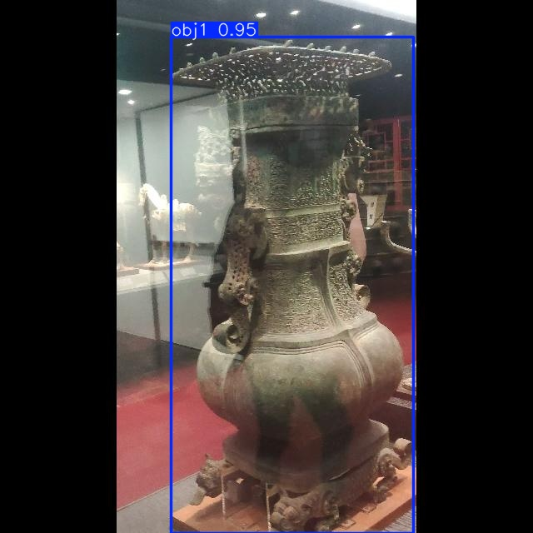 | 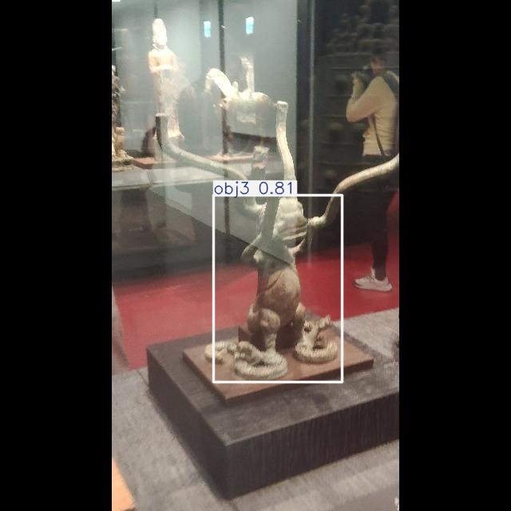 |  |  | 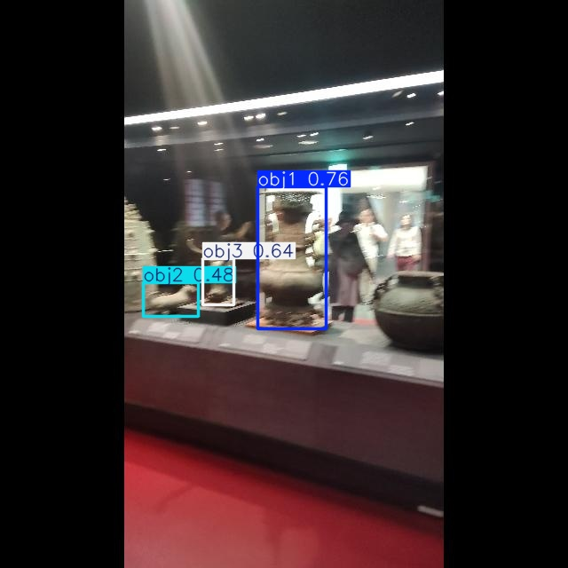
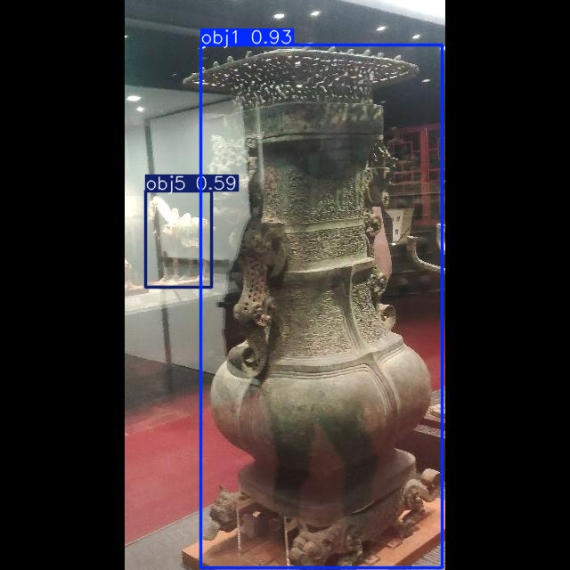 | 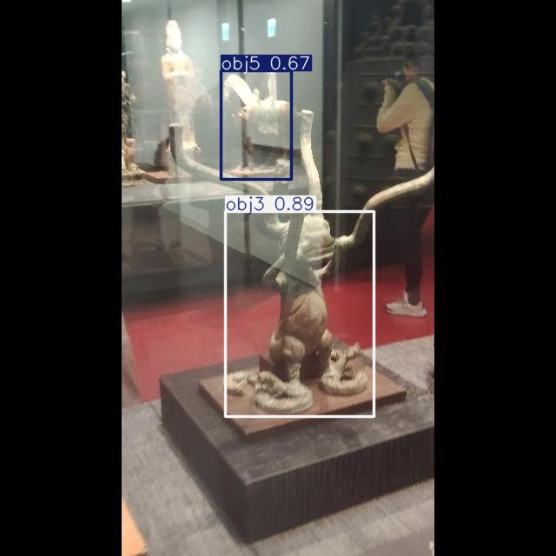 | 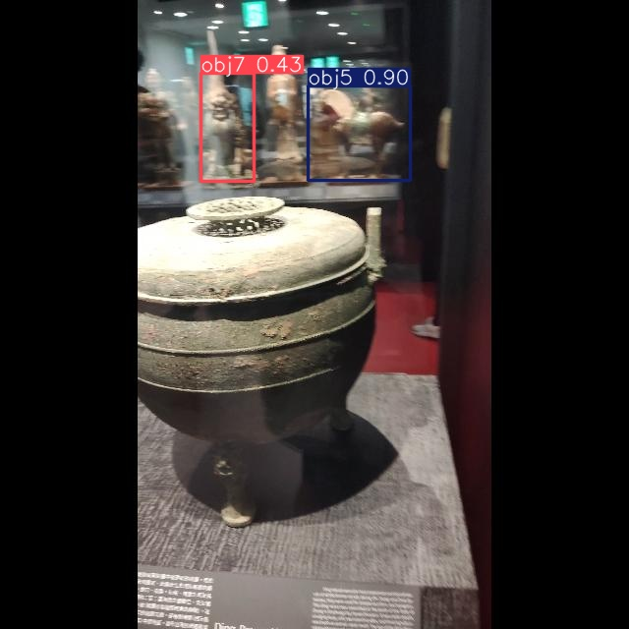 | 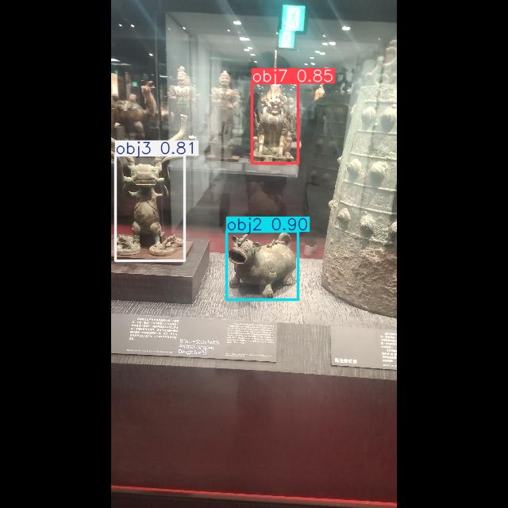 | 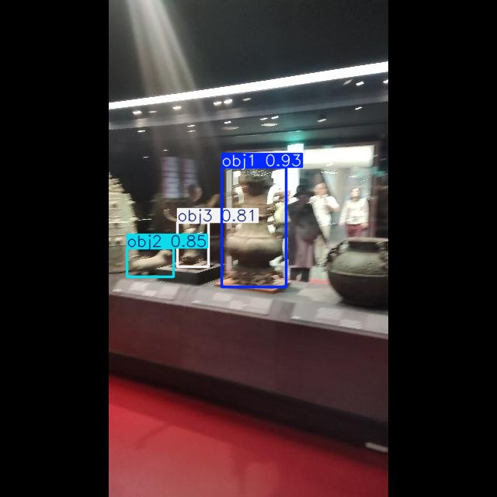
Fig. 8. YOLOv8 recognition result examples: comparison of detection bounding boxes and confidence values between images with reflection (top) and images processed by Pix2Pix+SGA (bottom).

5. Discussion

5.1. Why a Fixed Sobel Prior Enables Cross-Scene Generalization

The most central finding of this paper is that a model trained on a completely different domain, once equipped with SGA, generalizes directly to museum artifacts without any fine-tuning or domain adaptation (§4.6). The training dynamics in Fig. 7 also show that both D loss and G loss converge stably without obvious mode collapse, with no visible destabilization from adding SGA.
As described in §3.2.1, SGA uses fixed Sobel gradients as the attention-driving signal [6][8][31]. These gradients are computed solely from local pixel values of the input and are not adjusted to the training data's scene distribution. We conjecture this is one factor enabling the observed cross-scene transfer, since the attention-guidance signal does not undergo systematic shifts across scenes caused by differences in training distribution.
By contrast, if a learnable edge detector (such as HED [19]) were used as the driving signal, its weights would adjust to the training data's scene distribution and could produce semantic misjudgments of target-scene textures in cross-scene application.
This severity-dependence (§4.3) is consistent with the mechanism described above. Because the attention-guidance signal is driven directly by the magnitude of the Sobel gradient, its contribution is naturally larger when the gradient contrast between reflection and object structure is more pronounced — that is, under more severe reflection.

5.2. Limitation Analysis

This method has several limitations. First, the Sobel response is weak under large uniform low-gradient regions (e.g., plain ceramics) or strong dynamic reflections (e.g., intense outdoor sunlight, untested here), degrading SGA's guidance toward standard Pix2Pix. Second, the museum evaluation set lacks reflection-free ground truth (§4.1.2) and should be read alongside the SIRR ablation results. Third, the +1.8 pp improvement (§4.6) is jointly constrained by evaluation-set size and the recognition model's high baseline accuracy; the §4.3 severity stratification is likewise a coarse proxy, clear for PSNR but weak for SSIM/LPIPS. Future work will pursue a larger cross-scene dataset and more rigorous severity annotation.

6. Conclusion

Supervised SIRR generally faces the difficulty of obtaining target-domain paired data in real deployment. We address this with an SGA module integrated into Pix2Pix, using fixed Sobel kernels to drive CBAM-style dual-branch attention that distinguishes object structure from reflection interference without adding any trainable parameters. In a museum artifact case study, a model trained only on public SIRR datasets generalizes without fine-tuning, raising downstream YOLOv8 accuracy from 92.7% to 94.5% (+1.8 pp) — a measurable, if modest, benefit largest on more severely reflective cases (§4.3).

References

[1] K. Yang et al., "A Comprehensive Survey on Single Image Reflection Removal Using Deep Learning," arXiv:2502.08836, 2025.
[2] D. Reis, J. Hong, J. Kupec, and A. Daoudi, "Real-Time Flying Object Detection with YOLOv8," arXiv:2305.09972, 2023.
[3] F. Lu, C. Tang, T. Liu, Z. Zhang, and L. Li, "Multi-Attention Segmentation Networks Combined with the Sobel Operator for Medical Images," Sensors, vol. 23, no. 5, p. 2546, 2023. doi: 10.3390/s23052546.
[4] S. Woo, J. Park, J.-Y. Lee, and I. S. Kweon, "CBAM: Convolutional Block Attention Module," in Proc. ECCV, 2018, pp. 3-19.
[5] Z. Chi, X. Wu, X. Shu, and J. Gu, "Single Image Reflection Removal Using Deep Encoder-Decoder Network," arXiv:1802.00094, 2018.
[6] Q. Fan, J. Yang, G. Hua, B. Chen, and D. Wipf, "A Generic Deep Architecture for Single Image Reflection Removal and Image Smoothing," in Proc. IEEE ICCV, 2017, pp. 3238-3247.
[7] C. Li, Y. Yang, K. He, S. Lin, and J. E. Hopcroft, "Single Image Reflection Removal through Cascaded Refinement," in Proc. IEEE/CVF CVPR, 2020, pp. 3566-3574.
[8] Z. Dong, K. Xu, Y. Yang, H. Bao, W. Xu, and R. W. H. Lau, "Location-aware Single Image Reflection Removal," in Proc. IEEE/CVF ICCV, 2021, pp. 5017-5026.
[9] J.-J. Huang, T. Liu, Z. Yang, S. Fu, W. Zhao, and P. L. Dragotti, "DURRNet: Deep Unfolded Single Image Reflection Removal Network," arXiv:2203.06306, 2022.
[10] T. Wang, W. Lu, K. Zhang, T. Lu, and M.-H. Yang, "PromptRR: Diffusion Models as Prompt Generators for Single Image Reflection Removal," arXiv:2402.02374, 2024.
[11] I. Goodfellow et al., "Generative Adversarial Nets," in Adv. Neural Inf. Process. Syst. (NeurIPS), 2014, pp. 2672-2680.
[12] M. Mirza and S. Osindero, "Conditional Generative Adversarial Nets," arXiv:1411.1784, 2014.
[13] P. Isola, J.-Y. Zhu, T. Zhou, and A. A. Efros, "Image-to-Image Translation with Conditional Adversarial Networks," in Proc. IEEE CVPR, 2017, pp. 1125-1134.
[14] J.-Y. Zhu, T. Park, P. Isola, and A. A. Efros, "Unpaired Image-to-Image Translation using Cycle-Consistent Adversarial Networks," in Proc. IEEE ICCV, 2017, pp. 2223-2232.
[15] M.-Y. Liu et al., "Generative Adversarial Networks for Image and Video Synthesis: Algorithms and Applications," Proc. IEEE, vol. 109, no. 5, pp. 839-862, 2021.
[16] J. Hu, L. Shen, S. Albanie, G. Sun, and E. Wu, "Squeeze-and-Excitation Networks," IEEE Trans. Pattern Anal. Mach. Intell., vol. 42, no. 8, pp. 2011-2023, 2020.
[17] Y. Cao, J. Xu, S. Lin, F. Wei, and H. Hu, "GCNet: Non-local Networks Meet Squeeze-Excitation Networks and Beyond," in Proc. IEEE ICCVW, 2019, pp. 1971-1980.
[18] X. Wang, R. Girshick, A. Gupta, and K. He, "Non-local Neural Networks," in Proc. IEEE/CVF CVPR, 2018, pp. 7794-7803.
[19] S. Xie and Z. Tu, "Holistically-Nested Edge Detection," in Proc. IEEE ICCV, 2015, pp. 1395-1403.
[20] G. Ji, D.-P. Fan, Y.-C. Chou, D. Dai, A. Liniger, and L. Van Gool, "Deep Gradient Learning for Efficient Camouflaged Object Detection," Mach. Intell. Res., vol. 20, no. 1, pp. 92-108, 2023.
[21] H. Zunair and A. B. Hamza, "Sharp U-Net: Depthwise Convolutional Network for Biomedical Image Segmentation," Comput. Biol. Med., vol. 139, p. 104941, 2021.
[22] H. Li and J. Liu, "Edge, Structure and Texture Refinement for Retrospective High Quality MRI Restoration using Deep Learning," in Proc. IEEE ISBI, 2021.
[23] O. Ronneberger, P. Fischer, and T. Brox, "U-Net: Convolutional Networks for Biomedical Image Segmentation," in Proc. MICCAI, 2015, pp. 234-241.
[24] R. Wan, B. Shi, L.-Y. Duan, A.-H. Tan, and A. C. Kot, "Benchmarking Single-Image Reflection Removal Algorithms," in Proc. IEEE ICCV, 2017, pp. 3942-3950.
[25] K. Wei, J. Yang, Y. Fu, D. Wipf, and H. Huang, "Single Image Reflection Removal Exploiting Misaligned Training Data and Network Enhancements," in Proc. IEEE/CVF CVPR, 2019.
[26] C. Lei and Q. Chen, "Robust Reflection Removal with Reflection-free Flash-only Cues," in Proc. IEEE/CVF CVPR, 2021, pp. 14811-14820.
[27] Z. Wang, A. C. Bovik, H. R. Sheikh, and E. P. Simoncelli, "Image Quality Assessment: From Error Visibility to Structural Similarity," IEEE Trans. Image Process., vol. 13, no. 4, pp. 600-612, Apr. 2004.
[28] R. Zhang, P. Isola, A. A. Efros, E. Shechtman, and O. Wang, "The Unreasonable Effectiveness of Deep Features as a Perceptual Metric," in Proc. IEEE/CVF CVPR, 2018, pp. 586-595.
[29] Y. Blau and T. Michaeli, "The Perception-Distortion Tradeoff," in Proc. IEEE/CVF CVPR, 2018, pp. 6228-6237.
[30] C. Ledig et al., "Photo-Realistic Single Image Super-Resolution Using a Generative Adversarial Network," in Proc. IEEE/CVF CVPR, 2017, pp. 4681-4690.
[31] M. Pu, Y. Huang, Q. Guan, and H. Ling, "RINDNet: Edge Detection for Discontinuity in Reflectance, Illumination, Normal and Depth," in Proc. IEEE/CVF ICCV, 2021, pp. 6879-6888.

