Sobel-Guided Attention for Pix2Pix-Based Cross-Scene Single Image Reflection Removal
: A Case Study on Museum Artifact Recognition
¹Zi-Xian Zhuang (莊子賢), ^{1,*}Jiann-Shu Lee (李建樹)
¹ Department of Computer Science and Information Engineering, National University of Tainan, Tainan City, Taiwan
E-mail: s11159030@gm2.nutn.edu.tw

Abstract

The fundamental bottleneck of supervised single image reflection removal (SIRR) lies in the near-impossibility of obtaining pixel-aligned paired training data in real-world application scenes. Motivated by cross-scene generalization, this paper proposes a Sobel-Guided Attention (SGA) module integrated into the Pix2Pix image-to-image translation framework, investigating how a model trained on public SIRR datasets can be deployed to unseen target scenes without fine-tuning. The SGA module extracts per-channel edge gradient magnitudes using fixed Sobel convolution kernels to drive a CBAM-style channel-and-spatial dual-branch attention; since the Sobel kernels are fixed parameters whose computation is independent of the training data distribution, they provide a structurally guided foundation for cross-scene transfer. We validate the approach on museum artifact reflection removal: museums represent a real-world case where pixel-aligned paired data are completely unobtainable at scale due to immovable exhibits and protective glass enclosures. Experiments show that SGA enables the model to generalize successfully to museum artifacts across scenes, improving downstream YOLOv8 exhibit recognition accuracy from 92.7% to 94.5%, demonstrating the practical benefit of cross-scene reflection removal.
Keywords: Single image reflection removal, cross-scene generalization, Sobel structural prior, conditional generative adversarial network, Pix2Pix.

1. Introduction

Single image reflection removal (SIRR) is a persistently studied research problem in computer vision, with applications spanning museum exhibit photography, automotive windshield imaging, and numerous other real-world scenarios. However, existing supervised deep-learning methods face a fundamental training dilemma: models require pixel-aligned paired images (with/without reflection) for training, yet in the vast majority of real deployment scenarios, such paired data are nearly impossible to obtain at scale. In factory glass inspection, for example, replacing glass or controlling light sources entails prohibitive costs; in automotive scenes, continuously changing ambient lighting precludes acquiring static aligned pairs. This domain gap causes even models that perform well on public datasets to degrade substantially in actual target-scene deployment [1].
Museum artifact reflection removal is a representative instance of this dilemma. Exhibits are protected by glass enclosures and cannot be moved or arbitrarily disassembled; ambient lighting is dictated by exhibition design and cannot be freely adjusted, making pixel-aligned paired data virtually impossible to obtain at scale in practice. Yet the demand for museum smart-guide systems is real: when visitors photograph exhibits with smartphones, glass reflections substantially reduce the recognition accuracy of AI systems — in our experiments, YOLOv8 [2] achieved only 92.7% recognition accuracy on images with reflections. The museum setting thus provides an ideal case study with quantifiable downstream metrics, well-suited for validating the practical efficacy of cross-scene SIRR generalization methods.
The core research question of this paper is: can a model trained on public SIRR datasets be deployed directly in completely unseen target scenes without any fine-tuning? What architectural design can support such cross-scene transfer? The key insight is that if the feature representations a model relies on are scene-agnostic, then the reflection removal capability learned on one scene can naturally transfer. SIRR literature widely treats the low-gradient characteristic of reflection layers as a commonly used prior assumption [6][8], while object edges exhibit high-gradient responses due to material discontinuity — a foundational edge cause universally recognized in the computer vision edge detection literature [31]; this paper takes these two properties as the starting point for designing feature representations that capture this gradient difference.
Based on this observation, we propose a design strategy using fixed Sobel gradients as attention-driving signals. The Sobel convolution kernels are fixed parameters; their computed gradient magnitudes reflect only the local structural properties of the image, independent of the scene distribution of the training data. Lu et al. [3] demonstrated the effectiveness of Sobel-guided attention in medical image segmentation, while CBAM [4] established the complementary advantage of dual-branch channel-and-spatial attention — together providing the theoretical basis for our Sobel-Guided Attention (SGA) module design. SGA drives a CBAM-style dual-branch attention using fixed Sobel gradient magnitudes, performing edge-aware feature recalibration ahead of the first encoder block of the Pix2Pix U-Net generator, enabling the model to distinguish between 'exhibit structure' and 'reflection interference' at the pixel level [5].
The main contributions of this paper are as follows:
(1) We propose the SGA module, which uses fixed Sobel edge gradients to guide CBAM-style channel-and-spatial dual-branch attention. Without introducing any additional trainable parameters, it provides domain-agnostic structural prior guidance for Pix2Pix reflection removal.
(2) We adopt a 'train on public SIRR datasets, deploy directly to target scene' research framework to investigate the role of fixed structural priors in cross-scene SIRR generalization, providing a viable methodological path for real-world applications where paired data are difficult to obtain.
(3) We conduct a case study on museum artifact reflection removal, training on public SIRR datasets and applying across scenes to museum images, with quantitative validation via YOLOv8 recognition accuracy (92.7% -> 94.5%).

2. Related Work

2.1. Single Image Reflection Removal

SIRR research has evolved from optimization-based traditional methods to deep learning. Fan et al. [6] proposed CEILNet, the first cascaded CNN architecture to introduce edge information into SIRR: an E-CNN first estimates object edge maps, then an I-CNN uses edge maps as auxiliary input to recover the transmission layer. This design established the 'edge-guided restoration' technical paradigm, a key predecessor of our SGA module design.
Li et al. [7] proposed IBCLN, using convolutional LSTM to achieve iterative progressive alternating refinement of transmission and reflection layers, and built a real-scene paired dataset with dense ground-truth annotations — one of the datasets used in our training. Chi et al. [5] noted that information loss due to downsampling increases decoder restoration difficulty, an observation that echoes our design motivation for injecting edge attention before the encoder (see §3.1). Dong et al. [8] proposed location-aware reflection removal, using an explicit reflection location detection module to regress a reflection probability map to guide feature flow, demonstrating the effectiveness of 'explicit spatial location cues' in SIRR tasks.
Recent methods have advanced in different directions: DURRNet [9] endows the network with theoretical interpretability through algorithm unrolling; PromptRR [10] uses a diffusion model as a frequency-domain prompt generator to drive a Transformer, achieving the latest SOTA but with high inference cost due to multi-step sampling. Although these methods have achieved significant progress on public benchmarks, cross-scene generalization remains the core challenge for real-world deployment of deep-learning SIRR.

2.2. Image-to-Image Translation and Conditional Generative Adversarial Networks

Generative adversarial networks [11][15] learn data distributions via adversarial training between a generator and a discriminator, providing a powerful framework for image synthesis. Mirza and Osindero [12] proposed cGAN, incorporating condition vectors into both generator and discriminator, enabling the network to learn deterministic input-to-output mappings and establishing the theoretical foundation for Pix2Pix. Isola et al. [13] instantiated this paradigm as Pix2Pix: a U-Net generator paired with a PatchGAN discriminator, trained with an L1+cGAN loss combination, achieving breakthrough results on multiple paired translation tasks and establishing the effectiveness of paired supervised training in image restoration tasks.
CycleGAN [14] introduced cycle-consistency loss to learn cross-domain mappings without paired data, theoretically suitable for scenarios where paired data are difficult to obtain. Comparative experiments show that Pix2Pix outperforms CycleGAN and other unsupervised methods when sufficient paired data are available. Our choice to train Pix2Pix on public paired SIRR datasets and then deploy cross-scene is a design strategy that balances 'leveraging the supervisory strength of available paired data' with 'zero paired data in the target scene'.

2.3. Attention Mechanisms

Hu et al. [16] proposed SENet, which compresses spatial dimensions via global average pooling and then learns inter-channel dependencies through fully connected layers for channel feature re-weighting, establishing the position of channel attention in CNNs. Woo et al. [4] proposed CBAM, sequentially inferring attention maps along channel and spatial dimensions, outperforming SENet across extensive classification and detection experiments, demonstrating the complementarity of dual-branch attention. The dual-branch design of our SGA module derives directly from the CBAM framework, replacing pure learned statistics with fixed Sobel gradients as the driving signal — this substitution is the key to achieving domain-agnostic characteristics.
Lu et al. [3] proposed a multi-scale attention network guided by the Sobel operator for medical image segmentation, using gradient magnitude as a structural prior to drive the attention mechanism, significantly improving segmentation boundary precision. A significant domain gap also exists between medical images and natural scenes; that method achieved good segmentation results within a single medical domain using fixed Sobel gradients to drive attention, inspiring us to extend this design principle further to cross-scene scenarios for validation. The combination of global context modeling and channel calibration outperforms either mechanism alone, further supporting our dual-branch design [17][18].

2.4. Edge-Guided Image Processing

Using edge information to guide image restoration is a mature technical paradigm: Xie and Tu [19] proposed holistically nested edge detection, demonstrating through multi-scale deep supervision that edge features at different levels carry complementary structural information — an important benchmark for subsequent edge-guided methods; Ji et al. [20] proposed DGNet, which decouples texture and semantic features via object gradient supervision; our work is deeply inspired by its gradient-guided feature refinement approach.
Sharp U-Net [21] incorporates sharpening kernels before the skip connections of a U-Net, reducing the semantic dissimilarity between encoder and decoder features — echoing our design philosophy of injecting Sobel structural guidance before skip connections. Li and Liu [22] introduced a gradient-map edge quality loss in MRI super-resolution tasks, compelling the model to learn edge structural details, demonstrating that gradient-guided design is also applicable in the medical image domain.

3. Proposed Method

3.1. Overall Architecture

The proposed method uses Pix2Pix [13] as the backbone architecture, with the core innovation of inserting the SGA module before the first encoder block of the U-Net generator. The overall pipeline is shown in Fig. 1: given a reflection-contaminated input image Ir ∈ R(H×W×3), the SGA module first performs edge-aware feature recalibration, outputting a structurally enhanced feature map x', which is then mapped by the U-Net generator to a reflection-free output T̂ ∈ R(H×W×3). The PatchGAN discriminator evaluates the authenticity of local image patches during training, forcing the generator to produce outputs with realistic high-frequency details. SGA is inserted at the front rather than at an intermediate layer because reflection interference already exists at the pixel level; allowing the network to first perform downsampling before remediation risks losing structural detail information during the downsampling process [5], and intermediate-layer features are already mixed with domain-specific semantic information, which is detrimental to cross-scene transfer.

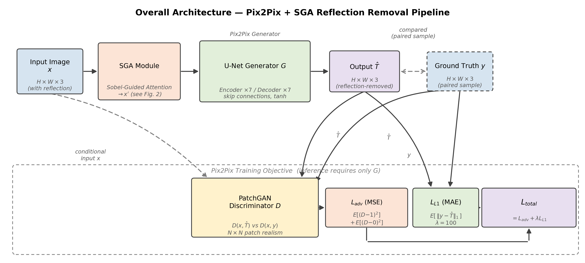
Fig. 1. Overall architecture diagram. The input image x (with reflection) is recalibrated by the SGA module (structure detailed in Fig. 2) to x', then mapped by the U-Net generator G to the reflection-free output T̂. During training, the PatchGAN discriminator D compares (x, T̂) with (x, y) to compute the adversarial loss Ladv, and T̂ is compared with ground truth y to compute LL1, combined as Ltotal = Ladv + λ·LL1 (λ = 100); during inference, only the generator G is required.

3.2. Sobel-Guided Attention Module (SGA)

The SGA module accepts the raw input image x ∈ R(H×W×3) and outputs a recalibrated feature map x' of the same dimensions, comprising three sequentially executed stages: Sobel feature extraction, channel attention, and spatial attention. All computations in SGA are based on fixed parameters, introducing no additional trainable parameters, ensuring that the domain-agnostic properties of the attention guidance signal do not degrade through training dynamics.

3.2.1. Sobel Feature Extraction
Fixed 3×3 Sobel horizontal convolution kernel Kx and vertical convolution kernel Ky are applied separately to each of the three input image channels (R, G, B) to compute gradient components:
G_{x,c} = x_{c} * K_{x}, G_{y,c} = x_{c} * K_{y}, c ∈ {R, G, B}
where Kx and Ky are defined as follows:
Kx = [-1 0 +1] Ky = [-1 -2 -1]
[-2 0 +2] [ 0 0 0]
[-1 0 +1] [+1 +2 +1]
The gradient magnitude is defined as:
M_{c} = √( G_{x,c}² + G_{y,c}² )
This yields the Sobel feature map S ∈ R(H×W×3), capturing the edge intensity distribution of each channel. As described in §1, reflection regions exhibit low gradients [6][8] while exhibit edges exhibit high gradients [31]; S therefore simultaneously captures the difference in gradient intensity between 'object structure' and 'reflection interference', providing the basis for SGA's attention design.

3.2.2. Channel Attention Branch
Global average pooling is applied to the Sobel feature map S to obtain a channel descriptor v ∈ R3. Channel attention weights are then generated via a 1×1 convolution and Sigmoid activation:
w_{c} = sigmoid( Conv_{1x1}( GAP(S) ) )
The channel-recalibrated feature map is Xc = x ⊙ wc, where ⊙ denotes element-wise multiplication broadcast along spatial dimensions. This operation adaptively adjusts the contribution ratio of R, G, B channels according to the relative importance of each channel's edge intensity, assigning higher weights to channels rich in edge information.

3.2.3. Spatial Attention Branch
Average pooling (AvgPool) and max pooling (MaxPool) are applied to the channel-recalibrated feature map Xc along the channel dimension separately, then concatenated and passed through a 7×7 convolution and Sigmoid activation to generate a spatial attention map:
w_{s} = sigmoid( Conv_{7x7}( [AvgPool(X_{c}) ; MaxPool(X_{c})] ) )
The final output of the SGA module is:
x' = x ⊙ w_{c} ⊙ w_{s}
This dual-branch design ensures that feature regions rich in object edges are enhanced along both channel and spatial dimensions, while diffuse reflection regions are suppressed due to their weak Sobel response. Since both wc and ws are driven by fixed Sobel gradients, their computation logic remains consistent across any scene, ensuring the stability of attention during cross-scene deployment.

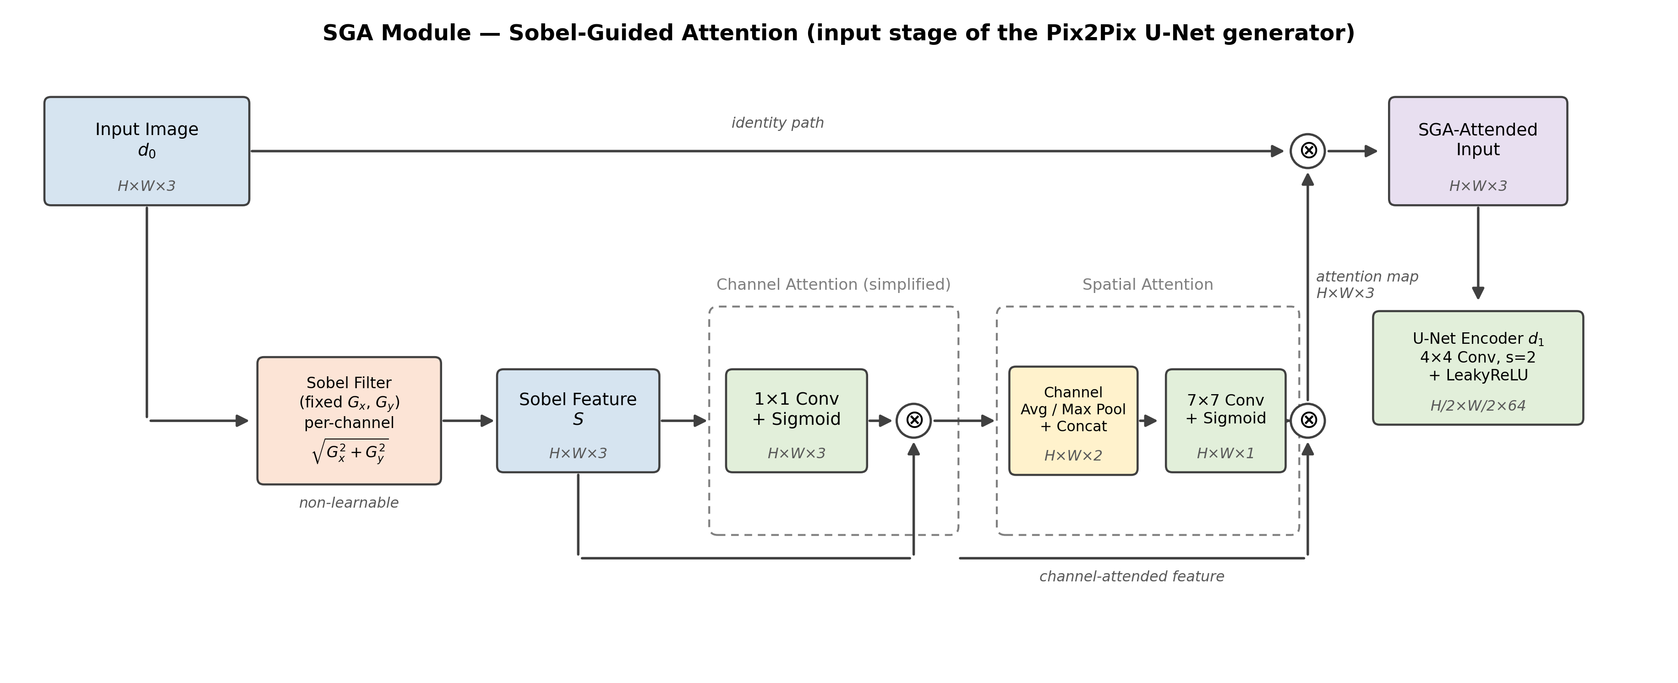
Fig. 2. Detailed structure of the SGA module. Sobel features are sequentially recalibrated by channel attention (1×1 convolution) and spatial attention (7×7 convolution), then element-wise multiplied with the original input and fed into the first encoder block of the U-Net.

3.3. U-Net Generator Architecture

The SGA module is followed by the standard Pix2Pix U-Net generator [13][23]. The encoder consists of 7 downsampling blocks and the decoder consists of 7 upsampling blocks, connected via skip connections that pass encoder feature maps at corresponding resolutions to preserve spatial details. The final layer outputs pixel values to [-1, 1] via tanh activation. All input and output images are normalized to [-1, 1] range via xnorm = x / 127.5 - 1.

3.4. PatchGAN Discriminator

The PatchGAN discriminator [13] judges the authenticity of overlapping N×N image patches in the image individually, rather than outputting a single scalar for the entire image. This design focuses the discriminator on the authenticity of high-frequency local textures, which is particularly appropriate for reflection removal — reflections primarily affect local regions, and patch-level judgment provides more precise gradient signals. Our discriminator consists of 4 convolutional layers followed by a 1×1 output layer.

3.5. Loss Function

The training objective combines adversarial loss with pixel reconstruction loss:
L_{total} = L_{adv} + λ·L_{L1}
The adversarial loss Ladv uses mean squared error:
L_{adv} = E[ ||D(G(x)) - 1||² ] + E[ ||D(y) - 0||² ]
The L1 pixel reconstruction loss spatially constrains the difference between the generated image and the ground-truth reflection-free image:
L_{L1} = E[ ||y - G(x)||₁ ]
The weight coefficient λ = 100 heavily favors the L1 term, ensuring pixel-level structural accuracy while the adversarial loss supplements perceptual realism. This configuration is consistent with the original Pix2Pix settings [13].

3.6. Training Configuration

Input and output images are uniformly resized to 256×256 pixels. The Adam optimizer is used with a learning rate of 5e-5, training for 500 epochs with a batch size of 8. Data augmentation employs random horizontal flipping applied synchronously to input-output pairs to maintain correct pixel correspondence.

4. Experiments

4.1. Experimental Design

The reflection removal model is trained entirely on public SIRR datasets without using any images from the target scene; after training, the model is deployed directly to museum scenes to evaluate its reflection removal performance in 'never-seen target domains'.

4.1.1. Training Dataset (Public SIRR Datasets)
The training data integrates four public single-image reflection removal datasets: SIR² [24] (large-scale real-scene paired reflection dataset with diverse reflection types), IBCLN [7] (real-scene reflection image pairs from multiple indoor environments), ERRNET [25] (reflection scenes under multiple material surfaces and lighting conditions with rich variation in reflection intensity gradients), and RFC [26] (paired data captured with flash assistance, covering multiple glass types and indoor lighting conditions).
The four datasets are merged and randomly split, with 80% as the training set (810 pairs) and 20% as the test set (248 pairs). Splitting uses random sampling rather than dataset-based partitioning, ensuring that training and test sets have similar distributions of reflection types, scene diversity, and lighting conditions.

Fig. 3. Sample examples from the training dataset (left: Original, source image with reflection; right: Generated, corresponding model output). The scenes involve ordinary architecture and vegetation, completely unrelated to museum artifacts, directly illustrating the absence of domain overlap between training data and evaluation scenes.

4.1.2. Case Study: Museum Collection Evaluation Set
Museum artifact reflection removal is the selected cross-scene case for this paper, representing a typical situation where 'target-scene paired data are completely unobtainable at scale', while also providing quantifiable downstream recognition accuracy as an evaluation metric. We collected museum artifact images with reflections as an evaluation set, covering 7 exhibit categories including ceramics, metal artifacts, and three-dimensional sculptures, totaling 699 images — entirely excluded from model training and used only for cross-scene benefit verification of the downstream recognition task.
This evaluation set provides only downstream recognition accuracy and cannot provide PSNR/SSIM/LPIPS quantitative metrics.

4.2. Evaluation Metrics

This paper adopts a two-tier evaluation strategy:
(1) Image restoration metrics (on the public SIRR test set): PSNR, SSIM [27], LPIPS [28];
(2) Cross-scene downstream benefit (on the museum evaluation set): YOLOv8 [2] exhibit classification accuracy, directly reflecting the impact of reflection removal on actual recognition tasks. The two-tier evaluation respectively quantifies the model's restoration quality within the training distribution and its practical benefit on the target domain, providing a complete picture of cross-scene generalization.

4.3. Ablation Study: Contribution of SGA to Generalization

To verify the effectiveness of the SGA module, this paper compares two configurations on the public SIRR test set: (a) Baseline Pix2Pix: standard Pix2Pix without any attention module; (b) Pix2Pix+SGA (ours): incorporating the complete dual-branch Sobel-guided attention module. Quantitative results are shown in Table 1.

Table 1. Ablation experiment results on the public SIRR test set (491 pairs).
方法 | PSNR (dB) ↑ | SSIM ↑ | LPIPS ↓
Baseline Pix2Pix [13] | 23.896 | 0.8706 | 0.1630
Pix2Pix + SGA（本文） | 22.682 | 0.8192 | 0.2178

Table 1 shows that after adding SGA, PSNR (22.682 dB) and SSIM (0.8192) are slightly lower than baseline Pix2Pix (23.896 dB / 0.8706), while LPIPS (0.2178) is higher than baseline (0.1630). This does not indicate degradation in reflection removal capability, but rather a characteristic typically observed when GAN-based methods optimize for perceptual quality. Blau and Michaeli [29] theoretically proved that a fundamental tradeoff exists between perceptual quality and distortion metrics — methods with higher perceptual quality tend to yield lower PSNR/SSIM, and this phenomenon does not disappear with choice of metric. Ledig et al. [30] experimentally confirmed in image super-resolution that 'minimizing MSE encourages the model to output the pixel-averaged over all plausible solutions, leading to over-smoothed results'; the Pix2Pix L1 loss [13] used in this paper has the same mechanistic characteristics, and SGA's adversarial training moves the model toward the perceptual boundary, so lower PSNR/SSIM is an expected phenomenon.

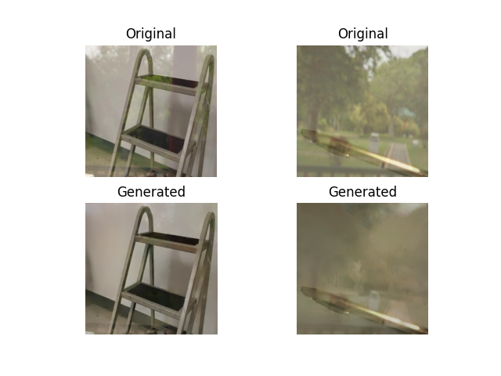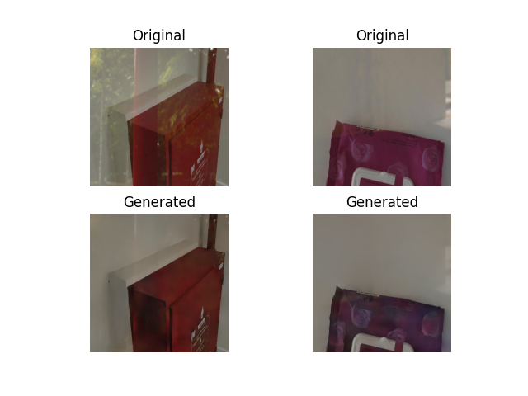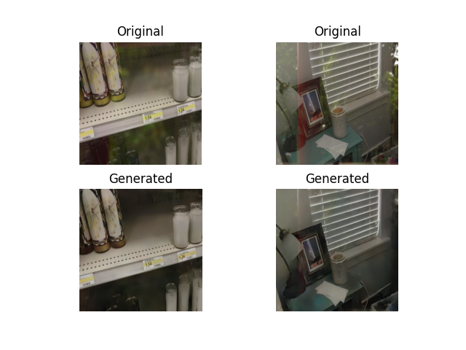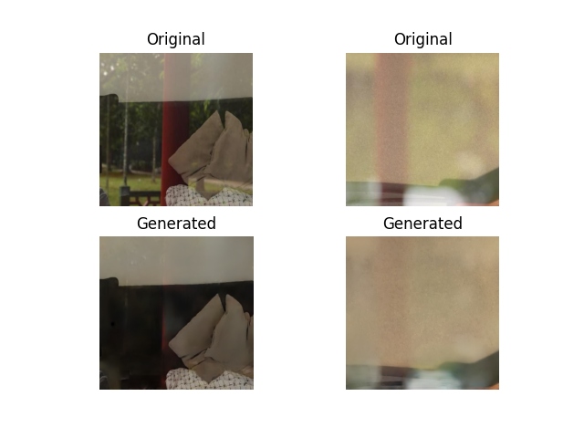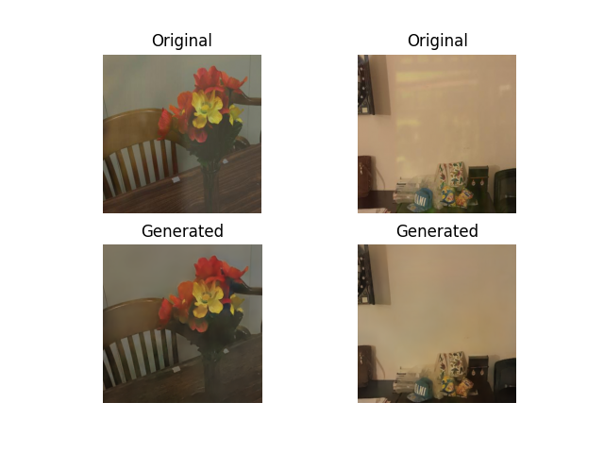
Fig. 4. Examples of reflection removal results on the training dataset (Original/Generated comparison). The reflection regions are visibly and substantially reduced, corroborating that the model has genuine reflection removal capability in its training domain — should be interpreted together with the quantitative metrics in Table 1 (see Perception-Distortion Tradeoff discussion above).

4.4. Visual Comparison and Attention Map Analysis

Fig. 5 presents a visual comparison of museum artifacts before and after Pix2Pix+SGA processing: reflection regions are visibly reduced, a difference that is quite intuitive to the human eye and constitutes the most direct visual evidence of this paper's effectiveness. This demonstrates that the Sobel prior indeed enables edge-aware attention to transfer effectively to museum scenes.
Fig. 6 presents a visualization of the Sobel Attention Map: attention is highly concentrated on exhibit edges and material detail regions, while attention weights in diffuse reflection regions are noticeably lower, directly verifying that SGA can still correctly identify the spatial distribution of 'object structure' versus 'reflection interference' in the museum domain.

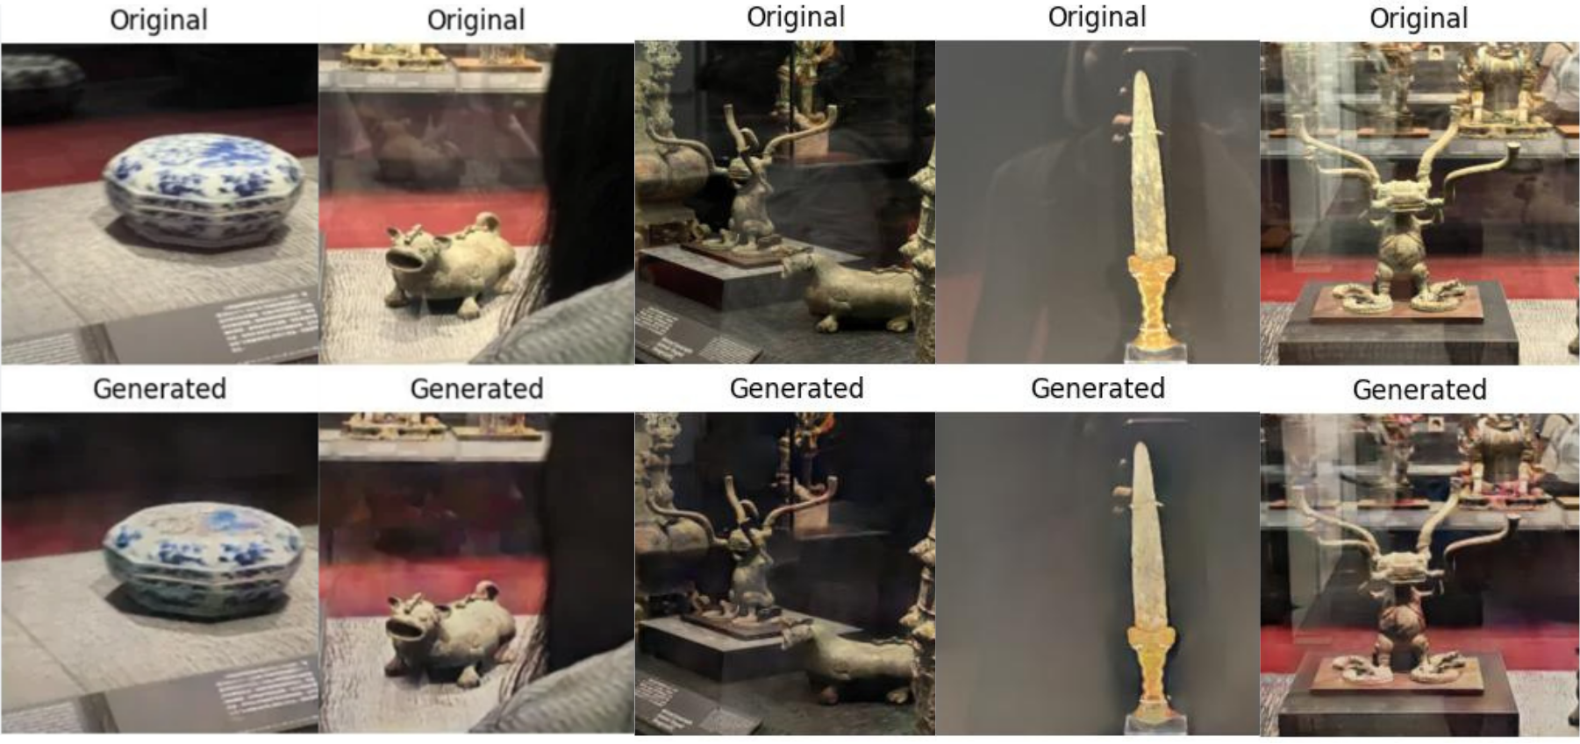
Fig. 5. Cross-scene visual comparison on museum collection items.

Top row: original images with reflection (Original); bottom row: Pix2Pix+SGA reflection removal results (Generated).

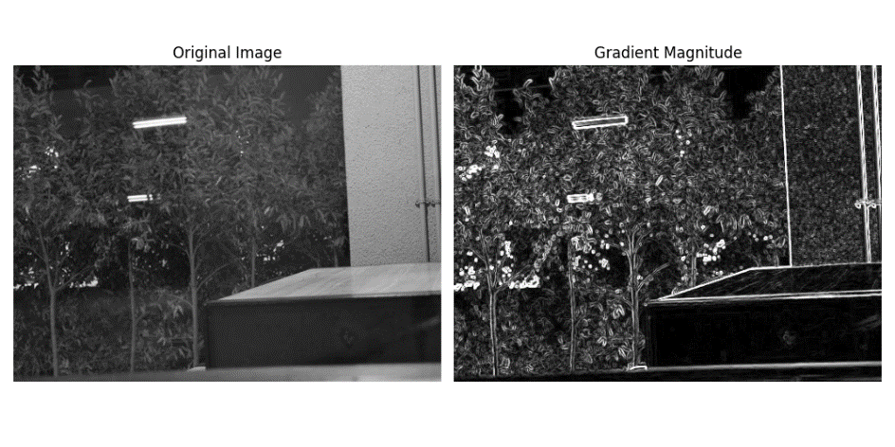
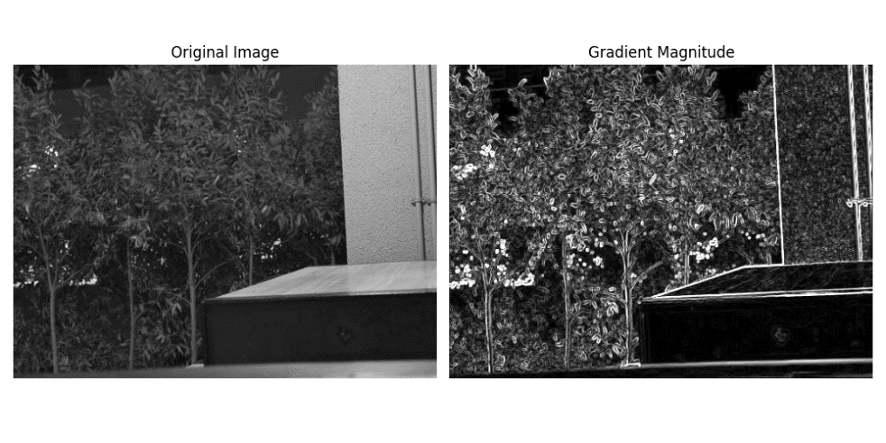
Fig. 6. Sobel gradient magnitude visualization (left: original image; right: gradient magnitude map). Top: scene with reflection — the reflection region produces high gradients only at its boundary while remaining low-gradient internally; bottom: scene without reflection — gradients are concentrated along object structural edges. This contrast is the domain-agnostic physical foundation of the SGA attention guidance signal.
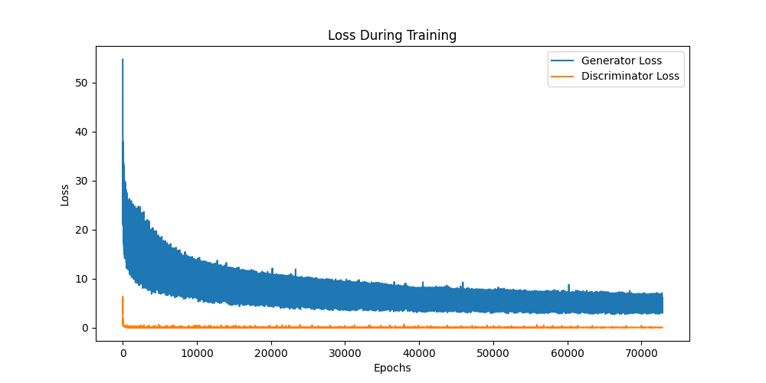
Fig. 7. Training loss curves. Blue line: Generator loss; orange line: Discriminator loss; horizontal axis: training iterations.

4.6. Cross-Scene Downstream Validation

Fig. 8 uses YOLOv8 recognition results as examples, presenting changes in detection bounding boxes and confidence values for the same exhibit images before and after reflection removal, demonstrating the direct gain of reflection removal on downstream recognition tasks.
At the quantitative level, YOLOv8 recognition results were tested on the museum evaluation set: the recognition accuracy of original reflection-containing images was 92.7% (40 of 699 images failed to be successfully recognized); after Pix2Pix+SGA reflection removal, 10 of these 40 (25%) were successfully recognized, raising overall accuracy to 94.5% (+1.8 pp).
The overall accuracy improvement (+1.8 pp) is relatively modest, attributed primarily to two constraining factors:
(1) The base number of correctable failure samples is inherently limited — only 40 of 699 images (5.7%) originally failed recognition; even if all were recovered, the theoretical accuracy ceiling would only increase by 5.7 percentage points. Measured by 'failure case recovery rate', this paper actually recovered 10/40 (25%), demonstrating that reflection removal provides substantial benefit to 'edge cases'.
(2) The recognition model itself already achieves a high baseline accuracy of 92.7% on original images, with inherently limited room for improvement, making the marginal contribution of reflection removal difficult to fully manifest in the overall metric. Furthermore, the scale of our museum evaluation set (699 images, 7 categories) is relatively small compared to large general-purpose detection benchmarks (such as COCO), with limited samples per category, making overall accuracy more sensitive to individual cases.
Table 2. Cross-scene downstream recognition accuracy (museum evaluation set, 699 images, 7 exhibit categories).
條件 | 準確率 (%) | 說明
原始影像（含反光） | 92.7 | 699 張中 40 張未能成功辨識
Pix2Pix + SGA（本文） | 94.5 | +1.8 pp；40 張中 10 張（25%）救回

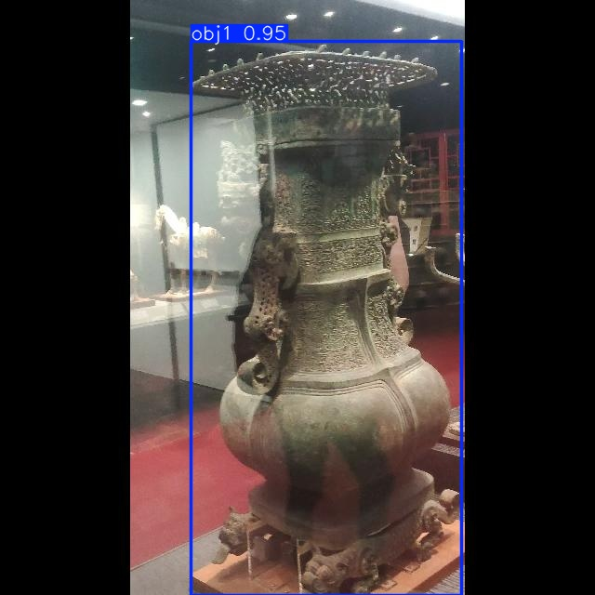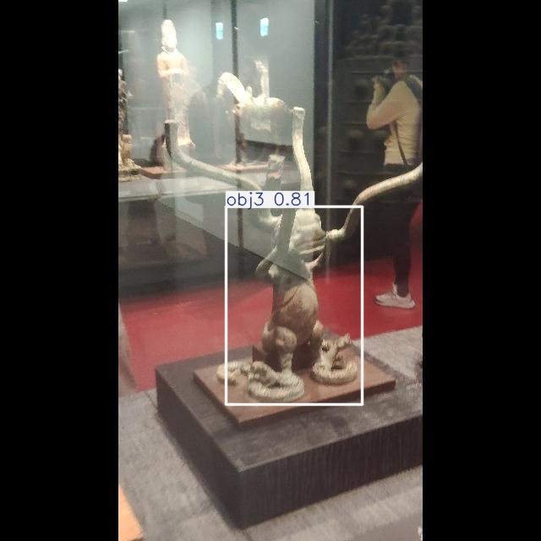

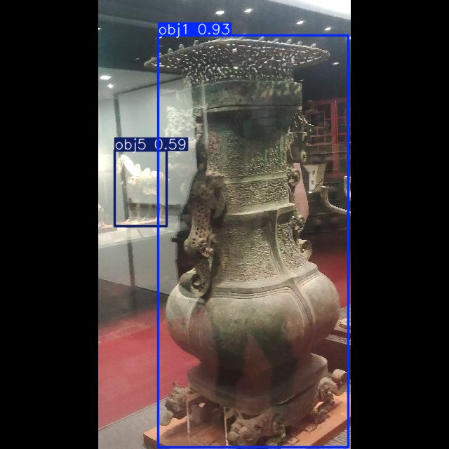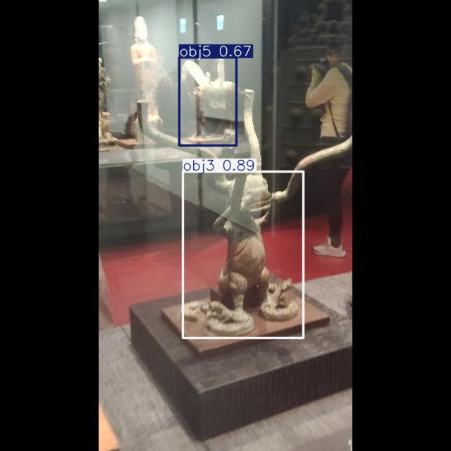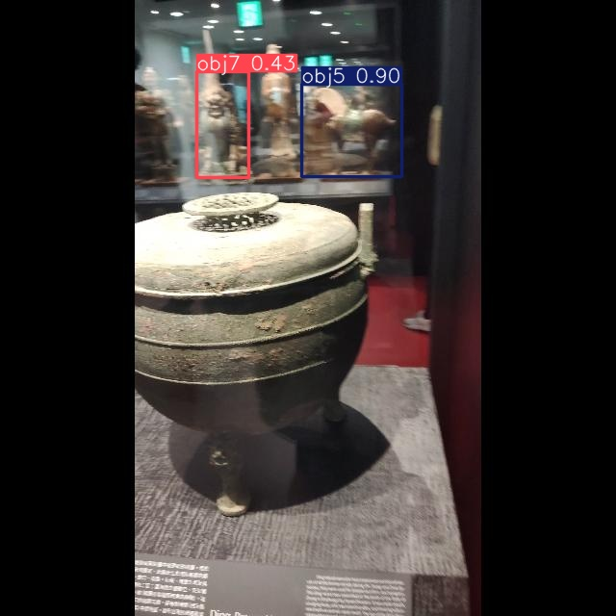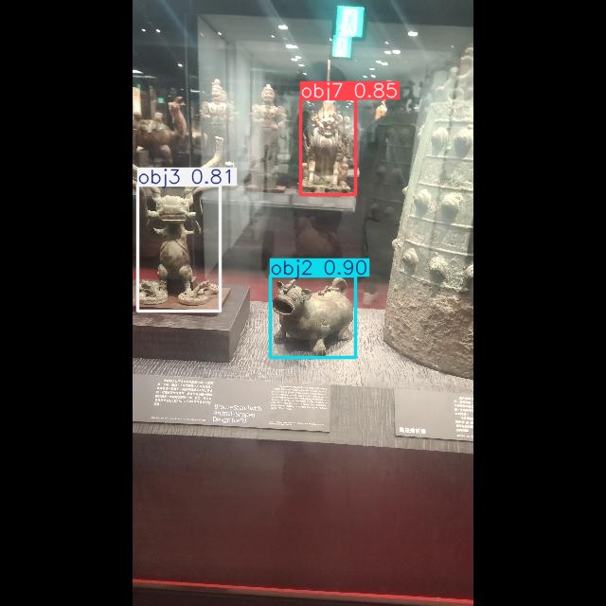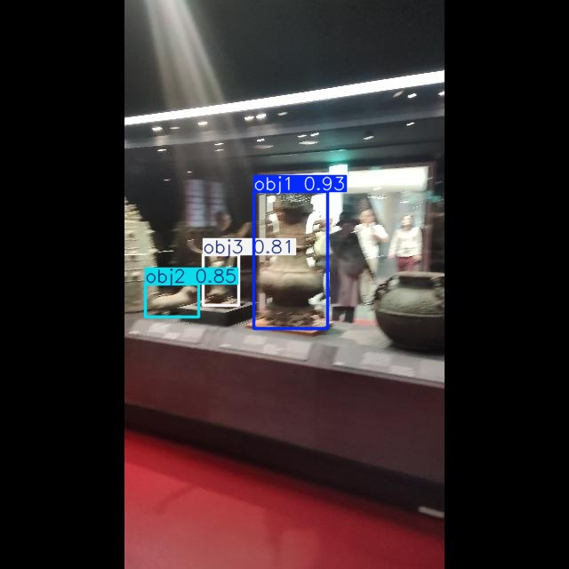
Fig. 8. YOLOv8 recognition result examples: comparison of detection bounding boxes and confidence values between images with reflection (top) and images processed by Pix2Pix+SGA (bottom).

5. Discussion

5.1. Why a Fixed Sobel Prior Enables Cross-Scene Generalization

The most central finding of this paper is that a model trained on a completely different domain can, after adding SGA, generalize directly to museum artifacts without any form of fine-tuning or domain adaptation (§4.6). From Fig. 7, we can observe the training dynamics on the public SIRR dataset: both D loss and G loss converge stably with no obvious mode collapse, indicating that the inclusion of the SGA module does not affect the stability of adversarial training.
As described in §3.2.1, SGA uses fixed Sobel gradients as attention-driving signals [6][8][31], with computation relying only on local pixel values of the input image, independent of the scene distribution of the training data. We conjecture that this may be one of the contributing factors to the cross-scene transfer phenomenon observed in this paper: SGA's computation logic does not adjust with the scene distribution of training data, so the attention guidance signals it generates are not subject to systematic shifts across different scenes due to differences in training distribution.
By contrast, if a learnable edge detector (such as HED [19]) is used as the attention-driving signal, its weights would be adjusted according to the scene distribution of training data, potentially resulting in semantic misidentification of target-scene textures by the edge detector during cross-scene application.

5.2. Limitation Analysis

This method has several limitations. First, when objects themselves contain large areas of uniform low-gradient regions (such as plain-colored ceramics or solid-color backgrounds), the Sobel response is weak, SGA's edge guidance is limited, and the model degrades toward behavior approximating standard Pix2Pix. Second, as noted in §4.1.2, the museum evaluation set in this paper lacks reflection-free ground truth; it must be interpreted together with the ablation results on the public SIRR test set to present a complete picture of cross-scene generalization. Third, this paper has not yet systematically validated the removal of strongly dynamic reflections (such as intense outdoor sunlight).
Fourth, as described in §4.6, the overall improvement of +1.8 pp is jointly constrained by the scale of the evaluation set and the baseline accuracy of the recognition model, with inherently limited theoretical improvement space; future plans to build larger-scale, cross-scene downstream evaluation datasets will be an important direction for subsequently validating the method's effectiveness — confirming the generalization capability of this paper (factory, automotive, etc.).

6. Conclusion

Supervised SIRR in real deployment scenarios universally faces the difficulty of obtaining target domain paired data. Motivated by cross-scene generalization, this paper proposes integrating the SGA module into the Pix2Pix architecture to investigate the mechanism of fixed structural priors in cross-scene SIRR. The SGA module extracts edge gradient signals using fixed Sobel convolution kernels to drive CBAM-style channel-and-spatial dual-branch attention, distinguishing object structure from reflection interference at the pixel level without introducing any additional trainable parameters. This paper conducts a case study on museum artifact reflection removal. Experimental results show that a model trained on public SIRR datasets can generalize to museum artifacts without any fine-tuning, improving downstream YOLOv8 exhibit recognition accuracy from 92.7% to 94.5% (+1.8 pp), quantitatively validating the practical benefit of fixed Sobel structural priors in cross-scene settings.

References

[1] K. Yang et al., "A Comprehensive Survey on Single Image Reflection Removal Using Deep Learning," arXiv:2502.08836, 2025.
[2] D. Reis, J. Hong, J. Kupec, and A. Daoudi, "Real-Time Flying Object Detection with YOLOv8," arXiv:2305.09972, 2023.
[3] F. Lu, C. Tang, T. Liu, Z. Zhang, and L. Li, "Multi-Attention Segmentation Networks Combined with the Sobel Operator for Medical Images," Sensors, vol. 23, no. 5, p. 2546, 2023. doi: 10.3390/s23052546.
[4] S. Woo, J. Park, J.-Y. Lee, and I. S. Kweon, "CBAM: Convolutional Block Attention Module," in Proc. ECCV, 2018, pp. 3-19.
[5] Z. Chi, X. Wu, X. Shu, and J. Gu, "Single Image Reflection Removal Using Deep Encoder-Decoder Network," arXiv:1802.00094, 2018.
[6] Q. Fan, J. Yang, G. Hua, B. Chen, and D. Wipf, "A Generic Deep Architecture for Single Image Reflection Removal and Image Smoothing," in Proc. IEEE ICCV, 2017, pp. 3238-3247.
[7] C. Li, Y. Yang, K. He, S. Lin, and J. E. Hopcroft, "Single Image Reflection Removal through Cascaded Refinement," in Proc. IEEE/CVF CVPR, 2020, pp. 3566-3574.
[8] Z. Dong, K. Xu, Y. Yang, H. Bao, W. Xu, and R. W. H. Lau, "Location-aware Single Image Reflection Removal," in Proc. IEEE/CVF ICCV, 2021, pp. 5017-5026.
[9] J.-J. Huang, T. Liu, Z. Yang, S. Fu, W. Zhao, and P. L. Dragotti, "DURRNet: Deep Unfolded Single Image Reflection Removal Network," arXiv:2203.06306, 2022.
[10] T. Wang, W. Lu, K. Zhang, T. Lu, and M.-H. Yang, "PromptRR: Diffusion Models as Prompt Generators for Single Image Reflection Removal," arXiv:2402.02374, 2024.
[11] I. Goodfellow et al., "Generative Adversarial Nets," in Adv. Neural Inf. Process. Syst. (NeurIPS), 2014, pp. 2672-2680.
[12] M. Mirza and S. Osindero, "Conditional Generative Adversarial Nets," arXiv:1411.1784, 2014.
[13] P. Isola, J.-Y. Zhu, T. Zhou, and A. A. Efros, "Image-to-Image Translation with Conditional Adversarial Networks," in Proc. IEEE CVPR, 2017, pp. 1125-1134.
[14] J.-Y. Zhu, T. Park, P. Isola, and A. A. Efros, "Unpaired Image-to-Image Translation using Cycle-Consistent Adversarial Networks," in Proc. IEEE ICCV, 2017, pp. 2223-2232.
[15] M.-Y. Liu et al., "Generative Adversarial Networks for Image and Video Synthesis: Algorithms and Applications," Proc. IEEE, vol. 109, no. 5, pp. 839-862, 2021.
[16] J. Hu, L. Shen, S. Albanie, G. Sun, and E. Wu, "Squeeze-and-Excitation Networks," IEEE Trans. Pattern Anal. Mach. Intell., vol. 42, no. 8, pp. 2011-2023, 2020.
[17] Y. Cao, J. Xu, S. Lin, F. Wei, and H. Hu, "GCNet: Non-local Networks Meet Squeeze-Excitation Networks and Beyond," in Proc. IEEE ICCVW, 2019, pp. 1971-1980.
[18] X. Wang, R. Girshick, A. Gupta, and K. He, "Non-local Neural Networks," in Proc. IEEE/CVF CVPR, 2018, pp. 7794-7803.
[19] S. Xie and Z. Tu, "Holistically-Nested Edge Detection," in Proc. IEEE ICCV, 2015, pp. 1395-1403.
[20] G. Ji, D.-P. Fan, Y.-C. Chou, D. Dai, A. Liniger, and L. Van Gool, "Deep Gradient Learning for Efficient Camouflaged Object Detection," Mach. Intell. Res., vol. 20, no. 1, pp. 92-108, 2023.
[21] H. Zunair and A. B. Hamza, "Sharp U-Net: Depthwise Convolutional Network for Biomedical Image Segmentation," Comput. Biol. Med., vol. 139, p. 104941, 2021.
[22] H. Li and J. Liu, "Edge, Structure and Texture Refinement for Retrospective High Quality MRI Restoration using Deep Learning," in Proc. IEEE ISBI, 2021.
[23] O. Ronneberger, P. Fischer, and T. Brox, "U-Net: Convolutional Networks for Biomedical Image Segmentation," in Proc. MICCAI, 2015, pp. 234-241.
[24] R. Wan, B. Shi, L.-Y. Duan, A.-H. Tan, and A. C. Kot, "Benchmarking Single-Image Reflection Removal Algorithms," in Proc. IEEE ICCV, 2017, pp. 3942-3950.
[25] K. Wei, J. Yang, Y. Fu, D. Wipf, and H. Huang, "Single Image Reflection Removal Exploiting Misaligned Training Data and Network Enhancements," in Proc. IEEE/CVF CVPR, 2019.
[26] C. Lei and Q. Chen, "Robust Reflection Removal with Reflection-free Flash-only Cues," in Proc. IEEE/CVF CVPR, 2021, pp. 14811-14820.
[27] Z. Wang, A. C. Bovik, H. R. Sheikh, and E. P. Simoncelli, "Image Quality Assessment: From Error Visibility to Structural Similarity," IEEE Trans. Image Process., vol. 13, no. 4, pp. 600-612, Apr. 2004.
[28] R. Zhang, P. Isola, A. A. Efros, E. Shechtman, and O. Wang, "The Unreasonable Effectiveness of Deep Features as a Perceptual Metric," in Proc. IEEE/CVF CVPR, 2018, pp. 586-595.
[29] Y. Blau and T. Michaeli, "The Perception-Distortion Tradeoff," in Proc. IEEE/CVF CVPR, 2018, pp. 6228-6237.
[30] C. Ledig et al., "Photo-Realistic Single Image Super-Resolution Using a Generative Adversarial Network," in Proc. IEEE/CVF CVPR, 2017, pp. 4681-4690.
[31] M. Pu, Y. Huang, Q. Guan, and H. Ling, "RINDNet: Edge Detection for Discontinuity in Reflectance, Illumination, Normal and Depth," in Proc. IEEE/CVF ICCV, 2021, pp. 6879-6888.

