UNDERGRADUATE RESEARCH OPPORTUNITY PROGRAMME
(UROP) PROJECT REPORT
Leakage-Safe Forecasting of Prediction-Market Repricing: News Signals and a Replicated Quote-Change Forecaster
By
Zhu Rong
[Department of Computer Science]
School of Computing
National University of Singapore
2026/2027

UNDERGRADUATE RESEARCH OPPORTUNITY PROGRAMME
(UROP) PROJECT REPORT
Leakage-Safe Forecasting of Prediction-Market Repricing: News Signals and a Replicated Quote-Change Forecaster
By
Zhu Rong
[Department of Computer Science]
School of Computing
National University of Singapore
2026/2027
Project No: project number
Advisor: Lu Yao
Deliverables:
Report: 1 Volume
Program: EventX source repository (Python), frozen release manifests and evaluation scripts
Data: hash-locked evaluation outputs and receipts (data/ directory)

Abstract
EventX asks whether information available at a decision time predicts short-horizon repricing in prediction markets, under strict point-in-time and evaluate-once rules. In a frozen historical study of 4,651 Kalshi and Polymarket markets, adding counts of conservatively available news articles to a market-history model lowered average precision and worsened the Brier score on 1.46 million out-of-fold rows, failing all five prespecified promotion gates. We then defined a narrower target: the probability that a contract’s quoted midpoint changes within 30 minutes. A gradient-boosted classifier on 18 point-in-time quote features, frozen before testing, reduced log loss against a logistic baseline by 16.8% on an unopened week and by 14.9% on 35 never-used contracts. Contract-clustered bootstrap intervals excluded zero, and the gain held in every market category. We also built a live forecasting runtime with validated network-time correction and tamper-evident journals, and ran a three-day prospective test on 30 new contracts. PENDING: one-sentence live result. Short-horizon quote activity is predictable from market state; simple news counts added no measurable value.
Subject Descriptors:
G.3 Probability and Statistics
I.2.6 Learning
H.2.8 Database Applications (Data mining)
J.4 Social and Behavioral Sciences (Economics)
Keywords:
Prediction markets, probabilistic forecasting, market microstructure, gradient boosting, leakage-safe evaluation
Implementation Software and Hardware:
Python 3.12, scikit-learn, PyArrow, NumPy, httpx; Polymarket CLOB WebSocket and Gamma API; pmxt hourly order-book archive; Lumid FinData; Apple macOS laptop (17 GB RAM)

Acknowledgement
I thank my advisor, Lu Yao, for guidance on research design and for insisting on honest, preregistered evaluation. I also thank the providers of the data used in this project: Lumid FinData for historical trades and news, the pmxt project for the public Polymarket order-book archive, and Polymarket for its public market-data interfaces. Add further acknowledgements if any.
Table of Contents
Abstract i
Acknowledgement ii
List of Figures v
List of Tables vi
1 Introduction 1
1.1 Background and motivation 1
1.2 Research questions 1
1.3 Summary of contributions 1
1.4 Organisation of the report 2
2 Background and Related Work 3
2.1 Prediction markets as forecasts 3
2.2 News, attention and asset prices 3
2.3 Market microstructure 3
2.4 Forecast evaluation and leakage 3
2.5 Learning method 4
3 Data and Leakage Safeguards 5
3.1 Data sources 5
3.2 Safeguards common to all studies 5
4 Track A: Incremental Value of News 7
4.1 Design of the historical primary study (V3.1) 7
4.2 Results 7
4.3 Richer news features (V4) and diagnostics (V5, V6) 8
5 Track B: Quote-Change Forecasting Method 9
5.1 Why the target changed 9
5.2 Target and eligibility 9
5.3 Features 9
5.4 Models and baselines 10
5.5 Evaluation protocol 10
6 Track B: Historical Results 11
6.1 Development and early replications 11
6.2 Unopened week, same cohort: 1–7 June 11
6.3 Never-used contracts: 8–14 June 11
6.4 Calibration and category breakdown 12
6.5 A further unopened fortnight: 15–28 June 14
7 Prospective Live Test 15
7.1 Design 15
7.2 Engineering problems and their solutions 15
7.3 Operation 16
7.4 Results 16
8 Discussion 17
8.1 What the evidence supports 17
8.2 Threats to validity 17
9 Conclusions 18
9.1 Summary 18
9.2 Limitations 18
9.3 Recommendations for further work 18
References 19
Appendix A – Feature Definitions A-1
Appendix B – Protocol Deviations and Failed Attempts B-1
Appendix C – Reproducibility C-1
List of Figures
Figure 1. Log-loss gain of the frozen booster over logistic regression on the two unopened June blocks, with 95% contract-clustered bootstrap intervals. Contributing contracts are given in parentheses.
Figure 2. Reliability diagram for the booster and logistic regression on 8–14 June (decile bins of forecast probability).
Figure 3. Booster log-loss reduction by market category in each June block. Point labels give the number of contracts.
List of Tables
Table 1. V3.1 development comparison of news-augmented (B1) and market-only (B0) models on 1,460,454 matched out-of-fold rows.
Table 2. Matched results, 1–7 June, development cohort (18 contributing contracts, 16,453 known outcomes, 2,068 positives). Lower log loss and Brier are better.
Table 3. Matched results, 8–14 June, never-used contracts (35 contributing contracts, 35,218 known outcomes, 8,830 positives).
Table 4. Booster log-loss reduction against activity logistic regression by category (descriptive, post hoc keyword rule).
Table 5. The 18 features of row_hgb7. Features marked * are also used by the 14-feature V03 live model.
Table 6. Deviations, failures and superseded versions, in chronological order.
Table 7. Principal scripts and outputs.

1 Introduction

1.1 Background and motivation
Prediction markets let traders buy contracts that pay one dollar if an event happens, so a contract’s price can be read as a crowd probability of that event (Wolfers and Zitzewitz, 2004; Arrow et al, 2008). Platforms such as Polymarket and Kalshi now list thousands of contracts on elections, sports, macroeconomic releases, technology and geopolitics. Prices move when new information arrives, but they also move for mechanical reasons: liquidity providers re-quote, the order book thins out overnight, and contracts become quiet as their resolution approaches.
The original goal of EventX was a benchmark for whether outside information (news articles, and later posts by influential social-media accounts) carries incremental, point-in-time predictive information about these price moves, beyond what market history already reveals. Results in this area are easy to overstate. A single look-ahead leak, a reused test period or a weak baseline can produce an apparent gain without any error showing up. The project therefore treats evaluation discipline as a first-class research output: every test set is frozen before it is opened, every model is frozen before it is scored, and each held-out period is evaluated exactly once.

1.2 Research questions
- RQ1 (news increment). Does news that was demonstrably available at decision time improve a forecast of the next 30-minute price jump beyond a market-history baseline?
- RQ2 (forecastable target). Is there a short-horizon market quantity that can be forecast reliably better than strong baselines, and does that advantage survive new time periods and never-seen contracts?
- RQ3 (live operation). Can such a forecaster run prospectively on live data, under the same frozen rules, with every decision auditable after the fact?

1.3 Summary of contributions
- A frozen, preregistered historical test of news value over 4,651 markets, with a negative answer to RQ1. Under the frozen design, news counts made forecasts slightly worse (Chapter 4).
- A quote-change forecaster whose advantage over logistic, rate-based and earlier boosted baselines replicates on two unopened June weeks, including 35 contracts never used before. It holds in every market category (Chapters 5 and 6).
- A prospective runtime that validates its own clock against network time servers, writes hash-chained journals, and refuses to evaluate more than once. A three-day live test was run on 30 newly selected contracts (Chapter 7).
- A full record of failed attempts and protocol deviations, kept rather than hidden (Appendix B).

1.4 Organisation of the report
Chapter 2 reviews related work. Chapter 3 describes the data and the leakage safeguards shared by all studies. Chapter 4 reports the news-increment study (Track A). Chapters 5 and 6 present the quote-change forecaster and its historical evaluations (Track B), and Chapter 7 the prospective live test. Chapter 8 discusses validity, and Chapter 9 concludes with limitations and recommendations. Appendices give feature definitions, the deviation log and reproduction instructions.

2 Background and Related Work

2.1 Prediction markets as forecasts
Prediction-market prices aggregate dispersed beliefs and often forecast at least as well as polls or experts (Wolfers and Zitzewitz, 2004; Arrow et al, 2008). Calibration is good on average but imperfect, especially for long-shot outcomes and far-off events (Page and Clemen, 2013). This project does not try to beat the market’s forecast of the final outcome. It forecasts the behaviour of the market’s own price over the next half hour.

2.2 News, attention and asset prices
Media content has measurable, short-lived associations with stock returns and trading volume (Tetlock, 2007), so news is a natural candidate signal for prediction markets as well. The difficulty is timing. A news record is only useful if it was available to a trader before the price moved, so timestamps must reflect availability (publication, ingestion and feed-delivery times) rather than event time. EventX therefore uses the most conservative available timestamp, and treats missing feed intervals as unknown rather than as zero news.

2.3 Market microstructure
Short-horizon price behaviour is driven largely by microstructure: the bid–ask spread, quote updates by liquidity providers, and the arrival of orders (O’Hara, 1995; Hasbrouck, 2007). The midpoint of the best bid and ask is the standard high-frequency price proxy. Whether a midpoint changes over a short window depends heavily on how active the book has recently been. Activity is persistent, which makes a quote-change target forecastable in principle.

2.4 Forecast evaluation and leakage
Probabilistic forecasts are evaluated with strictly proper scoring rules, which reward honest probabilities: here, log loss and the Brier score (Brier, 1950; Gneiting and Raftery, 2007). Tree ensembles can be poorly calibrated in some settings (Niculescu-Mizil and Caruana, 2005), so calibration is checked separately. Leakage, meaning information from the future or from the test set entering model building, is a common cause of false results in data mining (Kaufman et al, 2012). In financial time series it also arises from overlapping label windows, which requires purged, embargoed cross-validation (López de Prado, 2018). Observations within one market are dependent, so uncertainty is estimated by resampling whole blocks or whole contracts rather than individual rows (Künsch, 1989; Cameron, Gelbach and Miller, 2008).

2.5 Learning method
The forecasters use histogram-based gradient boosting (Friedman, 2001; Ke et al, 2017), as implemented in scikit-learn (Pedregosa et al, 2011). EventX makes no claim of algorithmic novelty. Its contribution is the target definition, the point-in-time feature construction, and the evaluation protocol around a standard learner.

3 Data and Leakage Safeguards

3.1 Data sources
- Lumid FinData supplies historical executed trades for Kalshi and Polymarket, and a news feed with publication and ingestion timestamps. All ingestion runs as resumable, checkpointed batch jobs under the provider’s rate limit, and analysis uses frozen, content-hashed extracts rather than live API calls.
- The pmxt Polymarket archive publishes one Parquet file of order-book events per hour (book snapshots, price changes, trades), each with venue and receive timestamps. Files are sorted by market identifier, so the project can download only the row groups that contain the selected contracts.
- Polymarket’s Gamma metadata API and CLOB WebSocket supply contract metadata (question, outcomes, token identifiers, start and end dates), and live book updates for the prospective test.

3.2 Safeguards common to all studies
The following rules apply to every experiment in this report. They are enforced in code rather than by convention.
- Point in time. Every feature for a decision at time t uses only records received at or before t. A forecast is issued only when the latest quote is fresh (at most 120 seconds old on both the venue and the receive clocks), valid (bid below ask, spread at most 0.05) and unambiguous.
- Frozen, hash-locked releases. Protocols, cohorts, model files and evaluation code are frozen as SHA-256 manifests before the data they will be judged on is retrieved. A changed file means a new version, never an edit in place.
- Evaluate once. Each test window is consumed by a single evaluation run, which writes a consumption receipt first and refuses to run again. Results are reported whether favourable or not.
- Protected identifiers and windows. 1,231 market identifiers and three time windows used by earlier confirmatory studies are filtered out at decode time, so no Track B experiment can read them.
- Outcome-blind cohort selection. New contract cohorts are chosen from identity, event-type and clock columns plus metadata only, before any price or quote column of the test period is read.
- Missing outcomes stay missing. If the 30-minute endpoint quote is unavailable, the forecast is scored as unknown. Deterministic worst-case bounds over all issued forecasts are reported alongside the scored results.

4 Track A: Incremental Value of News

4.1 Design of the historical primary study (V3.1)
The cohort contains 4,651 markets (3,832 Kalshi and 819 Polymarket) with a unique canonical YES outcome, at least 100 positive-notional executions and at least ten active days. Development covers 17 May to 22 July 2026, and a separate holdout covers 22 July to 8 August 2026. At each five-minute decision time the price is the latest executed YES trade. The binary target asks whether the absolute log-odds change over the next 30 minutes exceeds four times the trailing one-minute volatility.
B0 is a 12-feature market-history logistic ensemble: price log-odds, 5/30/120-minute momentum, 30/240-minute realised volatility, 60/240-minute trade counts and notional, time since last trade, and venue. B1 adds rolling counts of conservatively available, lexically associated news articles over 60, 360 and 1,440 minutes. Both are trained on identical rows across five purged, expanding-time folds. B1 would be promoted only if all five gates held: positive aggregate average-precision (AP) and Brier changes, positive changes in at least four folds, a positive lower bound on a 5,000-replicate paired block-bootstrap Brier interval, and no venue-level deterioration.

4.2 Results
Table 1. V3.1 development comparison of news-augmented (B1) and market-only (B0) models on 1,460,454 matched out-of-fold rows.
Quantity | Value | Interpretation
AP change (B1 − B0) | −0.001916 | news worse
Brier change | −0.000284 (worse) | news worse
Paired block-bootstrap Brier interval | [−0.000341, −0.000230] | excludes zero, against news
Folds improving (AP / Brier) | 0 of 5 | gate failed
Promotion gates passed | 0 of 5 | B0 selected

All five gates failed, so, as preregistered, only B0 was evaluated on the holdout: AP 0.171628 and Brier 0.107107 on 211,718 rows from 300 markets. That number is an absolute market-only benchmark, not an estimate of news value. One protocol deviation affects it: the holdout builder printed the positive-label count before the consumption receipt was written. Weights and formulas were already frozen, and the deviation is recorded (Appendix B).

4.3 Richer news features (V4) and diagnostics (V5, V6)
V4 freezes a nested ladder of richer news features: news volume (B1); relevance and seven-day novelty (B2); and publisher diversity with cross-publisher headline diffusion (B3). It tests them prospectively on 470 Polymarket contracts from 6 September to 30 October 2026. Success requires at least 0.001 nats of log-loss improvement for B3 over B0, with a positive bootstrap lower bound and Brier and venue guards. The sealed collection passed a label-blind health check on 27 October: 58 of 58 news days and 51 of 51 trade days had receipts, nothing was pending, and all 15 frozen hashes matched. PENDING: V4 B3-versus-B0 result, evaluated once after the collection closes on 30 October.
Exploratory work on already-opened data (V5) traced the apparent benefit of a residual-news model to controls. A context-only gate improved more than the full news correction did, and a nonlinear market-only model beat the full news model by 0.0085 nats. Adding the news mechanism itself changed log loss by −0.000871, with interval [−0.001457, −0.000208]. A contract-aware news-linking effort (V6) failed its strict link audit, and certified predictive support was 0 of 8,844 contract-days. Taken together, the answer to RQ1 so far is no: under strict availability rules, simple news representations did not add value beyond market history.

5 Track B: Quote-Change Forecasting Method

5.1 Why the target changed
Before settling on the current target, the project tried to forecast the exact midpoint 30 minutes ahead, both historically and in a live audited run on 25 October. Because most midpoints do not change over 30 minutes, the persistence forecast ("no change") is very hard to beat on mean absolute error. In the live run a ridge model was 30.9% worse than persistence on 257 observed outcomes. Point accuracy was the wrong question. The useful, forecastable quantity is whether the quote will change at all, which is a probability, and the right scores are proper scoring rules.

5.2 Target and eligibility
At each five-minute grid time t, the target is 1 if the recorded YES midpoint at t + 30 minutes differs from the midpoint at t by more than 10⁻¹², and 0 otherwise. The tolerance removes floating-point noise only; it is not an economic threshold. A forecast is issued only when the current quote passes the freshness and validity rules of Section 3.2. A target is assigned only when the endpoint quote passes the same rules. The target measures quote activity. It carries no information about direction, size, final resolution or profit.

5.3 Features
The primary model (row_hgb7) uses 18 features computed from quotes received by decision time (Appendix A):
- the midpoint and its log-odds, and the spread;
- the source and receive ages of the quote;
- the hour of day, encoded as sine and cosine;
- the number and fraction of valid quote states in the last 30 minutes;
- signed and absolute midpoint changes over 5, 15 and 30 minutes, each with an explicit missing flag.
The live-runtime model (V03 hgb7) uses a 14-feature subset that drops the age and activity-count features. Those four depend on archive receive clocks that a live system cannot reproduce exactly. No news, order-depth or contract-identity features are used, so the models are contract-agnostic.

5.4 Models and baselines
The forecaster is a histogram gradient-boosting classifier (100 iterations, learning rate 0.05, at most 7 leaves, minimum leaf size 100, L2 penalty 10, no early stopping and no class reweighting). Every comparison is against fixed baselines fitted on the same training rows:
- a smoothed global event rate;
- a per-contract rate shrunk toward the global rate with 20 pseudo-observations;
- an activity logistic regression on nine activity and lag features, the primary comparator;
- a full-feature logistic regression;
- the earlier frozen booster (legacy HGB).
row_hgb7 was selected and refit on 7–9 May 2026 data from 50 development contracts before any later block was retrieved. Nothing has been refit, recalibrated or re-thresholded since.

5.5 Evaluation protocol
Each evaluation block follows the same sequence. First the protocol is frozen, including the primary comparison and the pass rule. Then the cohort is selected outcome-blind, the hourly archive files are captured (with one permitted retry for transport failures), and finally the block is evaluated exactly once. The primary metric is matched, row-weighted log loss of row_hgb7 against activity logistic regression. A block passes when four conditions hold:
- the booster’s log loss is below both logistic regression and the global rate;
- its Brier score is no higher than logistic regression’s;
- the 95% contract-clustered bootstrap interval for the log-loss gain over logistic regression has a lower bound above zero (5,000 resamples of whole contracts).
Date-clustered intervals, per-date and per-contract win counts, a nonoverlapping 30-minute subset, a strict continuous-path subset, and worst-case missing-outcome bounds are reported as secondary results.

6 Track B: Historical Results

6.1 Development and early replications
An earlier frozen booster cut log loss by 18.1% against activity logistic regression on a new time block, 28–30 April (3,729 rows, 11 markets). The broader-trained row_hgb7 reduced log loss by 22.7% on 10–12 May for the development cohort and by 9.6% for ten reserved contracts. On the seven-day replication of 13–19 May, row_hgb7 achieved 0.3583 against logistic regression’s 0.4524 (20.8%). For six training-excluded contracts the gain was only 3.5%, and their worst-case missing-outcome bounds crossed zero. That gap motivated the dedicated test on new contracts in Section 6.3.

6.2 Unopened week, same cohort: 1–7 June
No earlier study had read any June quote data. All 168 hourly files were captured, with 0 protected rows read. Only 20 of the 60 fixed contracts were still quoting, because the rest had expired or gone inactive. These were kept unchanged rather than replaced.
Table 2. Matched results, 1–7 June, development cohort (18 contributing contracts, 16,453 known outcomes, 2,068 positives). Lower log loss and Brier are better.
Model | Log loss | Brier | AUC | Booster log-loss reduction
row_hgb7 | 0.2931 | 0.0848 | 0.835 | —
Activity logistic | 0.3523 | 0.1003 | — | 16.8%
Legacy HGB | 0.3285 | — | — | 10.8%
Global rate | 0.3854 | — | 0.500 | 24.0%

All pass conditions held. The 95% contract-clustered interval for the gain over logistic regression is [0.039, 0.081] nats, and the date-clustered interval is [0.047, 0.073]. The booster won on 7 of 7 dates and 17 of 20 contracts. The nonoverlapping subset (0.2922 against 0.3471) and the strict subset (0.1554 against 0.2270) agree.

6.3 Never-used contracts: 8–14 June
To test transfer to new identities, 40 contracts were selected by metadata only. Their identifiers lie in a hexadecimal range disjoint from every earlier cohort, they are binary Yes/No, at most one is taken per event and none shares an event with earlier cohorts, and they were open across the whole week. They span sports, politics, finance, technology and geopolitics. A local DNS outage failed 74 hourly downloads on both permitted attempts. Before any evaluation, those hours were refetched outcome-blind into a separate directory, and 165 of 168 hours were then available. This exceeds the single-retry rule, so it is recorded as a protocol deviation. The original source is preserved unevaluated.
Table 3. Matched results, 8–14 June, never-used contracts (35 contributing contracts, 35,218 known outcomes, 8,830 positives).
Model | Log loss | Brier | AUC | Booster log-loss reduction
row_hgb7 | 0.4208 | 0.1335 | 0.827 | —
Activity logistic | 0.4943 | 0.1584 | 0.756 | 14.9%
Legacy HGB | 0.4873 | 0.1547 | 0.785 | 13.6%
Global / contract rate | 0.5843 | 0.1945 | 0.500 | 28.0%
V03 hgb7 (live model) | 0.4270 | 0.1358 | 0.825 | 19.7% vs its full logistic

All pass conditions held again. The contract-clustered interval for the gain over logistic regression is [0.033, 0.119] nats from 35 clusters. The booster won on 7 of 7 dates and 27 of 35 contracts, and its equal-contract-weighted log loss is 0.4222 against 0.5134. The worst-case missing-outcome bounds over all 39,656 issued forecasts are [+0.009, +0.114] nats, positive even if every unknown endpoint had gone against the booster. A secondary analysis of the V03 live model, registered before evaluation, gave a 19.7% reduction with interval [0.066, 0.147] and wins on 31 of 35 contracts. That cleared V03 for the live test in Chapter 7.
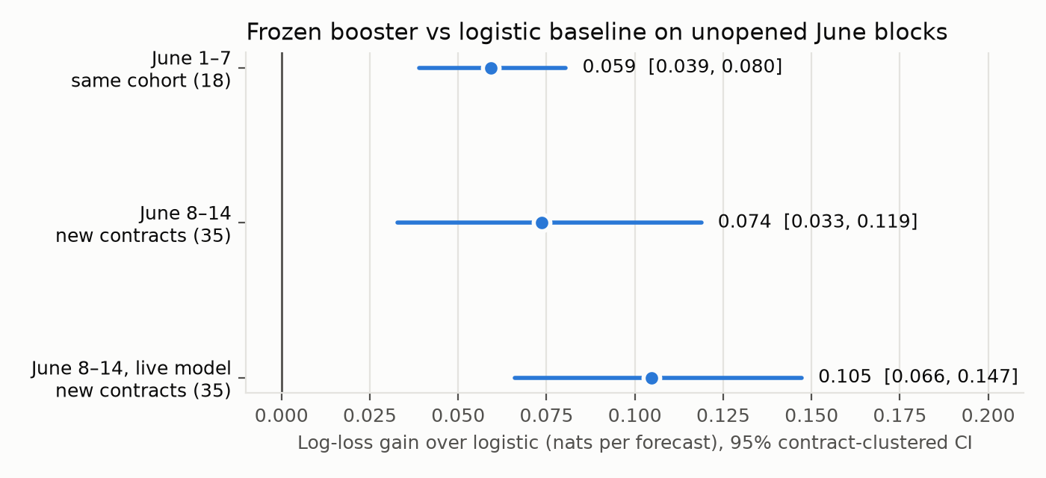
Figure 1. Log-loss gain of the frozen booster over logistic regression on the two unopened June blocks, with 95% contract-clustered bootstrap intervals. Contributing contracts are given in parentheses.

6.4 Calibration and category breakdown
Figure 2 shows that both models are close to the diagonal below a forecast probability of 0.2, where most forecasts lie. Both under-predict somewhat in the upper deciles, the booster slightly less at the top. Because the evaluation must not change the frozen model, no recalibration was applied.
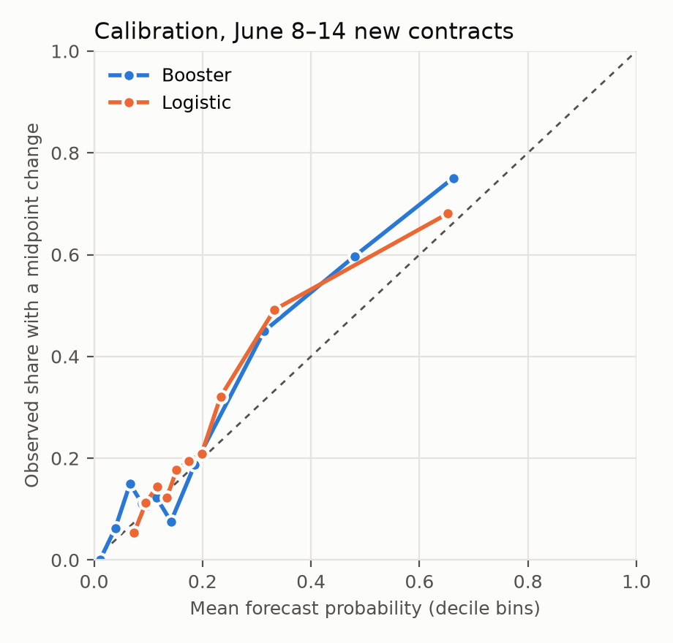
Figure 2. Reliability diagram for the booster and logistic regression on 8–14 June (decile bins of forecast probability).
As a descriptive check, contracts were assigned to categories by a fixed keyword rule on the question text, written before scores were joined. The booster has lower log loss than logistic regression in every category in both weeks (Table 4, Figure 3), so the result is not driven by one dominant category. Most categories contain only two to twelve contracts, so these are descriptions, not separate tests.
Table 4. Booster log-loss reduction against activity logistic regression by category (descriptive, post hoc keyword rule).
Block / category | Contracts | Known | Reduction | Contracts won | 95% contract CI (nats)
June 1–7 sports | 5 | 5,670 | 22.1% | 5/5 | [0.038, 0.103]
June 1–7 finance/crypto | 6 | 3,670 | 17.5% | 5/6 | [0.033, 0.101]
June 1–7 politics | 5 | 5,425 | 11.8% | 4/5 | [0.001, 0.075]
June 1–7 entertainment | 2 | 1,688 | 15.9% | 2/2 | too few
June 8–14 sports | 12 | 11,498 | 10.3% | 9/12 | [0.001, 0.096]
June 8–14 finance/crypto | 8 | 7,167 | 12.1% | 6/8 | [−0.028, 0.248]
June 8–14 politics | 6 | 6,927 | 14.3% | 5/6 | [−0.016, 0.116]
June 8–14 geopolitics | 4 | 6,335 | 28.8% | 4/4 | [0.044, 0.241]
June 8–14 tech/science | 3 | 2,680 | 14.7% | 2/3 | [−0.038, 0.273]
June 8–14 entertainment | 2 | 611 | 1.7% | 1/2 | too few

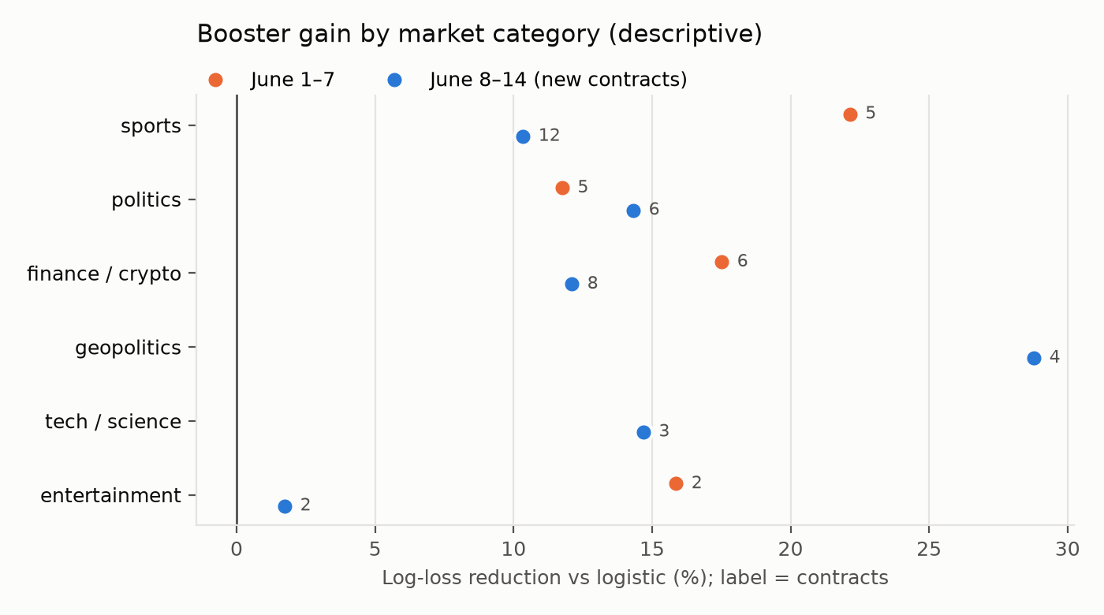
Figure 3. Booster log-loss reduction by market category in each June block. Point labels give the number of contracts.

6.5 A further unopened fortnight: 15–28 June
A third test on 15–28 June uses 21 further never-used contracts, frozen from metadata in a new identifier range before any price was read. An earlier selection with a stricter end-date rule found only 15 contracts. It was superseded before any data was read and is preserved. Both frozen models are scored in a single once-only evaluation. PENDING: June 15–28 result (capture deferred until after the live window to avoid loading the live host).

7 Prospective Live Test

7.1 Design
Historical replay cannot rule out subtle advantages from hindsight, such as metadata that is only known today or receive clocks that are reconstructed. A prospective test removes both. The live runtime is split into a source process and an emitter process:
- the source subscribes to the Polymarket WebSocket for the cohort and polls metadata. It writes every message to an append-only journal in which each record carries the SHA-256 hash of the previous one;
- the emitter reads that journal and, at each five-minute grid time, issues a forecast from the frozen V03 model or records an abstention with machine-readable reasons. Each forecast is committed at least 250 ms before its grid time.
An evaluator scores the forecasts once, after the window closes, against endpoints taken from the same journal. The cohort is 30 contracts, chosen by metadata only. They are active, binary, order-book enabled, at least seven days old, resolve no earlier than 10 November, have at least $10k of 24-hour volume (used as a floor only), are taken in salted-hash order with one contract per event, and are disjoint from every earlier cohort.

7.2 Engineering problems and their solutions
Each problem below caused a rehearsal or activation to be stopped and archived, never patched in place.
- Unreliable host clock. The first runtime version failed its readiness rehearsal with 0 of 16 decisions ready. The laptop’s built-in time client returned empty server packets while the clock was about 287 ms fast, and the operating system then stepped the clock back by 110 ms, which reset the transport warmup. The new version uses its own SNTP client (Mills et al, 2010). It keeps the raw packets and recomputes offsets from them. An estimate is accepted only if at least two servers agree, at least one round trip is short, and the residual uncertainty is at most 50 ms. Corrected time is then carried forward on the monotonic clock, so operating-system clock steps are logged but cannot move decision times.
- Memory and latency growth. The first activation kept the whole journal in memory (about 317 MB per hour) and rescanned it at every decision. A bounded, incremental input store keeps three hours of history, more than every rule needs. It matched the unbounded version in 510 of 510 decision and endpoint comparisons, and cut decision time from 370 ms to 11 ms per grid.
- A thread race in the hash chain. In the second activation, a clock-probe thread wrote to the journal at the same time as the main loop, which forked the hash chain. The emitter’s chain check detected this and stopped. Now only the event loop writes the journal, and a regression test enforces it.
After these fixes, a fresh 60-minute readiness rehearsal passed. 156 of 180 post-warmup decisions were ready, across 27 of 30 contracts; 58 of 61 clock estimates were valid; one OS clock step was absorbed; and there were 0 chain breaks, stamp errors or replay mismatches. The test was activated at 17:53:53 UTC on 26 October, with grids from 27 October 00:30 to 29 October 23:25 UTC (24,840 scheduled decisions). The window was shortened from seven days to three, before any prospective decision, so that it would finish before this report’s deadline.

7.3 Operation
The test has known operating losses, all recorded rather than repaired:
- First grid. All 30 decisions abstained, because the emitter’s pre-loaded inputs were handed over without one final refresh (0.12% of the schedule).
- Host stall. A concurrent analysis job pushed the already memory-constrained laptop into heavy swapping, so four grids missed their emission deadlines and roughly an hour of warmup abstentions followed. Heavy jobs were then deferred until the window closed.
- Venue disconnects. The venue WebSocket disconnects about once an hour or more, and each reconnect costs 30 minutes of abstentions under the frozen warmup rule.
These losses reduce coverage but cannot leak information, since every failure leads to a recorded abstention or miss and nothing is backfilled.

7.4 Results
PENDING: coverage (issued, abstained, missed); matched log loss, Brier and AUC of V03 hgb7 against full logistic regression and global rate; contract-clustered interval; missing-outcome bounds. To be filled from the single evaluation run after 29 October 23:57:30 UTC, whatever the sign.

8 Discussion

8.1 What the evidence supports
The answers to RQ1 and RQ2 differ sharply. Simple news counts did not improve a market-history forecaster under strict availability rules, while a microstructure target was forecast reliably better than strong baselines on every unopened block. This is consistent with a market in which public news is either quickly priced or too weakly linked to individual contracts to be detected by counts, whereas quote activity is persistent and well summarised by recent quote changes, spread and price level. The booster’s advantage over logistic regression suggests that these effects interact nonlinearly. For example, the same recent change implies different future activity at different price levels and spreads.

8.2 Threats to validity
- Dependence. Forecasts from one contract are strongly correlated. This is why the headline intervals resample whole contracts, and why the effective sample size is closer to the number of contracts (18–35) than to the number of rows.
- Cohort and venue. Cohorts are convenience samples that require quotes to be available, and all Track B evidence comes from one venue and one era (2026). The new-contract test reduces, but does not remove, the risk that results depend on contract identity.
- Metadata timing. Historical cohorts use current metadata, so a contract’s present description may differ from what was known in June. Only the live test is free of this.
- Conditioning on observed endpoints. Scores use only forecasts with observed endpoints. The worst-case bounds show that missing endpoints cannot reverse the June 8–14 conclusion, but in June 1–7 the lower bound falls just below zero.
- Protocol deviations. The DNS refetch and the V3.1 prevalence exposure are real departures from the intended protocols. They were outcome-blind or happened before any metric was computed, but they are disclosed rather than argued away.
- Causal language. None of the results is causal. Track A estimates predictive value conditional on observable news; information that surfaces first on unobserved channels (private chats, livestreams) remains a confounder.

9 Conclusions

9.1 Summary
EventX built a leakage-safe evaluation framework for prediction-market forecasting and applied it to two questions. In a frozen study of 4,651 markets, simple news counts added no predictive value beyond market history. A 30-minute quote-change probability, however, can be forecast well: a frozen gradient-boosted classifier beat logistic, rate-based and earlier boosted baselines by 15–20% in log loss on two unopened June weeks, including 35 never-used contracts. Contract-clustered intervals excluded zero, and the gain held in every category. A prospective runtime with validated clock correction, bounded inputs and tamper-evident journals was built and run live for three days. PENDING: one-sentence live and V4 outcome.

9.2 Limitations
- The quote-change target measures activity, not direction, size or profit. A good score does not imply a trading edge.
- Track B uses one venue and small numbers of contributing contracts, and historical cohorts rely on current metadata.
- Track A tested count-based news representations under conservative timestamps. Richer text models and social-media signals were not evaluated within the frozen protocols.
- The live test ran on a laptop whose memory pressure and network drops reduced coverage. A disciplined server would give a cleaner prospective estimate.

9.3 Recommendations for further work
- Run the live runtime on a dedicated host with a disciplined clock and enough memory, for at least seven days, on a larger metadata-selected cohort.
- Extend the target to signed and size-graded quote moves, which are closer to economically meaningful questions, keeping the same once-only protocol.
- Re-test news value with contract-aware linking only after the link audit passes, using the quote-change model as the strong market-only baseline.
- Replicate on Kalshi, whose historical intraday data has a different coverage pattern, to test venue transfer.

References
Arrow, K.J., Forsythe, R., Gorham, M., Hahn, R., Hanson, R., Ledyard, J.O., Levmore, S., Litan, R., Milgrom, P., Nelson, F.D., Neumann, G.R., Ottaviani, M., Schelling, T.C., Shiller, R.J., Smith, V.L., Snowberg, E., Sunstein, C.R., Tetlock, P.C., Tetlock, P.E., Varian, H.R., Wolfers, J. and Zitzewitz, E. (2008). The Promise of Prediction Markets. Science, Vol. 320, No. 5878, pp. 877 – 878.
Brier, G.W. (1950). Verification of Forecasts Expressed in Terms of Probability. Monthly Weather Review, Vol. 78, No. 1, pp. 1 – 3.
Cameron, A.C., Gelbach, J.B. and Miller, D.L. (2008). Bootstrap-Based Improvements for Inference with Clustered Errors. Review of Economics and Statistics, Vol. 90, No. 3, pp. 414 – 427.
Friedman, J.H. (2001). Greedy Function Approximation: A Gradient Boosting Machine. Annals of Statistics, Vol. 29, No. 5, pp. 1189 – 1232.
Gneiting, T. and Raftery, A.E. (2007). Strictly Proper Scoring Rules, Prediction, and Estimation. Journal of the American Statistical Association, Vol. 102, No. 477, pp. 359 – 378.
Hasbrouck, J. (2007). Empirical Market Microstructure: The Institutions, Economics, and Econometrics of Securities Trading. Oxford University Press, New York, 2007.
Kaufman, S., Rosset, S., Perlich, C. and Stitelman, O. (2012). Leakage in Data Mining: Formulation, Detection, and Avoidance. ACM Transactions on Knowledge Discovery from Data, Vol. 6, No. 4, Article 15.
Ke, G., Meng, Q., Finley, T., Wang, T., Chen, W., Ma, W., Ye, Q. and Liu, T.-Y. (2017). LightGBM: A Highly Efficient Gradient Boosting Decision Tree. In Advances in Neural Information Processing Systems 30 (Long Beach, California, December 4 – 9, 2017), pp. 3146 – 3154.
Künsch, H.R. (1989). The Jackknife and the Bootstrap for General Stationary Observations. Annals of Statistics, Vol. 17, No. 3, pp. 1217 – 1241.
López de Prado, M. (2018). Advances in Financial Machine Learning. John Wiley & Sons, Hoboken, New Jersey, 2018.
Mills, D., Martin, J., Burbank, J. and Kasch, W. (2010). Network Time Protocol Version 4: Protocol and Algorithms Specification. RFC 5905, Internet Engineering Task Force, June 2010.
Niculescu-Mizil, A. and Caruana, R. (2005). Predicting Good Probabilities with Supervised Learning. In Proceedings of the 22nd International Conference on Machine Learning (Bonn, Germany, August 7 – 11, 2005). ACM, New York, 2005, pp. 625 – 632.
O’Hara, M. (1995). Market Microstructure Theory. Blackwell Publishers, Cambridge, Massachusetts, 1995.
Page, L. and Clemen, R.T. (2013). Do Prediction Markets Produce Well-Calibrated Probability Forecasts? The Economic Journal, Vol. 123, No. 568, pp. 491 – 513.
Pedregosa, F., Varoquaux, G., Gramfort, A., Michel, V., Thirion, B., Grisel, O., Blondel, M., Prettenhofer, P., Weiss, R., Dubourg, V., Vanderplas, J., Passos, A., Cournapeau, D., Brucher, M., Perrot, M. and Duchesnay, E. (2011). Scikit-learn: Machine Learning in Python. Journal of Machine Learning Research, Vol. 12, pp. 2825 – 2830.
Polymarket. (2026). Polymarket CLOB and Gamma API Documentation. Online documentation, accessed October 2026.
Tetlock, P.C. (2007). Giving Content to Investor Sentiment: The Role of Media in the Stock Market. Journal of Finance, Vol. 62, No. 3, pp. 1139 – 1168.
Wolfers, J. and Zitzewitz, E. (2004). Prediction Markets. Journal of Economic Perspectives, Vol. 18, No. 2, pp. 107 – 126.

Appendix A – Feature Definitions
All features are computed from YES-token quotes received at or before the decision time t. A quote state is valid when bid < ask, both lie strictly inside (0, 1), and the spread is at most 0.05. Missing lag values are encoded as zero together with a missing flag.
Table 5. The 18 features of row_hgb7. Features marked * are also used by the 14-feature V03 live model.
Feature | Definition
midpoint* | (best bid + best ask) / 2 of the current valid quote
logit_midpoint* | ln(m / (1 − m)) of the midpoint
spread* | best ask − best bid
source_age | seconds since the venue timestamp of the current quote
receive_age | seconds since the receive timestamp of the current quote
hour_sin, hour_cos | UTC hour of day on the unit circle
log_valid_updates30 | log(1 + number of valid quote states in the last 30 min)
valid_state_fraction30 | fraction of the last 30 min covered by valid quote states
delta5, abs_delta5, missing5* | signed and absolute midpoint change since t − 5 min; flag if unavailable
delta15, abs_delta15, missing15* | same over 15 minutes
delta30, abs_delta30, missing30* | same over 30 minutes

The activity logistic baseline uses midpoint, source age, log_valid_updates30, abs_delta5, missing5, abs_delta15, missing15, abs_delta30 and missing30. All logistic models standardise inputs and use L2 regularisation with C = 0.1.

Appendix B – Protocol Deviations and Failed Attempts
Every item below is preserved in the repository with its original outputs. None was rescued by changing a threshold after outcomes were seen.
Table 6. Deviations, failures and superseded versions, in chronological order.
Item | What happened | Handling
V3 activity gate | 204,069 zero-count Kalshi rows; 19 markets missed activity minimum | V3.1 removed exactly those 19, label-blind; V3 failure kept
V3.1 holdout | Builder printed positive count (26,381) before consumption receipt | Disclosed; weights and formulas already frozen
Exact-price forecasting | Ridge 30.9% worse than persistence on MAE in a live audit | Reported as negative; target changed
V01 live runtime | Readiness 0/16: host clock faults | Frozen as failed; V02 built
June 8–14 capture | DNS outage failed 74 hours on both attempts | Outcome-blind refetch to separate directory; disclosed
V02 rehearsal 1, 2 | Startup crash; WebSocket logged before clock was valid | Fixed with regression tests; archived
V02 activation 1 | Memory about 317 MB/h and full rescans; 0 forecasts | Superseded by bounded inputs (510/510 equivalent)
V02 activation 2 | Thread race forked hash chain; 0 forecasts | Single-writer journal; readiness re-run and passed
V02 live, first grid | Pre-loaded inputs not refreshed; 30 abstentions | Fail-closed; not patched during the test
V02 live, host stall | Concurrent job caused swapping; 4 grids missed | Heavy jobs deferred until close
June 15–28 cohort v1 | Only 15/60 contracts passed the end-date rule | Superseded before any price read by v2 (21 contracts)

Appendix C – Reproducibility
All code is in the EventX repository. Frozen releases live under eventx/release/, and results with their hash manifests under data/. The principal entry points are listed below (run from the repository root with the project virtual environment).
Table 7. Principal scripts and outputs.
Purpose | Command or path
June 1–7 test | python -m eventx.tasks.run_v7_june_replication_20261026
June 8–14 test | python -m eventx.tasks.run_v7_new_identity_test_20261026 {select,capture,evaluate}
V03 secondary | python -m eventx.tasks.evaluate_v7_new_identity_v03_20261026
June 15–28 test | python -m eventx.tasks.run_v7_late_june_test_20261027_v2 {capture,evaluate}
Category breakdown | python -m eventx.tasks.analyze_v7_category_breakdown_20261027
Figures | python -m eventx.tasks.plot_v7_report_figures_20261027
Live runtime health | python -m eventx.tasks.status_v7_forecast_runtime_20261026_v02
Live evaluation (once) | python -m eventx.tasks.evaluate_v7_forecast_runtime_20261026_v02
V4 close-out (once, in order) | audit_v4_confirmatory_collection, consume_v4_confirmatory_holdout, prepare_v4_confirmatory_inputs, build_v4_confirmatory_examples, evaluate_v4_confirmatory
Runtime tests | python -m eventx.tasks.check_v7_forecast_runtime_20261026_v02 (32 tests)

