Section 3.8 Figure and Table Package
Table 11. State-replay summary of rearrangement-cascade effects preceding terminal Essentiality Gate failure.
Analysis level | Rearrangement class or measure | Count | Result
Trajectory history | Any preceding inversion or duplication | 196,246 / 438,708 trajectories | 44.73% of Gate-failing trajectories
Event replay | Inversion precursors | 241,208 events in 162,430 trajectories | All events before the terminal deletion
Event replay | Duplication precursors | 86,890 events in 74,133 trajectories | All events before the terminal deletion
Exact terminal pair | Hazard increased after inversion | 8,836 / 241,208 events | 3.66% (95% Wilson interval, 3.59–3.74%)
Exact terminal pair | Hazard increased after duplication | 3,270 / 86,890 events | 3.76% (95% Wilson interval, 3.64–3.89%)
Trajectory level | At least one inversion-associated increase | 8,597 / 162,430 trajectories | 5.29% (95% Wilson interval, 5.18–5.40%)
Trajectory level | At least one duplication-associated increase | 3,270 / 74,133 trajectories | 4.41% (95% Wilson interval, 4.27–4.56%)
Finite probability amplification | Inversion, ≥2-fold / ≥10-fold / ≥100-fold | 1,155 / 110 / 7 events | Maximum finite increase, 248.06-fold
Copy-specific pair creation | Duplication activated the eventual terminal pair | 3,437 / 86,890 events | 3.96%
Gate-span change | Inversion activated a Gate-failing deletion span | 705 / 241,208 events | 0.29%
All-pair one-step hazard sample | Hazard increased after inversion | 1,833 / 4,400 states | 41.66%; 16.07% decreased and 42.27% were unchanged
All-pair one-step hazard sample | Hazard decreased after duplication | 4,239 / 4,385 states | 96.67%; 3.33% increased
Note: Exact terminal-pair analyses included every inversion or duplication preceding Gate failure. The all-pair hazard analysis used a deterministic scenario-stratified sample of up to 50 events per event type and scenario. Percentages are descriptive and are conditional on trajectories that later failed the strict Essentiality Gate.

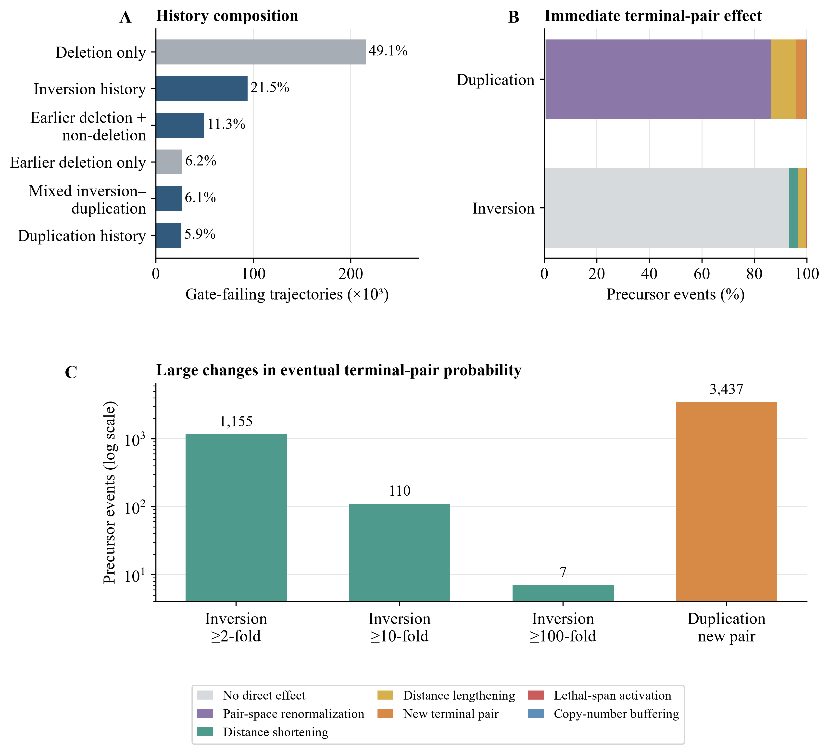
Figure 10. Precursor rearrangements altered the accessibility of later Gate-failing deletion paths. (A) Composition of event histories among 438,708 Gate-failing trajectories. (B) Mutually exclusive classifications of 241,208 inversion and 86,890 duplication precursor events according to their immediate effect on the eventual terminal-deletion pair. (C) Inversion events producing finite increases of at least 2-, 10-, or 100-fold in the proposal probability of the eventual terminal pair; duplications that created a previously absent copy-specific terminal pair are shown separately.

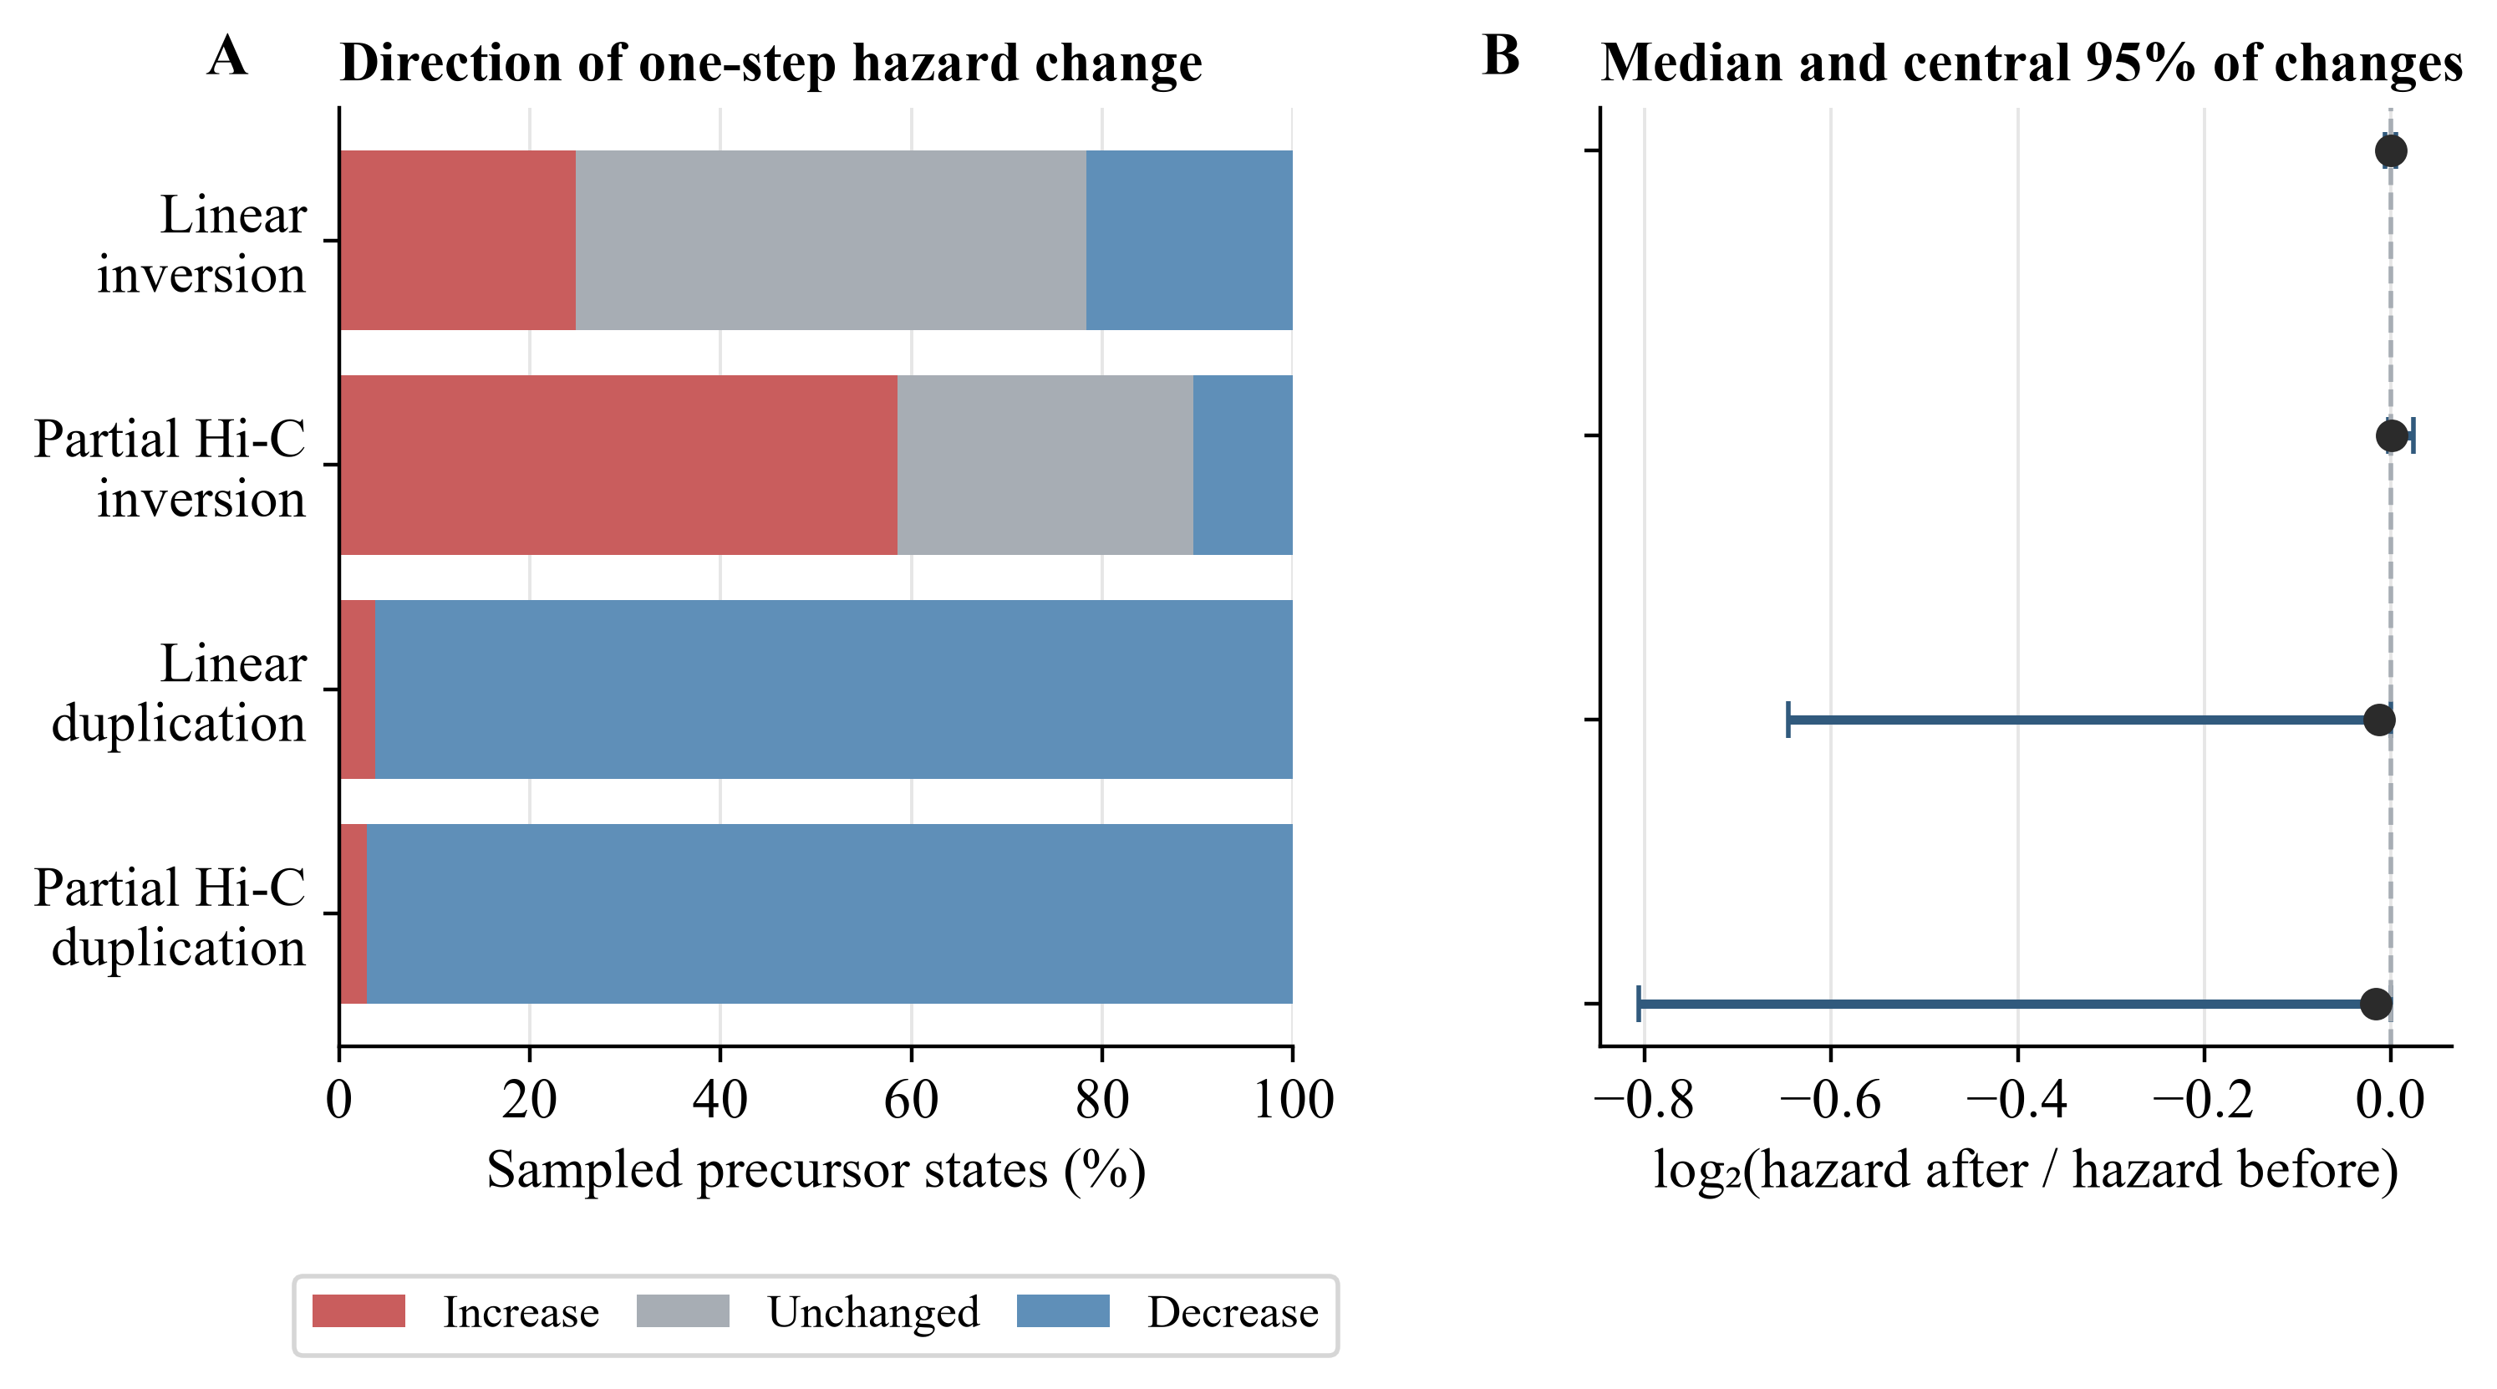
Figure 11. Precursor events produced event- and model-dependent changes in the total one-step Gate-failing deletion hazard. (A) Direction of hazard change after inversion or duplication under linear-distance sampling and partially Hi-C-informed sampling with distance-based fallback. (B) Median and central 95% of the descriptive distribution of log₂-transformed after-to-before hazard ratios. The scenario-stratified sample comprised 8,785 precursor states; intervals in panel B are distributional quantiles rather than confidence intervals.

