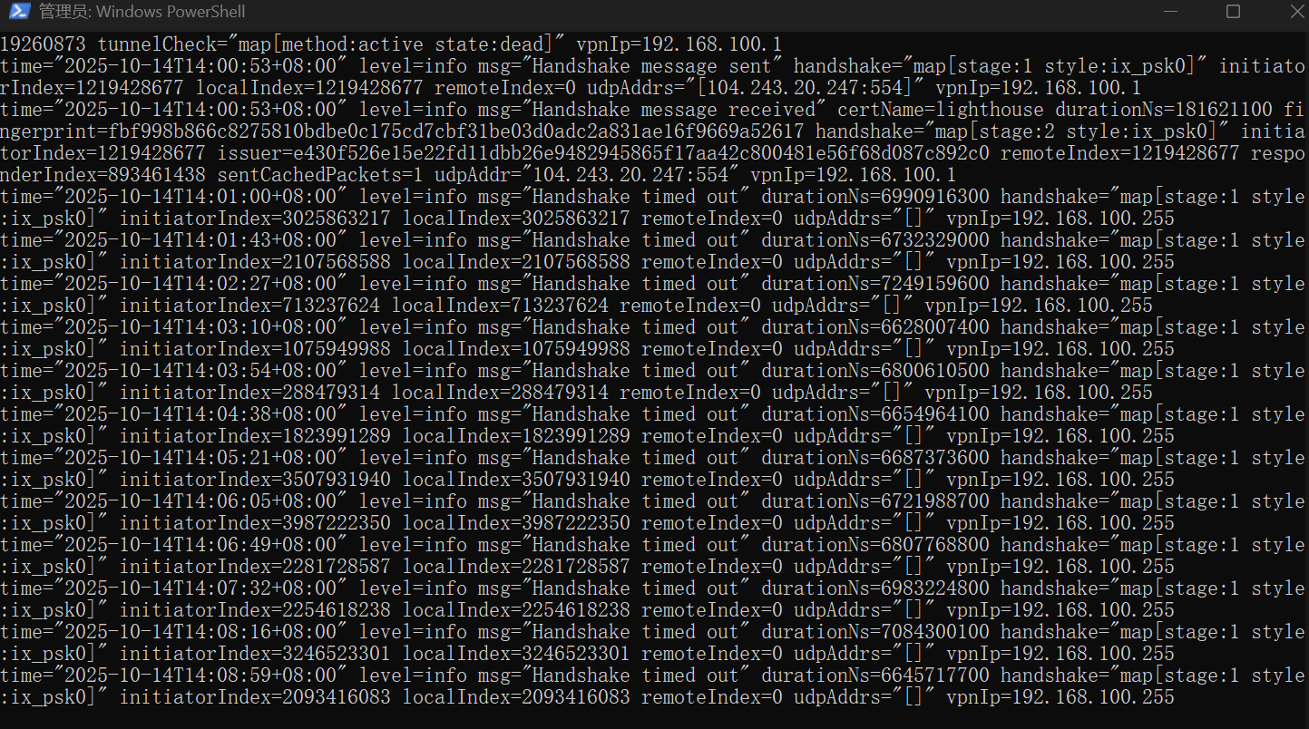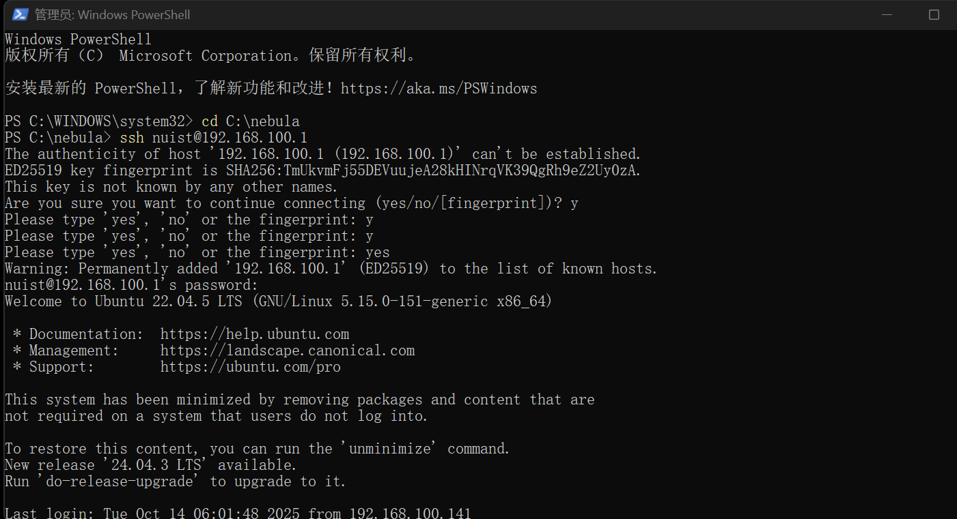

Based on the two screenshots provided, I successfully completed Lab 2 by first establishing a Nebula overlay network where I configured a lighthouse server with the IP 192.168.100.1, then connected through SSH to verify the Ubuntu server accessibility. The process involved resolving multiple handshake timeouts between nodes behind NATs by properly configuring certificate authority and node certificates, ultimately achieving secure peer-to-peer connectivity across the distributed network environment