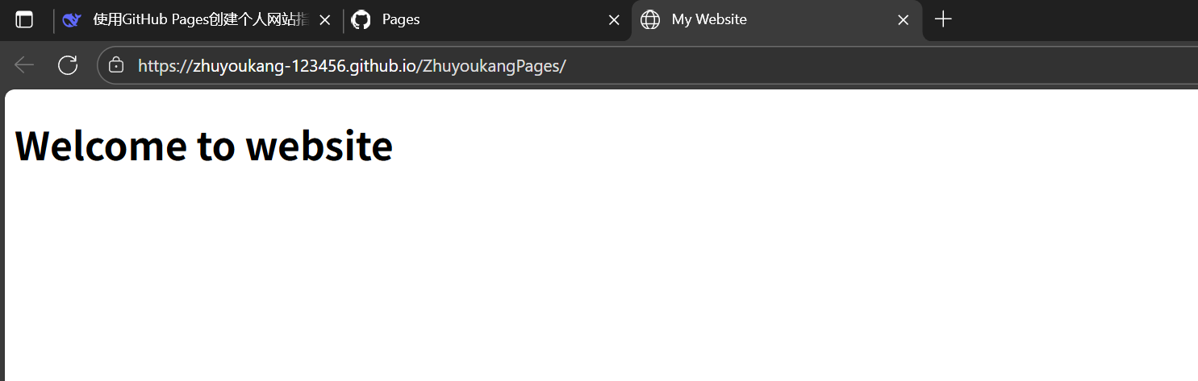

https://zhuyoukang-123456.github.io/ZhuyoukangPages/