Go to the [Istio release](https://github.com/istio/istio/releases/tag/1.27.3" \t "https://istio.io/latest/docs/setup/getting-started/_blank) page to download the installation file for your OS, or [download and extract this](https://istio.io/latest/docs/setup/additional-setup/download-istio-release/)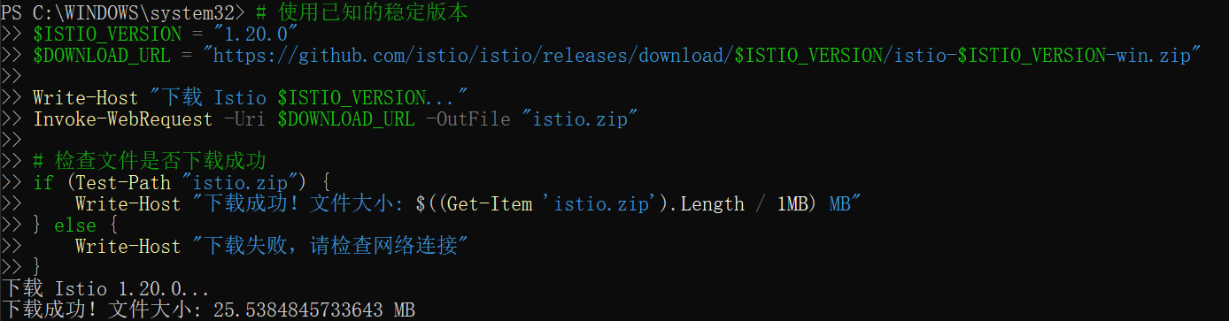

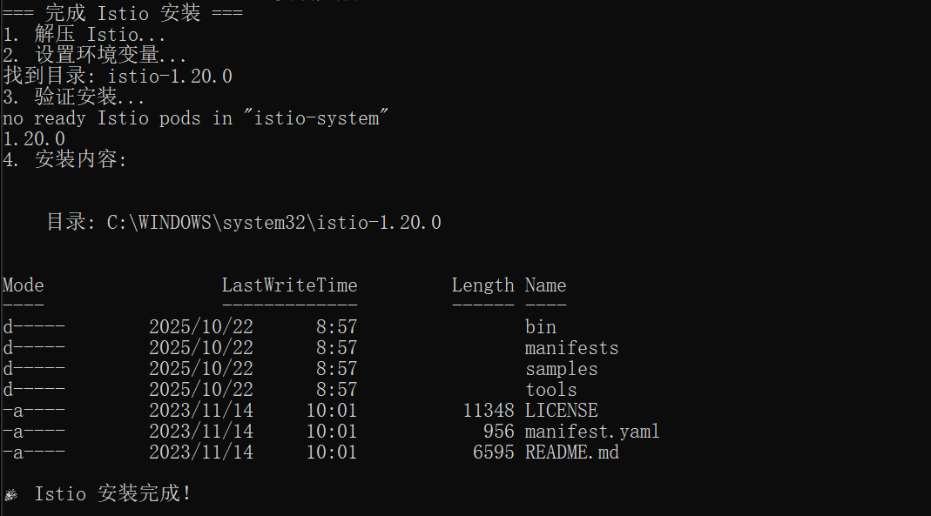

Unlike [Istio Gateways](https://istio.io/latest/docs/concepts/traffic-management/" \l "gateways), creating [Kubernetes Gateways](https://gateway-api.sigs.k8s.io/api-types/gateway/" \t "https://istio.io/latest/docs/setup/getting-started/_blank) will, by default, also [deploy gateway proxy servers](https://istio.io/latest/docs/tasks/traffic-management/ingress/gateway-api/" \l "automated-deployment). Because they won’t be used, we disable the deployment of the default Istio gateway services that are normally installed as part of the profile.demo

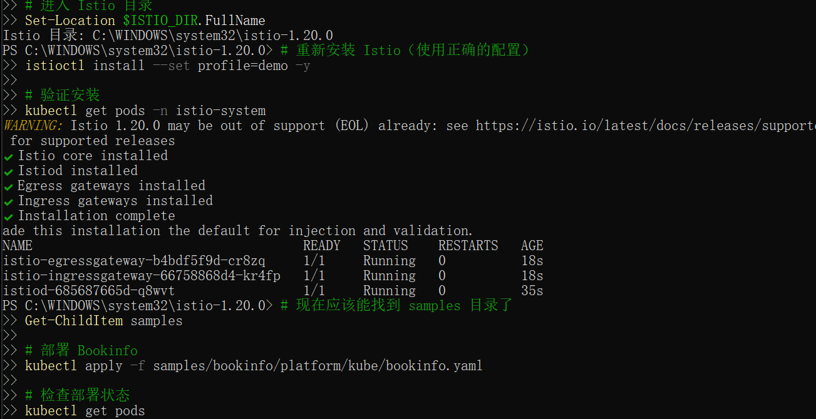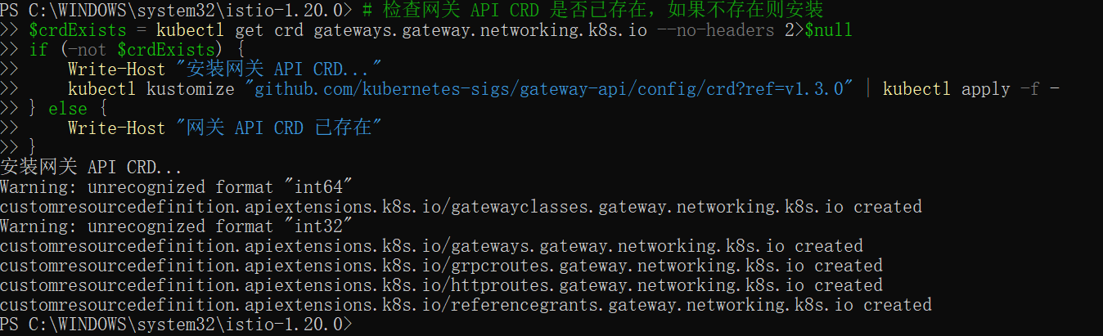

The Kubernetes Gateway API CRDs do not come installed by default on most Kubernetes clusters, so make sure they are installed before using the Gateway API.

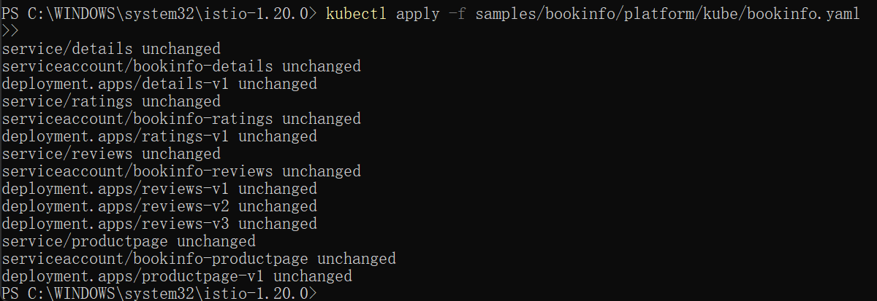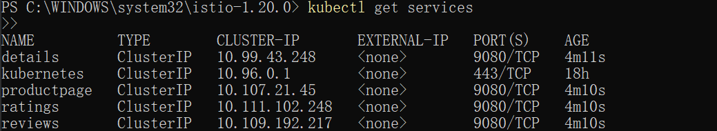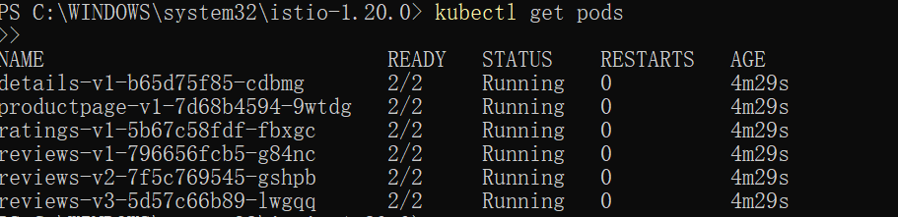

Validate that the app is running inside the cluster by checking for the page title in the response:



The Bookinfo application is deployed, but not accessible from the outside. To make it accessible, you need to create an ingress gateway, which maps a path to a route at the edge of your mesh.

Change the service type to by annotating the gateway:ClusterIP

check the status of the gateway



connect to the Bookinfo service through the gateway you just provisioned. To access the gateway, you need to use the command:productpagekubectl port-forward

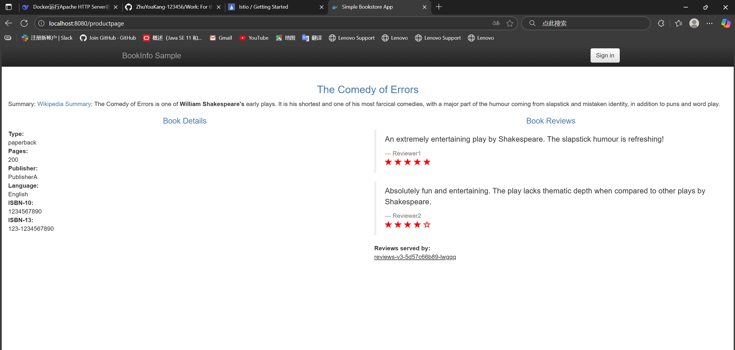

Istio integrates with [several different telemetry applications](https://istio.io/latest/docs/ops/integrations/). These can help you gain an understanding of the structure of your service mesh, display the topology of the mesh, and analyze the health of your mesh.

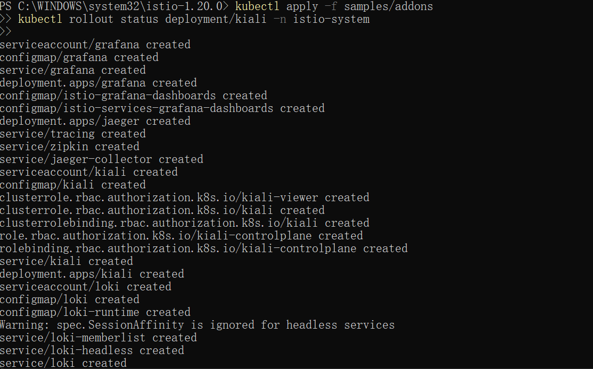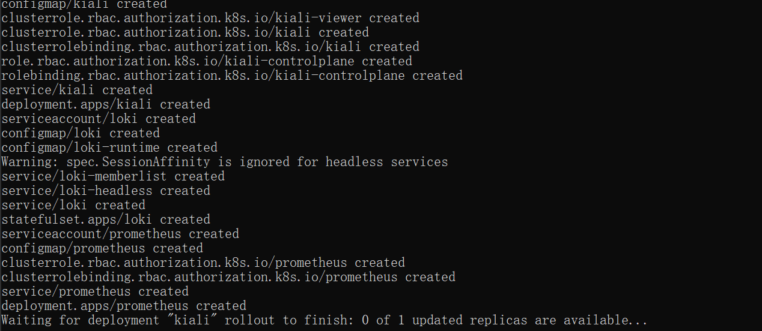



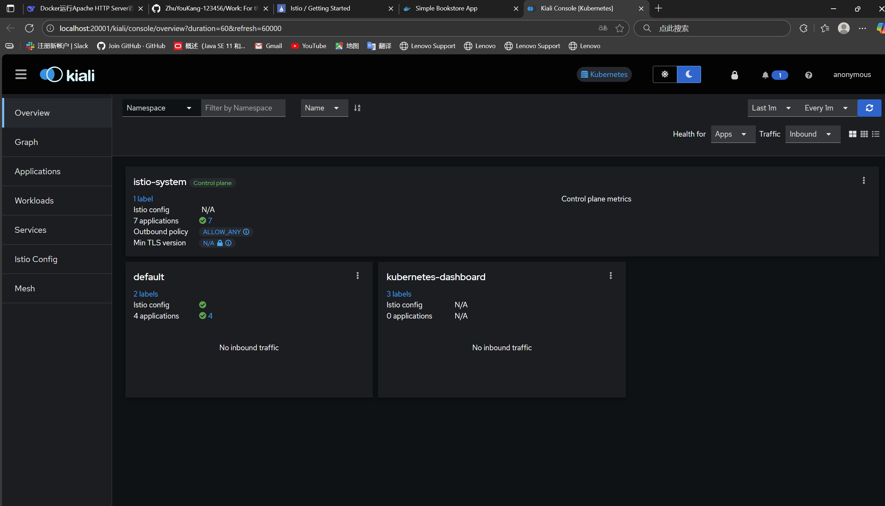

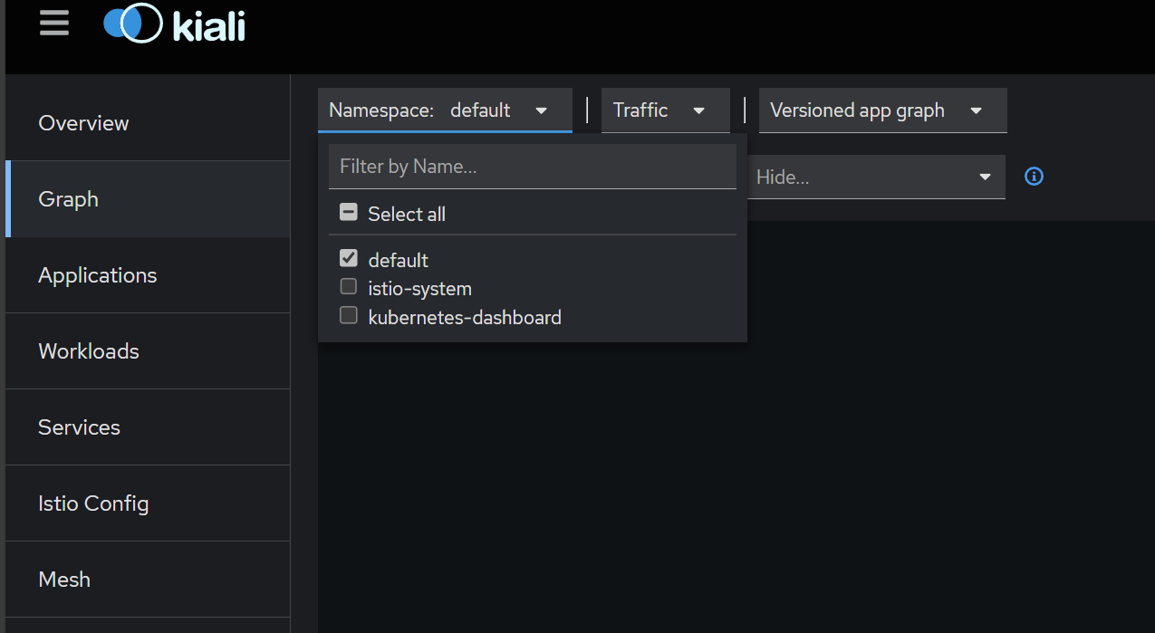

To see trace data, you must send requests to your service. The number of requests depends on Istio’s sampling rate and can be configured using the [Telemetry API](https://istio.io/latest/docs/tasks/observability/telemetry/). With the default sampling rate of 1%, you need to send at least 100 requests before the first trace is visible. To send 100 requests to the service, use the following command:productpage

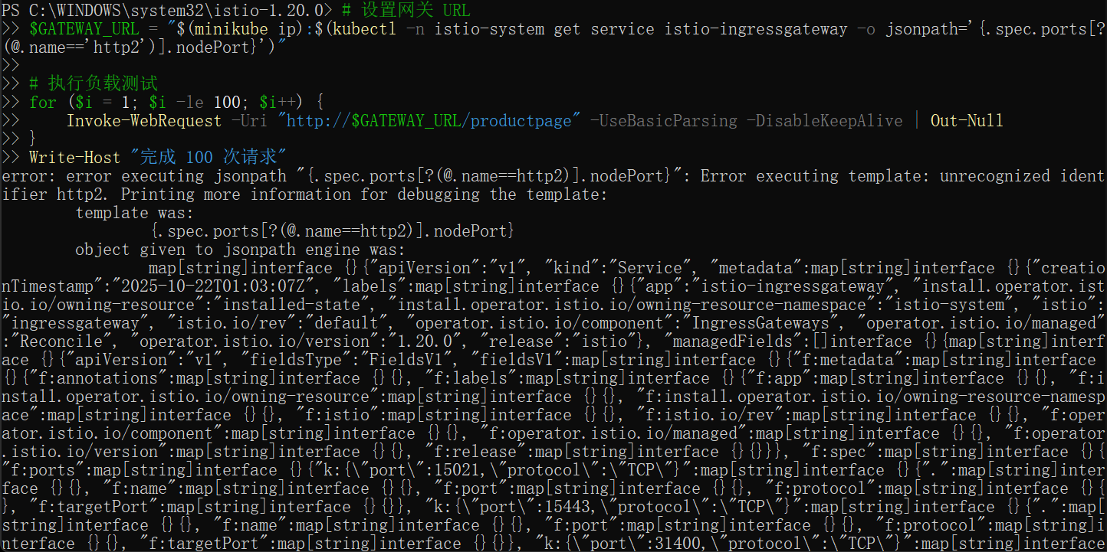

he Istio uninstall deletes the RBAC permissions and all resources hierarchically under the namespace. It is safe to ignore errors for non-existent resources because they may have been deleted hierarchically.istio-system

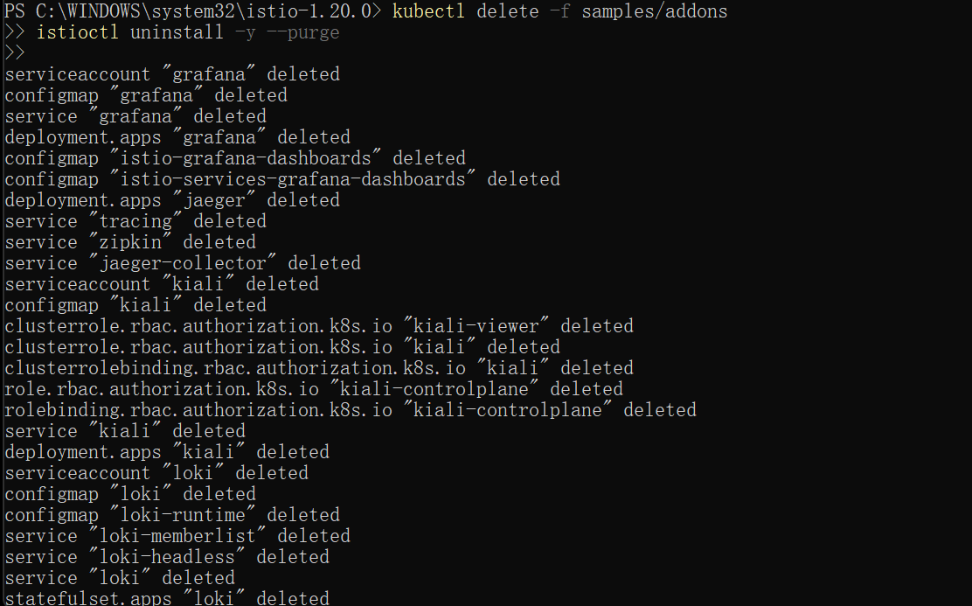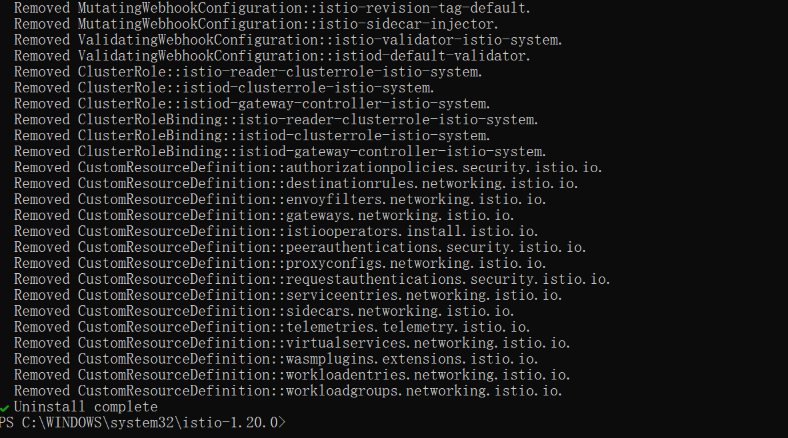The namespace is not removed by default. If no longer needed, use the following command to remove it:istio-system

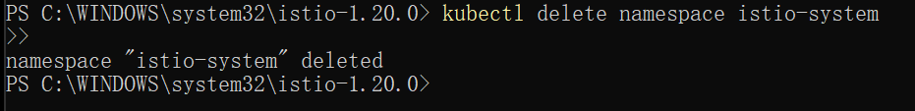

The label to instruct Istio to automatically inject Envoy sidecar proxies is not removed by default. If no longer needed, use the following command to remove it:



Installed the Kubernetes Gateway API CRDs and would now like to remove them, run one of the following commands:

