1:
Make sure you have the following tools installed:
kubectl - The Kubernetes command-line tool
helm - for installing KServe and other Kubernetes operators
curl - for the quickstart script and for testing API endpoints (installed by default on most systems)
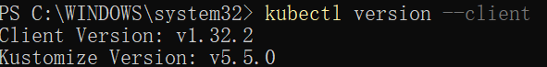
If you want to run a local Kubernetes cluster, you can use Kind. It allows you to create a Kubernetes cluster using Docker container nodes.
First, ensure you have Docker installed on your machine. Install Kind by following the Kind Quick Start Guide if you haven't done so already.
Then, you can create a local Kubernetes cluster with the following command
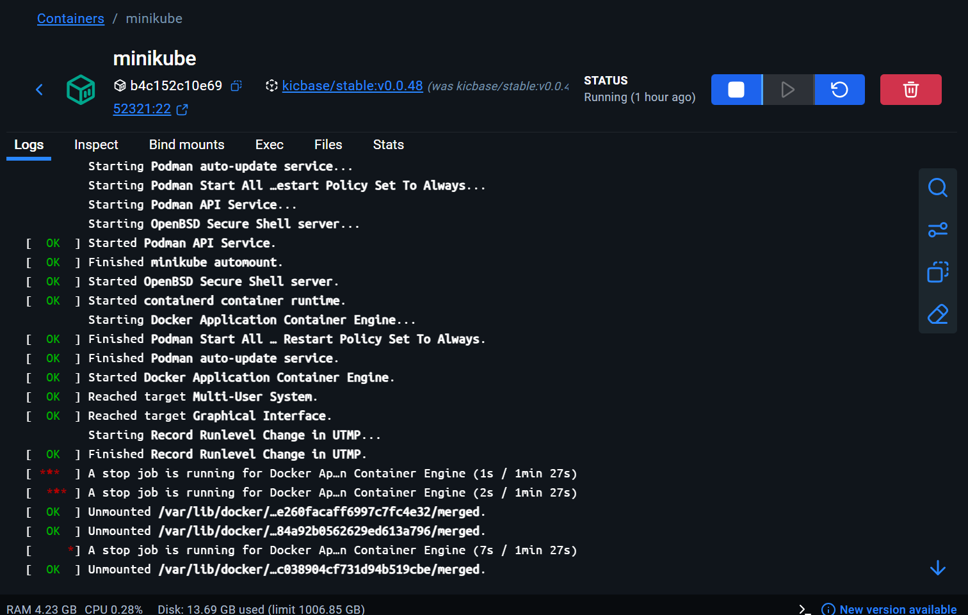
Install all dependencies, KServe (Standard), and LLMInferenceService:
After installation, verify all components are working:
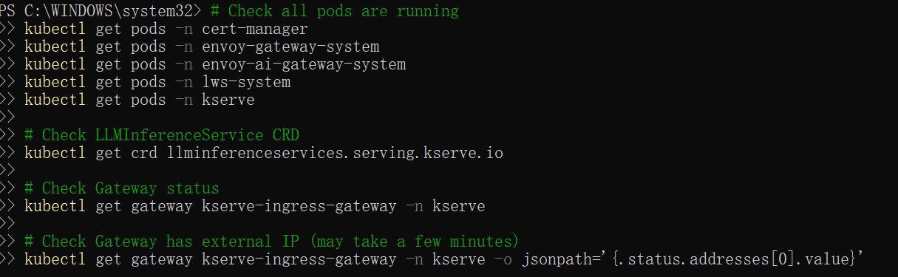
First, create a namespace to use for deploying KServe resources:
Create an InferenceService to deploy the Qwen LLM model. This model will be served using KServe's Hugging Face runtime with vLLM backend for optimized performance.
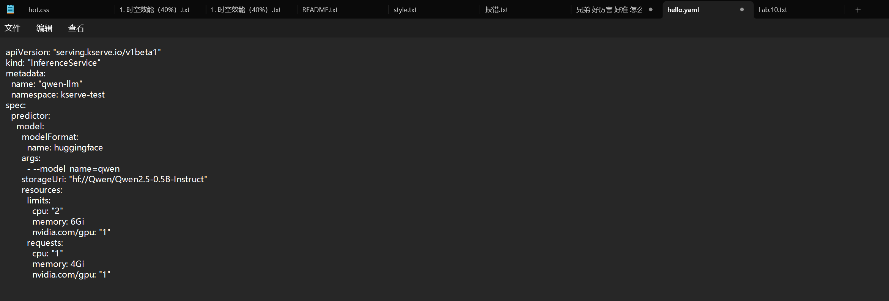
If you need to authenticate with Hugging Face, first create a secret:
Then create a clusterstoragecontainer resource with the secret reference:
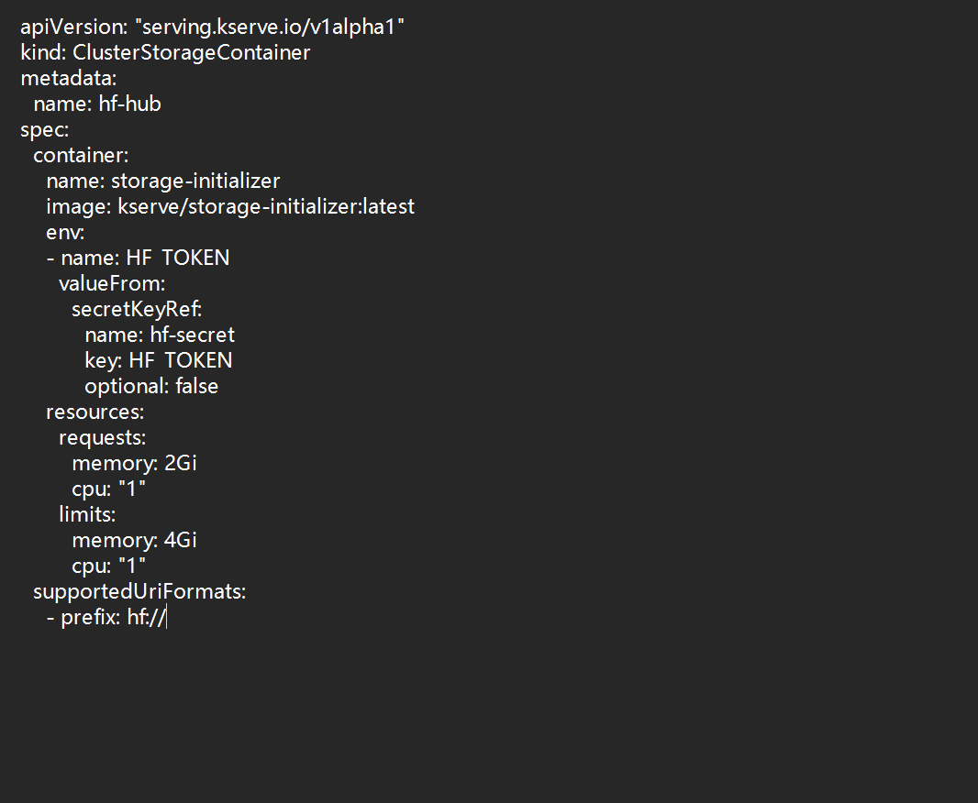
Check InferenceService status
Execute the following command to determine if your Kubernetes cluster is running in an environment that supports external load balancers
If the EXTERNAL-IP value is set, your environment has an external load balancer that you can use for the ingress gateway.
Create a JSON file named chat-input.json with the following content to send a chat completion request to the Qwen model:
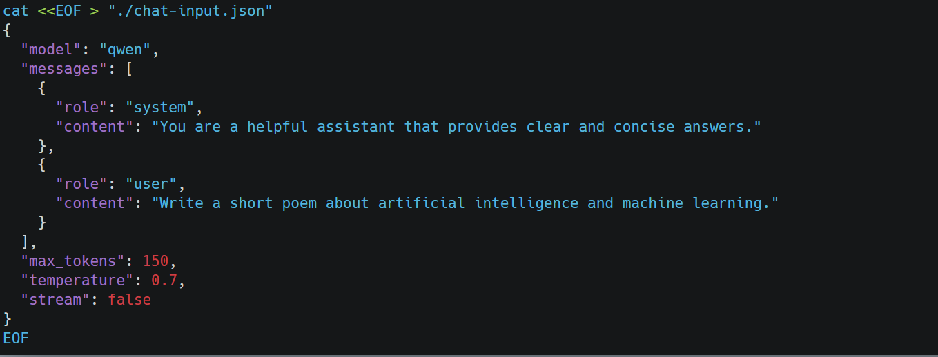
Depending on your setup, use one of the following commands to curl the InferenceService:
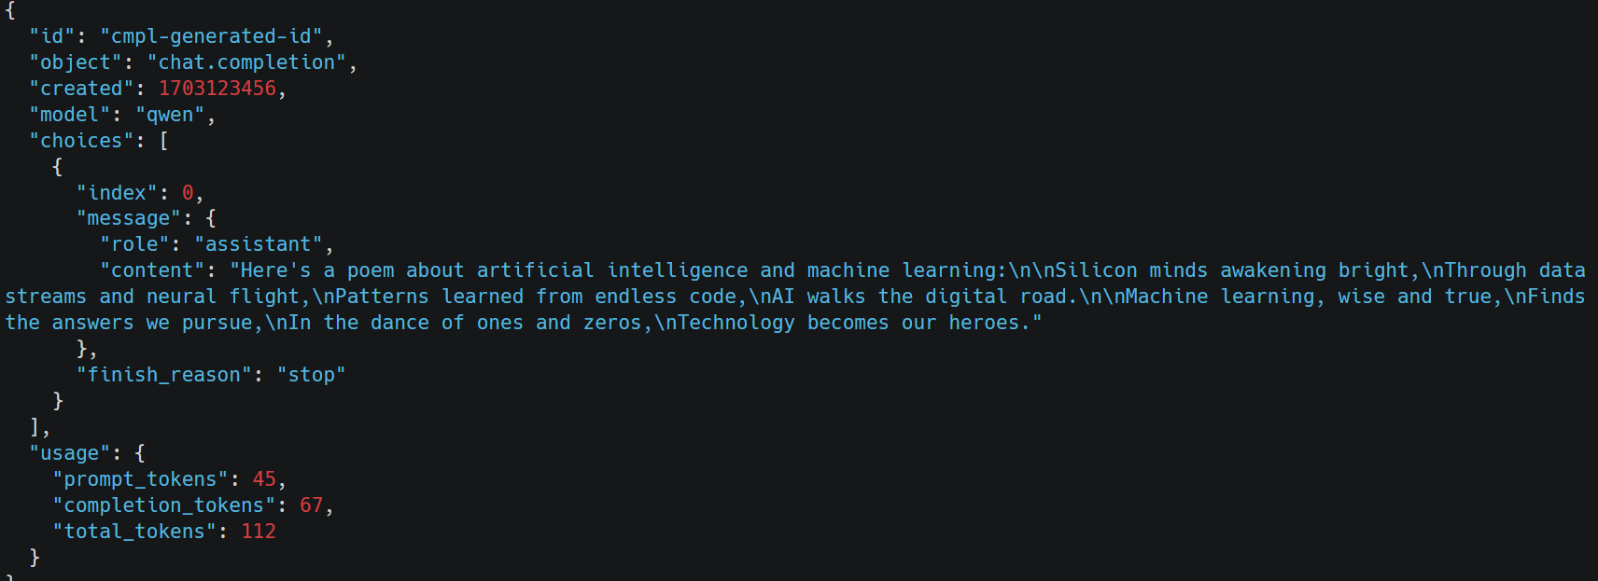
To clean up the resources created in this tutorial, delete the InferenceService and the namespace:

Create a Namespace

Deploy Facebook OPT-125M model (small model for CPU testing):

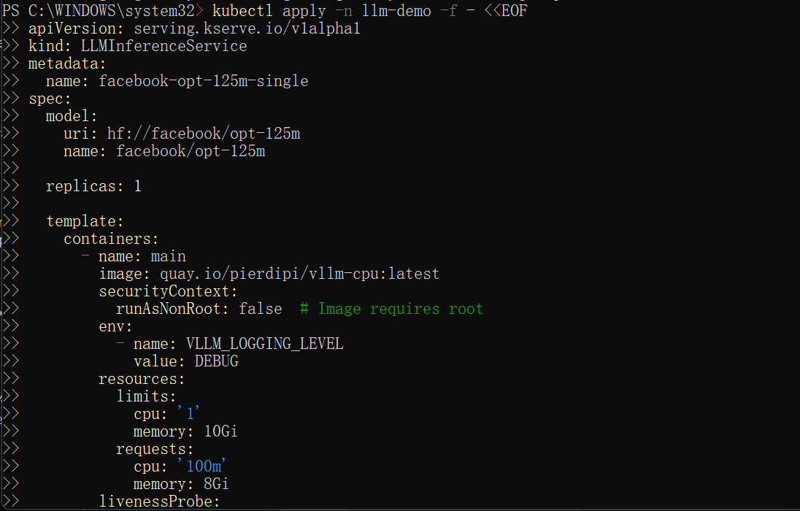
Check the deployment status:
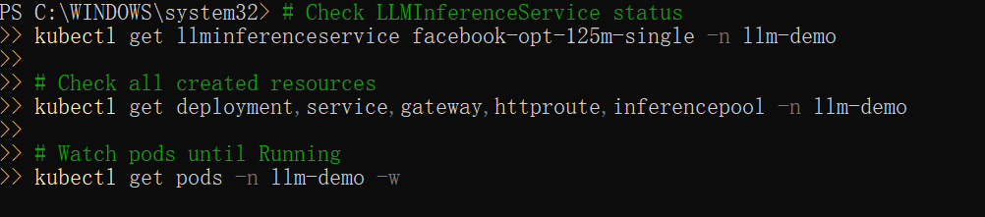
Once the service is ready, test it with a completion request:
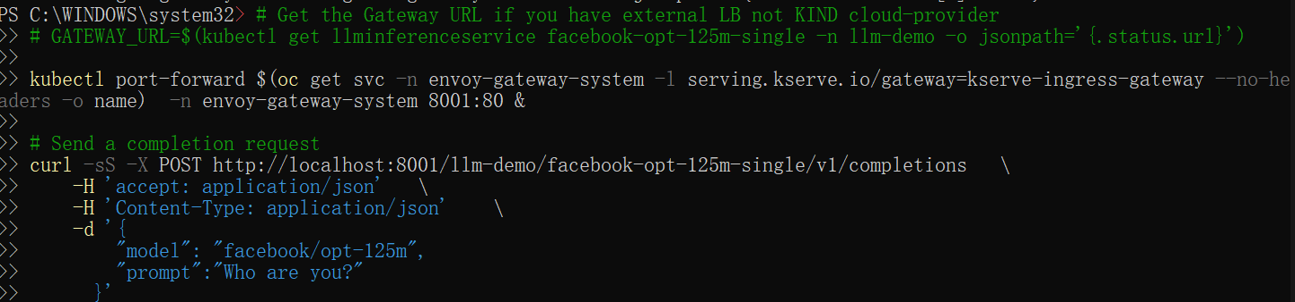
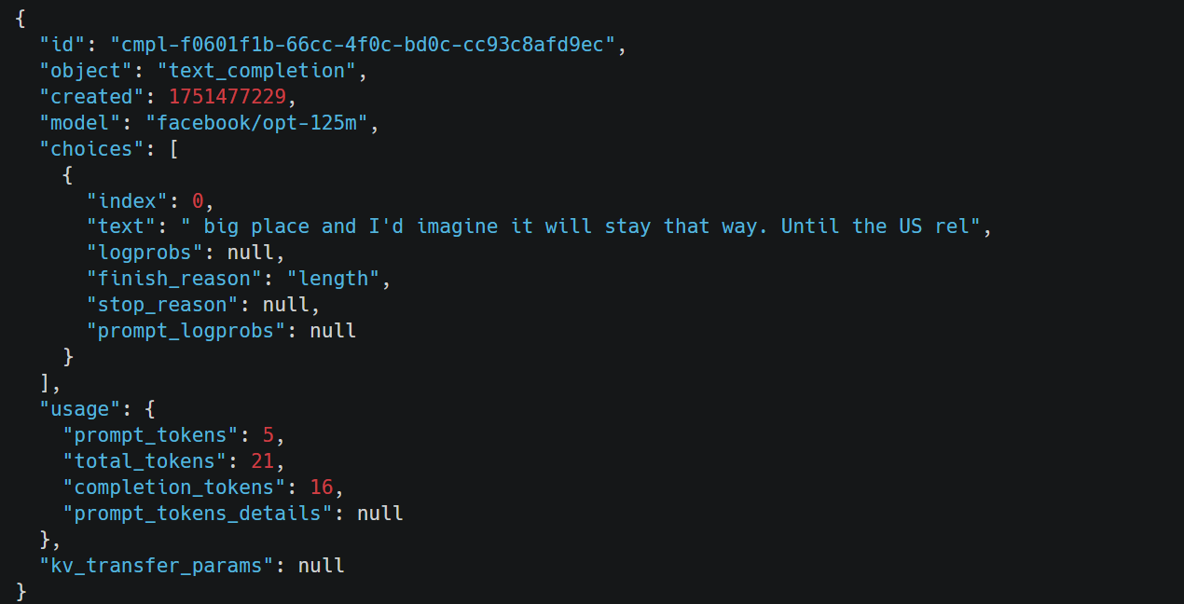
When you're done testing, remove all resources:
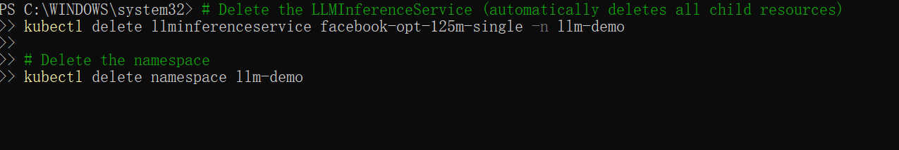

2:
First, create a namespace to use for deploying KServe resources:
Create an InferenceService to deploy the Iris model. This model will be served using KServe's Scikit-learn runtime for optimized performance.
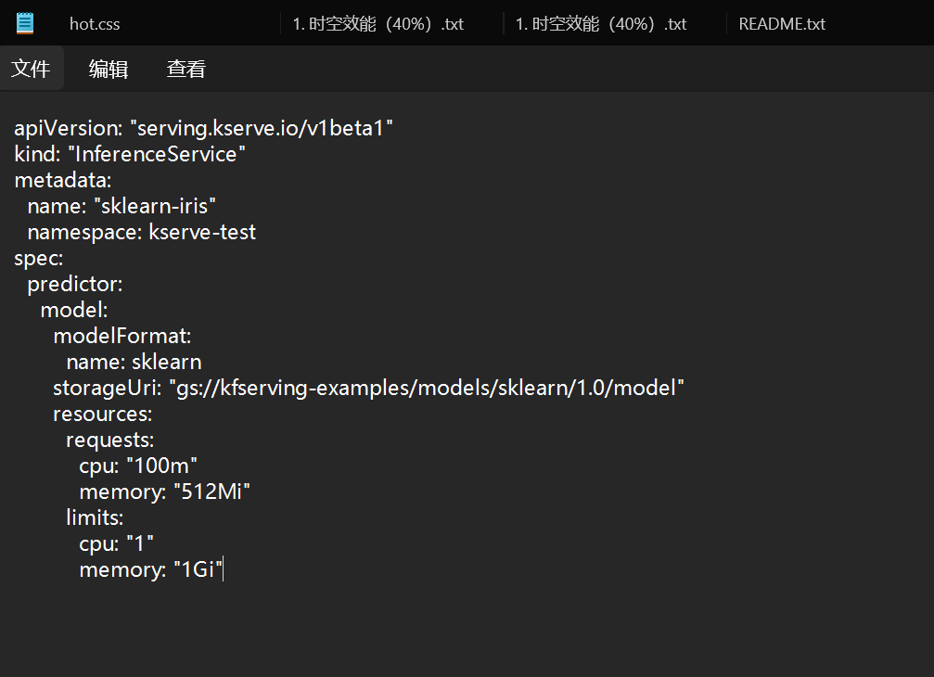
Check InferenceService status
Execute the following command to determine if your kubernetes cluster is running in an environment that supports external load balancers
If the EXTERNAL-IP value is set, your environment has an external load balancer that you can use for the ingress gateway.
First, prepare your inference input request inside a file:

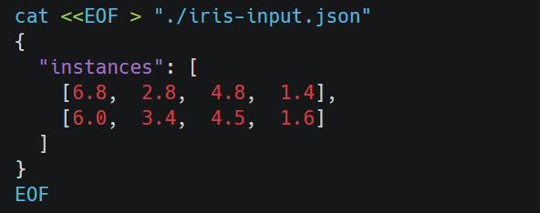
If you have configured the DNS, you can directly curl the InferenceService with the URL obtained from the status print.
If you want to load test the deployed model, try deploying the following Kubernetes Job to drive load to the model:
Execute the following command to view output:
