1:
You can install Knative Functions either by using the standalone func CLI, or by installing the kn func plugin that is available for the Knative kn CLI.
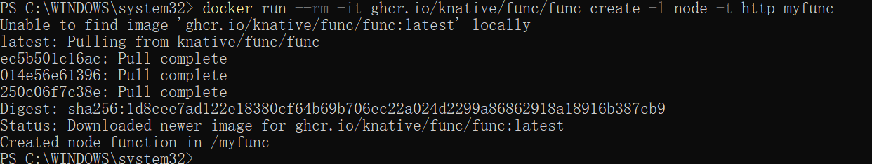
You can install Knative Functions as a kn CLI plugin, by downloading the executable binary for your system and placing it in the system path.
Move the executable binary file to a directory on your PATH by running the command:
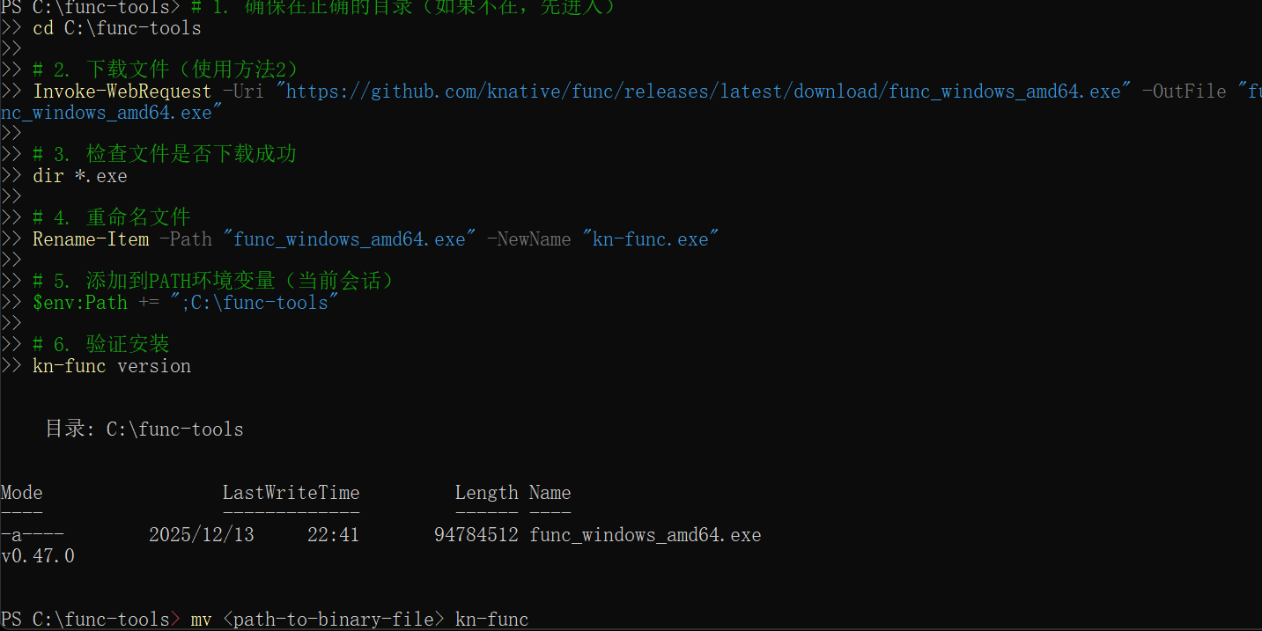
Verify that the CLI is working by running the command:
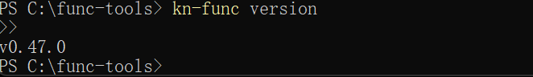
After you have installed Knative Functions, you can create a function project by using the func CLI or the kn func plugin
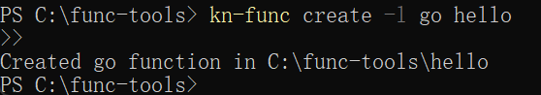
The run command builds an image for your function if required, and runs this image locally, instead of deploying it on a cluster.

You can force a rebuild of the image by running the command:
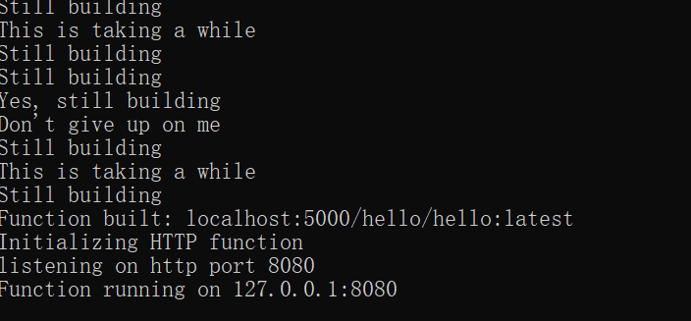

You can verify that your function has been successfully run by using the invoke command and observing the output:

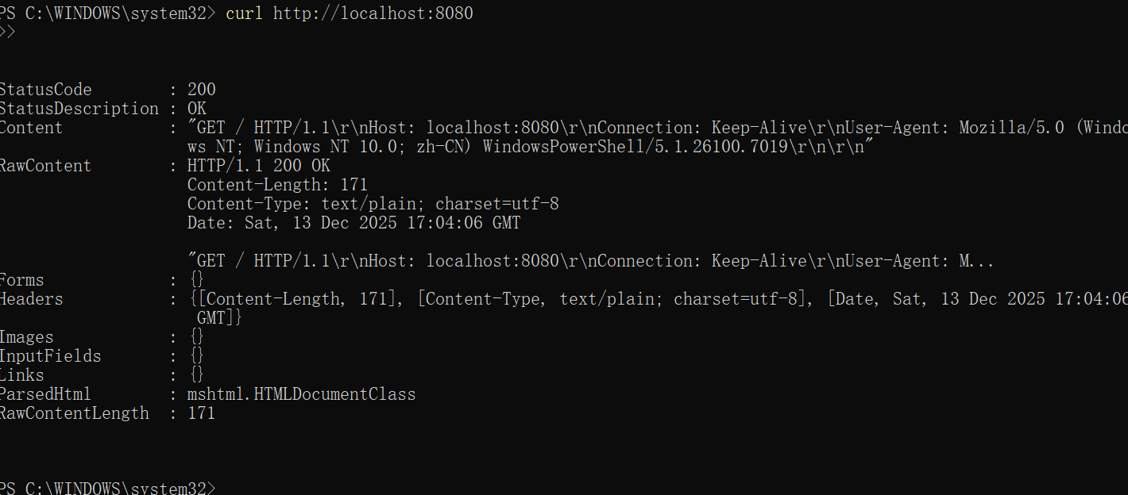

2：
In this tutorial, you will deploy a "Hello world" Knative Service that accepts the environment variable TARGET and prints Hello ${TARGET}!.
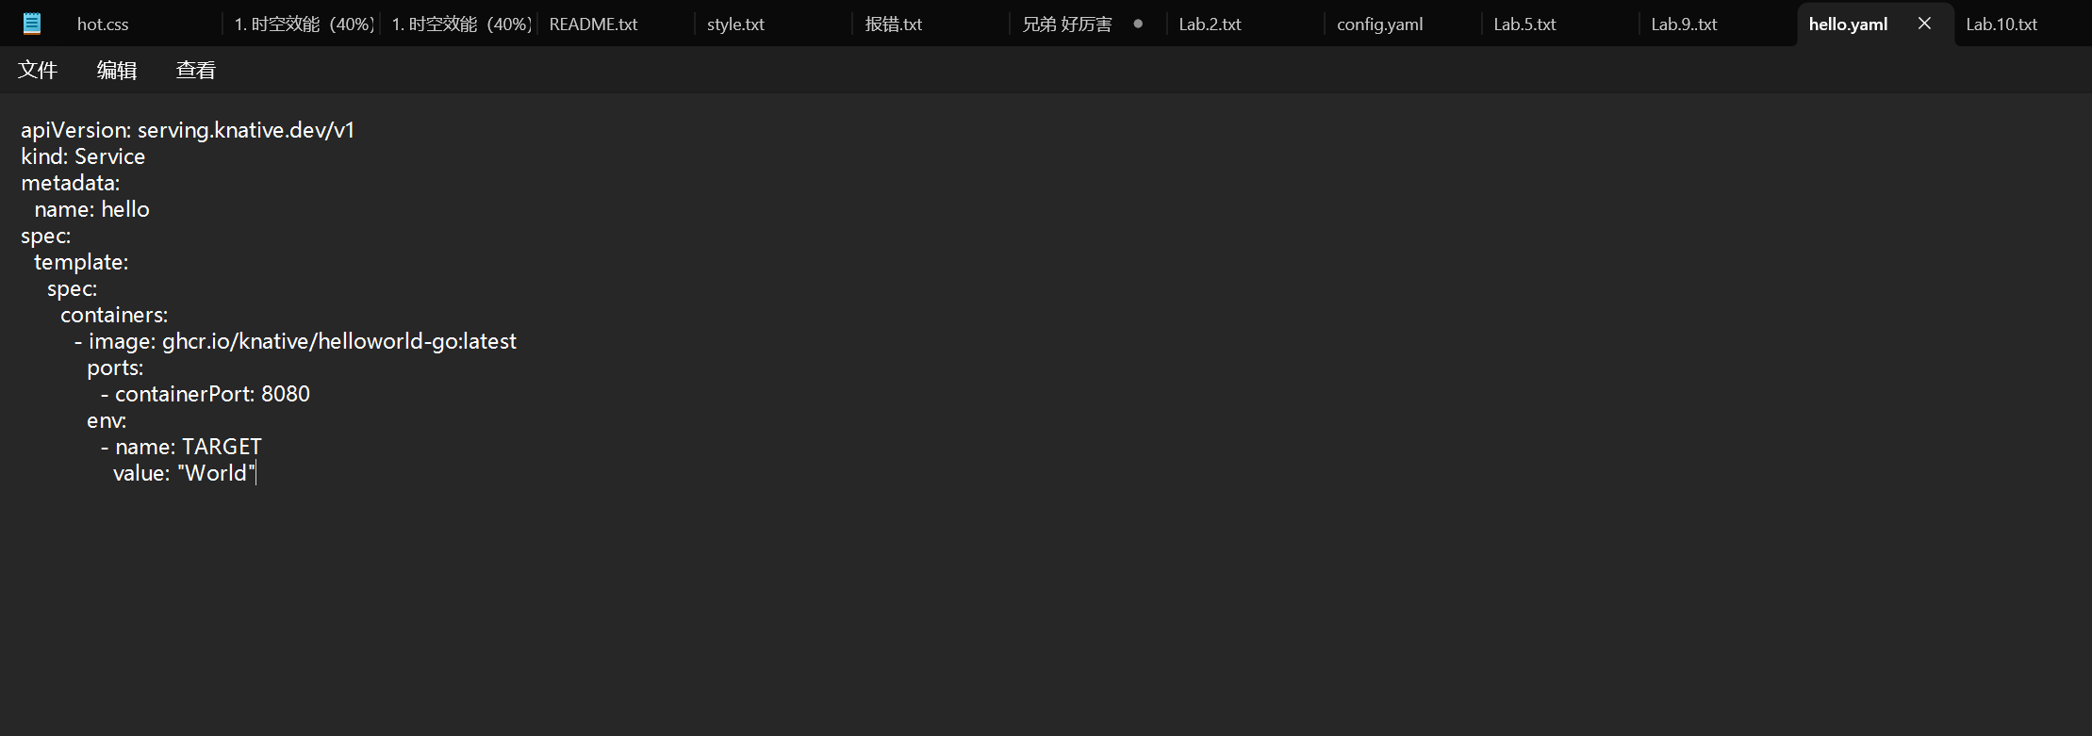
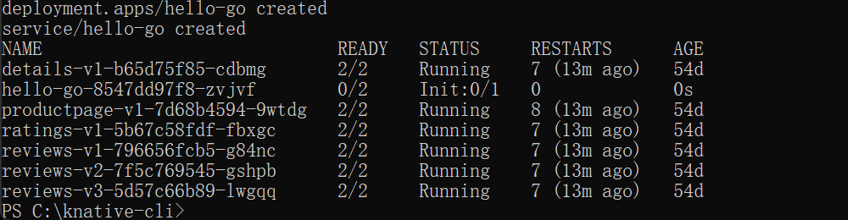
View a list of Knative Services by running the command:
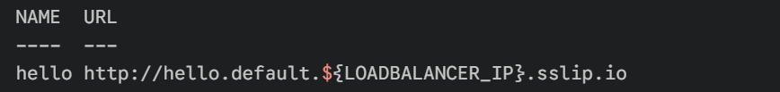
Access your Knative Service by opening the previous URL in your browser or by running the command:
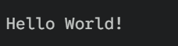
Watch the pods and see how they scale to zero after traffic stops going to the URL:
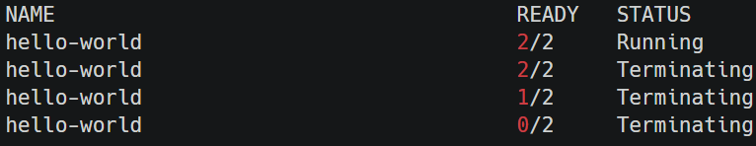
Rerun the Knative Service in your browser. You can see a new pod running again:
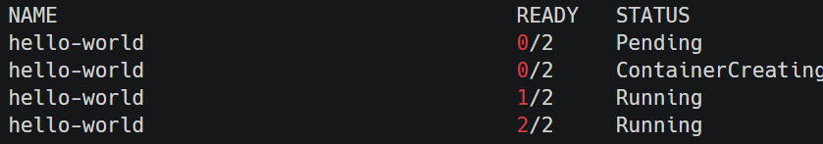
Deploy the updated version of your Knative Service by running the command:
Here is the expected outcomes.

To see the change, access the Knative Service again on your browser or use curl in your terminal:
The outcome:
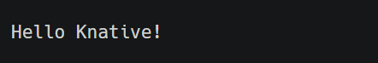
You can view a list of existing Revisions by using the Knative (kn) or kubectl CLI:
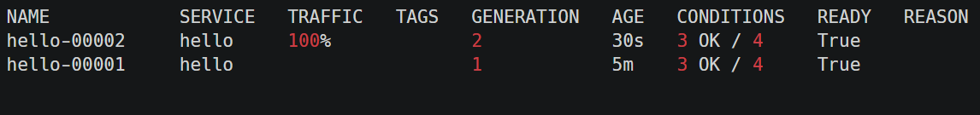
Split the traffic between the two Revisions:
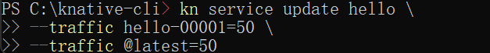
To verify that the traffic split has configured correctly, list the Revisions again by running the command:
Similarly, you can access the Service URL from the terminal multiple times to see the traffic being split between the Revisions.
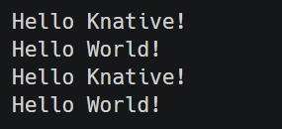

3：
Verify that the Broker is installed by running the following command:
Expected output
The CloudEvents Player acts as a Source for CloudEvents by intaking the name of the Broker as an environment variable, BROKER_NAME. If the Broker is located in a different namespace it is possible to also set the BROKER_NAMESPACE environment variable. Alternatively, you can just use the BROKER_URI.
The service is now running but it doesn't know where the broker is so let's create a SinkBinding between the service and the broker.
You can use the CloudEvents Player to send and receive CloudEvents. If you open the Service URL in your browser, the Create Event form appears.
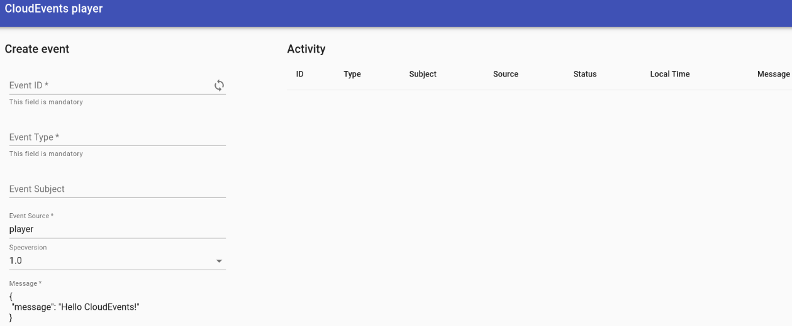
Try sending an event using the CloudEvents Player interface:
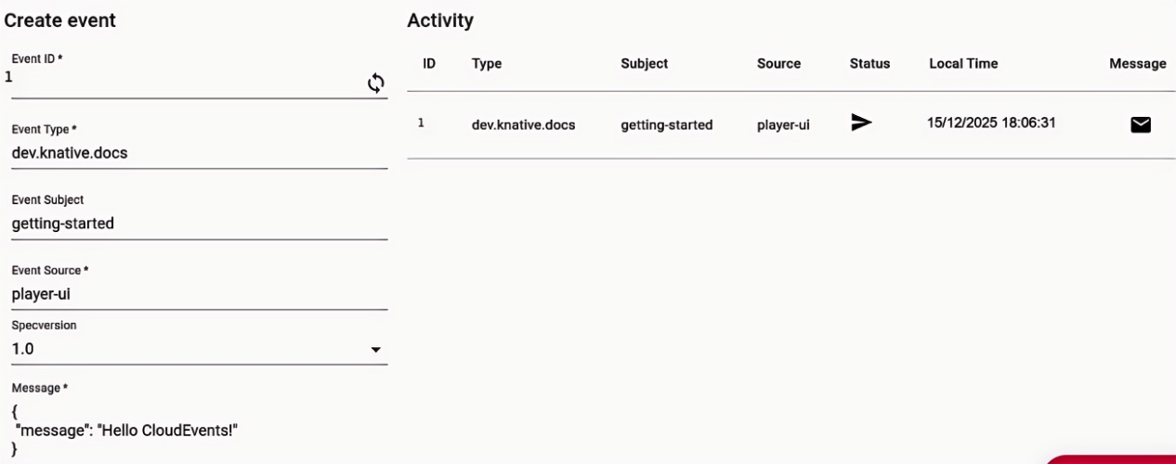
Create a Trigger that listens for CloudEvents from the event source and places them into the sink, which is also the CloudEvents Player app.
