1：
A common use case is to migrate traffic gradually from an older version of a microservice to a new one. In Istio, you accomplish this goal by configuring a sequence of routing rules that redirect a percentage of traffic from one destination to another.
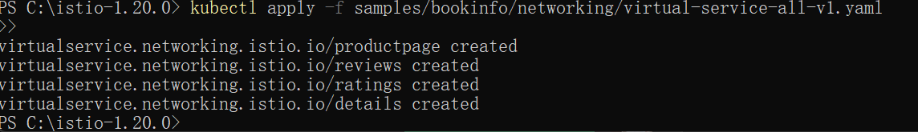
Notice that the reviews part of the page displays with no rating stars, no matter how many times you refresh. This is because you configured Istio to route all traffic for the reviews service to the version reviews:v1 and this version of the service does not access the star ratings service.
Wait a few seconds for the new rules to propagate and then confirm the rule was replaced:
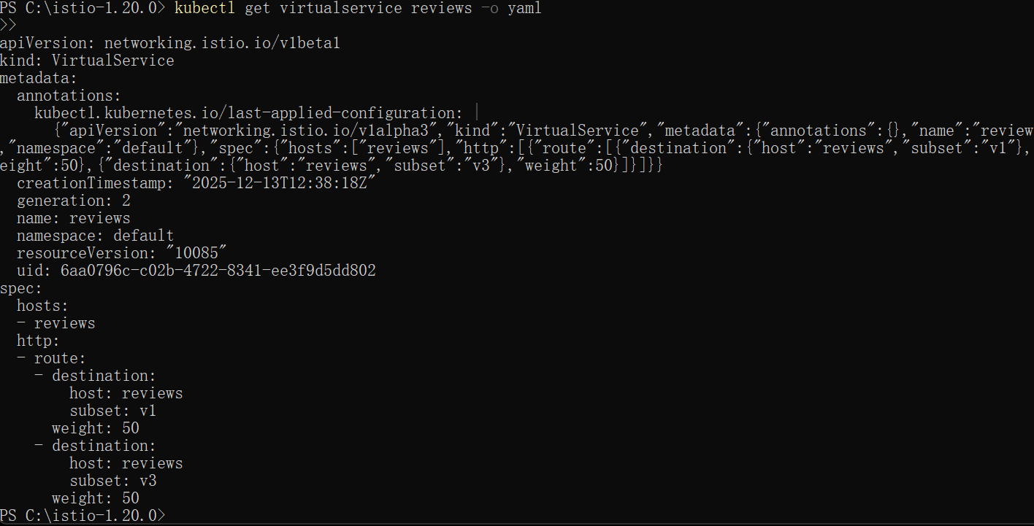
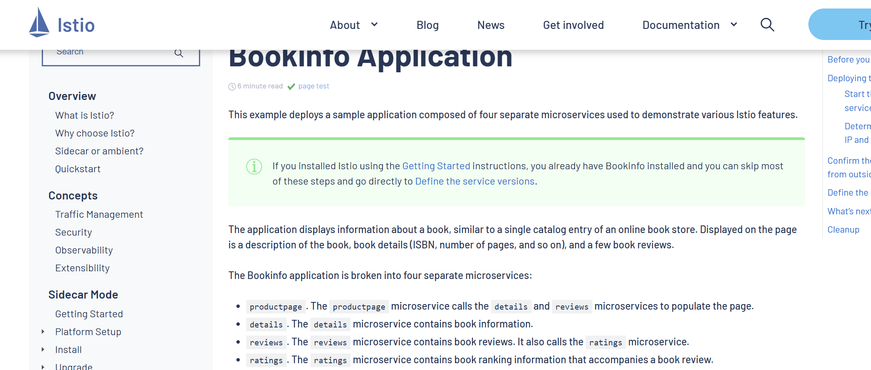
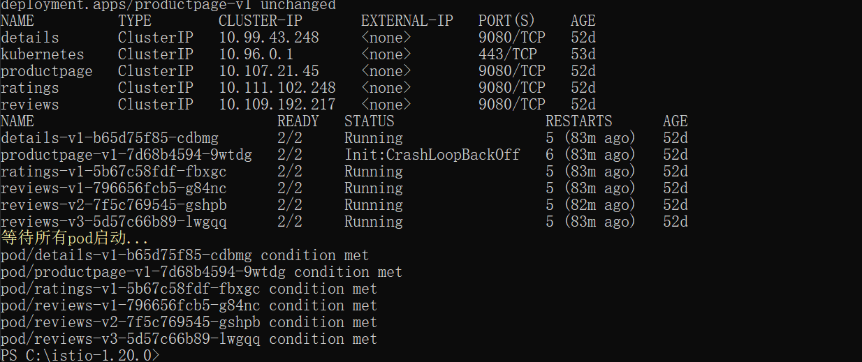
Refresh the /productpage in your browser and you now see red colored star ratings approximately 50% of the time. This is because the v3 version of reviews accesses the star ratings service, but the v1 version does not.
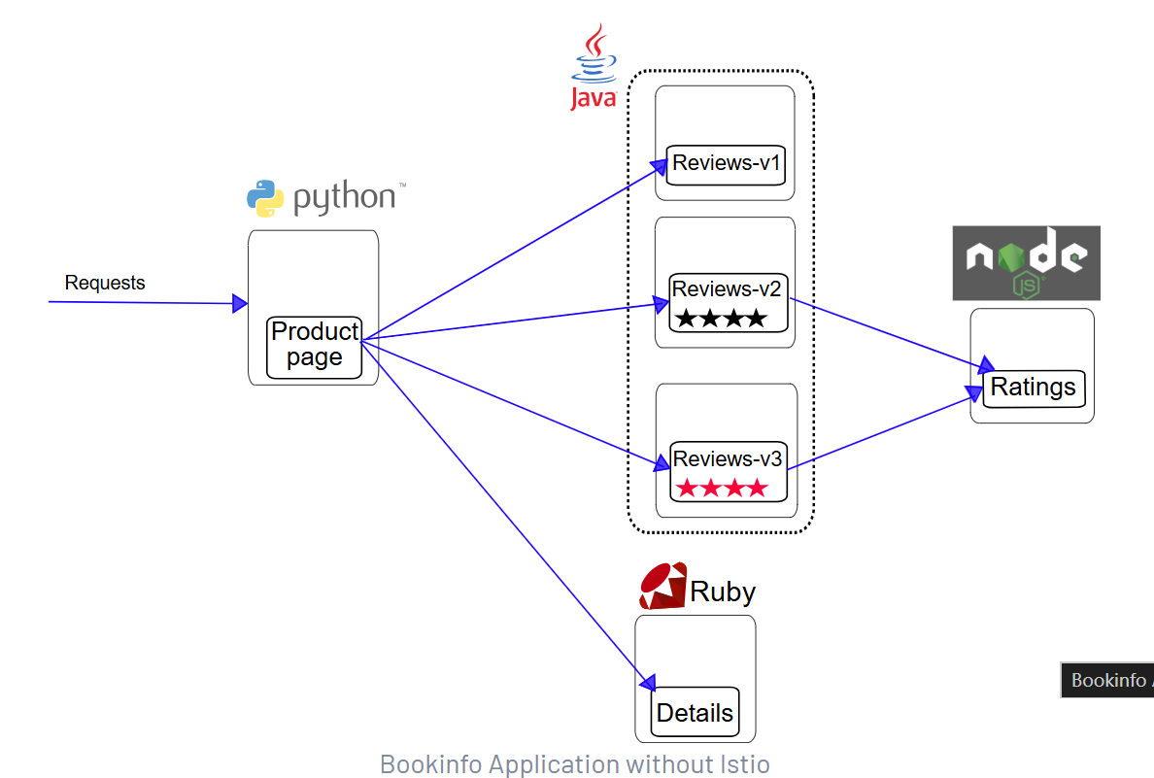

Remove the application routing rules:
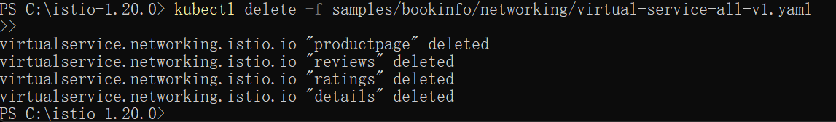

2：
To route to one version only, you configure route rules that send traffic to default versions for the microservices.
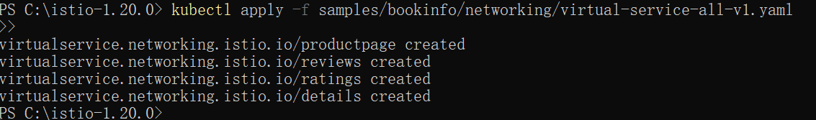
Display the defined routes with the following command:

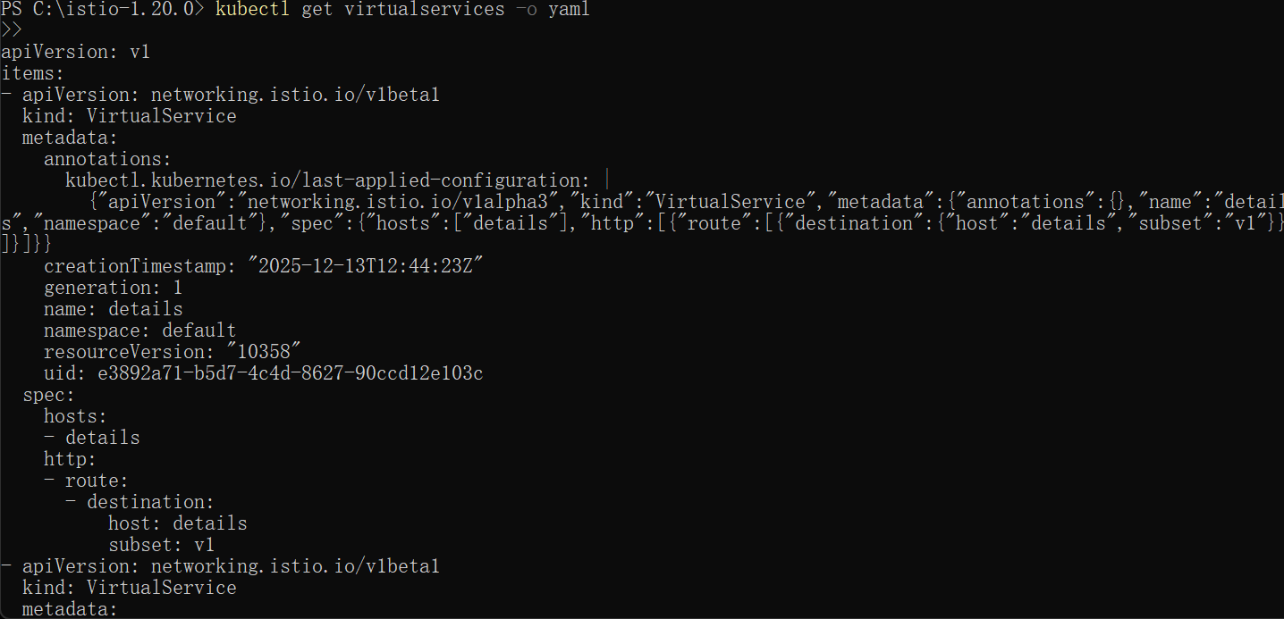
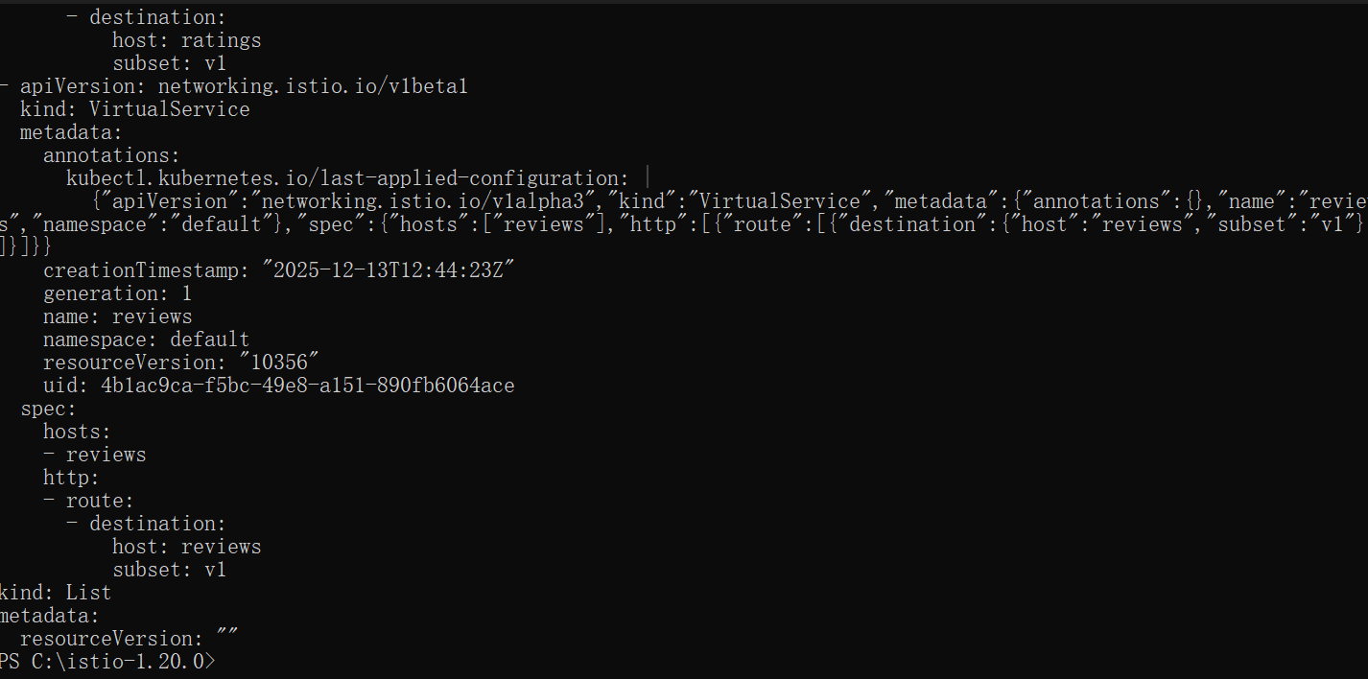
You can also display the corresponding subset definitions with the following command:
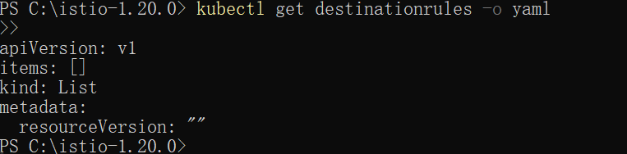
You can confirm the rule is created using the following command:
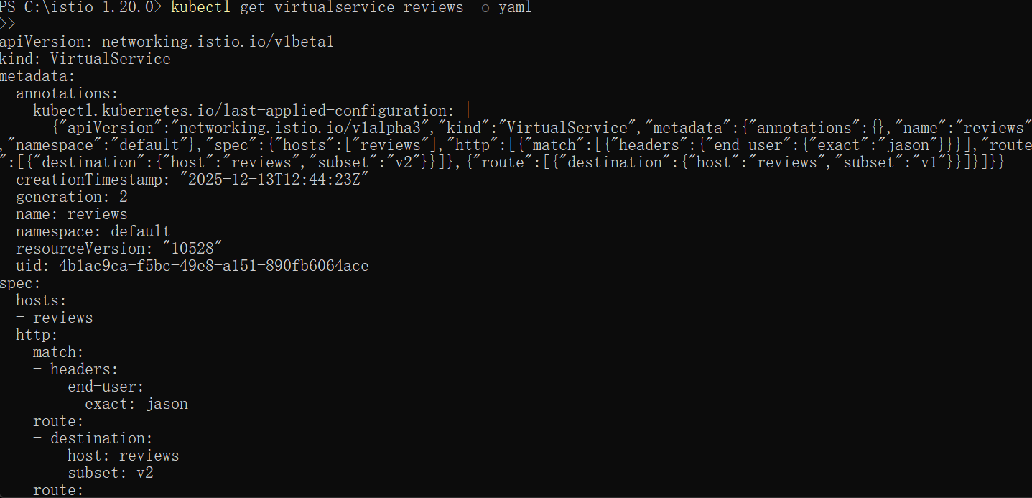
On the /productpage of the Bookinfo app, log in as user jason.
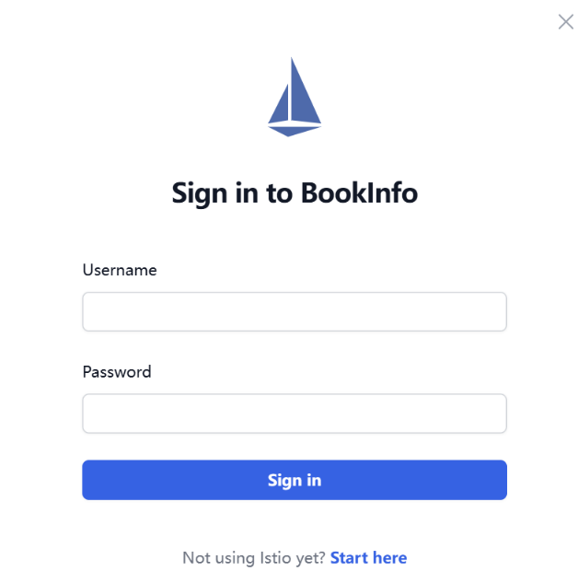
Log in as another user (pick any name you wish).

Remove the application route rules:
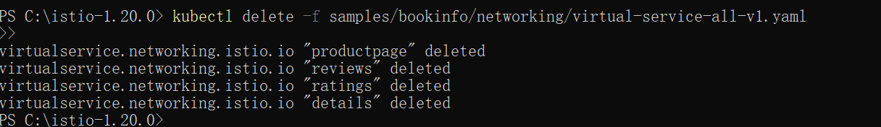

3：
Create a fault injection rule to delay traffic coming from the test user jason.

Confirm the rule was created:
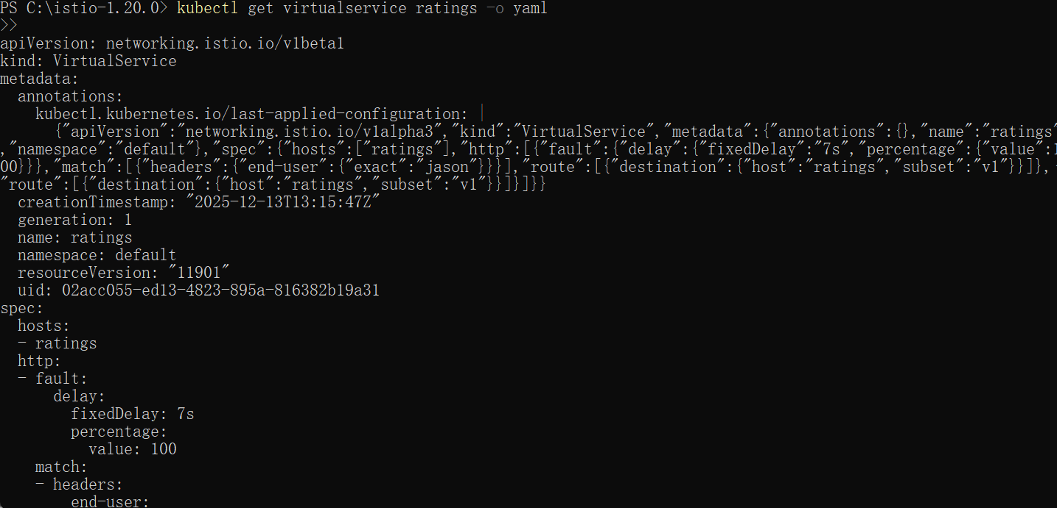
You expect the Bookinfo home page to load without errors in approximately 7 seconds. However, there is a problem: the Reviews section displays an error message:
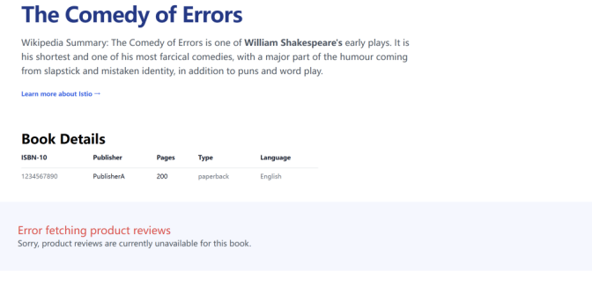
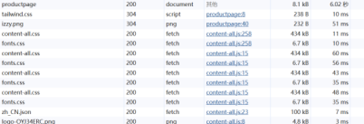
Create a fault injection rule to send an HTTP abort for user jason:

Confirm the rule was created:
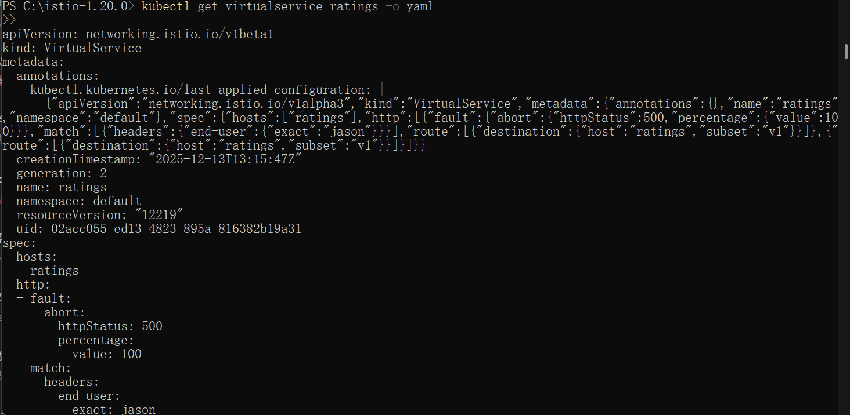
On the /productpage, log in as user jason.
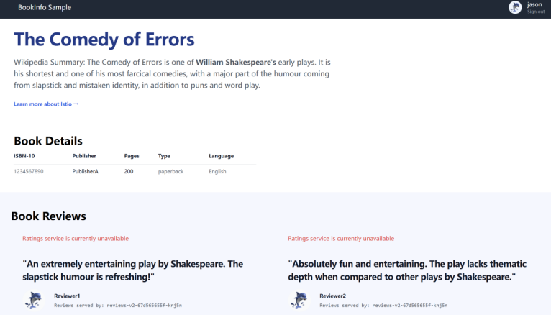

If you log out from user jason or open the Bookinfo application in an anonymous window (or in another browser), you will see that /productpage still calls reviews:v1 (which does not call ratings at all) for everybody but jason. Therefore you will not see any error message.

4：
Start the httpbin sample.
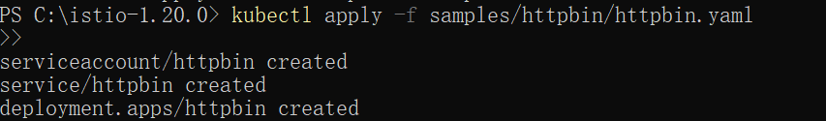
Otherwise, you have to manually inject the sidecar before deploying the httpbin application:
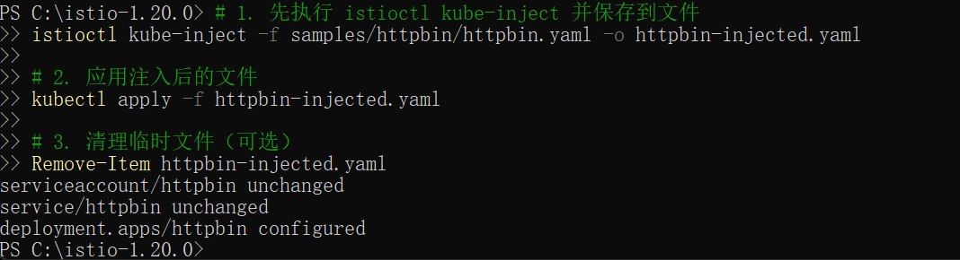
Create a destination rule to apply circuit breaking settings when calling the httpbin service:
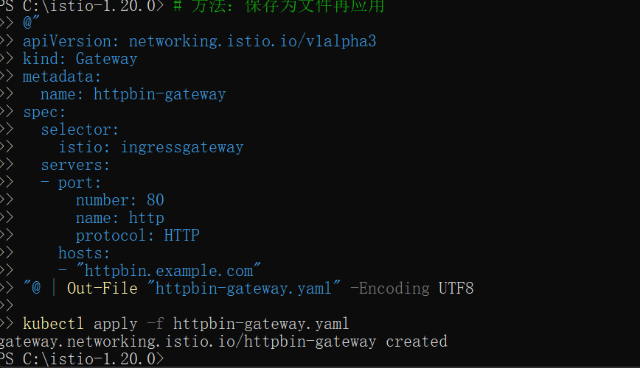
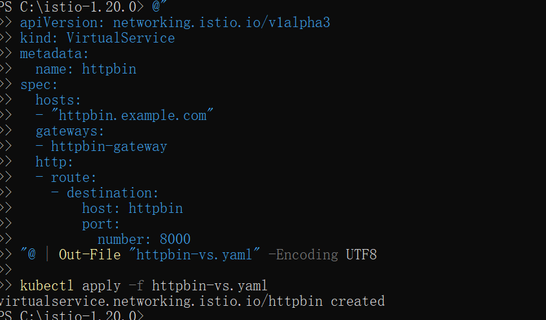
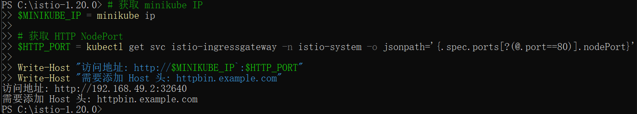
Verify the destination rule was created correctly:
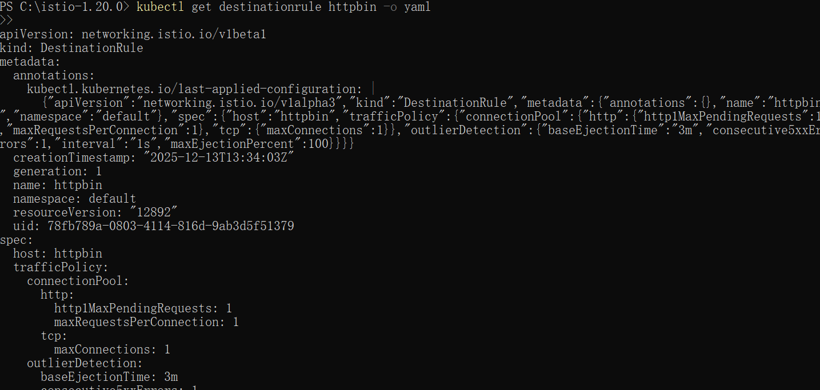
Create a client to send traffic to the httpbin service. The client is a simple load-testing client called fortio. Fortio lets you control the number of connections, concurrency, and delays for outgoing HTTP calls. You will use this client to “trip” the circuit breaker policies you set in the DestinationRule.
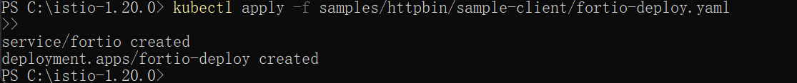

Otherwise, you have to manually inject the sidecar before deploying the fortio application:
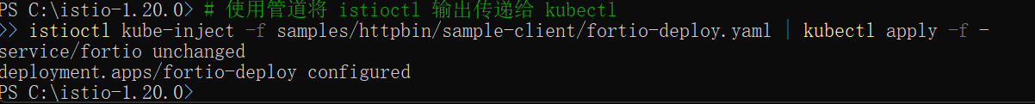
Log in to the client pod and use the fortio tool to call httpbin. Pass in curl to indicate that you just want to make one call:
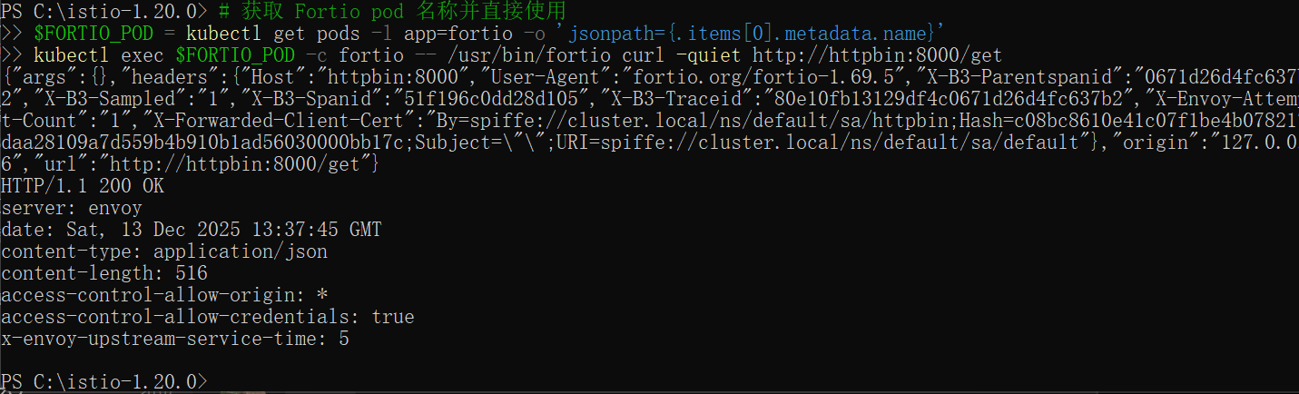
In the DestinationRule settings, you specified maxConnections: 1 and http1MaxPendingRequests: These rules indicate that if you exceed more than one connection and request concurrently, you should see some failures when the istio-proxy opens the circuit for further requests and connections.
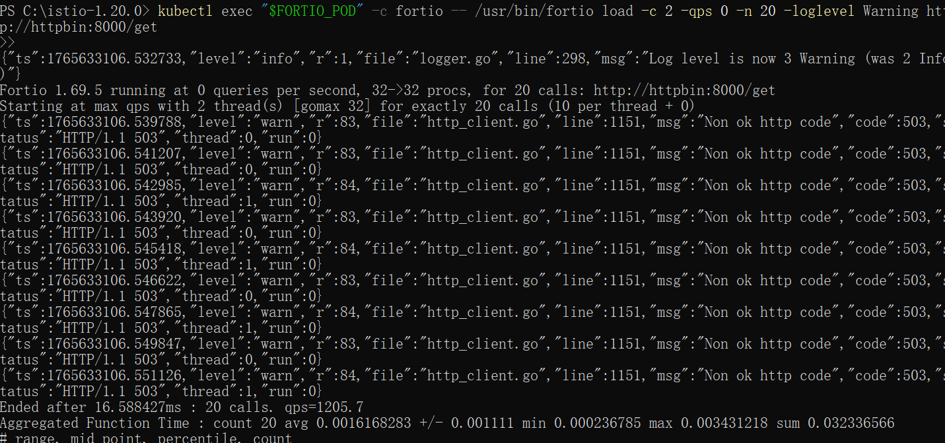
Bring the number of concurrent connections up to 3:
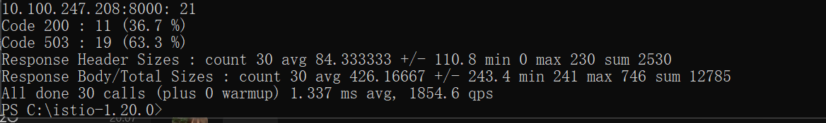

Query the istio-proxy stats to see more:

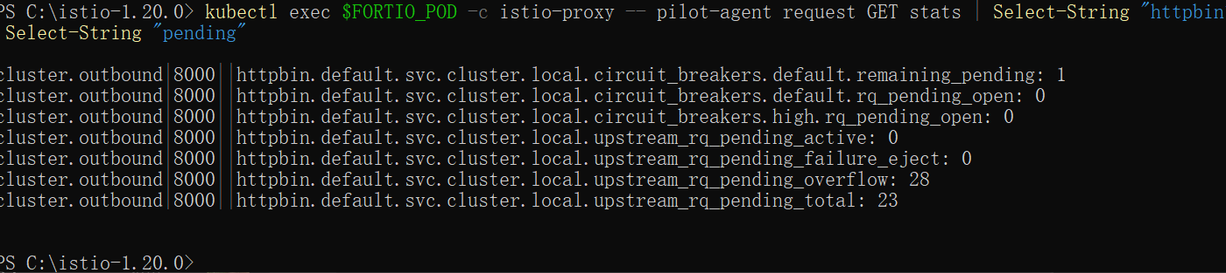
Remove the rules:
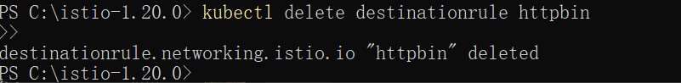
Shutdown the httpbin service and client:
