Three-Blade Co-Directional Folding Hub: Design Report

1 Design Inputs
Item | Value
Number of blades | 3
Tip radius R | 1.4 m
Root radius | 0.28 m
Airfoil | NACA 0012, chord 246 to 103 mm, twist 29.3 to 6.8 deg
Operating speed | 982 rpm
Design check speed | 1080 rpm (110%)
Blade mass | 1.229 kg, CG radius 0.729 m
Hover thrust / torque / power at 982 rpm | 1932 N / 263 N·m / 27.0 kW

2 Concept
The hub consists of an upper and a lower 7075-T6 aluminium plate with a centre spacer ring; the three arms are identical. Each blade grip has a tongue that sits between the two plates and is located by two vertical pins: a pivot bolt and a quick-release lock pin. The pins are 40 mm apart in the chordwise direction at a radius of 190 mm.
Each arm carries two flight holes and two parking holes (PARK1, PARK2). All arms share the same hole pattern, so the rotor mass distribution remains symmetric.
Blade A (azimuth 180 deg) stays in place. Blade B (azimuth 60 deg) is released by pulling the trailing-edge lock pin, rotated +122 deg about the leading-edge bolt, and locked in PARK1. Blade C (azimuth 300 deg) is released by pulling the leading-edge lock pin, rotated -122 deg about the trailing-edge bolt, and locked in PARK2. The three blades end up pointing in the same direction with a 2 deg spread. Deployment is the reverse sequence.
The hinge plane is 47 mm below the pitch axis. At this offset the centrifugal moment about the hinge plane cancels the thrust moment. Both scale with rotor speed squared, so the steady flap moment at the hinge is zero at any hover speed, and the pins and plates carry only the alternating part.
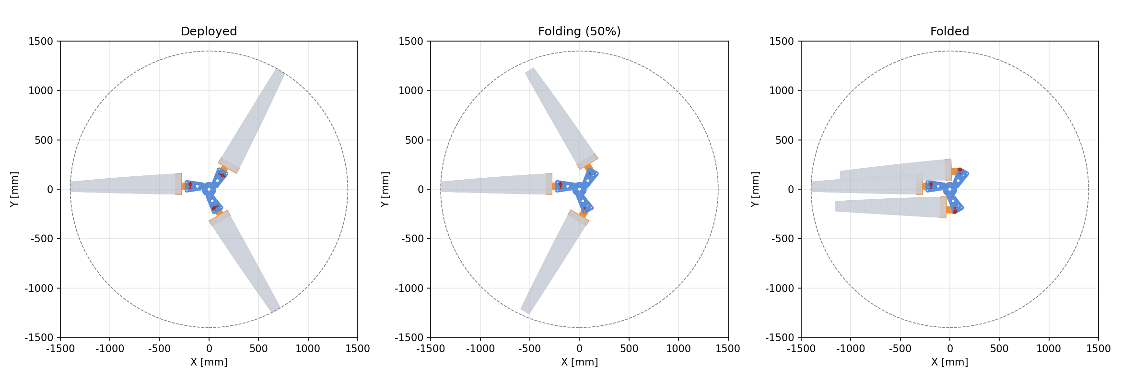
Figure 1. Folding sequence, top view (deployed / 50% / folded)
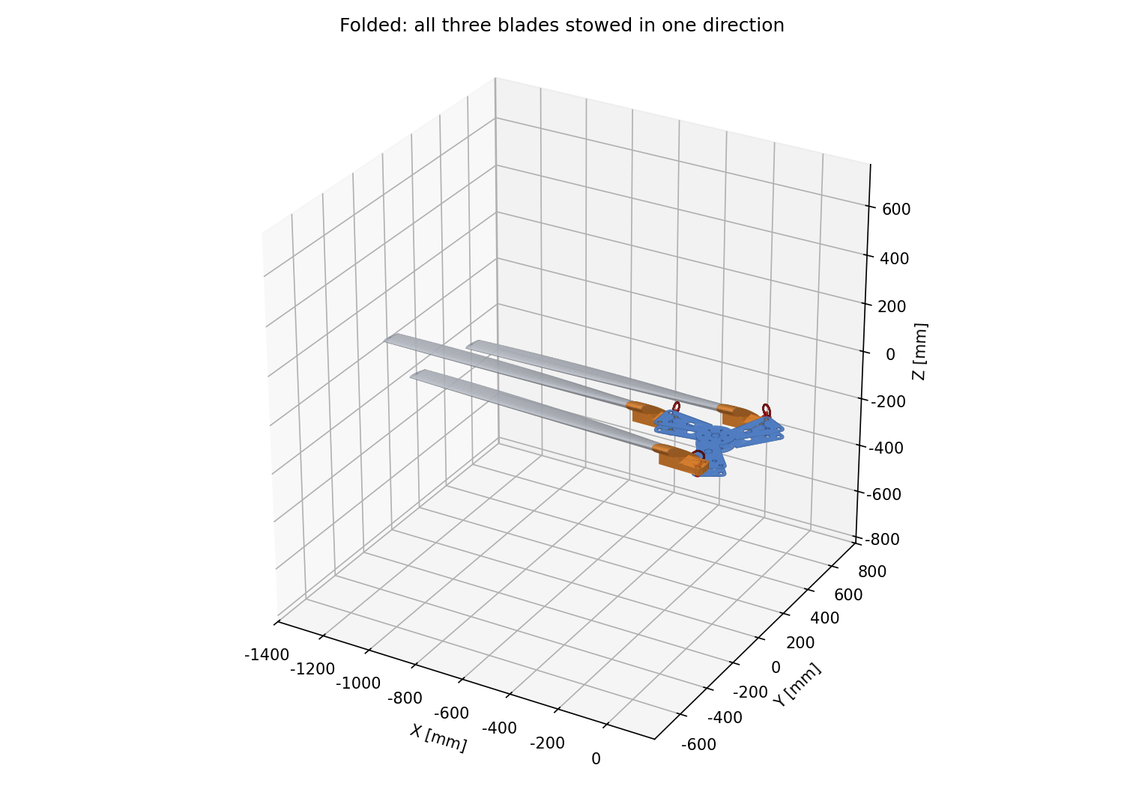
Figure 2. Folded assembly
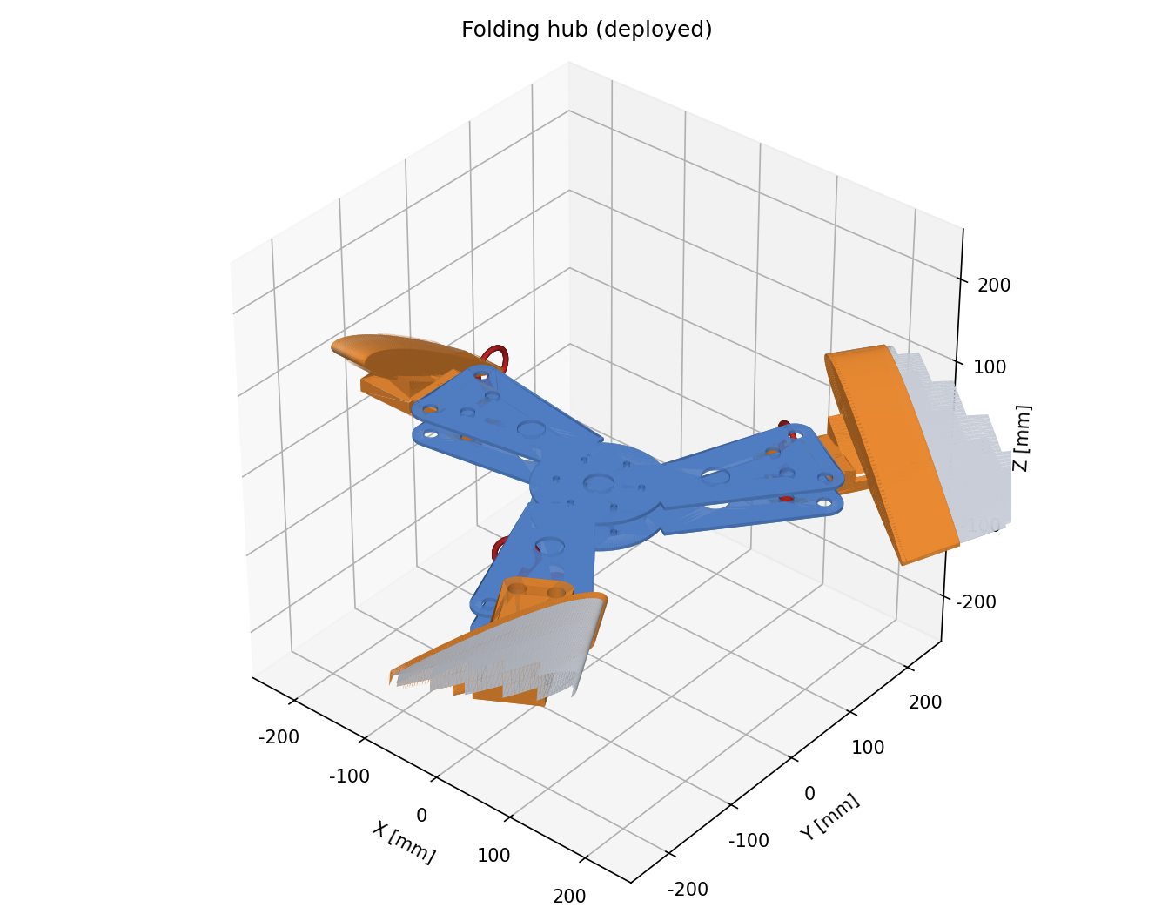
Figure 3. Folding hub, deployed
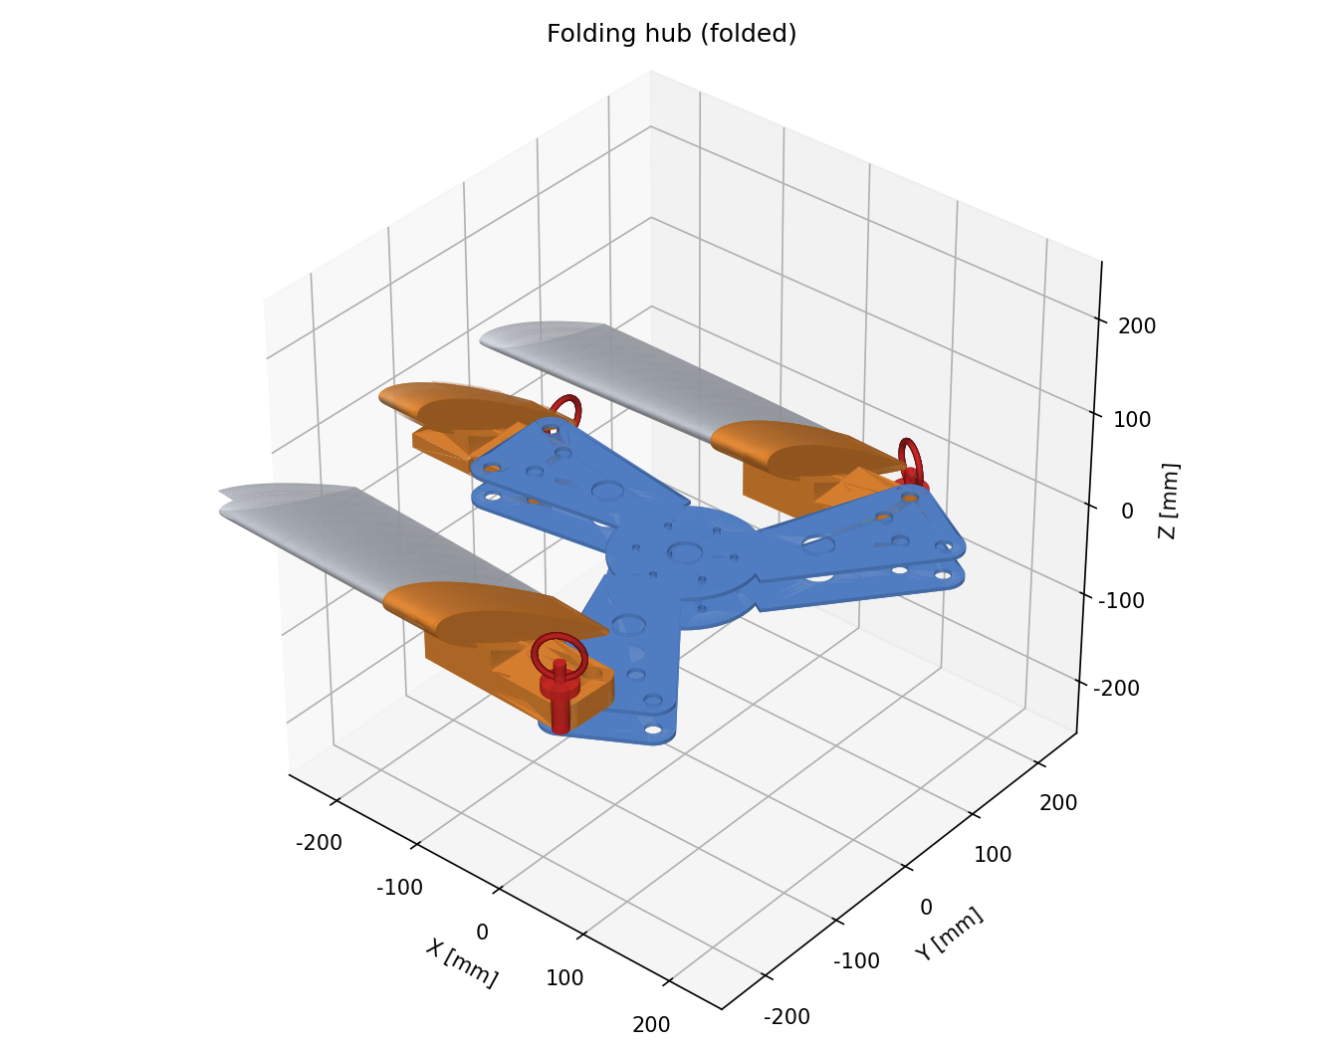
Figure 4. Folding hub, folded
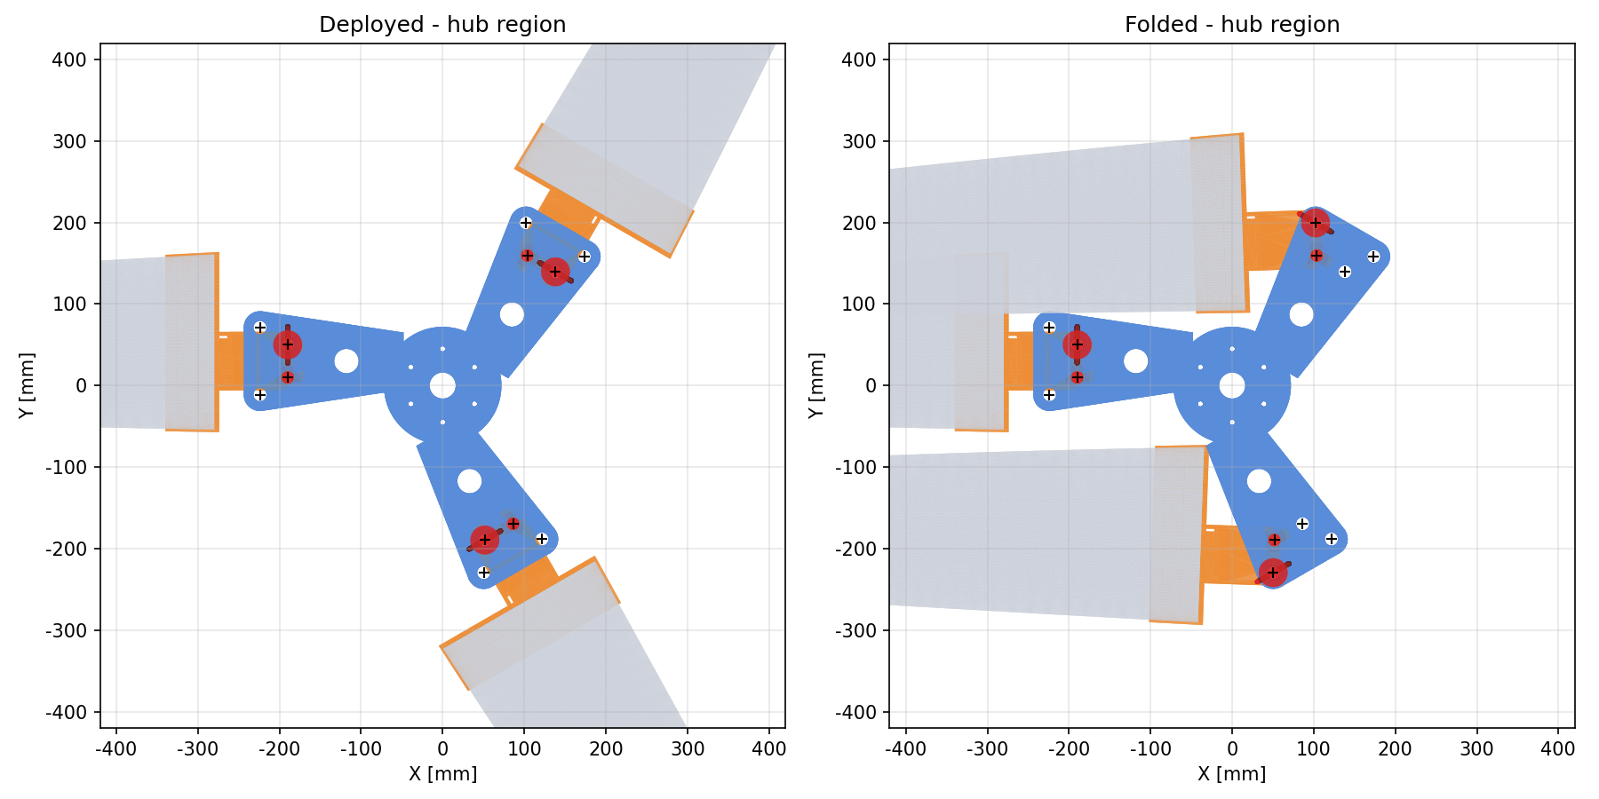
Figure 5. Hub plate hole pattern

3 Main Dimensions
Parameter | Value [mm]
Hinge radius r_h | 190
Pin spacing s | 40
Pin diameter d | 16
Tongue thickness | 27
Tongue lug outer radius | 16
Plate thickness (each) | 4
Plate lug outer radius | 20
Plate arm width | 70
Hinge plane height z_h | -47
Cuff length / wall | 60 / 3

4 Parts List
Part | Material | Qty | Mass each [kg]
hub_plate_upper | 7075-T6 | 1 | 0.734
hub_plate_lower | 7075-T6 | 1 | 0.734
hub_spacer | 7075-T6 | 1 | 0.340
blade_grip | 7075-T6 | 3 | 1.031
pivot_bolt | 42CrMo | 3 | 0.174
lock_pin | 17-4PH | 3 | 0.183
sleeve_bushing | Aluminium bronze | 6 | 0.020
Total (without blades) |  |  | 6.10

5 Stowed Envelope
State | Plan area [m²] | Envelope [mm]
Deployed | 6.16 | 2800 x 2800 x 124
Folded | 0.71 | 1566 x 605 x 128

The folded plan area is 11.6% of the deployed value and the envelope volume is 12.5%.
Solid boolean interference checks at 25%, 50%, 75% and 100% fold give zero overlap between grips and between grips and the hub. Minimum clearances [mm]:
Fold | A-B | A-C | B-C | A-hub | B-hub | C-hub
25% | 276.4 | 275.4 | 311.6 | 25.3 | 28.4 | 28.2
50% | 231.4 | 219.4 | 314.9 | 26.3 | 41.1 | 41.0
75% | 159.1 | 162.2 | 303.3 | 26.5 | 24.6 | 24.8
100% | 14.8 | 70.0 | 184.4 | 25.6 | 12.1 | 7.8

In the folded position the gap between the cuff of blade C and the lower plate edge is 7.8 mm; that plate edge is chamfered C5.

6 Strength Check
Design loads are taken at 1080 rpm with an ultimate factor of 1.5, a gust factor of 1.3 and an alternating flap ratio of 0.35. Fatigue uses the Goodman line with a safety factor of 1.5. Ultimate centrifugal force at the hinge is 14.2 kN and the flap moment is 363 N·m.
Check | Utilisation
Pin shear | 0.13
Pin bending | 0.64
Pin yield | 0.40
Tongue shear-out | 0.05
Tongue bearing | 0.20
Tongue net section | 0.03
Tongue root | 0.13
Plate shear-out | 0.40
Plate bearing | 0.27
Plate net section | 0.27
Plate arm bending | 0.19
Pin fatigue | 0.76
Plate lug fatigue | 0.94
Plate hole fatigue | 0.29
Tongue root fatigue | 0.25
Tongue stiffness (<= 0.25 deg) | 0.88
Plate arm stiffness (<= 0.25 deg) | 0.93
Plate fretting contact pressure | 0.47

All utilisations are at or below 1.0.
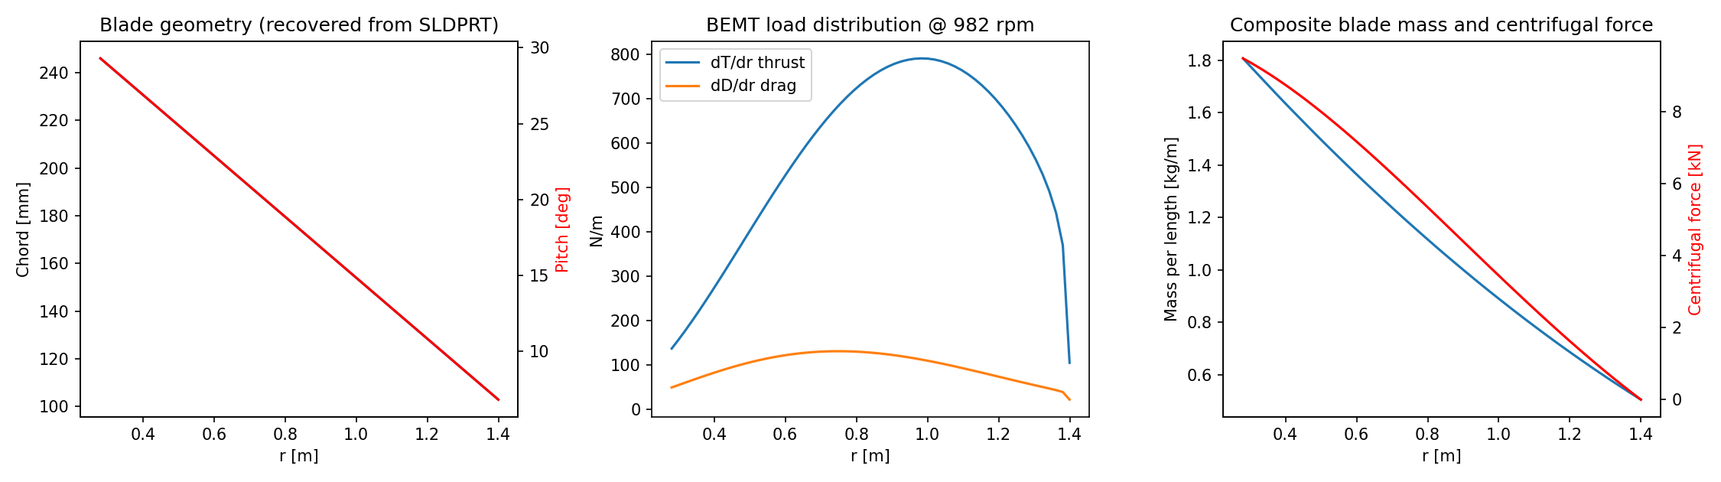
Figure 6. Load distribution
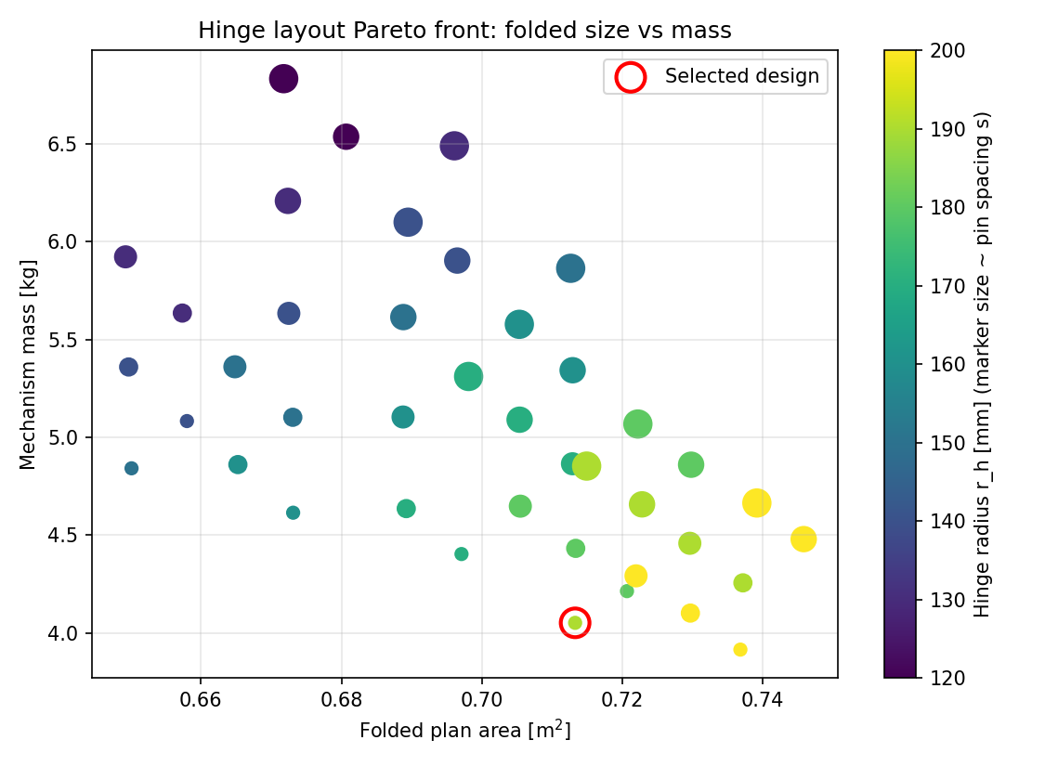
Figure 7. Hinge layout Pareto front

