# RefreshLayout_harmonyos功能介绍

## 组件介绍： RefreshLayout_harmonyos是一款下拉刷新组件

## 手机模拟器上运行效果：

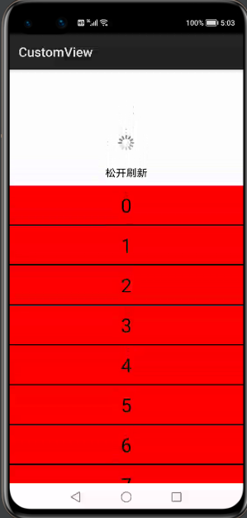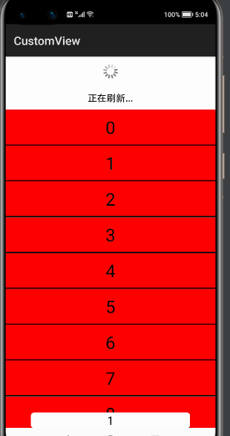

# RefreshLayout_harmonyos使用方法

2.1在目录build.gradle下

implementation project(":refreshlayout_harmonyos")

2.2 xml中引用

<com.example.refreshlayout_harmonyos.RefreshComponent  
 ohos:id="$+id:myView"  
 ohos:height="match_parent"  
 ohos:width="match_parent"  
 >  
  
 <ListContainer  
 ohos:id="$+id:list"  
 ohos:height="match_parent"  
 ohos:width="match_parent"  
 ohos:background_element="red"  
 />  
  
</com.example.refreshlayout_harmonyos.RefreshComponent>

2.3基本用法

//获取到刷新组件  
RefreshComponent myView = (RefreshComponent) findComponentById(ResourceTable.*Id_myView*);  
//设置头部刷新样式,可自定义样式  
HeadDefaultComponent headDefaultComponent = new HeadDefaultComponent(this);  
//添加样式到头部  
myView.setHeadComponent(headDefaultComponent);  
//设置刷新回调  
myView.setRefreshListener(new IRefresh.RefreshListener() {  
 @Override  
 public void onRefresh() {  
  
 new EventHandler(EventRunner.*getMainEventRunner*()).postTask(new Runnable() {  
 @Override  
 public void run() {  
 // 数据更新完 结束掉刷新  
 myView.refreshFinish();  
 }  
 }, 2000);  
 }  
  
 @Override  
 public boolean enableRefresh() {  
 return false;  
 }  
});

# RefreshLayout_harmonyos开发实现

RefreshLayout_harmonyos 自定义componentContainer 并且实现touchEventListener和LayoutRefreshedListener接口 .

监听touch中的滑动各种滑动事件,计算滑动坐标点以及子component的滚动冲突.