|  |  |  |
| --- | --- | --- |
| year | occR | number |
| 2002 | 0 | 443 |
| 2002 | 1 | 1186 |
| 2006 | 0 | 4134 |
| 2006 | 1 | 905 |
| 2008 | 0 | 3382 |
| 2008 | 1 | 592 |
| 2009 | 0 | 3311 |
| 2009 | 1 | 509 |
| 2010 | 0 | 2916 |
| 2010 | 1 | 1552 |
| 2014 | 0 | 2956 |
| 2014 | 1 | 649 |
| 2017 | 0 | 5389 |
| 2017 | 1 | 977 |
| 2019 | 0 | 2930 |
| 2019 | 1 | 1189 |

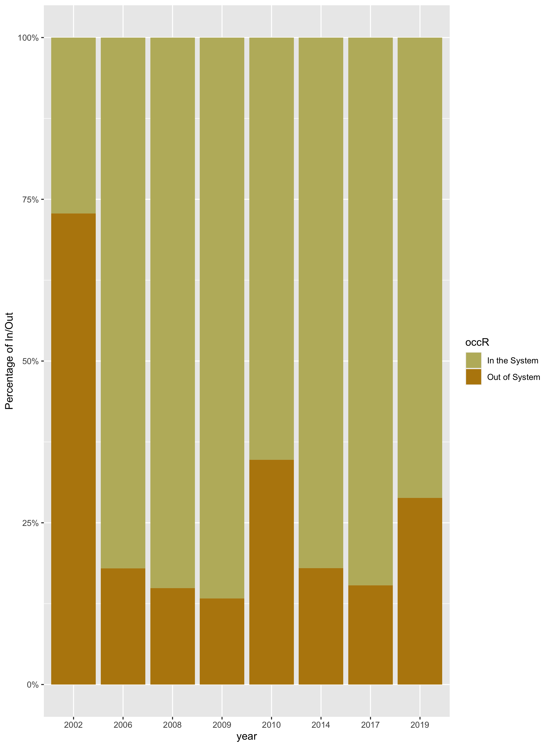

|  |  |  |  |
| --- | --- | --- | --- |
| year | occR | trust_gover | number |
| 2002 | 0 | 0 | 47 |
| 2002 | 0 | 1 | 383 |
| 2002 | 1 | 0 | 101 |
| 2002 | 1 | 1 | 1045 |
| 2006 | 0 | 0 | 193 |
| 2006 | 0 | 1 | 3941 |
| 2006 | 1 | 0 | 45 |
| 2006 | 1 | 1 | 860 |
| 2008 | 0 | 0 | 704 |
| 2008 | 0 | 1 | 2321 |
| 2008 | 1 | 0 | 129 |
| 2008 | 1 | 1 | 424 |
| 2009 | 0 | 0 | 121 |
| 2009 | 0 | 1 | 3053 |
| 2009 | 1 | 0 | 24 |
| 2009 | 1 | 1 | 473 |
| 2010 | 0 | 0 | 466 |
| 2010 | 0 | 1 | 2450 |
| 2010 | 1 | 0 | 205 |
| 2010 | 1 | 1 | 1347 |
| 2014 | 0 | 0 | 556 |
| 2014 | 0 | 1 | 2121 |
| 2014 | 1 | 0 | 143 |
| 2014 | 1 | 1 | 473 |
| 2017 | 0 | 0 | 486 |
| 2017 | 0 | 1 | 4788 |
| 2017 | 1 | 0 | 72 |
| 2017 | 1 | 1 | 896 |
| 2019 | 0 | 0 | 298 |
| 2019 | 0 | 1 | 2495 |
| 2019 | 1 | 0 | 99 |
| 2019 | 1 | 1 | 1053 |

