老板扫码



<https://s6.jpg.cm/2022/04/18/L9T2E5.png>

[![L9T2E5.png]([https://s6.jpg.cm/2022/04/18/L9T2E5.png)](https://imagelol.com/image/L9T2E5](https://s6.jpg.cm/2022/04/18/L9T2E5.png)%5d(https://imagelol.com/image/L9T2E5))

GcoreV2

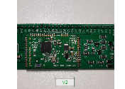

<https://s6.jpg.cm/2022/04/18/L9aItE.jpg>

[![L9aItE.jpg]([https://s6.jpg.cm/2022/04/18/L9aItE.jpg)](https://imagelol.com/image/L9aItE](https://s6.jpg.cm/2022/04/18/L9aItE.jpg)%5d(https://imagelol.com/image/L9aItE))

GIK87

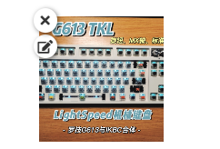

<https://s6.jpg.cm/2022/04/18/L9aqUS.jpg>

[![L9aqUS.jpg](https://s6.jpg.cm/2022/04/18/L9aqUS.jpg)](https://imagelol.com/image/L9aqUS)

按键转旋钮模块

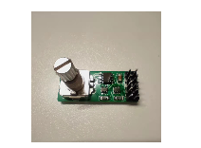

<https://s6.jpg.cm/2022/04/18/L9apFD.jpg>

[![L9apFD.jpg](https://s6.jpg.cm/2022/04/18/L9apFD.jpg)](https://imagelol.com/image/L9apFD)

RGB控制模块V1

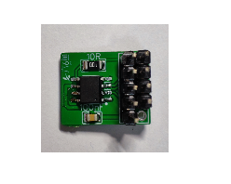

<https://s6.jpg.cm/2022/05/12/LDAHC4.jpg>

[![LDAHC4.jpg](https://s6.jpg.cm/2022/05/12/LDAHC4.jpg)](https://imagelol.com/image/LDAHC4)