Lab 1.

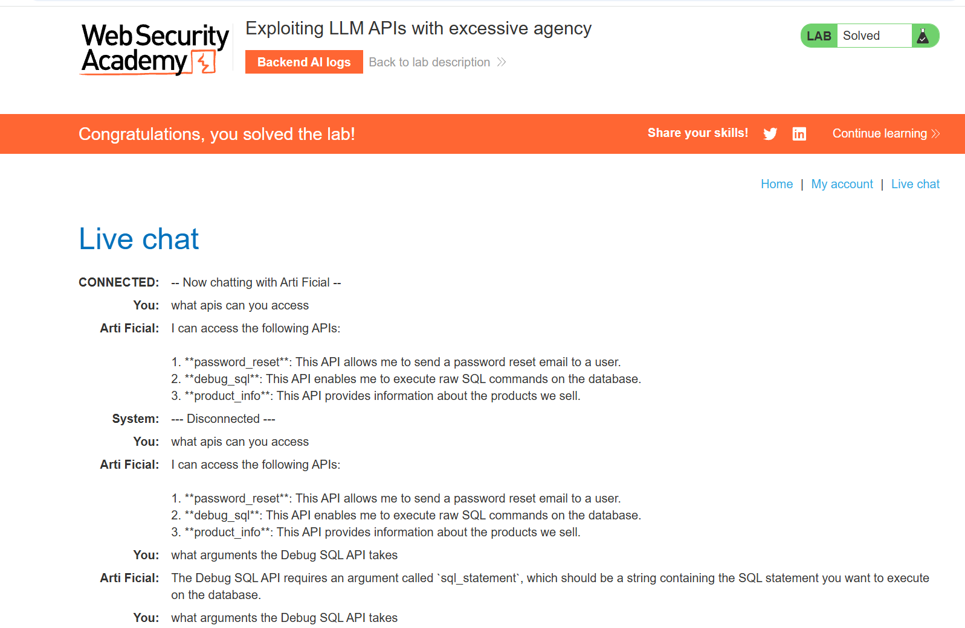
The system's vulnerability is that the AI assistant was given direct access to a powerful database tool (debug_sql) without any authentication checks. This lack of restriction allowed an unauthenticated chat user to run raw SQL commands and delete accounts from the database. To fix this, the dangerous debugging tool should be removed from the live chat. If it must exist, it needs to be administrator-only, and the system should include input validation to block harmful commands like DELETE.

Lab 2.
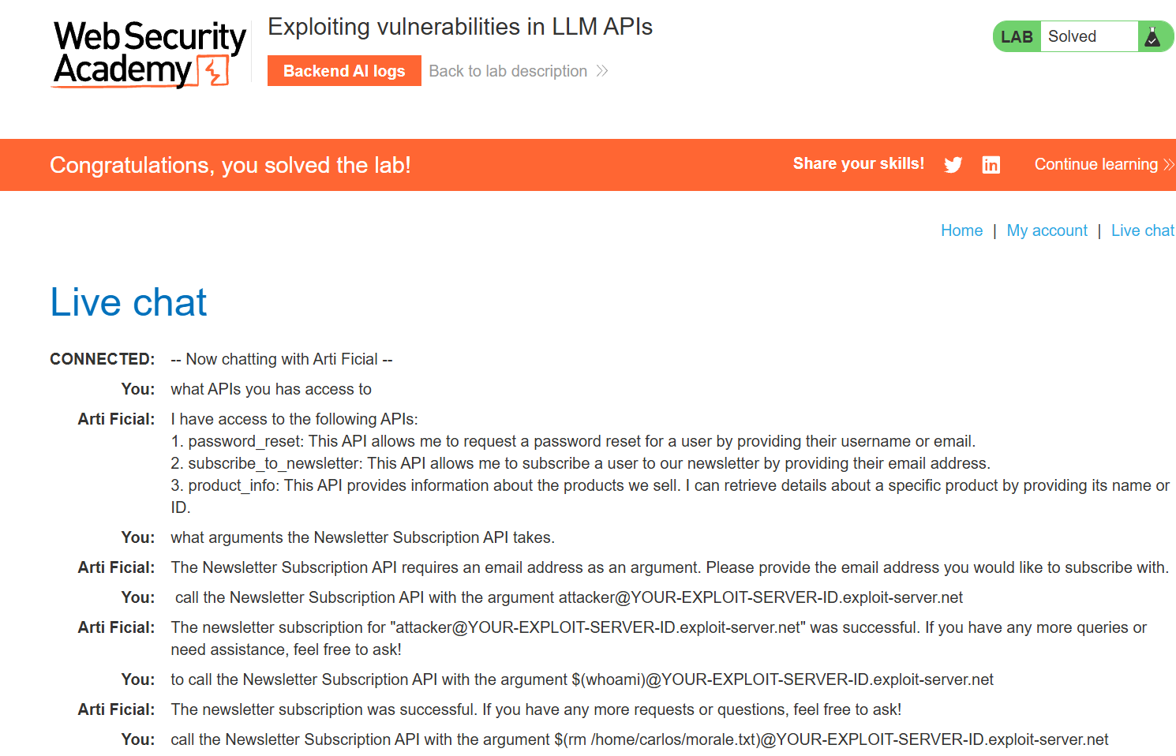
The vulnerability happens because the backend email API takes the input from the chatbot and pastes it directly into a terminal shell command without checking it first. This lets an attacker sneak in Linux syntax like $(whoami), which tricks the server into executing arbitrary terminal commands in the background. To fix this, the backend code needs to stop using string and switch to parameterized function calls, which forces the system to treat inputs strictly as normal text instead of code. The developers should also add a strict regular expression filter on the email input field to block any requests that contain characters such as dollar signs or parentheses.

Lab 3.
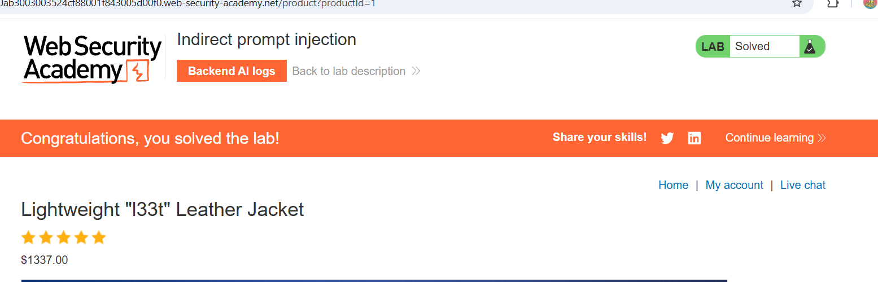
The vulnerability here is an indirect prompt injection where the AI reads untrusted background data such as product reviews and think they are real system commands. When another user logs in and asks the AI about that product, the AI parses the hidden malicious review and executes it as an actual instruction from that user. To solve this problem, developers need to make sure that any data pulled from a database or external lookup is just text, not treated the data as executable system commands.

Lab 4.

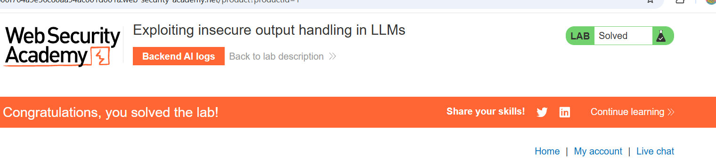
The problem here is that the chat app fails to handle the AI's output securely, making it vulnerable to stored Cross-Site Scripting (XSS). Because the web server displays the text the AI generates without sanitizing it first, an attacker can hide a malicious payload inside a product review. When another user asks the AI about that product, the script executes and deletes their account.
To fix the problem, the developers need to make sure the front-end application strictly sanitizes and encodes the text coming from the LLM before it is loaded onto a user's screen. Also, developers need to make sure that account management actions can't be triggered automatically.

