CSC 631

Multi-Players Game Design

HW3

Reflection

Zhuojun He

909688525

Feb, 27, 2020

**Table of Contents**

**Description -------------------------------------------------------------------2**

**Goals Accomplish -----------------------------------------------------------3**

Object a **--------------------------------------------------------------------3**

Object b **--------------------------------------------------------------------4**

Object c **--------------------------------------------------------------------5**

Object d **------------------------------------------------------------------- 6**

Object e **------------------------------------------------------------------- 6**

Object f **-------------------------------------------------------------------- 7**

Object g **------------------------------------------------------------------- 8**

Object h **--------------------------------------------------------------------8**

**Summary and Improvement ---------------------------------------------9**

**Description:**

It seems my group mate all start doing hw2 individually, everyone has their own version of hw2, so we didn’t integrate everything together. I keep asking please share your hw2 on GitHub or somewhere, but I didn’t get any post except me. (<https://app.slack.com/client/TTM2RTXM3/CTAT2BQD7>)

Our next group meeting is on this Friday, I don’t know, maybe we will teach each on that day? Not sure. But anyway, I deceive to start writing the refection earlier because the due day is on Friday. I attached my second version of 2Dshooter. I learnt and teach by myself. It basically contains all the objectives you need, except the d. particle effects.

**Goals Accomplish:**

1. Make camera move (i) behind of object as the object moves (like the cube) and (ii) a top down view that looks down the whole scene and switch between (i) and (ii) should be done by key input.

You can change the camera now by pressing “c” or “space” in my app. This is the new feature I added in my second version. In this part of homework, I learn some major compound about the camera such as Audio Listener which charging which camera is in use. And you only can active one camera in a scene at a time. By creating two cameras in two different position and adjusting a good angle for both and them. Then you will need to create a camera switching script. It basically by trigger these two cameras on and off by turning its “Audio Listener” and “SetActive” compound Ture or False to switch them.

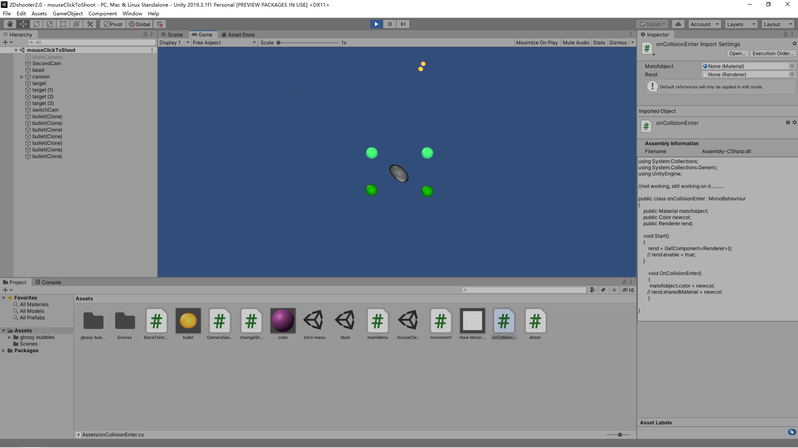

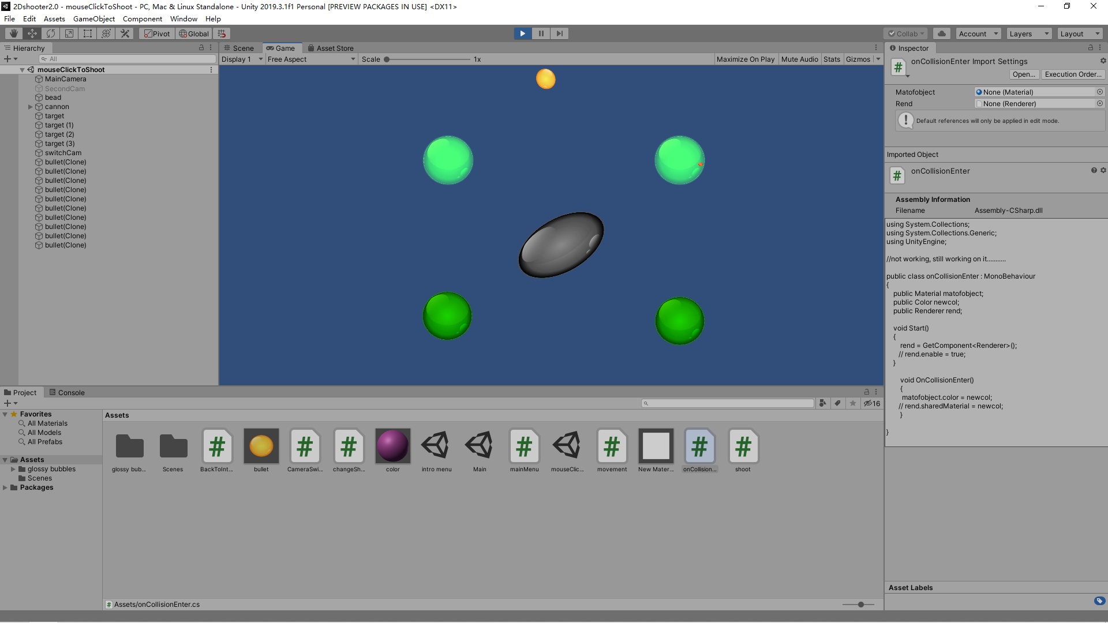

b. Demonstrate that you can add texture and shading effects on the objects in the scene and change them with button clicks.

Using key: 1, 2, 3, 4, 5 to change shading. This feature is done on the first version already. I generally download some texture asset online and drag it on the object I need to plain. What’s more, we can also right click to create new material on the project fold, then adjust the parameter of it and apply this same material on to group of different objects. Changing their sharing effect with a button, we need to create a script within the target object, then access to its “object.material.shader” element to modify its value. For example,

if (Input.GetKeyDown(………))

object.material.shader = ……….

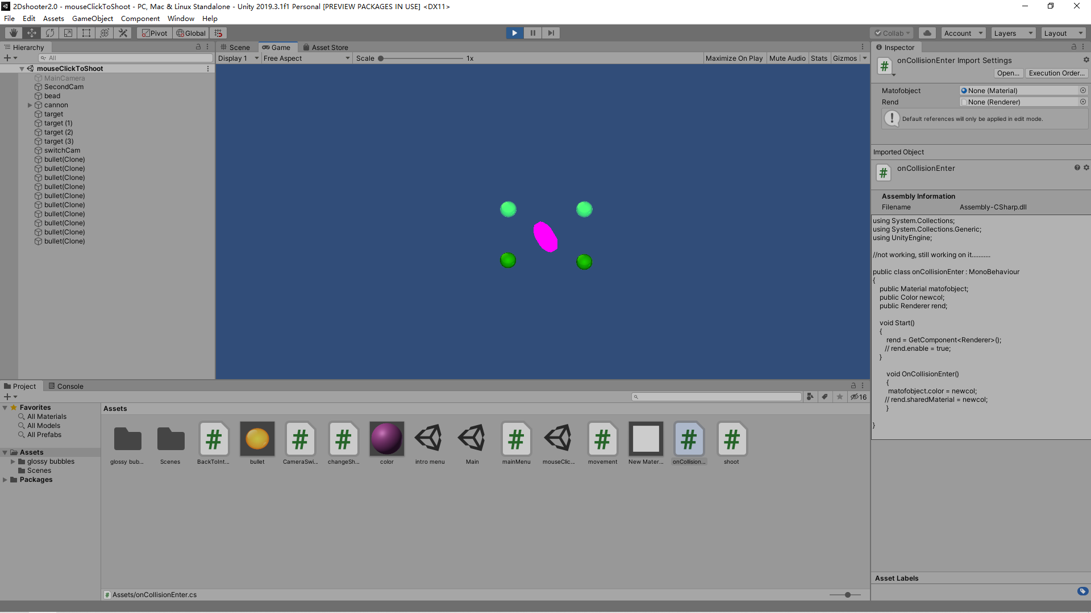

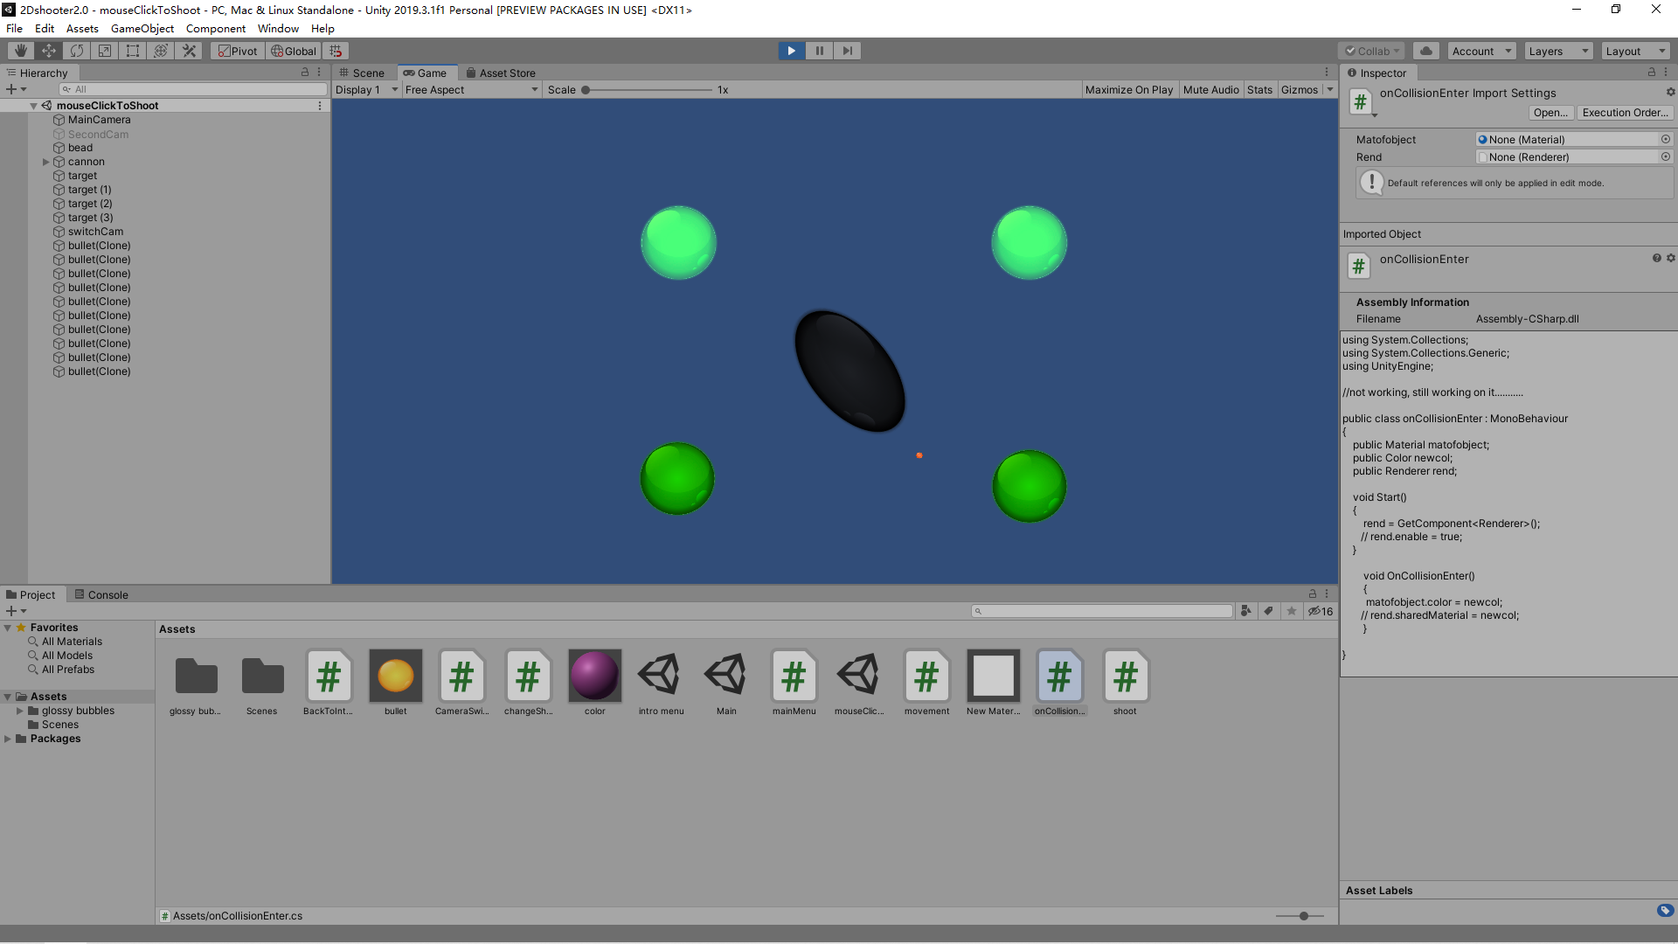

c. Demonstrate that your objects can respond to collision (and physics properly) and add special effects as a consequence of collision.

Targets and bullets will have collision effect. I learnt the two major elements to handle collision is the rigidbody and collider. You almost have a good collision if you add these two components into you target two objects which want to has collision effect. Of course, you need to adjust some of the parameter in it for example, do you need the gravity, change to body type to Kinematic to make it stable etc. If you want to add more effect on the collision, you need to write your own OnCollisonEntry method in a new script. You may find I tried to write my own OncolisonEntry script to try to change the object’s color when collier. However, it doesn’t success. I am still struggle on that. What I think is maybe I didn’t access the correct color element correct. Is it “object.material.color” ?

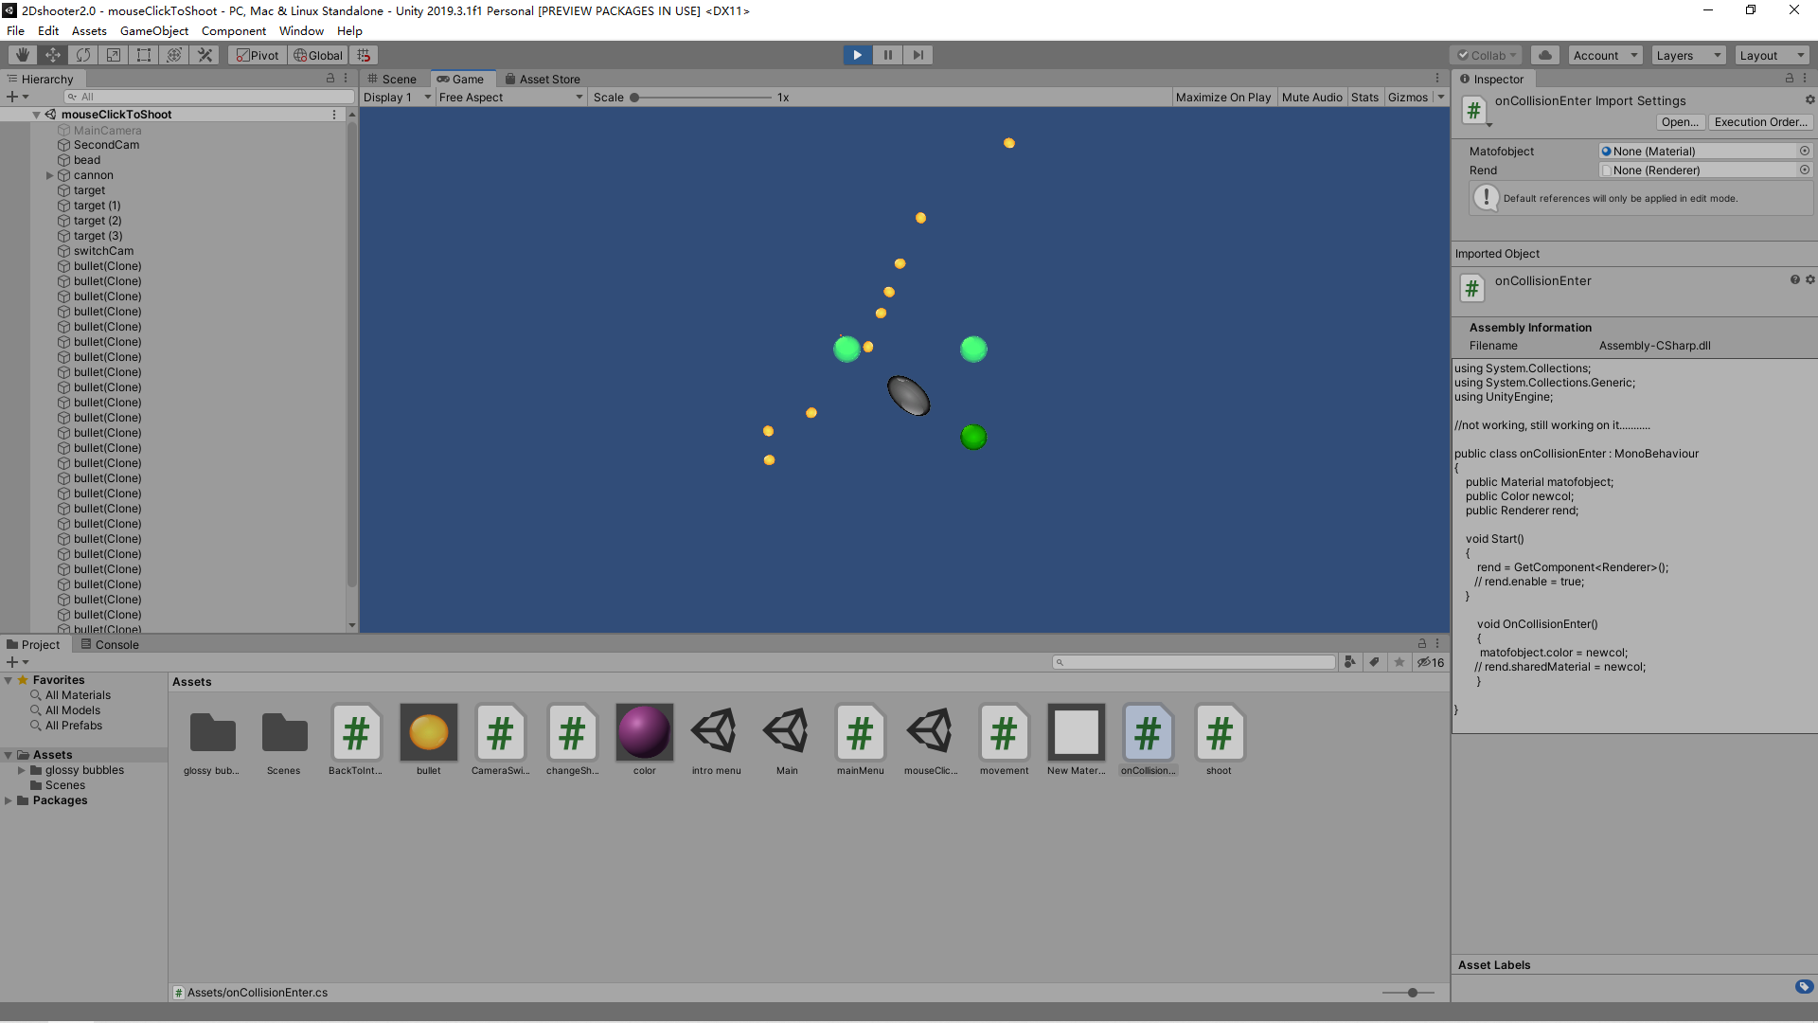

d. Add particle effects something like this -- <https://www.youtube.com/watch?v=xenW67bXTgM>

All right, I skip this part. The video you provide is hard to follow and understand. It is kind of doing a chemistry experiment. The author keeps create different new material and try to mix them together to get a new product. I am totally loss how the chain goes through. You maybe want to learn how to create a new material using the method from the video. But what I think maybe easier is just download the material or particle effect we need from the asset store, then drag and use it directly onto the object just the material skin.

e. A button makes a scene transition (so you should make at least 2 scene)

You can click the play button to enter the game in the intro scene and push “Esc” button to go back to the intro scene when you are in the game. Again, this is another new feature I add in my game. I learnt how to apply “UnityEngine.SceneManagement” in my script to change different scene. In addition, we should setup an index of each scenes by adding our scenes in the build setting menu.

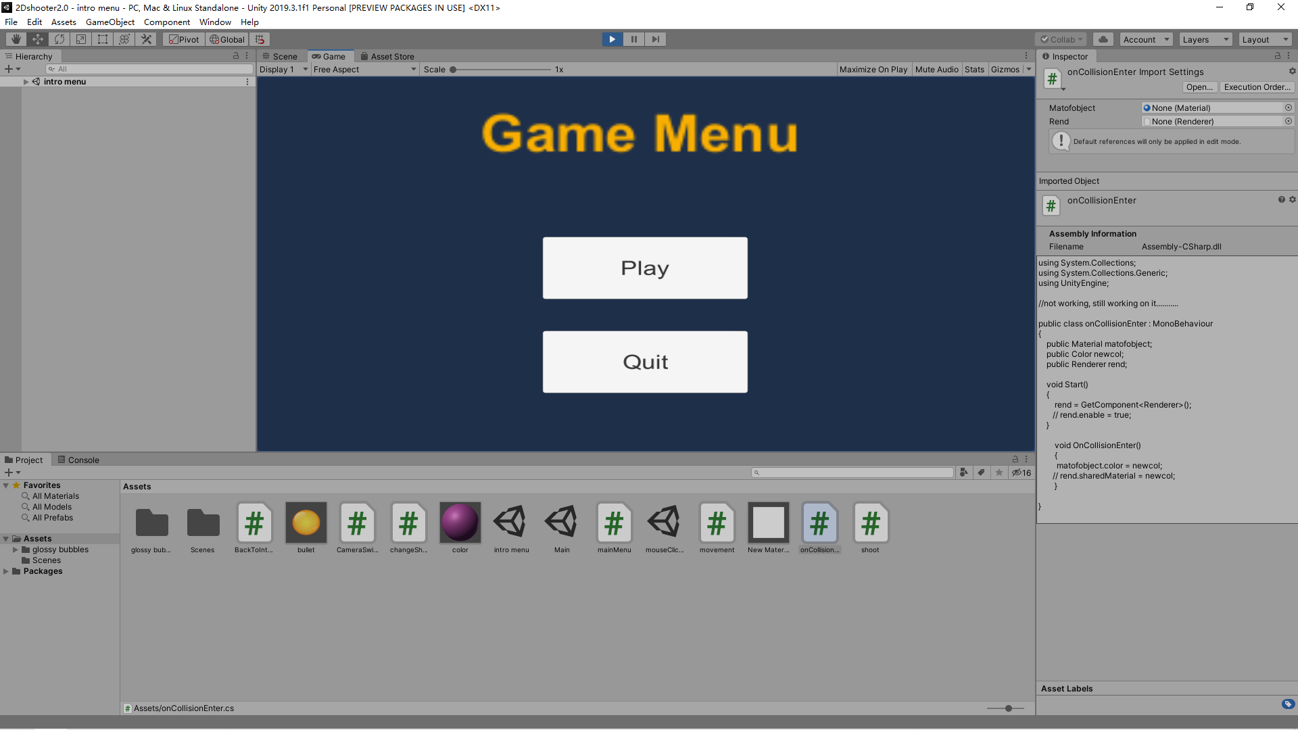

f. A button activates simple character animation

Player can be moved by pushing “W, A, S, D” keys. I learnt the simple object movement script from the homework 1 by just adding force on the object. (the car game). Maybe it is not you want…. It is different than what you teach last class. Maybe I should create some new animation by having a chain map of different status. Still need to learn about it later.

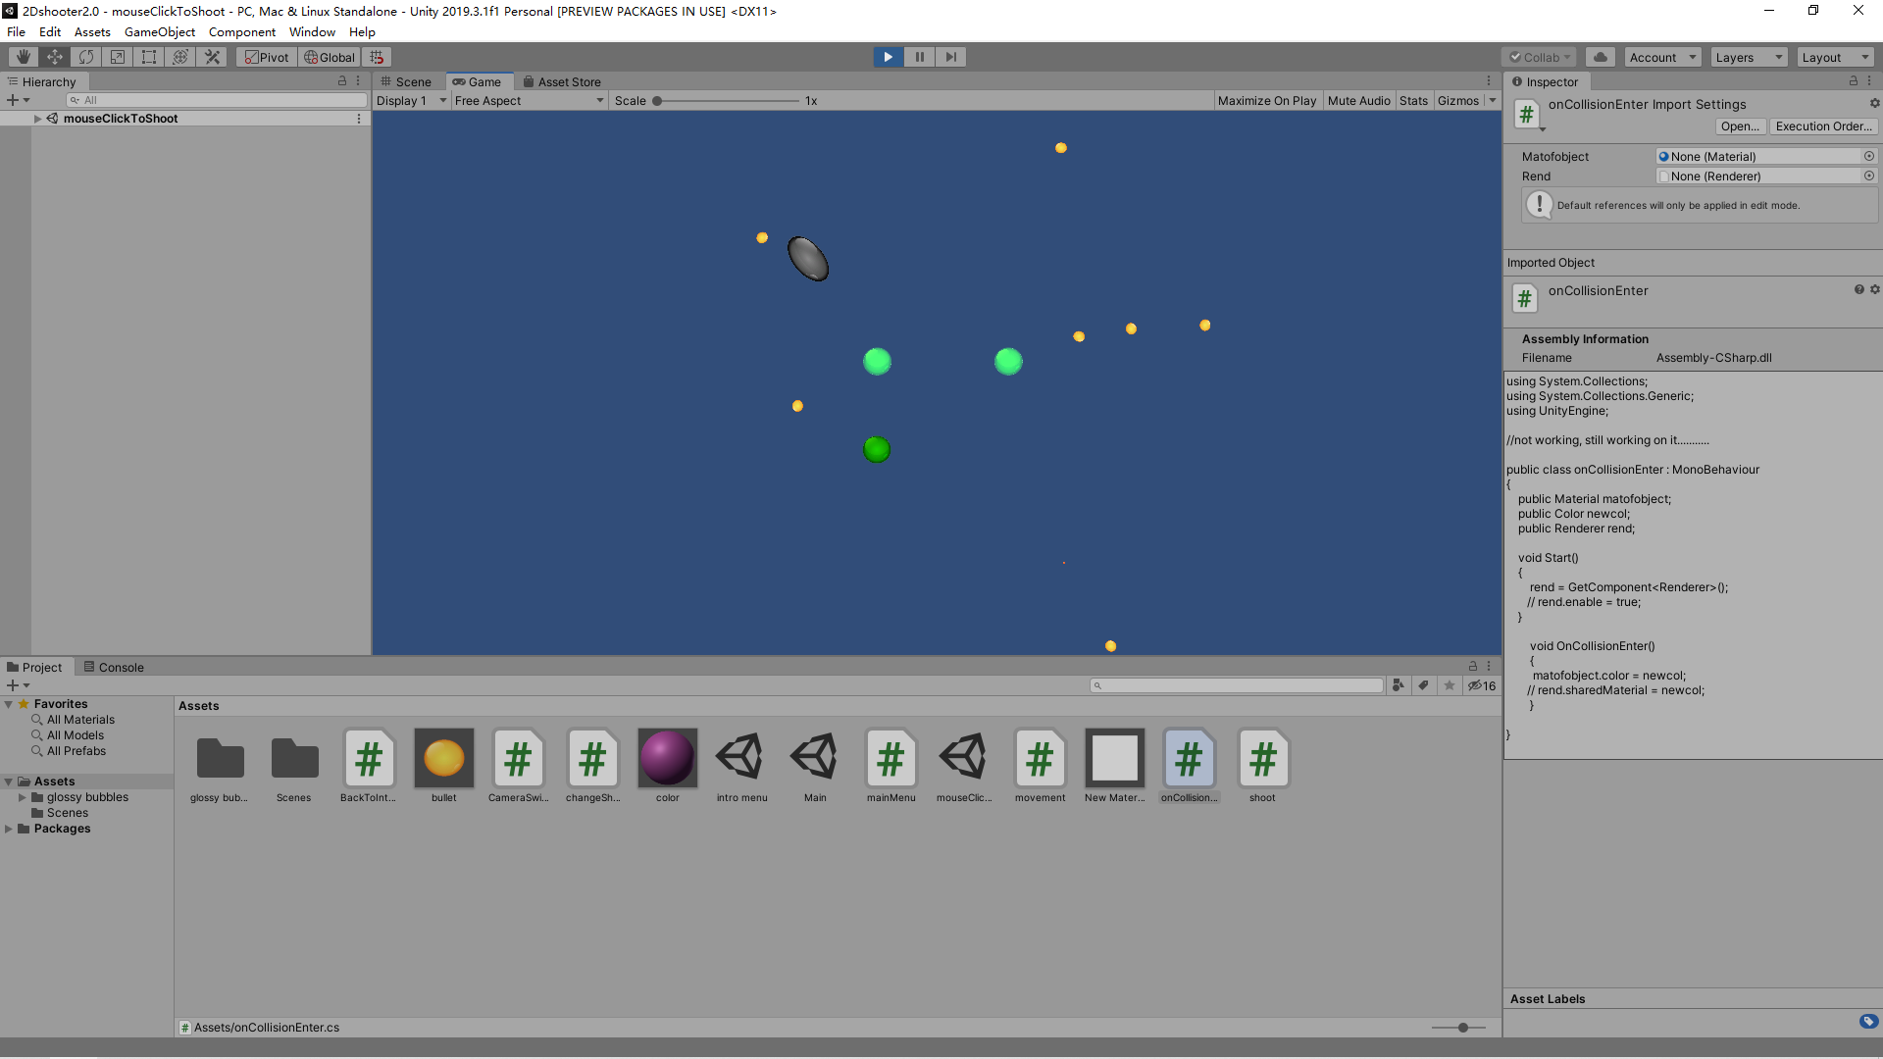

g. A button changes shading effect (day to night scene or something else)

I am not very sure what’s the different between this and goal b.

Using key: 1, 2, 3, 4, 5 to change shading.

h. Mouse click picks up an object or creates (instantiates) an object in a scene

Player can shoot along with the cursor. I found the front sign moving along with the cursor is difficult, there are a lot of angle calculation which I still don’t really understand. Honestly, I just copy the tutor’s code for this part.

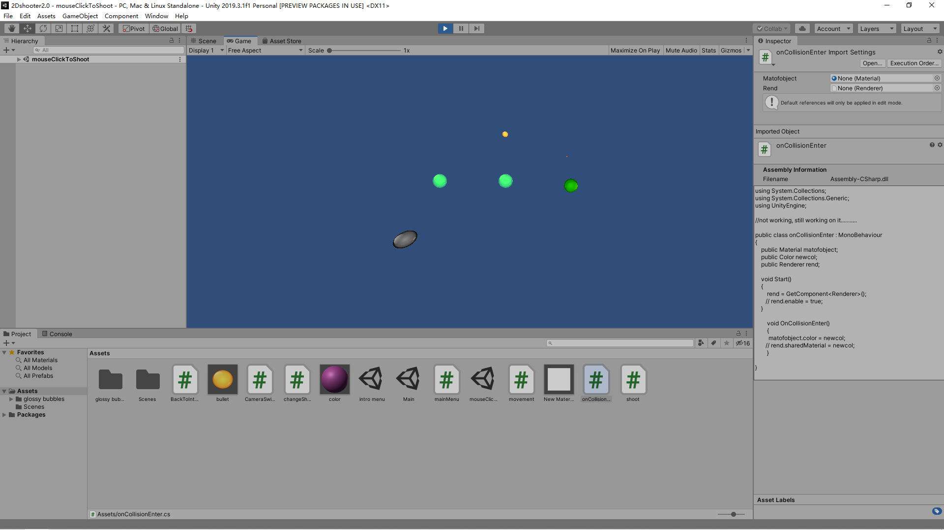

**Summary and Improvement**

I learnt a lot of different subjects during this assignment. For example, how to change a camera from First person view to Third person view, how to change different shader of a object. How to access different element in the material class, how to handle collision and different scenes, creating new materials and new animation and so on. What I think to improve is I need more practice on all this knowledge. I think I will try to do this on 3D model which can make my game more fun and vivid.