Software Requirements Specification

September 6, 2023

Online Bookstore (OB)

Zhuofan Huang

zhuang21@umd.edu

zhuang21

**Table of Contents**

1.0. Description 1

1.1. Overall Description 1

1.2. Detailed Description 2

2.0. Use cases 3

2.1 User use case 3

2.2 Administrator use case 4

**List of Figures**

Figure 1 – Basic Structure 1

**1.0. Description**

**1.1. Overall Description**

The OB application is a web-based platform that allows users to browse, search for and order books online. It serves as a convenient way for users to access a vast catalog of books with detailed information. Additionally, the OB application provides features to improve user interaction and ensure a pleasant shopping experience. Moreover, the OB system includes an administrative panel for managing book inventories, user accounts, and orders.

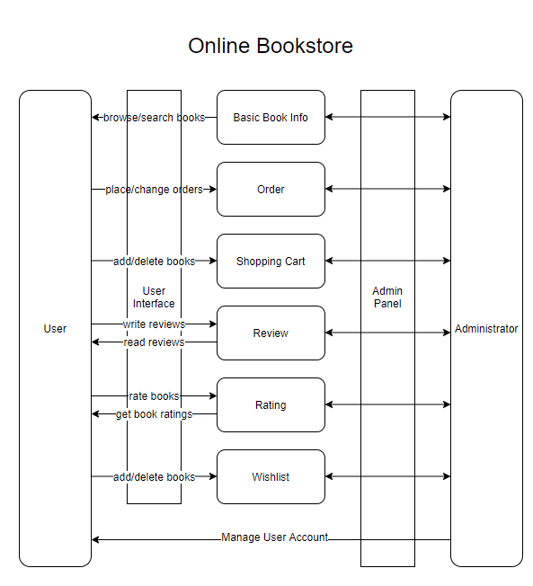

Figure 1 – Basic Structure

## 1.2. Detailed Description

The OB application allows user to create and manage accounts. User can create accounts with name, e-mail address and password.

The OB application have a book catalog which can be organized by categories, genres, authors, or other relevant criteria. User can search for books with title, author, genre or keywords. Books can be displayed with details, including the title, author, cover image, description, average rating and user reviews.

Users can add books to their shopping cart and wishlist while browsing the catalog. The shopping cart displays the added books’ titles, quantity, each book’s price and the total price. Users can update the quantity of books and remove books in the cart. The OB application can calculate shipping costs and taxes in the cart. Users can add or delete books from wishlist.

Users can leave ratings and reviews for the books they have purchased or read. Average rating and reviews can be viewed in book details.  
 The administrator can use administrative panel to add books, see book information, change book information.

**2.0. Use cases**

## 2.1 User use case

Use case: **Registration**

**Brief Description**

A user wants to create an account to access the full features of the online bookstore application.

**Step-by-Step Description**

1.The user visits the online bookstore website.

2.The user clicks on the "Sign Up" button.

3.The system presents a registration form where the user enters their name, email address, and password.

4.The user submits the form.

5.The system validates the user's information and creates a new account.

6.The user receives a notification that their account has been successfully created.

Use case: **Book Search and Browsing**

**Brief Description**

A user wants to find a specific book or explore books based on their interests.

**Step-by-Step Description**

1.The user enters keywords, author name, or book title in the search bar.

2.The system displays search results matching the query, including book titles and cover images.

3.The user selects a book from the search results or navigates through different book categories or genres.

4.The system presents the book's details, including the title, author, cover image, price, description, and average rating.

5.The user can read reviews and ratings left by other users.

6.The user can add the book to their shopping cart or wishlist if interested.

Use case: **Adding Books to the Shopping Cart**

**Brief Description**

A user wants to add one or more books to their shopping cart for purchase.

**Step-by-Step Description**

1.The user clicks on the "Add to Cart" button on the book's detail page.

2.The system adds the selected book to the user's shopping cart.

3.The system displays a notification confirming the successful addition of the book to the cart.

4.The user can continue browsing and add more books to the cart or proceed to the checkout process.

## 2.2 Administrator use case

Use case: **Managing Book Inventory**

**Brief Description**

The administrator wants to manage the book inventory of the OB application.

**Step-by-Step Description**

1.The administrator logs into the admin panel.

2.The administrator navigates to the "Manage Book Inventory" section.

3.The administrator can search for books, filter by various criteria, or view the complete inventory.

4.The administrator can add new books to the inventory by entering the book details, such as title, author, description, cover image, and price.

5.The administrator can update existing book information, such as price, availability, or description.

6.The administrator can mark books as obsolete or out of stock, removing them from the available inventory.

7.The system updates the book inventory accordingly, reflecting the changes made by the administrator.