Application Design Specification

September 6, 2023

Online Bookstore (OB)

Zhuofan Huang

zhuang21@umd.edu

zhuang21

**1. Purpose**

The purpose of this document is to outline the design specifications for the development of an online bookstore application.

**2. System Overview**

The online bookstore system aims to provide a user-friendly platform for users to browse, search, and purchase books online.

**3. System Architecture:**

1. Presentation Layer: ASP.NET Web Application with user interfaces for browsing books, managing the shopping cart, and placing orders.

2. Business Logic Layer: Contains the core business logic and rules for processing orders, managing inventory, and user authentication.

3. Data Access Layer: Manages data persistence and interacts with the underlying database.

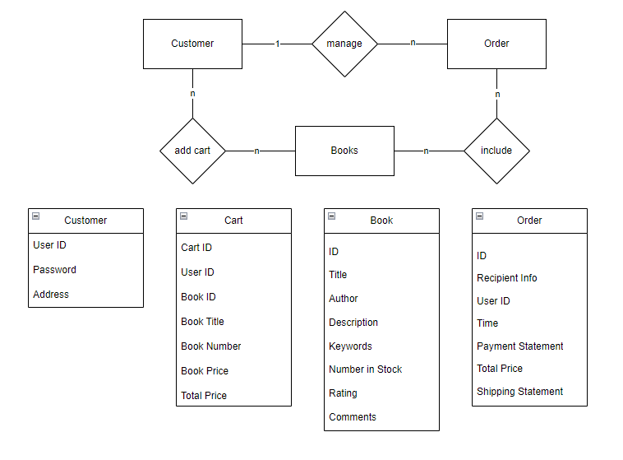

Figure.1

**4. Functional Requirements:**

1. User Registration and Authentication:

Users should be able to register an account with the system using their email address and password.

2. Book Search and Browsing:

Users should be able to search for books based on titles, authors, genres, or keywords.

The system should provide filtering and sorting options to help users refine their search results.

Users should be able to view detailed information about each book, including title, author, description, cover image, price, and average rating.

3. Shopping Cart and Checkout:

Users should be able to add books to their shopping cart and manage the cart contents.

The system should calculate the total price, including taxes and shipping charges, for the items in the shopping cart.

Users should be able to proceed to the checkout process, enter shipping and billing information, and complete the purchase securely.

4. User Reviews and Ratings:

Users should be able to leave reviews and ratings for books they have purchased or read.

The system should display average ratings and user reviews on book detail pages.

**5. User Interface Design:**

The user interface should have an intuitive and user-friendly design, with clear navigation and responsive layout for different screen sizes.

The design should prioritize readability and accessibility, ensuring that users can easily browse and interact with the application.

Visual elements, such as book cover images and icons, should be used to enhance the user experience and make the application visually appealing.

**6. Application Software Components:**

Customer Management Component: Manages customer profiles, authentication.

Book Catalog Component: Handles book information, including title, author, ISBN, price, and description. Supports searching, filtering, and sorting functionalities.

Shopping Cart Component: Tracks the books selected by the customer, manages quantities, and calculates the total amount.

Order Management Component: Processes customer orders, generates order IDs, and manages order status updates.

**7.Application Software UI Components:**

The online bookstore application's user interface includes the following components:

Homepage: Displays featured books, promotions, and navigation links.

Book Listing Page: Presents a list of books with details and options to add them to the shopping cart.

Shopping Cart Page: Shows the selected books, quantities, and total amount. Allows customers to modify the cart contents.

Checkout Page: Collects customer shipping and payment information to complete the order.

**8.Application Data Components:**

The online bookstore application utilizes the following data components:

Book Table: Stores book information such as BookID, Title, Author, ISBN, Price, and Description.

Customer Table: Contains customer details like CustomerID, Name, Email, and Address.

Order Table: Holds information about orders, including OrderID, OrderDate, and TotalAmount.

OrderItem Table: Stores the relationship between orders and the books they contain, including OrderItemID and Quantity.