The implementation of our application

(The code follows the idea of the given example in the workshop7-8.1)

This application uses **point to point communication** (supported by MPI/mpi4py module) to achieve the parallelization. The main idea is, if there are n processes running, each process should only process $\frac{1}{n}$ tweets and let one of the processes (master) gather all the result from other processes (slaves).

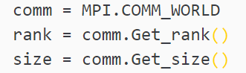Each process would know how many processes there are and whether it is a master or a slave through:

Every process uses serial numbers generated during file reading, processes size, and its rank to determine if this tweet belongs to it to process:

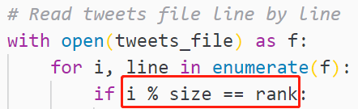

Once the master process finished its own task, it would gather results from other slave processes by sending a ‘return_data’ signal to all other slave processes and kill them by sending an ‘exit’ signal when it receives all results successfully.

The whole process can be generalized as:

|  |  |  |
| --- | --- | --- |
| Sequence | Master | Slave |
| 1 | Get rank, size, and process tweets | Get rank, size, and process tweets |
| 2 | Send ‘return_data’ signal | Receive ‘return_data’ signal |
| 3 |  | Send processed result |
| 4 | Receive and process all the results |  |
| 5 | Send ‘exit’ signal, Print results | Receive ‘exit’ signal |
| 6 | Finished | Finished (exited) |

Spartan submitting scripts

The application should be running under the environment of foss/2018b and python/3.7.4, with number of nodes and cores being specified separately in three .slurm files.

