|  |
| --- |
| **SOUTHERN CROSS UNIVERSITY** |

**ASSIGNMENT COVER SHEET**

For use with online submission of assignments

Please complete all of the following details and then make this sheet the **first page of each file of your assignment – do not send it as a separate document.**

Your assignments must be submitted as either **Word documents, text documents with .rtf extension or as .pdf documents**. If you wish tosubmit in any other file format please discuss this with your lecturer well before theassignment submission date.

|  |  |
| --- | --- |
| Student Name: | **Hongqing Q** |
| Student ID No.: | **23812042** |
| Unit Name: | **Designing the User Experience** |
| Unit Code: | **PROG2006** |
| Tutor’s name: | **Yunzhong Liang** |
| Assignment No.: | **Assignment 3** |
| Due date: | **2022/4/20** |
| Date submitted: | **2022/4/20** |

Declaration:

*I have read and understand the Rules Relating to Awards ([Rule 3 Section 18 – Academic Misconduct Including Plagiarism](http://policies.scu.edu.au/view.current.php?id=00140" \l "s18)) as contained in the SCU Policy Library. I understand the penalties that apply for plagiarism and agree to be bound by these rules. The work I am submitting electronically is entirely my own work.*

|  |  |
| --- | --- |
| Signed:  (please type your name) | Hongqing Qu |
| Date: | 2022/4/20 |

**[Plane adventure]**

**Design Documentation**

By [Hongqing Qu]

Table of Contents

[Team name 1](#_Toc29222)

[Storyboards 1](#_Toc30870)

[Dimensions: 1](#_Toc4521)

[Media Used: 1](#_Toc1400)

[Buttons: 1](#_Toc24681)

[Background: 2](#_Toc4652)

[Dimensions: 2](#_Toc17422)

[Media Used: 2](#_Toc27670)

[Buttons: 2](#_Toc16739)

[Mood board 3](#_Toc1536)

[evidence of your team assigning the menu and navigation tasks ,evidence of participation in the development of the menu 3](#_Toc5637)

[evidence of participation in the development of the overall project discussing UX principles and encouraging others to participate 5](#_Toc25539)

[6](#_Toc23001)

# Team name

Study groups of four

# Storyboards

**Title**:Plane adventure **Frame ID**: *1.3*

## **C:\Users\q1556\Desktop\8987f3c965d910d51ae15ad5535833a.png8987f3c965d910d51ae15ad5535833aDimensions:**

**This scene shows most of the game content, including the main character and background.**

## **Media Used:**

**SOUNDS**

**Plane: a 'deng' sound will appear when the plane receives gold.**

**FONTS**

**The upper left and upper right corner have suggestive text and are displayed in bold.**

**Passing through the page will show 'pass' in bold green.**

**The failure page shows' Fail 'and is highlighted in bold red.**

**IMAGES**

**The model aircraft was created by himself.**

**The billboard in the background was found on the web.**

**The main page uses photos found on the web and adds its own elements.**

**Color**

**The main colors are background white, brown, red, yellow.**

**The color is black, red and green.**

## **Buttons:**

**Four buttons have been added to the home page, each corresponding to the games of the four team members.**

**In the game page, there is an exit button in the lower right corner to return to the main page.**

**On the passed page, there are buttons to restart the game and return to the main page.**

**On the failed page, there are buttons to restart the game and return to the main page.**

## **Background:**

With the development of fast times, games have become the first choice for people to relax and entertain themselves. At the same time, the game should be playable, enjoyable and short-term. With this in mind, I created the game Airplane Adventure. The background is a beautiful city, easy to use, high playability and short time.

In this game, you operate planes to collect gold coins. To give you a better experience, you can use the mouse to see planes and backgrounds from different angles. WSAD keys are front, back, left, and right, and QE keys are up and down. One point is added for each coin collected for 30 seconds. Each coin is in a different place. The playthrough screen will show you the playthrough and you can return to the main menu or restart the game. When you don't reach 5, a failure screen appears and you can return to the main menu or restart the game. You can also go straight to the game's main menu. You can see the countdown in the upper left corner, your score in the upper right corner, and the exit button in the lower right corner.

**Title**:The main menu **Frame ID**: *1.0*

## **C:\Users\q1556\Desktop\beab5299fc20c34886f716a254f689d.jpgbeab5299fc20c34886f716a254f689dDimensions:**

**This scene shows t**he main menu.

## **Media Used:**

**SOUNDS**

**No sound**

**FONTS**

**The font for each button is bold.**

**IMAGES**

**The main page uses photos found on the web and adds its own elements.**

**Color**

The main colors are background white, blue, pink and green.

The word color is black.

**My task**

My task was to integrate and layout the page and merge the parts completed by other team members.

## **Buttons:**

**Four buttons have been added to the home page, each corresponding to the games of the four team members.**

# Mood board

# 

# evidence of your team assigning the menu and navigation tasks ,evidence of participation in the development of the menu

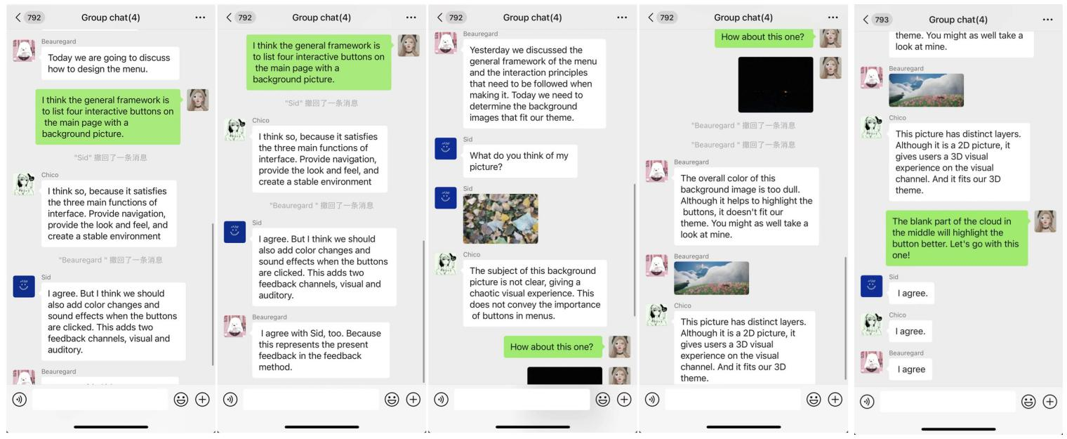

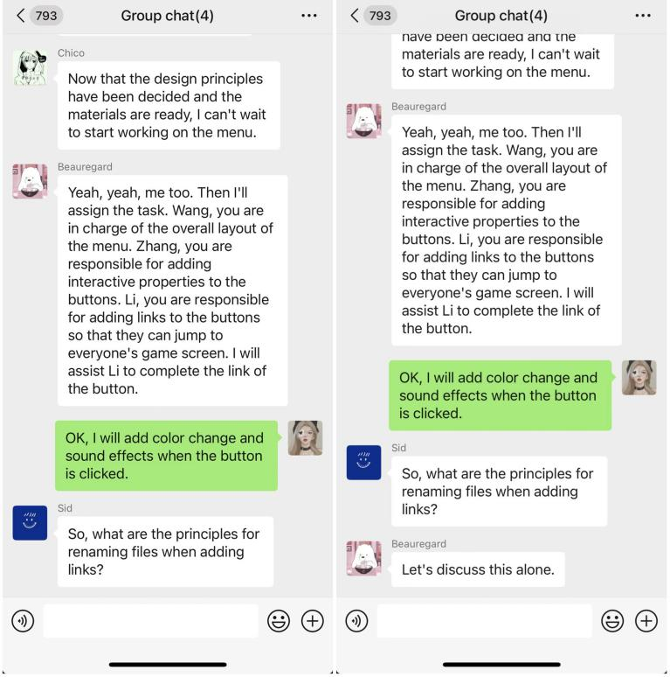

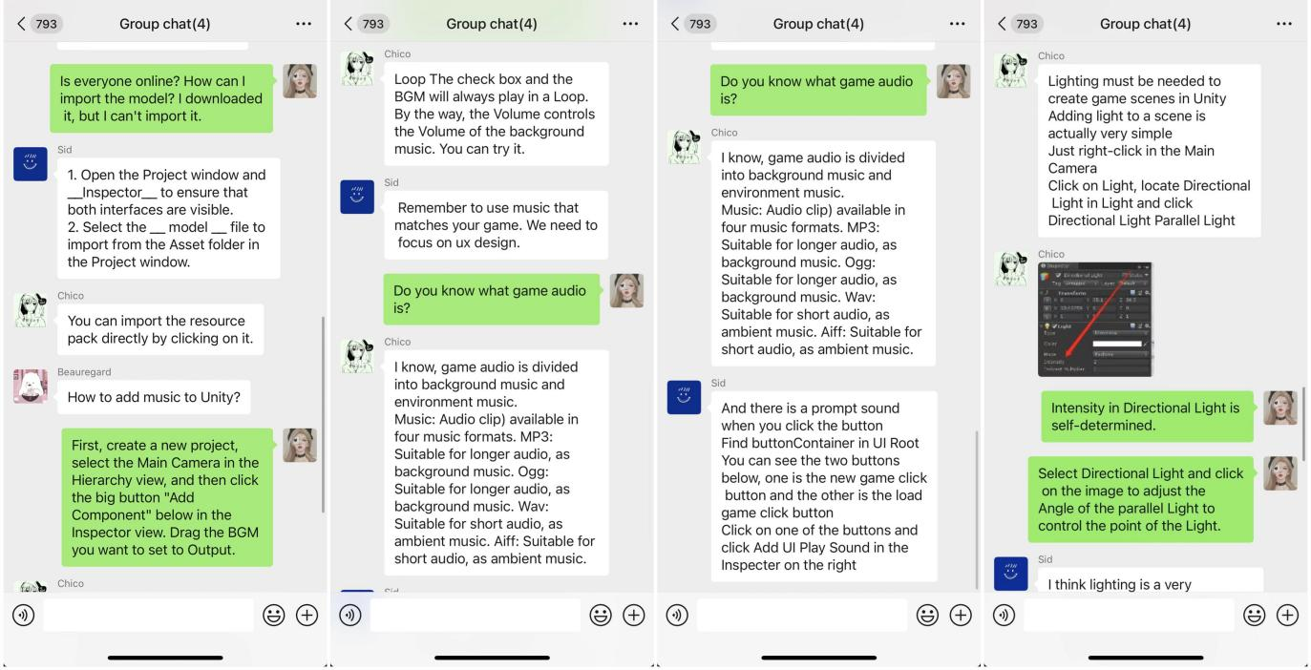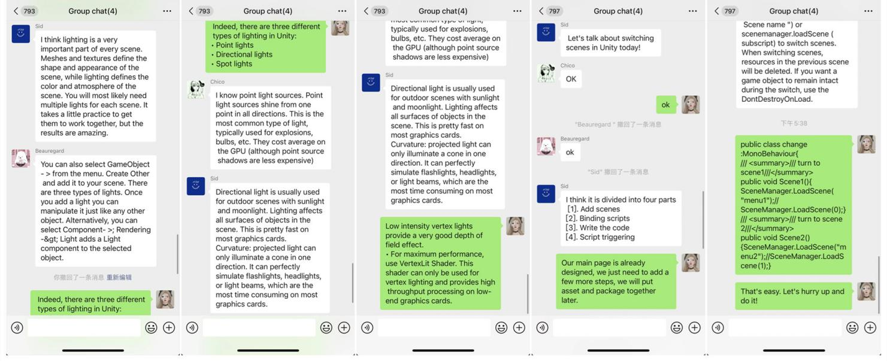

# 9b02cbdd859d9312c26050a3423867fe3e1ca5c0fbcd00472da2c100f187f0f211ac1441caf3c6e3dddcd2ad078e9evidence of participation in the development of the overall project discussing UX principles and encouraging others to participate

# 1_副本1_副本

# 9_副本