In the Milestone 3, we built high-fidelity prototypes of our restaurant ordering system. It includes a horizontal high-fidelity prototype of our overall ordering system, and two vertical prototypes of 2 main tasks, which are “Ordering Food” and “View Restaurant Statistic”. During making high-fidelity prototypes of ordering system, we make some changes from our low-fidelity prototypes.

In “Ordering Food” section, we have two main functions. One is “Combo Ordering”, the other one is “A La Carte Ordering”. In our low-fidelity prototypes, we plan to let customers to choose their customer type between “Fresh Customer” and “Frequent Customer” in the main page. In the Milestone 2, we received some suggestions from different people, one of interviewee called Meimei Li, she said that these two customers types selections will make customers confused. So we decided to cancel this page, let customers to choose if they want to get a combo or order food from a full menu. Another reason of cancelling this feature, it is because we think customer type selections are a redundant step, customers has ability to choose the ordering way that suitable for them, rigid divided customers type into two is not proper enough.

图片包含 屏幕截图

已生成极高可信度的说明

In the “Combo Ordering”, there are two combo options. One is “Fixed Combo”, there are three choices (it’s customizable, we can add more choices if the restaurant owner needs). Each choice has perfect match food: one meat dish, one vegetable dish and rice. The other combo type is “Optional Combo”. Customers need to select three dishes to combine it as a combo. There are more combinations can be made compare to “Fixed Combo” menu. We design “Fixed Combo” for people who know little about Chinese food, and “Optional Combo” is for people who don’t know much about Chinese food, but want to pick some dishes instead of getting the fixed combo. Each combo displayed by a picture, lets customers know the combo’s look. We also show the material will be used in the combo. It helps customers to know more about the combo, because some customer might not identify the material by looking at the picture. We also list common allergens in the combo, and the spicy level and total calories of the combo, it helps customers who sensitivity to food consumption to select a suitable meal. Then, we use a larger font to show the price of the combo. Customers can enter the quantity of food they need in the textbox. This information (dishes picture, material, common allergens, spicy level, calories and price) not only shows in “Fixed Combo” menu, but also shows in all types of menus, which include menus in “A La Carte Ordering” part. It’s one of the standard of our ordering system.

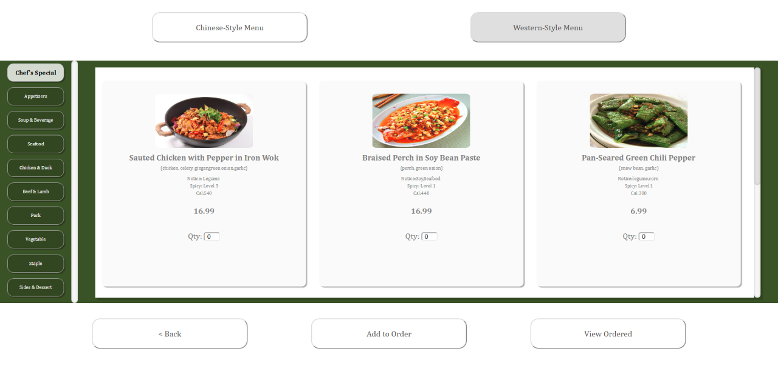

In the “A La Carte Ordering”, we provide two types of menus: Chinese-Style Menu and Western-style Menu. These two menus have same dishes, but we refer to customer’s habit to divide dishes in a different way. Dishes in the “Chef’s Special” category are recommended dishes for all customers, and these dishes are also restaurant’s specials. We use larger fonts for “Chef’s Special”, it’s for catching customers eye. Chinese usually eating main dishes first, then having some snacks and soup, that’s why we arrange food categories in that way. For occidental, they usually start with appetizers, then eating main dishes, having dessert in the end. Therefore, we arrange food categories for occidental in another way.

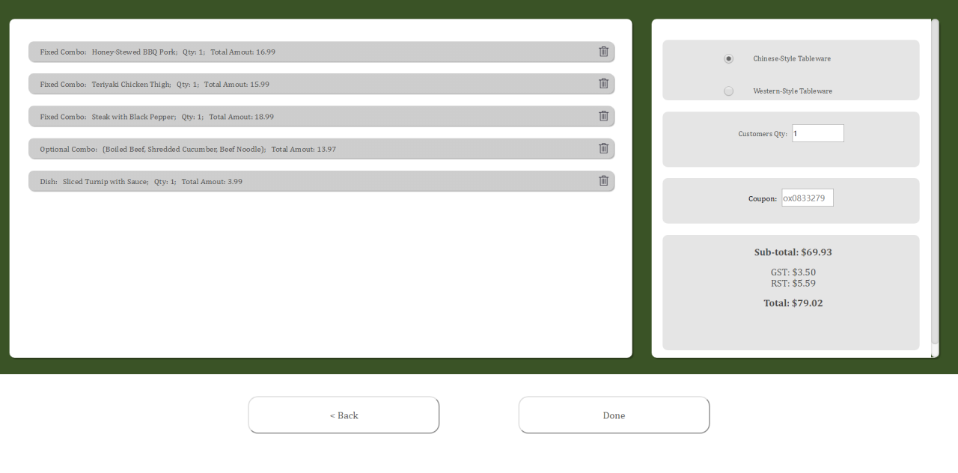

After customers enter the quantity of the food, then click “Add to Order” button, the system will show a successful ordered message if customers already selected dishes. If not, the system will remind customers that they need to select some dishes first, then they can click “Add to Order”. customers can click “View Ordered” button to check the dishes they ordered. In View Order page, customer can either go back to the menu page to modify the order by clicking “Back” button, or click “Done” button to confirm the order then moves to the payment section. Also, there are some textbox for customers to enter additional information about the order. Such as chose what type of tableware to use, and numbers of customers. Coupon textbox allows customers to enter the coupon code if they have.

These four paragraphs above is the description about “Ordering Food” section, and this section is the most important section of our ordering system. In the next two paragraphs, I will introduce “Pay the Bill” section and “Statistic” section.

After customers click “Done” button on the “View Order” page, a pop-up window will be shown, it remind that if customers confirm the order, then it will go to the payment section. In the “Pay the Bill” section, customers can choose pay by card or pay by cash. When customers finished the payment method selection, system will lead customers to the payment page, customers can add tips on the page. Then click “Confirm” button, then the system will show a button to jump back to the main page. It means the order is finished, the system is ready to receive the new order.

In the “Statistic” section, it will show statistical data about orders. It design for restaurant owners, therefore the first page of this section asks users to enter the password. “Sale” part will show the popular dishes and unpopular dishes. “Inventory” part shows the inventory of some dishes.

The paragraphs above are introduction of our ordering system. We took suggestion and opinions from our Milestone 2’s interviewee. We also make small changes during making high-fidelity prototypes, because we came up with better ideas, but sometimes are due to the limitations of our ability. There are some strengths of the system.

First, our ordering system is simple, clear and elegant. Simple doesn’t mean it limited in functions, our ordering system has basic function for ordering food, such as add and remove selected dishes. We also provide additional functions, things like using different type of menu to order the food. Our color scheme is using as less color as possible in the interface. The dominant hue of our interface is white and green. Both of color give customers a positive feeling, white symbolizes clean, green symbolizes healthy. And that’s the impression that we want to leave to our customers.

Secondly, our ordering system is easy to understand, and it also easy to use. In the Milestone 2, one of the interviewee told us, he didn’t notice there was a menu type selection on the top of the pages in our low-fidelity prototypes. Therefore, we make every button become bigger, it easy for customers to find the buttons. Each component of the ordering system has description, for example, after click “Fixed Combo”, it will show a short description about fixed combo, so customers won’t be confused about the meaning of terms. We also have detailed description about dishes, it shows in smaller font. Therefore, customers can ignore these descriptions, or they can read the description if they want to know more about the dishes. We also provide contextual help in each textbox, it will guide customers to enter the correct format of information.

Thirdly, we innovative show Chinese cuisine in the map. In the first page of our ordering system, there is a button called “More”. After clicking it, this page will be opened in a new tab. This new page shows an ink painting style map of China, and 6 buttons around the map. We divided Chinese cuisine into six parts depend on geographical locations. We introduce each type of cuisine, and show what dishes we have for the type of cuisine. It helps customers to learn Chinese food culture. This is an innovation feature that no other ordering system had. We found this idea from Group Brainstorming of Milestone 2, the original name of this idea is called “Learn more about Chinese Food for ordering”. In the beginning, we want to add this feature in “Ordering Food” section, but we realize that ordering food using the map is hard to implement and interaction. Therefore, we make it to be an additional introduction page of Chinese food, and it won’t disturb during customers ordering the food.

There are some problems we found in our prototypes.

* If user click “Fixed Combo” or “Optional Combo” too fast, there is a chance that hint page will be shown above the dishes page at the same time.
* In Chinese cuisine section, if the window's size is small, the text will exceed the background picture.
* The system won’t check the password in the Statistic section. If users don’t enter anything in the textbox, the system will still go to the next page.
* The system won’t check the correctness of the coupon code. Therefore, no matter what coupon code entered, the total amount won’t change.
* Dishes inventory won’t change.
* Customers’ orders won’t effect “Best Seller” and “Worst Seller” in the Statistic section.
* Customers need to enter the quantity of dishes they want to order the food, or there is “up” and “down” button way to select dishes. But the buttons are small, it’s hard to resize them. Makes buttons bigger will also cause the page looks inharmonious.