034054 Mechanical Design 1M
Homework4: Turntable Drive System Design

Tao Wang (999020910)
Lining Xie (999021090)
Dongming Zheng (999021371)
Zhuorui Yun (999021264)
Li Yan (999021157)

Abstract
This report serves as an extension of the design project initiated in Homework 3, which involved the design of a mechanical turntable to support a heavy payload of 9.5 × 10³ kg in rotation. The previous assignment focused on the structural integrity and bearing selection for the turntable itself. In this assignment (Homework 4), the objective shifts to the design of the drive system necessary for the efficient and safe operation of the turntable. The main tasks of this report include the selection and specification of a suitable standard (off-the-shelf) reduction gearbox, as well as determining the required rated power and nominal speed for a three-phase electric motor. The design takes into account a variable-speed control system capable of adjusting the motor speed by a factor η (0.6 ≤ η ≤ 1.5) around the nominal operating speed. Accordingly, the gearbox selection process emphasizes reliability and the capability to meet torque requirements across this specified speed range.

New Design
Our new design incorporates the addition of a double-layer track beneath the structure’s original rollers, with the track securely fastened using M10 bolts. This configuration distributes loads to mitigate deformation risks; meanwhile, the double-layer structure delivers dual support, minimizing vibration and positional deviation during movement—thereby ensuring smoother travel of the circular assembly. It also allows for more precise control over the movement path and prevents misalignment, rendering it ideal for fixed-route material handling applications. Below are the detailed design drawings and cross-sectional views of this setup.
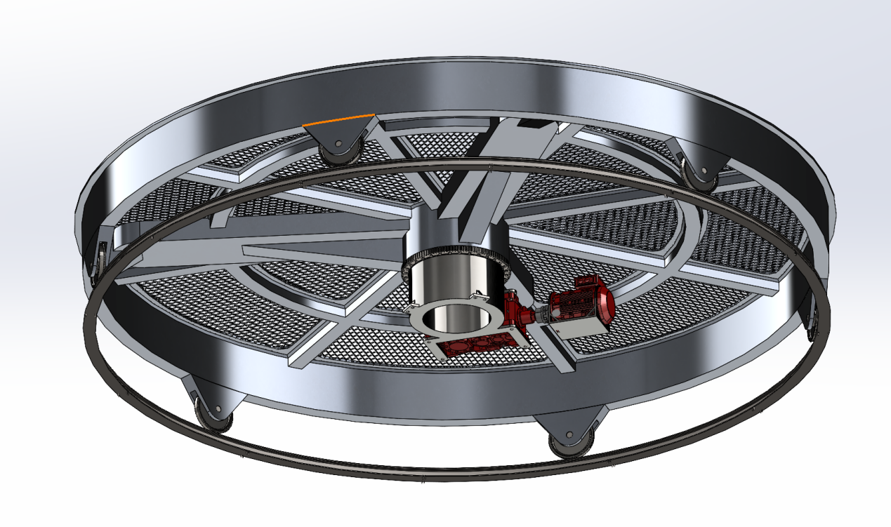
Figure1. Design main body

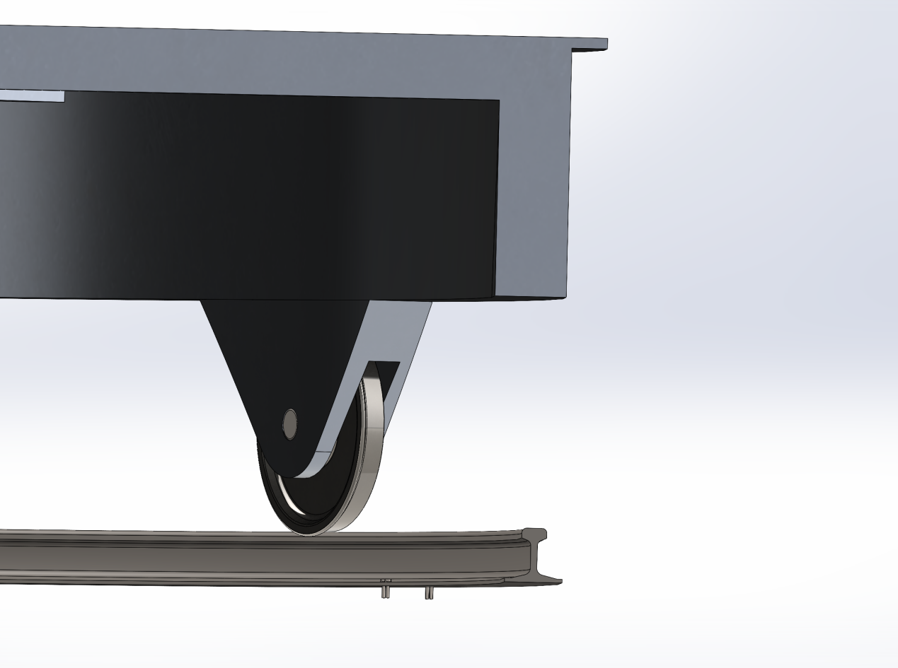
Figure2. Cross-section of the track

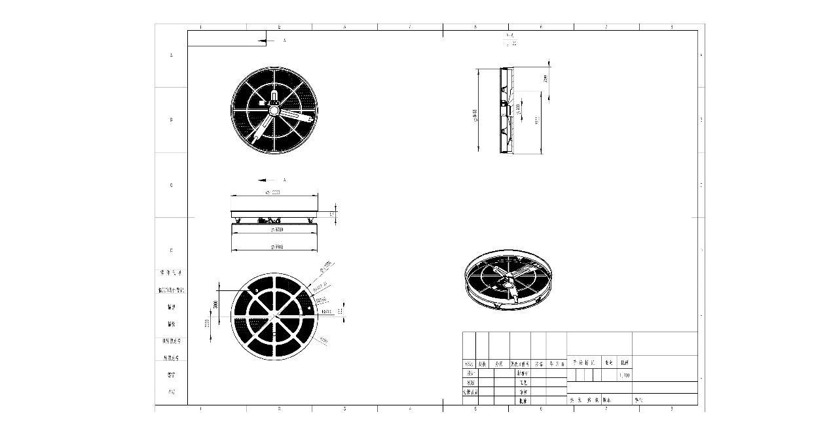
Figure3. Engineering drawing of the main part

Material Selection and Properties
For this design, I selected AISI 1045 steel as the material for the shaft. According to the material tables, the mechanical properties are:
- Ultimate Tensile Strength: $S_{ut}=625\text{ MPa}$
- Yield Strength: $S_{y}=530\text{ MPa}$
- Elastic Modulus: $E=2.05×{10}^{11}\text{ Pa}$
First, I estimated the uncorrected endurance limit ($S_{e}^{'}$). Since the tensile strength is below 1400 MPa, we can use the standard approximation:
$$S_{e}^{'}=0.5S_{ut}$$
$$S_{e}^{'}=0.5×625\text{ MPa}=312.5\text{ MPa}$$
Marin Factors
To find the actual endurance limit ($S_{e}$) for the real part, I applied the Marin modification factors as taught in class. The formula is:
$$S_{e}=k_{a}k_{b}k_{c}k_{e}S_{e}^{'}$$
Here is how I determined each factor:
Surface Factor ($k_{a}$):
The part will be machined. Using the parameters $a=3.04$ and $b=-0.217$ from the textbook:
$$k_{a}=aS_{ut}^{b}=3.04{\left(625\right)}^{-0.217}=0.7519$$
Size Factor ($k_{b}$):
Since the diameter is relatively small, the size effect is not significant, so I assumed:
$$k_{b}=1$$
Load Factor ($k_{c}$):
The shaft experiences combined loading. For conservative design regarding torsion/shear, I used:
$$k_{c}=0.59$$
Reliability Factor ($k_{e}$):
I want a high reliability of 99.9% for this component. The corresponding factor is:
$$k_{e}=0.753$$
Resulting Endurance Limit:
Plugging these values back into the equation:
$$S_{e}=0.7519×1×0.59×0.753×312.5\text{ MPa}$$
$$S_{e}≈104.39\text{ MPa}$$
Stress Concentration
Since there is a change in the geometry (like a shoulder or groove), I need to calculate the stress concentration factor to see how much the stress increases locally.
The maximum stresses are given by:
$$σ_{max}=K_{f}σ_{0} \text{and} τ_{max}=K_{fs}τ_{0}$$
To find $K_{f}$, I first looked up the theoretical stress concentration factor ($K_{t}$) and then calculated the notch sensitivity ($q$).
Theoretical Factor ($K_{t}$):
For the geometry with diameters $d=10$ and $w=20$, the ratio is $d/w = 0.5$. Checking the chart for this ratio, I found:
$$K_{t}=2.18$$
Notch Sensitivity ($q$) & Neuber Constant ($\sqrt{a}$):
I calculated the Neuber constant $\sqrt{a}$ using the equation for steel based on $S_{ut}:$
$$\sqrt{a}=1.24-2.25×{10}^{-3}S_{ut}+1.6×{10}^{-6}S_{ut}^{2}-4.11×{10}^{-10}S_{ut}^{3}$$
Substituting $S_{ut}=625$, I got:
$$\sqrt{a}≈0.3584 \sqrt{\text{mm}}$$
Fatigue Stress Concentration Factor ($K_{f}$):
I assumed a radius of $r=5\text{ mm}$ for the fillet/notch (approximating an M10 thread root or shoulder). The final factor is:
$$K_{f}=1+q\left(k_{t}-1\right) and K_{fs}=1+q_{s}\left(K_{ts}-1\right)$$
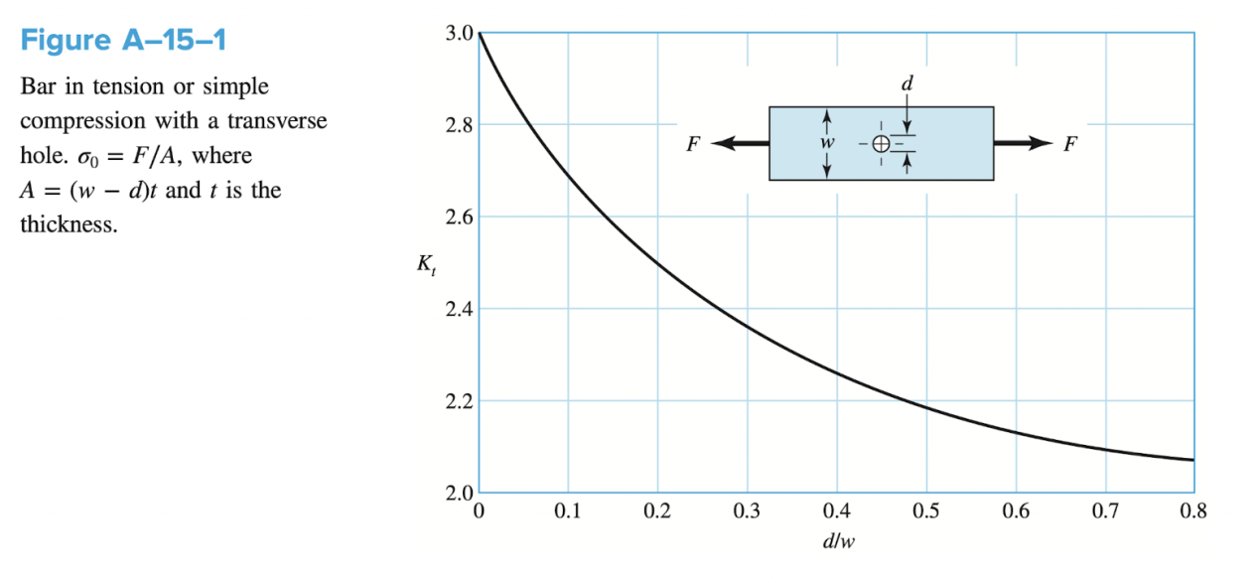
We design that d=10mm and w=20mm, so d/w=10/20=0.5
From the plot we can find that $K_{t}=2.18$
$$\sqrt{a}=1.24-2.25*{10}^{-3}S_{ut}+1.6*{10}^{-6}S_{ut}^{2}-4.11*{10}^{-10}Sut^{3}=0.3584$$
We assume r=5mm (M10) , according to the formula $K_{f}=1+\frac{K_{t}-1}{1+\frac{\sqrt{a}}{\sqrt{r}}}=2.017$
Fluctuating force:
$$σ_{min}=0 , σ_{max}=26.15 MPa r_{tot}=\sqrt{{1.4737}^{2}+{1.15792}^{2}}=1.8742$$
$$F_{r}=mrw^{2}=F_{r,tot}=9.5*{10}^{3}×1.8742×{\left(\frac{15×2π}{60}\right)}^{2}=43931.195 N=43.931 kN$$
For one side orbit: $F_{each}=\frac{F_{r}}{2}=21.965 kN$
For each bolt: $F_{bult}=\frac{F_{r}}{4}=4.393 kN$
$$σ_{a}=\frac{σ_{max}-σmin}{2}=13.075=σ_{m}$$
$$σ_{a'}=σ_{m'}=kf*13.075=26.372 MPa$$
So the safety factor is: $n_{f}={\left(\frac{σ_{a^{'}}}{S_{e}}+\frac{σ_{m^{'}}}{S_{ut}}\right)}^{-1}={\left(\frac{26.372}{104.3896}+\frac{26.372}{625}\right)}^{-1}=3.39$
$$σ_{eq}=\frac{σ_{a}}{1-\frac{σ_{m}}{S_{ut}}}=27.534 MPa$$
And the finite fatigue: $n_{f}=\frac{S_{y}}{σ_{eq}}=22.88$

Motor selection
Floor: $I_{floor}=38534 kg·m$
Moment inertia for three loads:
$$I_{load}=I_{A}+I_{B}+I_{C}=3000×13+5000×17+1500×4=130000 kg⋅m^{2}$$
Total moment of inertia: $I_{tot}=130000+38534=168534 kg⋅m^{2}$
External gear ratio: 144:20 = 7.2:1
So gear ratio in gear unit is $≈\frac{100}{7.2}=13.89$
Angular velocity: $ω=\frac{2π}{60}⋅15=1.57 rad/s$
Angular acceleration: $α=\frac{π}{16}$
Torque output = $J×α=168534×\frac{π}{16}=33091.57 Nm$
The torque input by motor should be $T_{in}=\frac{T_{out}}{100}=330.92 Nm$
Operation torque from gear unit: $330.92×13.89=4596.1 Nm$
Power of motor: $P=T×ω≈52Kw$

High-Speed Coupling:
The coupling is installed between the 110 kW Electric Motor (output shaft $ϕ 65 mm$) and the Gear Unit input shaft $(ϕ 50 mm$). Its primary function is to transmit the motor's torque while compensating for minor angular, parallel, and axial misalignments, and damping the vibrations during the 8-second acceleration phase.
Design Parameters & Requirements
- Nominal Speed (n): $1500 rpm$
- Input Shaft Diameter ($D_{in}):$ $65 mm$ (Motor side).
- Output Shaft Diameter ($D_{out}):50 mm$ (Gearbox side).
The torque produced by the motor is 300Nm as calculated before. Based on the dynamic requirements of the 9.5-metric ton turntable system, the R+W EK1 4500 A Elastomer Coupling was selected for the high-speed interface between the motor and the gear unit.
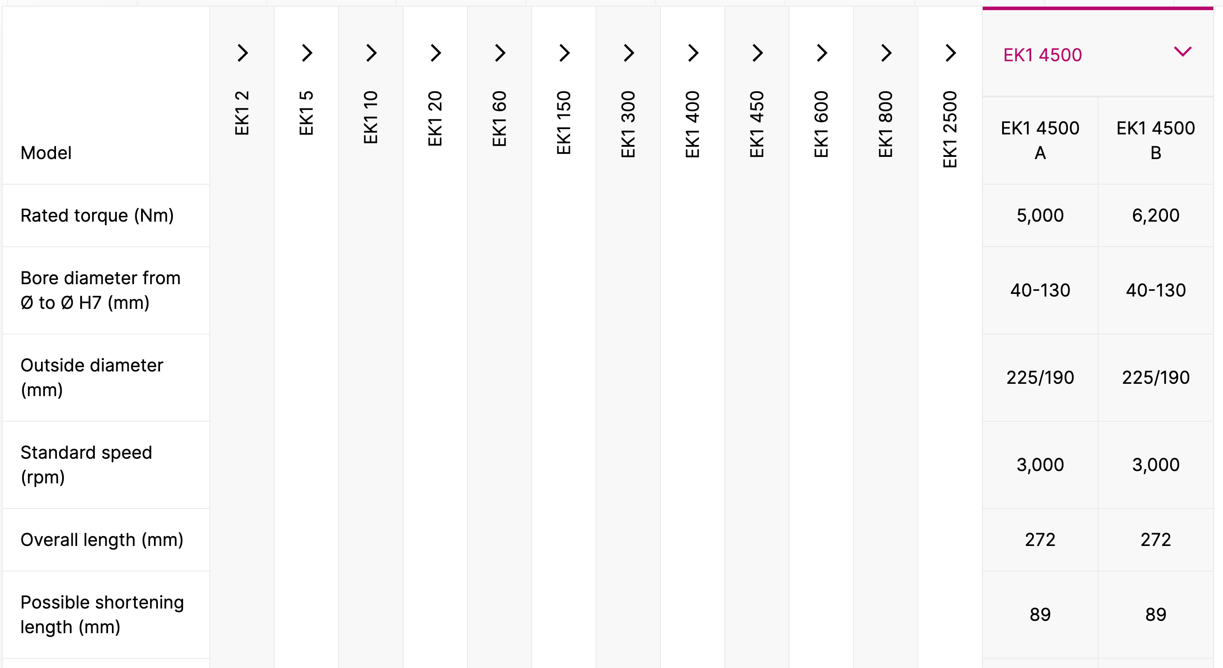
The EK1 4500 model is rated for a nominal torque of 5,000 Nm. This selection provide a safety factor of approximately 15x over the nominal motor torque. This high margin is critical for handling the inertial shock loads during the mandatory 8-second acceleration phase of the 9.5-ton payload.

To find the proper bolt, we did the following calculation.
Using moment balance:
$$P*66=21965.597×152$$where
$$F=21965.597 N$$
So we get:
$$P=50587.4355N$$
Each of them share forced
$$\frac{P}{2}=25293.72 N$$So the stress is:
$σ_{b}=322.05MP$a

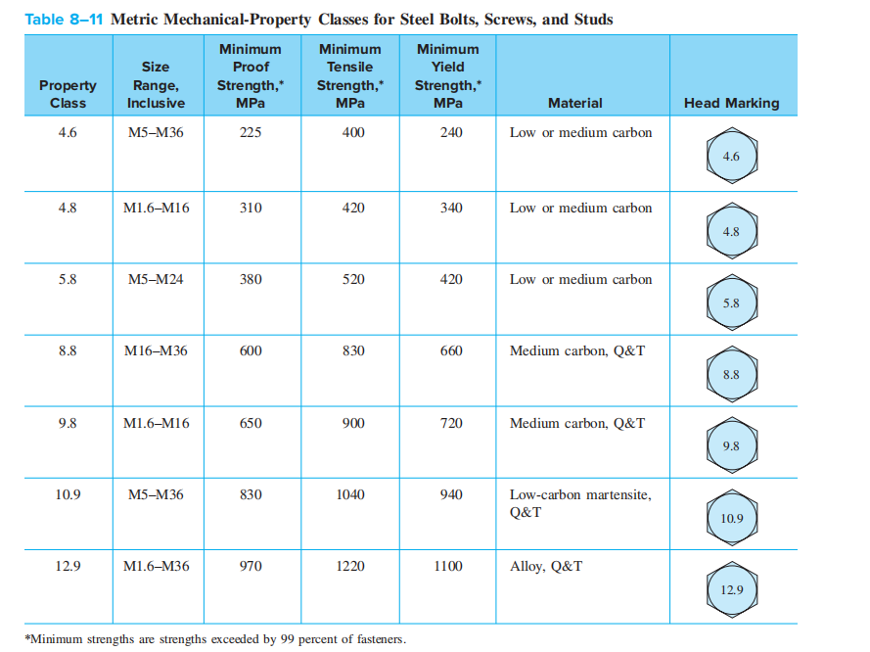
We take property class 10.9, from the table we know
$$S_{p}=830MPa$$
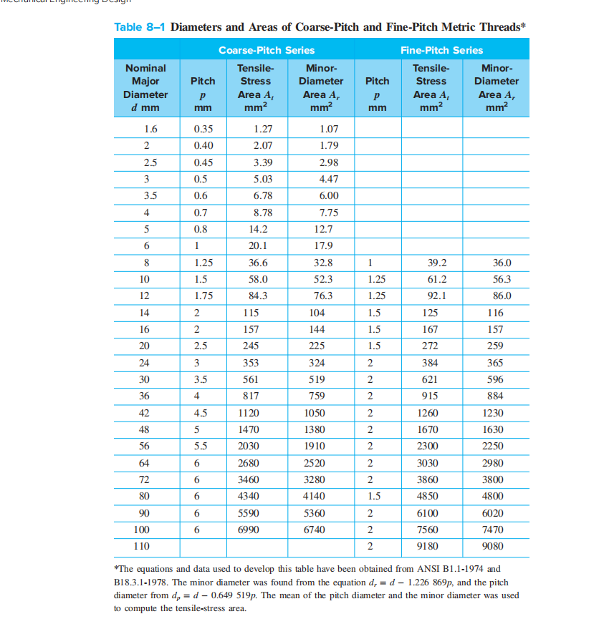
From this table, we know
$$A_{t}=58mm^{2}$$
$$F_{i}=0.75A_{t}S_{p}$$

So we calculate:
$$σ_{b}=\frac{F_{b}}{A_{t}}=\frac{cP+F_{i} }{A_{t}}=\frac{0.3×25293.72+36105}{58}=753.33 MPa$$
Under this circumstance, the safety factor is:

$$n_{p}=\frac{S_{p}}{σ_{b}}=1.102$$

It might be too low, so we consider $F_{i}=10000N$
Now,
$$σ_{b}=303.243MPa$$
So $n_{p}=\frac{S_{p}}{σ_{b}}=2.737$

We consider it a good design.
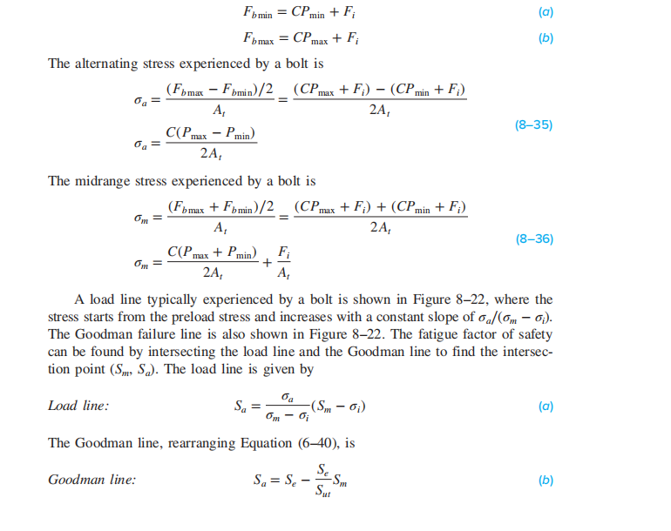
Next we calculate the fatigue:
$$F_{b}min=10^{4}$$
$$F_{b}max=0.3×25293.72+10^{4}=17588.116N$$
$$σ_{m} =\frac{{(F}_{bmax}+F_{bmin})/2}{A_{t}}=\frac{(17599.1+{10}^{4})/2}{58}=237.83 MPa$$
$$σ_{a} =\frac{{(F}_{bmax}-F_{bmin})/2}{A_{t}}=65.415 MPa \\ σ_{i}=\frac{{10}^{4}}{58}=172.41MPa$$
$$S_{e}=162 MPa$$
$$S_{ut}=1000 MPa$$
Finally, we can find that the safety factor is:
$$n_{f}=\frac{S_{e}(S_{ut}-σ_{i})}{S_{ut} σ_{a}+S_{e}(σ_{m}-σ_{i})}=\frac{162(1000-172.41)}{1000*65.415+162*(237.83-172.41)}=1.764$$
We consider its a good design.

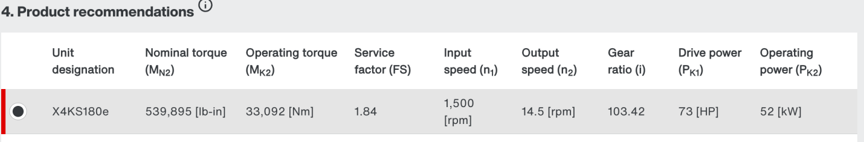
Here is the point-by-point explanation in English for the selection of the motor (SEW Eurodrive K167DRN200L4TF, 30 kW):
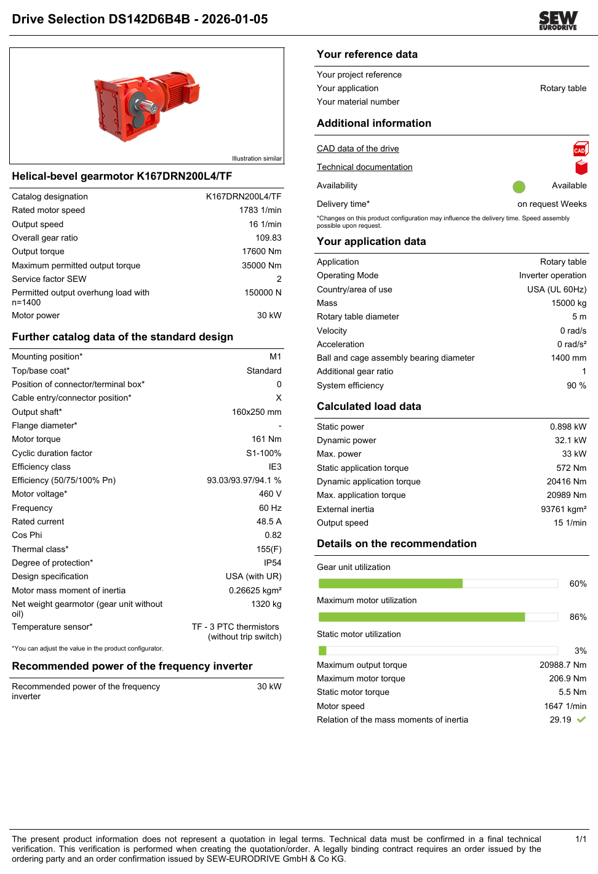
Figure4. Driven Selection
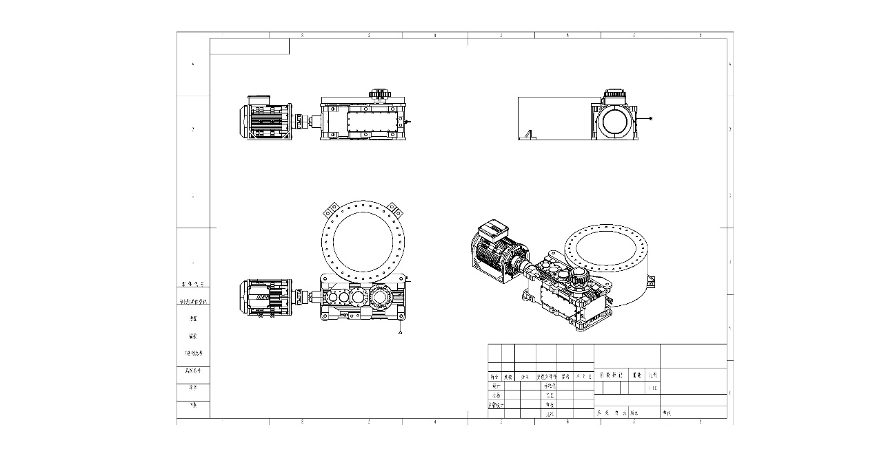
Figure5. Reduction drive drawings
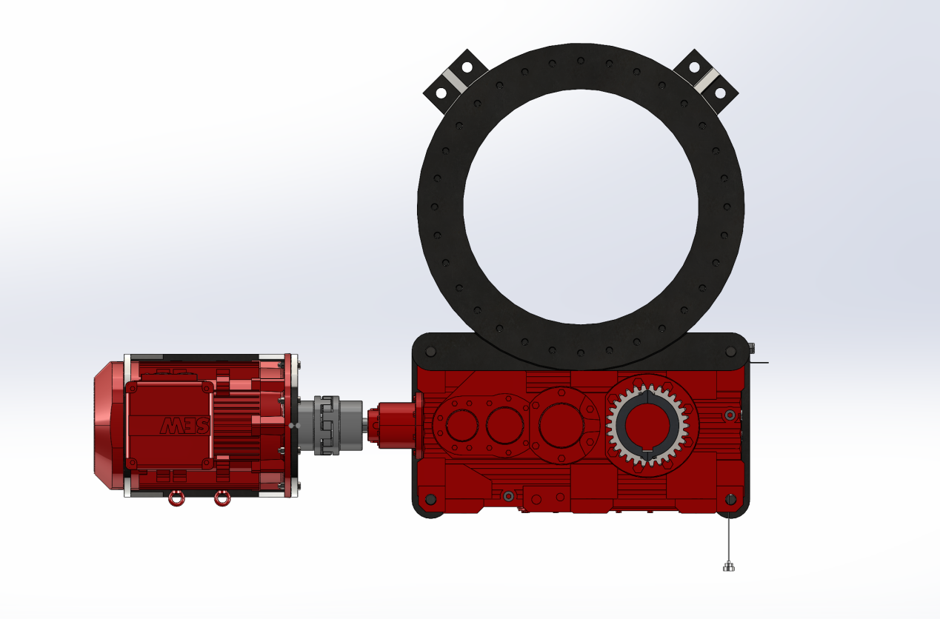
Figure6. 3D view of the Reduction drive

1. Power Matching
Initial calculations indicated a theoretical power requirement of approximately 52 kW. However, a detailed selection analysis revealed that the system's actual peak power demand is around 33 kW. The selected 30 kW motor provides good overload capacity (with a maximum utilization of only 86%) and is paired with a recommended 30 kW frequency inverter, fully meeting the demands of dynamic operating conditions.
2. Torque Capability
The motor-gear unit offers a rated output torque of 17,600 Nm and a maximum allowable torque of 35,000 Nm. This significantly exceeds the calculated operational torque requirement of approximately 4,596 Nm, providing a sufficient torque reserve.
3. Speed Matching
With a total gear reduction ratio of 109.83, the motor's rated speed of 1,783 rpm is reduced to an output speed of 16 rpm. This closely matches the target speed of 15 rpm, meeting the turntable's speed requirement.
4. Reliability and Adaptability
The unit features a high service factor of 2, enabling it to reliably withstand load fluctuations caused by the speed adjustment range (η = 0.6–1.5). This makes it suitable for variable-speed operating conditions.
5. Energy Efficiency and Protection
The motor complies with the IE3 efficiency standard, achieving over 94% efficiency, which helps reduce long-term energy consumption. Its IP54 protection rating makes it suitable for typical industrial environments.
6. Compatibility and Control
A 30 kW frequency inverter is recommended for pairing, facilitating motor speed control and meeting the system's requirement for adjustable speed.
In summary, this motor meets the design requirements in terms of power, torque, speed, reliability, energy efficiency, and control compatibility, representing a rational and reliable engineering choice.
Catalogue Source：seweurodrive.com/os/dud?search=K167DRN200L4/TF&tab=documents
CAD Specification：seweurodrive.com/os/dud?search=K167DRN200L4/TF

