Step 1: VE and IE at 1k Ohm Resistor connected to the emitter. Also getting r’e afterwards.

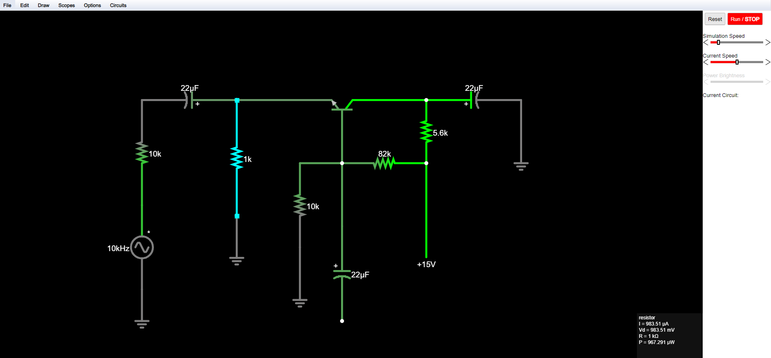

Step 2: Getting Vin (AC SOURCE), Vout(DC OUTPUT), Avo, and its Phase Relationship (In Phase)

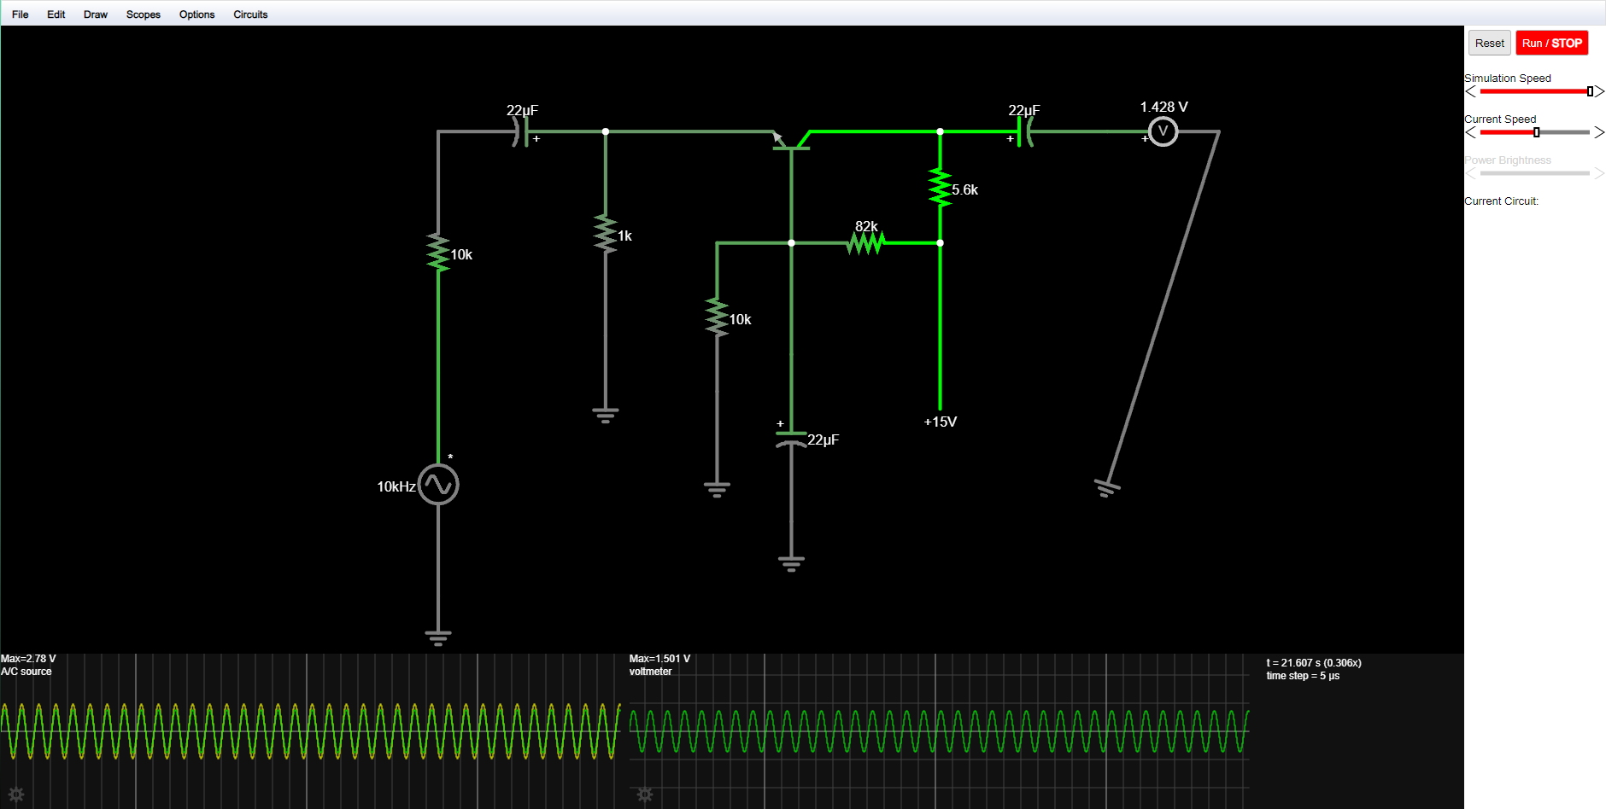

Step 3: Getting Zo, the output impedance by adjusting potentiometer until output is at 1.5V

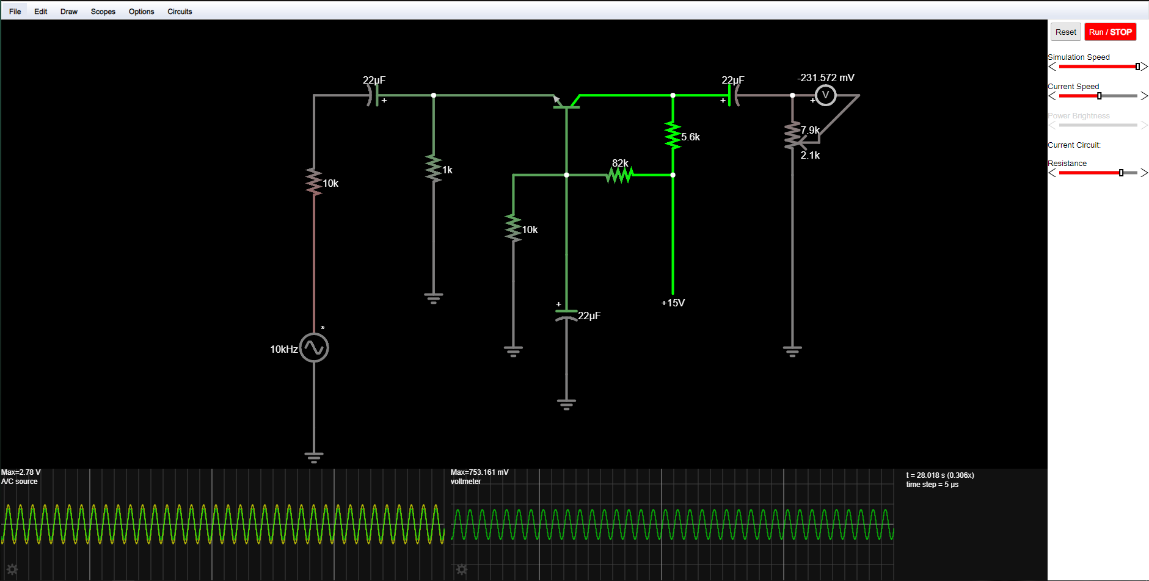

Step 4: Circuit adjust

Step 5: Getting Vs and Av

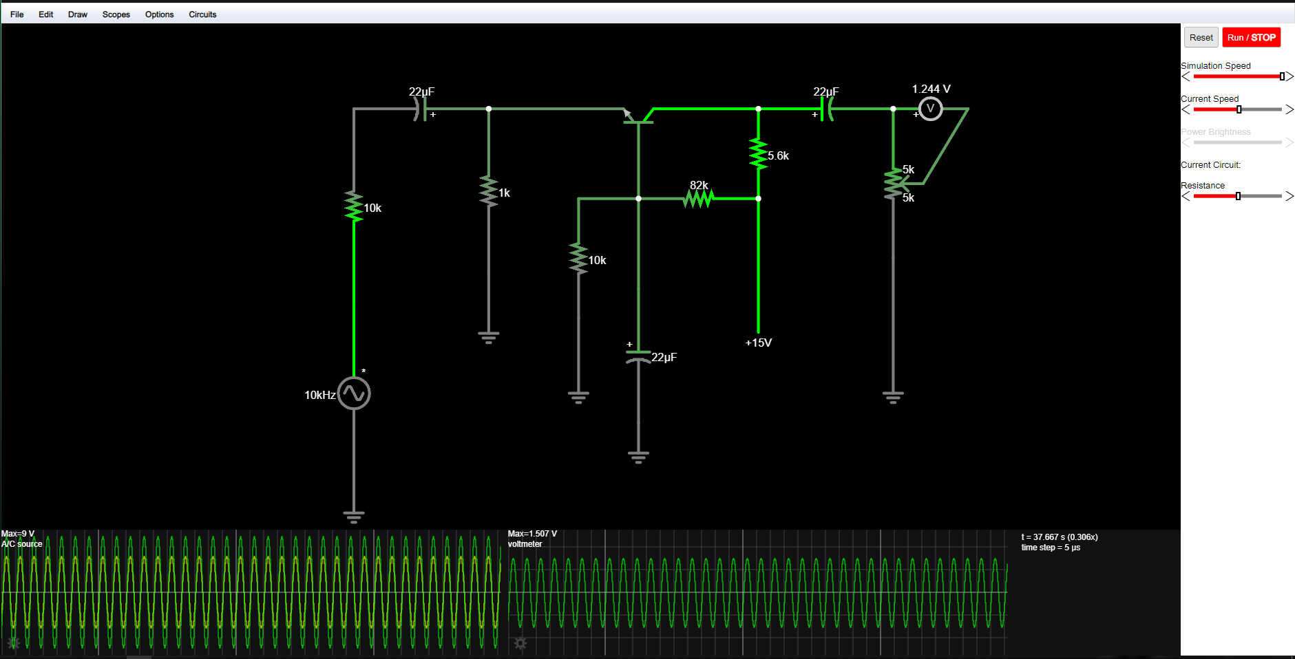

Step 6:

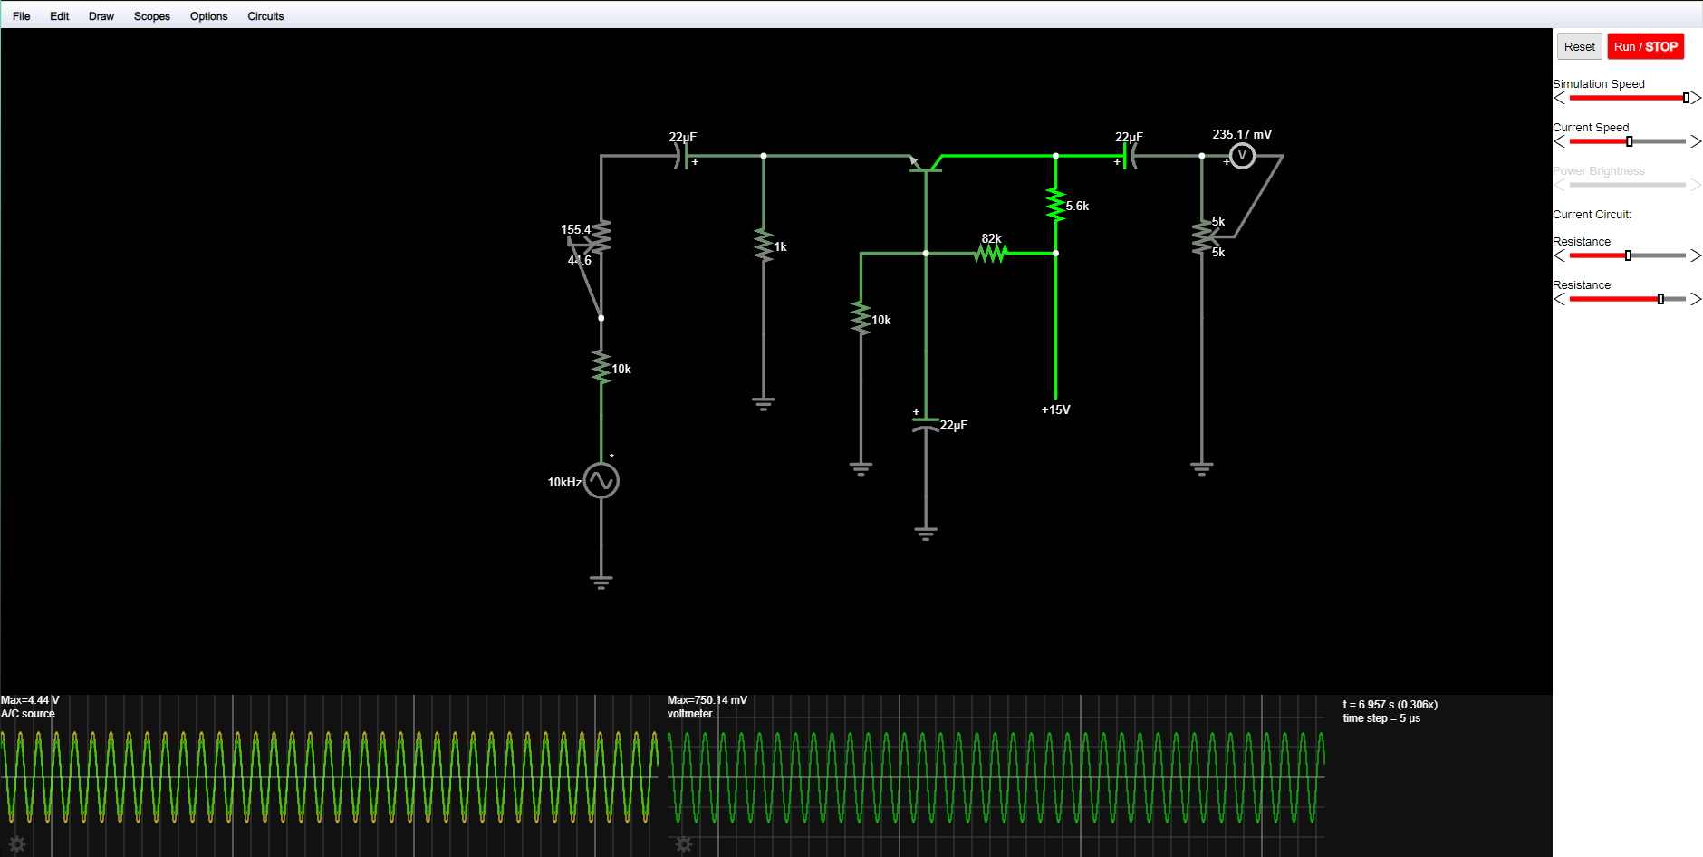

Step 7: Vpeak = 1.851 V, Vp-p = 3.702 V distortion

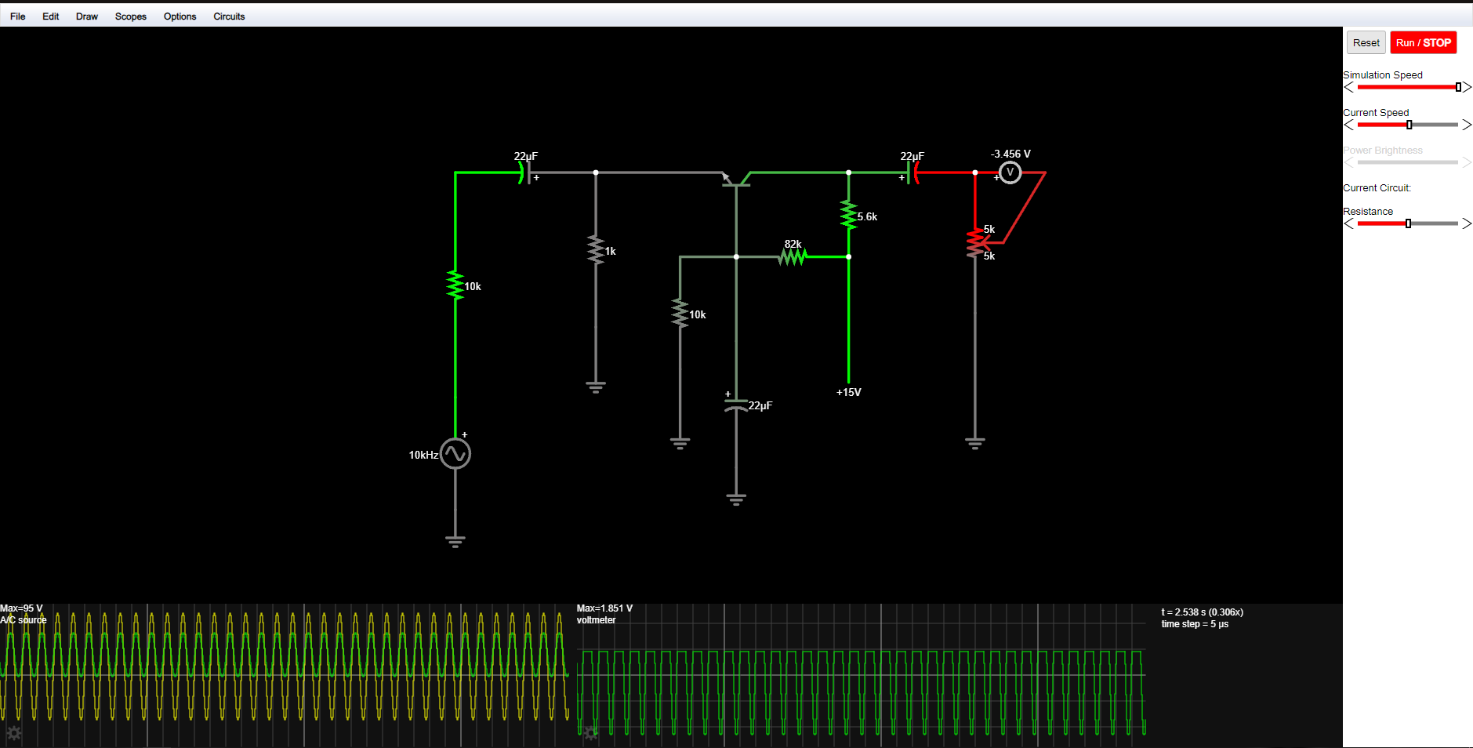

**EXPERIMENT 8**

**DATA AND RESULTS**

|  |  |  |
| --- | --- | --- |
| **Step** | **Result** |  |
| **1** | **VE** | 983.51 mV |
| **IE** | 983.51 µA |
| **R’e** | 26.4359 ohms |
| **2** | **Vin** | 2.78 V |
| **Phase Relationship** | In phase relationship |
| **Vo** | 3.002 V |
| **AVo** | 1.0799 |
| **3** | **Zo** | 0.2324 ohm |
| **5** | **Vs** | 9 V |
| **Av** | 0.1674 |
| **6** | **rs** | 0.0163 ohm |
| **Zin** | 25.755 ohms |
| **7** | **VL(pk-topk)distorted** | 3.702 V |