Database Design
Revision History:
Date | Author | Description
2020-09-12 | 朱晨 | Version 1

目录
Database Design 1
1. Introduction 2
1.1 Purpose of writing 2
1.2 Scope of application 2
1.3 Readers 2
2. Database environment description 3
3. Logical analysis and design 3
3.1 system functions 3
3.2 Entity Relationship Diagram 4
4. Physical design 4
4.1 uinfo 4
4.2 bookinfo 4
4.3 bookrating 5

Introduction

1.1 Purpose of writing
As an important part of the software design document, this document mainly makes unified provisions on the conceptual model design and physical model design of the background database, and determines the data dictionary structure of each table. This file is an important reference for developers and testers to code and test.

Scope of application
Database design documents are provided to system designers and detailed designers. This document is only applicable to the development of this book recommendation system.

Readers
Readers of this document include:
1. Book Recommendation System Designer: module designer
2. Book recommendation system developers: Database developers and coders
3. Book recommendation system tester

Database environment description
The database is established and maintained by MySQL 8.0 database management system.

Logical analysis and design

3.1 system functions
3.1.1 user management
Information about the user is as follows: user ID.
The user can log in with the user name.
Users can comment on books.
3.1.2 book management
Information about the book is as follows: Book Number ISBN, title, release date, publisher, author, cover link.
3.1.3 comment management
The related information of the review is as follows: user ID, comment score, Book Number ISBN.

3.2 Entity Relationship Diagram
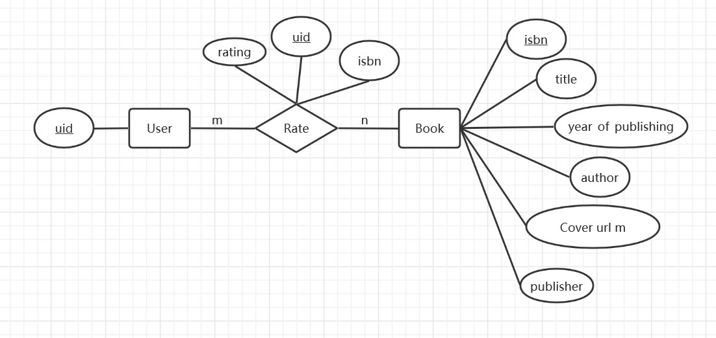

Physical design

4.1 uinfo
No. | Field name | Type | If empty | Primary | Field description
1 | uid | Varchar(100) | N | Y | User ID

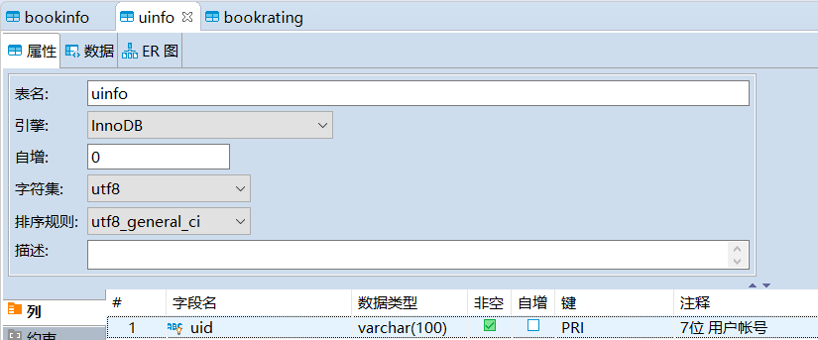

4.2 bookinfo
No. | Field name | Type | If empty | Primary | Field description
1 | isbn | Varchar(100) | N | Y | Book number
2 | title | Varchar(255) | N | N | Title of the book
3 | author | Varchar(100) | N | N | Writer of the book
4 | year_of_publishing | Varchar(100) | N | N | Date of publication
5 | publisher | Varchar(100) | N | N | publisher
6 | Cover url m | Varchar(255) | N | N | Link of the book cover

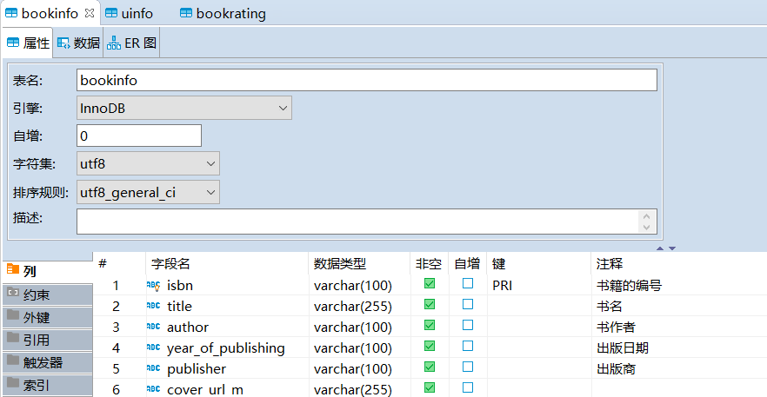

4.3 bookrating

No. | Field name | Type | If empty | Primary | Field description
1 | uid | Varchar(100) | N | Y | User ID
2 | isbn | Varchar(100) | N | N | Book number
3 | rating | float | N | N | Rating of the book

