1. Login | Username: abc | Password: abc

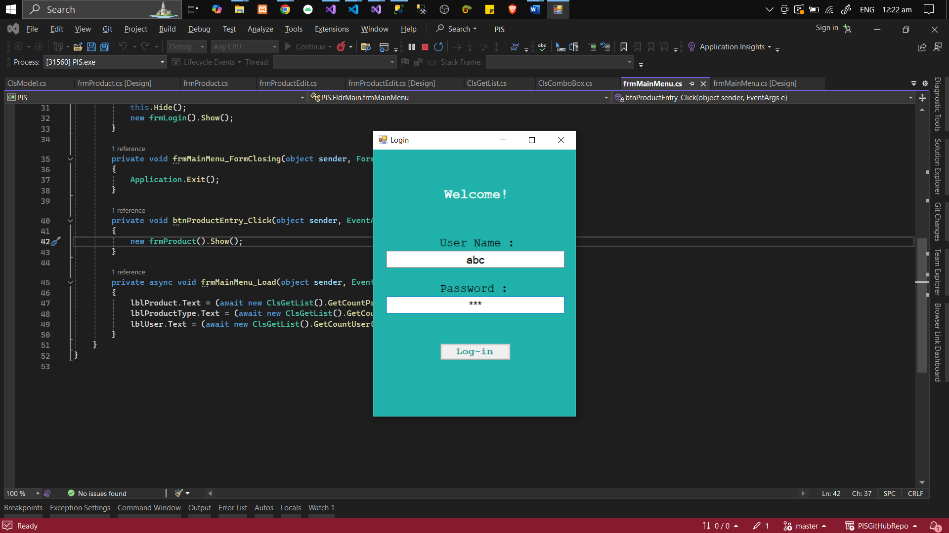

1. Dashboard

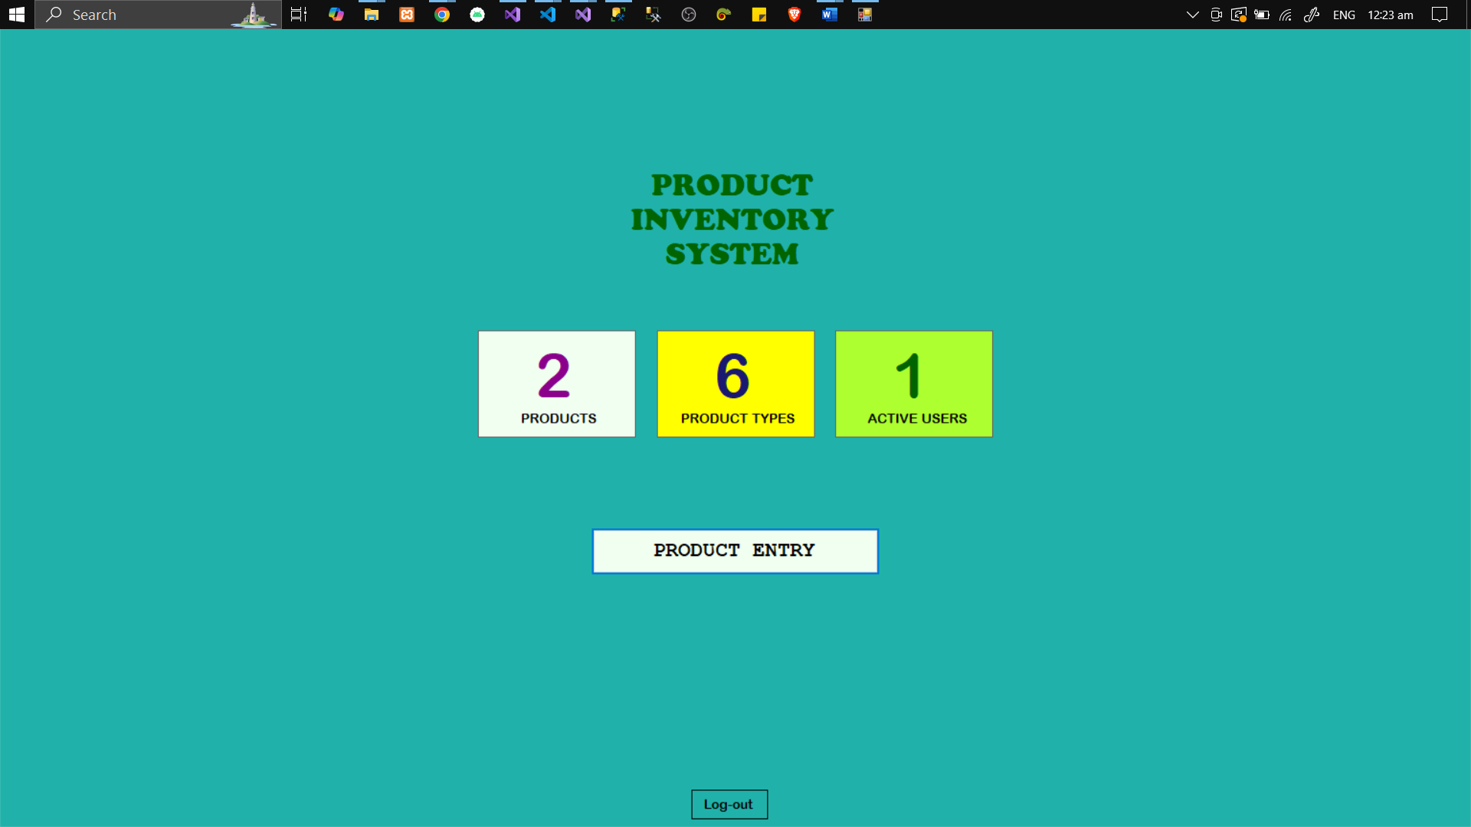

1. Product Entry

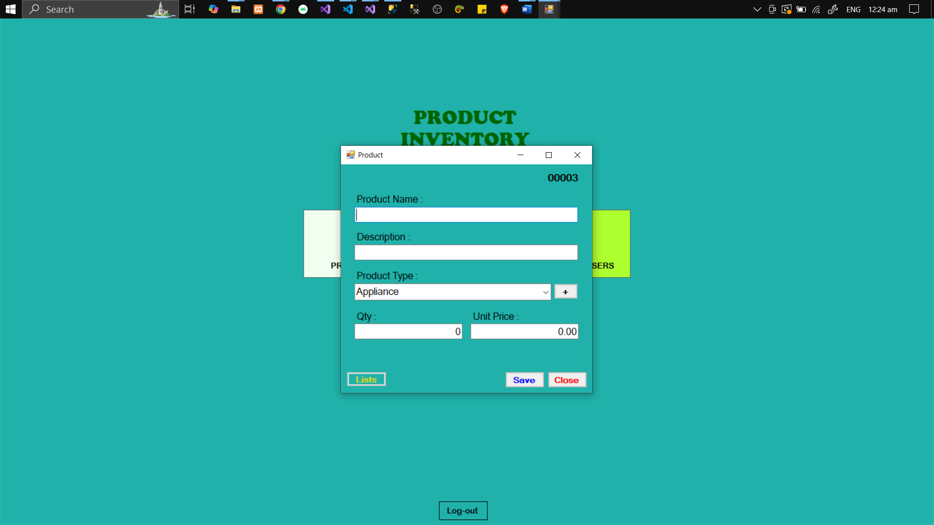

1. Click **List** button will show lists of Product entry (can edit and delete)

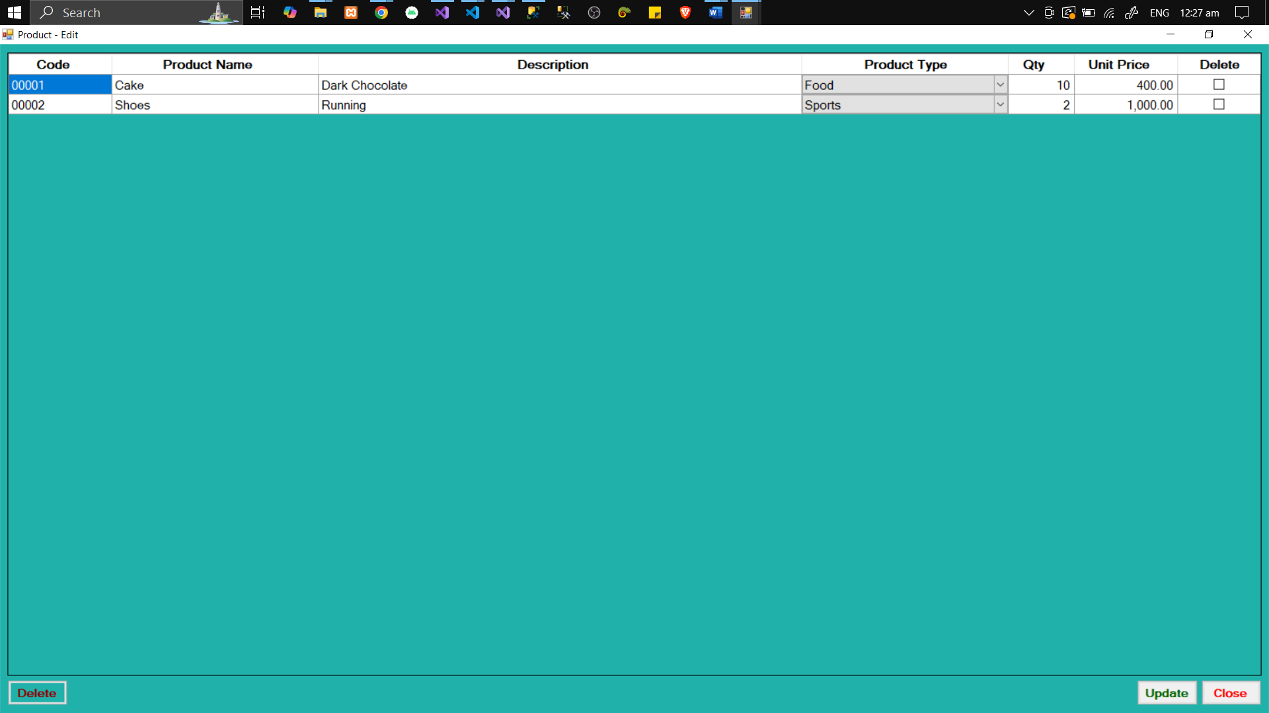

1. Click + button besides the Product Type will show the **Product Type entry**

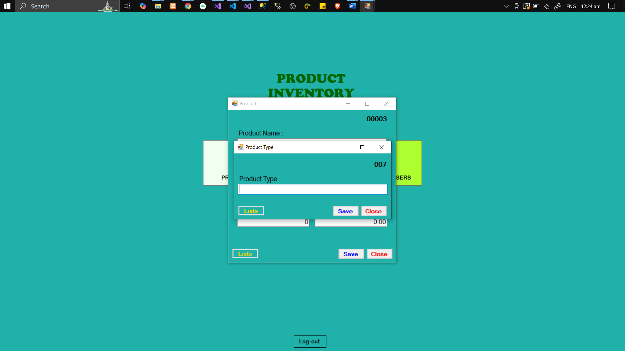

1. Click **List** button in Product Type will show the lists of Product Type (can edit and delete)

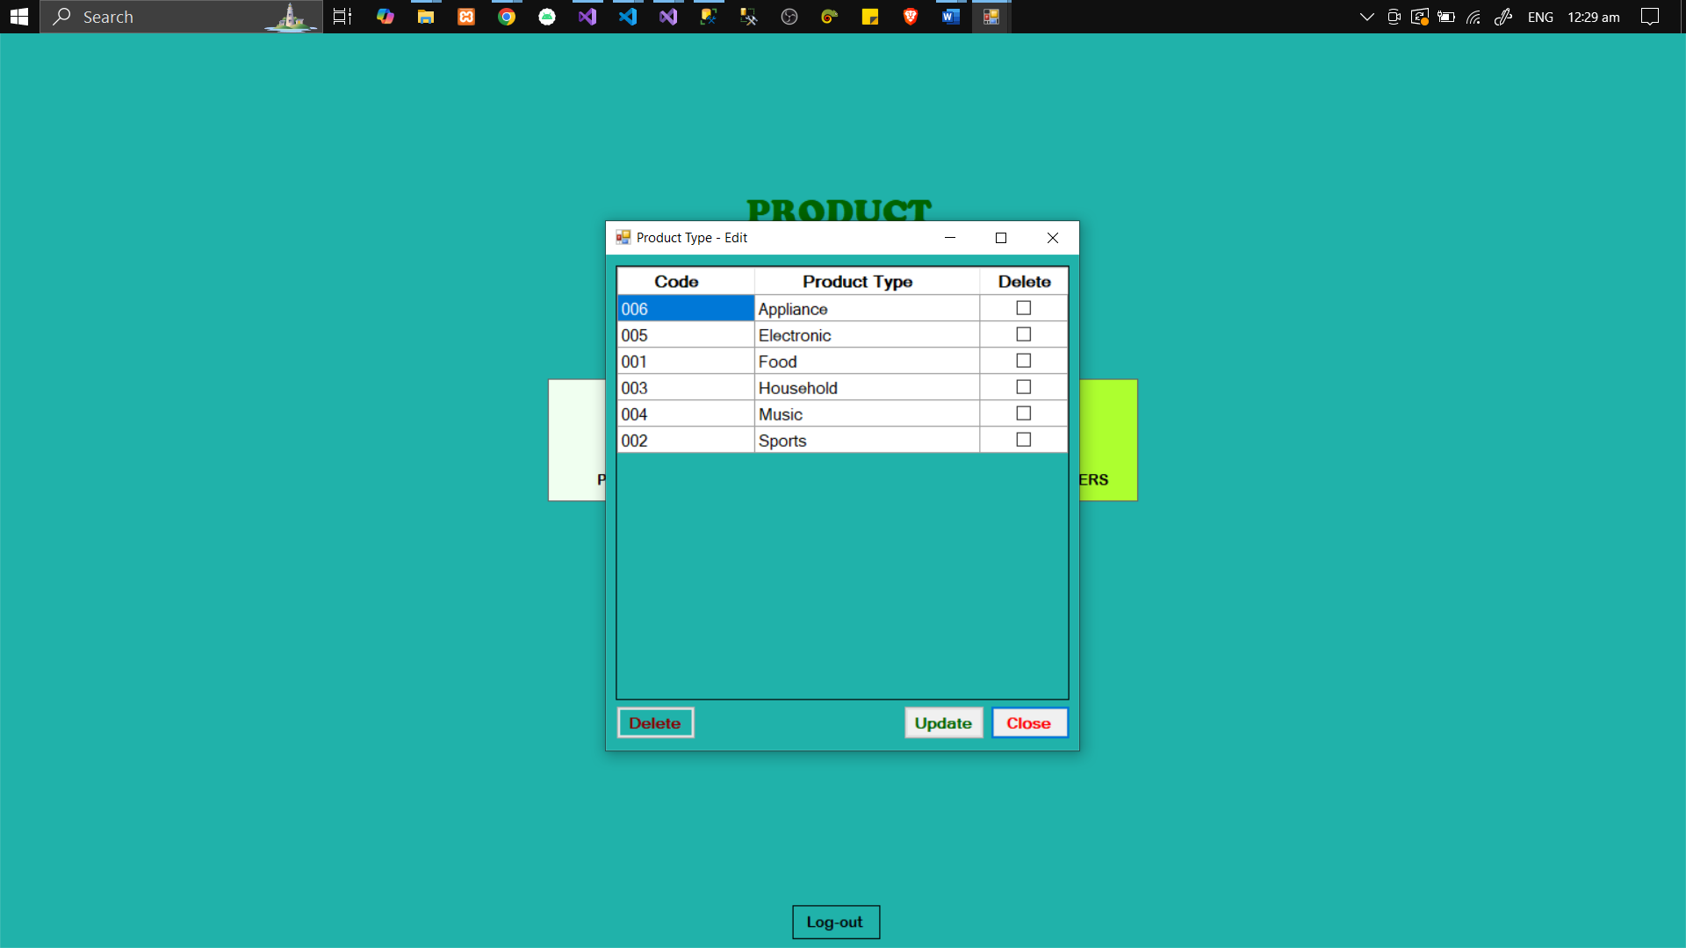

**Additionally**:

* JWT Authentication are used for Authorization and Tokens.
* Visual Studio 2022 for the IDE
* MSSQL for the Database
* C# Programming Language
* Windows Form App (.Net Framework)
* **ASP .NET Core Web API (8.0)**

Thank You!

**Jediael A. Ferrer**