ES Next

## FOLDER STRUCTURE

FL_11_17_homework_es_next/*

homework/*

index.html*

js/*

tasks.js* //All tasks go here, include script in index.html

## TASK

1. Create a function which finds max element in array
   * Use Math.max()

https://lh3.googleusercontent.com/oO53liibAAuGnVyGjO46SgcgNDWx0_OwjWvxi3aLBfqVXeJhb5yiTN98bHApW2VkLLpdnf5S-kyH4kNWq7AIpvfe6-ifPKTNjG8SzXsfaeyjxU1Dafe4o8v8QA4Q-zddE1BqUDUI

1. Create function which copies array

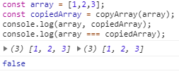

1. Create function to enhance element with unique id. Here is how function should be invoked:
   * Use Symbol() as a unique identifier

https://lh3.googleusercontent.com/KzMhB1HInPbLzPVKVwJDs5y2iHfRlYnk8ZVV1mAvNchoC55M4VouA-H7_-Z59sJx3MnMOG21Btt6V3n4T2STmHB1inCSbO73-g3CZmEO9vQKUgLuFTKqUHLDBMk_Mg5K_nWeYnCx

* + As a result, returned object should have extra property - unique identifier. Returned object should be copy of the passed parameter. Original object should not contain this id.

1. Write a function which regroups object properties
   * Destruct old object and construct new

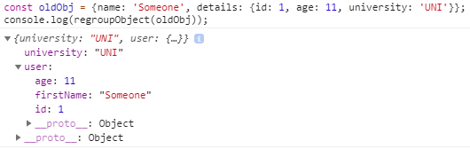

1. Create a function which finds unique elements in array
   * Use one of the new data types

https://lh6.googleusercontent.com/lWlz9M4DjwvhRX0DaI5-SYsJG3PLvcSuZ1ZP5dTICBi6UKNGgYyEtQKV5JnXz-tccq48WdDs-zUDClhWIJxb02iy2fCarips3EmFtVfaTj2fK53LuARuSzRteslDFjrytxTrSrsC

1. Create a function which masks phone number, leaves only last 4 digits
   * Use padStart

https://lh3.googleusercontent.com/ftF_lJlGry4QN1VNNpGnsC4IvENtdAHjF2H4uq66CfAFWDjnvjyIZZ_oks3S_P5F9uxZMM0aIYQfCSvL674C_041uLj-YLMnYBKVBUB0Iq5Srrj4aD97kwOsOHGqFkDOzLRlLE5N

1. Create function which has all parameters always required. If they are not - throw error.
   * Use default parameters feature

https://lh5.googleusercontent.com/jgbgpuXPXJf_h4LZS6FfazTJxT7zzzJxb9g8NKxXyWuL0bxJIJ4Qgo__A4MiU5L_TJotbQpUFhe3tfUQX5rVWWpgb1ljxCfDsJKOjfpzbeLxsuIRzj9pliKWA6TNdNo2xvhJTyPQ

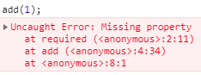

1. Create a function which calls some API and logs array of ‘name’ fields in alphabetical order. Use promises.
2. Rewrite previous task using async/await instead of promises.

***Extra information for tasks 8-9:***

* To call API use `fetch`. <https://developer.mozilla.org/en-US/docs/Web/API/Fetch_API/Using_Fetch>
* Run `.json()` on fetched data to be able to work with retrieved information
* Use these endpoints:
* [https://api.github.com/users/${yourUser}/repos](https://api.github.com/users/electricera/repos) , where yourUser - is your username. (GitHub API, returns your repositories, you can log out names of your repositories)

or

* <https://jsonplaceholder.typicode.com/users> (JSONPlaceholder API, returns random information, log out names of people)

## RESTRICTIONS

* Do not use any external libraries

## BEFORE SUBMIT

* Check if invocation examples are working with your code;
* Check file structure;
* Check code structure (remove unnecessary code/comments).

**SUBMIT**

* The folder should be uploaded to github repository '**FL11**' into **master** branch