* Moving 1 model following a smooth cubic spline trajectory with 4 control points.
* Changing the interpolation to add geodesic distance interpolation such that the model is always moving at a constant world-space speed on the spline
* Created 50 models to form a boid flock. Lead the flock using the model moving on the spline. Tuned the boids parameters (alignment, separation, and cohesion) so that the flock behaves more natural.
* The heads of the boids will always point at the direction of movement.

Cubic spline is visualized by gizmo. The sphere will move along the cubic spline.

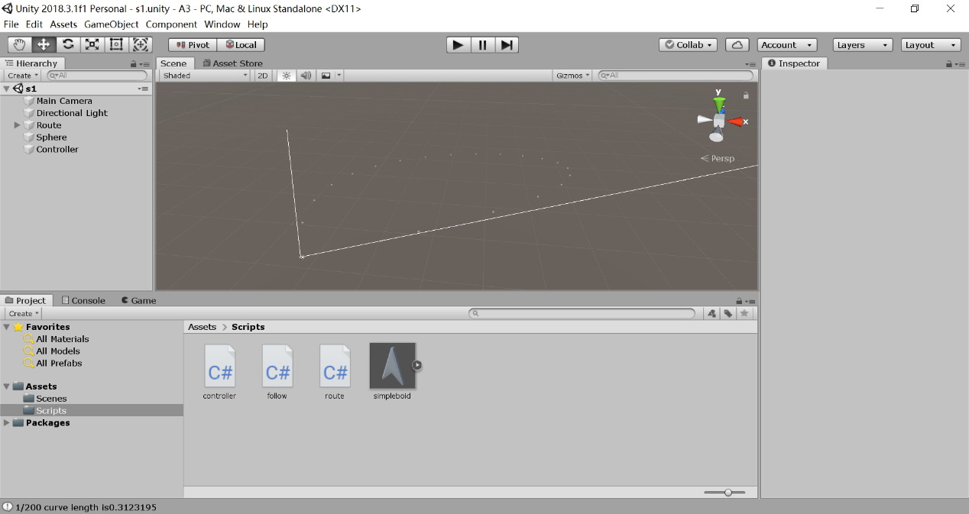

After pressing start, boids spawn and move toward the sphere

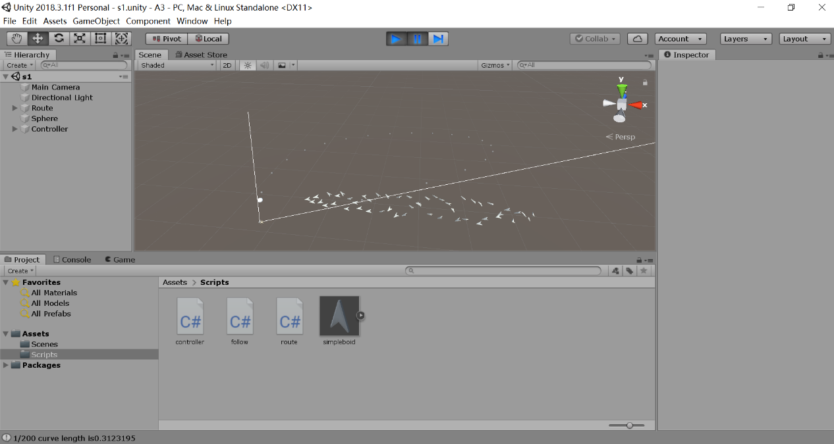

When the boids are close enough to the sphere, it will perform alignment, cohesion, and separation based on the parameters.

