Equal Width Bin Edges (4 bins):

[20.703125 27.24609375 33.7890625 40.33203125 46.875001 ]

DataFrame head with Equal Width BMI Groups:

孕妇BMI 孕妇 BMI BMI_Group_Equal BMI 分组相等

0 28.125000 Equal_Bin_2 相等分组 2

1 28.515625 Equal_Bin_2 相等分组 2

2 28.515625 Equal_Bin_2 相等分组 2

3 28.906250 Equal_Bin_2

4 33.331832 Equal_Bin_2

Calculating time to target Y concentration for Decision Tree Binning...

Time to target DataFrame head (for Decision Tree Binning):

孕妇代码 孕妇BMI 孕妇 BMI 达标时间

0 A001 28.515625 20.142857

1 A002 33.962434 13.857143

2 A003 31.226562 13.000000

3 A004 28.721359 11.000000

4 A005 31.077778 12.285714

Optimal BMI Split Points for Decision Tree Binning (3 splits):

[28.525752067565918, 36.92152786254883, 38.16303253173828]

DataFrame head with Decision Tree BMI Groups:

孕妇BMI 孕妇 BMI BMI_Group_DT BMI 集团 DT

0 28.125000 DT_Bin_1

1 28.515625 DT_Bin_1

2 28.515625 DT_Bin_1

3 28.906250 DT_Bin_2

4 33.331832 DT_Bin_2

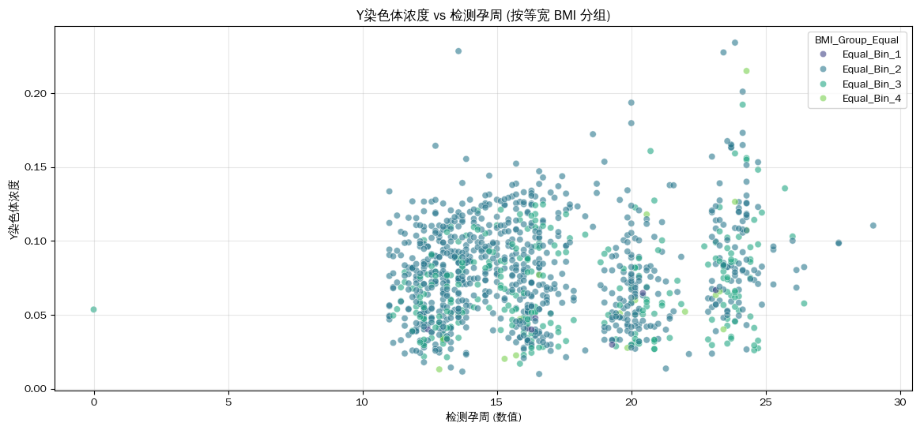

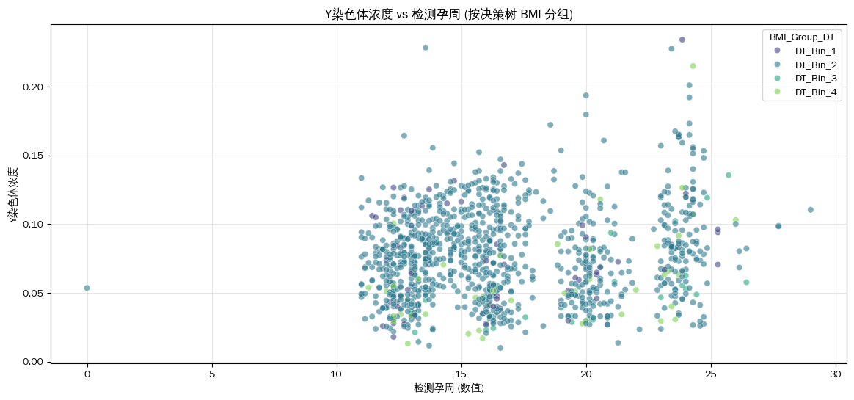

/tmp/ipython-input-2362922889.py:135: FutureWarning:

Passing `palette` without assigning `hue` is deprecated and will be removed in v0.14.0. Assign the `x` variable to `hue` and set `legend=False` for the same effect.

sns.boxplot(data=df_male_fetus, x='BMI_Group_Equal', y='Y染色体浓度', palette='viridis')

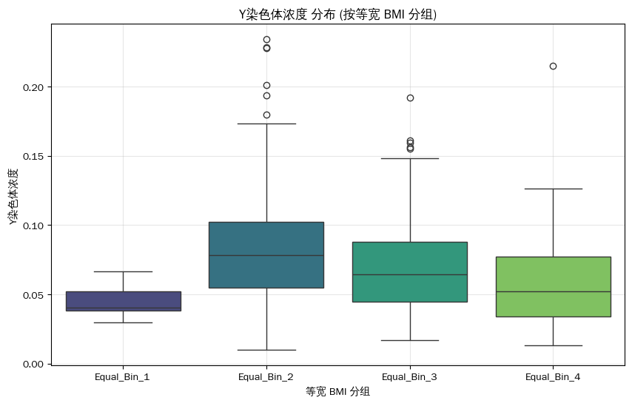

/tmp/ipython-input-2362922889.py:145: FutureWarning:

Passing `palette` without assigning `hue` is deprecated and will be removed in v0.14.0. Assign the `x` variable to `hue` and set `legend=False` for the same effect.

sns.boxplot(data=df_male_fetus, x='BMI_Group_DT', y='Y染色体浓度', palette='viridis')

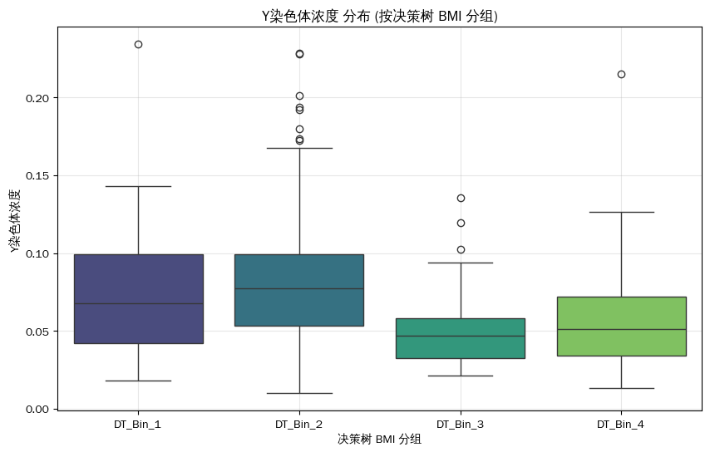

Summary Statistics by Equal Width BMI Group:

/tmp/ipython-input-2362922889.py:157: FutureWarning: The default of observed=False is deprecated and will be changed to True in a future version of pandas. Pass observed=False to retain current behavior or observed=True to adopt the future default and silence this warning.

equal_group_stats = df_male_fetus.groupby('BMI_Group_Equal')[['孕妇BMI', '检测孕周_数值', 'Y染色体浓度']].agg(['mean', 'std', 'count'])

孕妇BMI 孕妇 BMI 检测孕周_数值 Y染色体浓度

mean 平均 std count mean std count 计数 mean 均值 std 标准差 count 计数

BMI_Group_Equal BMI 分组相等

Equal_Bin_1 23.782352 3.297343 8 17.160714 3.622442 8 0.045491 0.013670 8

Equal_Bin_2 相等分组 2 31.007931 1.557253 792 16.512446 3.964001 792 0.080556 0.033457 792

Equal_Bin_3 35.697204 1.537379 265 17.592453 4.395344 265 0.068717 0.030701 265

Equal_Bin_4 42.833654 2.313280 17 19.630252 3.998424 17 0.067149 0.050709 17

Summary Statistics by Decision Tree BMI Group:

/tmp/ipython-input-2362922889.py:181: FutureWarning: The default of observed=False is deprecated and will be changed to True in a future version of pandas. Pass observed=False to retain current behavior or observed=True to adopt the future default and silence this warning.

dt_group_stats = target_time_with_groups.groupby('BMI_Group_DT')[['孕妇BMI', '达标时间']].agg(['mean', 'std', 'count'])

孕妇BMI 孕妇 BMI 达标时间

mean std count mean std count 计数

BMI_Group_DT BMI 集团 DT

DT_Bin_1 28.033164 1.804050 20 13.950000 2.777567 20

DT_Bin_2 32.114308 2.091089 226 13.318584 2.531758 226

DT_Bin_3 37.175359 0.309077 4 20.107143 6.092680 4

DT_Bin_4 40.559998 2.067568 10 15.500000 3.487100 10