Timestamped Market Judgment Portfolio
Original evidence, translations, and outcome tracking

Evidence Standard
Verified cases are ordered from newest to oldest.
Original screenshots are embedded where available. Original Chinese wording is kept separate from English translation and later interpretation.
Subsequent price action is recorded separately so that later outcomes do not alter the original call.
Unverified oral or personal recollections are kept in a separate section and are also ordered newest to oldest.
This is a personal market-judgment record, not an audited investment-performance statement.

Verified Case Summary
Date | Case | Asset(s) | Core Call | Evidence | Status
2026-09-03 | MU Initial Call | MU | Next-session test of 1000 | Public timestamped post | VERIFIED
2026-09-04 | MU Thesis Update | MU | After 1000, expect consolidation rather than runaway continuation | Public timestamped comment | VERIFIED
2026-08-12 | MSTR / COIN | MSTR / COIN / BTC | Bullish BTC-linked rotation / options-positioning view | Timestamped chat | VERIFIED
2026-07-24 | TSLA | TSLA | Entry ~$303-310; target ~$330; ~1 week | 2 timestamped chats | VERIFIED
2026-06-26 | ON | ON | Avoid immediate entry after 23% drop; possible rebound but downside risk remained | Timestamped chat | VERIFIED
2025-01-26 | BABA / PDD | BABA / PDD | Bullish cross-stock inference from NVDA overnight action | Public dated post | VERIFIED

Current Open Call
UBER — Open Call, 2026-09-04
“Cybercab could be a catalyst for Uber. The conditions for a short squeeze appear to be in place, although it may require a longer period to validate. I hope the move develops within this month.”
Status: OPEN — outcome not yet known.

1.1 Initial Call - 2026-09-03
Evidence status: VERIFIED / TIMESTAMPED
Platform: Xiaohongshu public post
Displayed post time: Yesterday, 22:09 (screenshot captured on 2026-09-04)
Post on Xiaohongshu:
Will Micron surge to 1000 tomorrow?
Outcome: The target area was subsequently reached during the following session.

Figure 1. Original public MU post showing the 22:09 timestamp and next-session 1000 call.

1. MU - Initial 1000 Call and Next-Day Thesis Update

1.2 Thesis Update - 2026-09-04
Evidence status: VERIFIED / TIMESTAMPED
Platform: Xiaohongshu public comment reply
Post on Xiaohongshu
It doesn't look like there will be a major surge; it will probably just oscillate around for a while.
Outcome: MU fluctuate around 1000, high to 1007, down to 992 after the post and before 3:30 PM on 9/4/2026.


Figure 2. Original public MU follow-up comment showing the next-day thesis update.

2. MSTR / COIN - Options-Positioning Call
Timestamp: 2026-08-12, approximately 14:55-15:01
Assets: MSTR, COIN, BTC
Core call: Possible bullish rotation in BTC-related names, with supportive market and options-positioning behavior in MSTR.
Conversation between a friend and Me
Me: “Let me explain why I think options on this stock may be worth trading. Since you did not buy today, you may have avoided a loss, but I’ll share my reasoning for reference.
- I believe market rotation may be moving toward Bitcoin-related names. Bitcoin has consolidated for quite a while, so I think it has room for an upward move. Based on their market behavior, MSTR and COIN also appear to have that possibility.
- MSTR’s options chain itself shows a similar tendency. I believe there was significant participation from large market players last Friday.”
Outcome: At the time of the original call, MSTR was trading at approximately $94.80. By September 4, 2026, the stock had risen to approximately $142.00, an increase of about 49.8%. This subsequent move was consistent with the bullish view expressed in the original conversation.
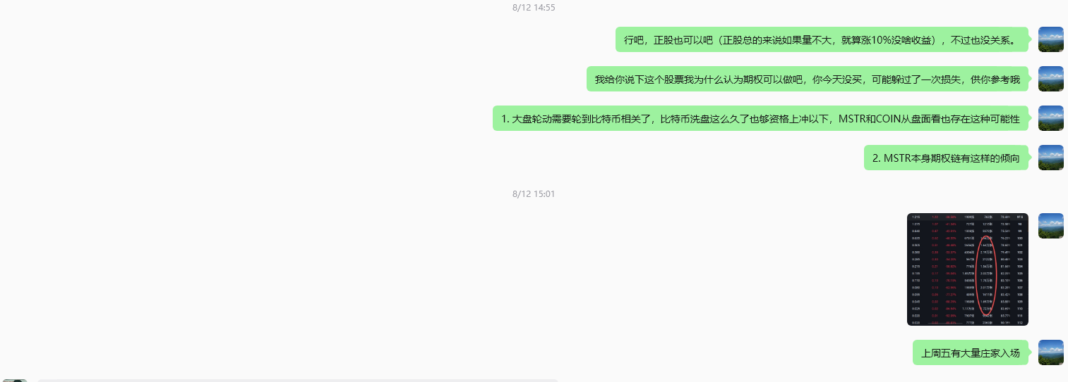
Figure 3. Original timestamped MSTR/COIN/BTC chat evidence.

3. TSLA - Short-Term Timing Call
Timestamp: 2026-07-24, approximately 22:57-23:09
Asset: Tesla (TSLA)
Entry plan: Around $310; more aggressive entry around $303 or near the Monday close.
Target: Around $330
Expected return: Approximately 6-10%
Expected horizon: Roughly one week
Conversation between a friend and Me
Friend: “Do you think the current market conditions in SpaceX and Tesla present a good opportunity?”
Me: “I uninstalled the software. [Facepalm]”
Me: “Let me reinstall it and take a look.”
Friend: “Hahaha.”
Me: “Brother Feng, my suggestion is that you should hold back and wait for a full cycle. Doing T-trades like this is similar to thinking about making 20% every day. If you keep doing it, it can become a habit and affect your judgment of the bigger market picture.”
Me: “Then we can look more specifically at the recent price action.”
Me: “TSLA has already used up most of its downside for this month. For a normal stock, especially one that has a major influence on the broader market, the monthly decline usually cannot be too extreme.”
Me: “Since TSLA has already used up its downside allowance for this month, that means over the next few days, before the end of the month, you can buy if it comes to around 310.”
Me: “Then sell around 330.”
Friend: “I don’t really understand this, so I’m asking for your advice. If you think the time is right, let me know. Thank you!”
Me: “You can buy now.”
Me: “TSLA.”
Me: “And if you buy it, you should sell around 330.”
Me: “You have about one week to make this round trip.”
Me: “If it gets close to 310, just enter.”
Me: “Once it gets to 330, sell and exit.”
Me: “Your profit range is about 6%.”
Me: “Based on Tesla’s usual behavior, I think it may print another red day next Monday to make everyone feel hopeless.”
“Entering near the end of the trading session would be relatively safer.”
Me: “Do not trade SPCX. It has no clear bottom and no clear top. At this stage, the large market players can push it either way. Overall, I think it still needs to move lower. Institutions are unlikely to drive it higher until they have accumulated enough shares.”
Me: “To summarize: TSLA is tradable. Buy next Monday if you are looking for roughly a 6–10% profit opportunity.”
Friend: “Got it. I bought a few thousand dollars’ worth of Tesla to try it.”
Me: “There are two ways to enter: one is to set a buy order at 303 and wait for the price to come down to it; the other is to buy at the market near the end of the trading session.”
Me: “Good luck.”
Outcome: After the original call, TSLA declined to approximately $297.38 that month and then rebounded to approximately $328 within about one week. This price path was broadly consistent with the original expectation that the stock could experience additional short-term weakness before rebounding toward the $330 target area.
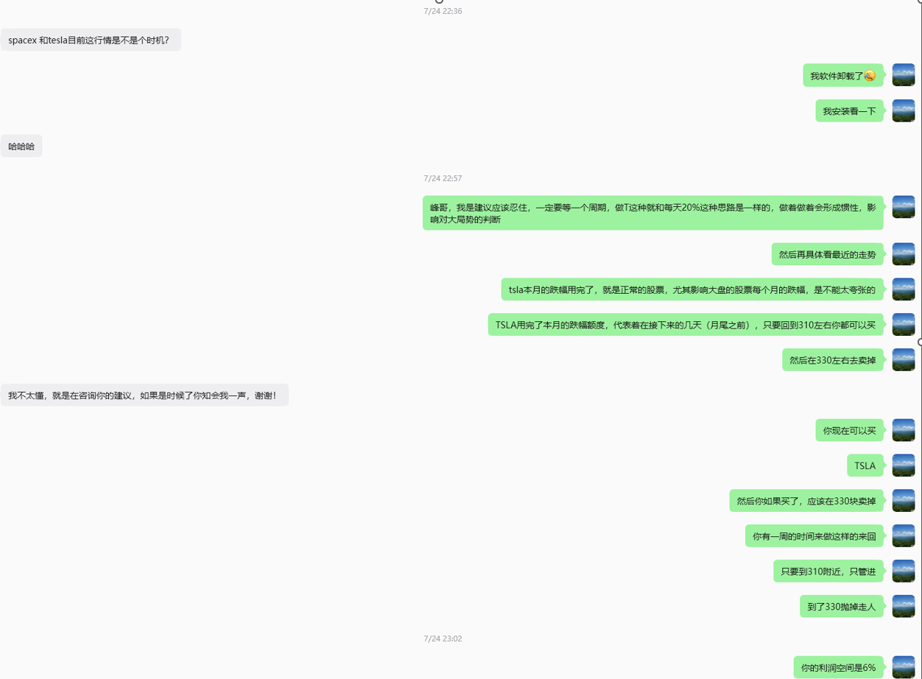
Figure 4. Original timestamped TSLA chat evidence (part 1).
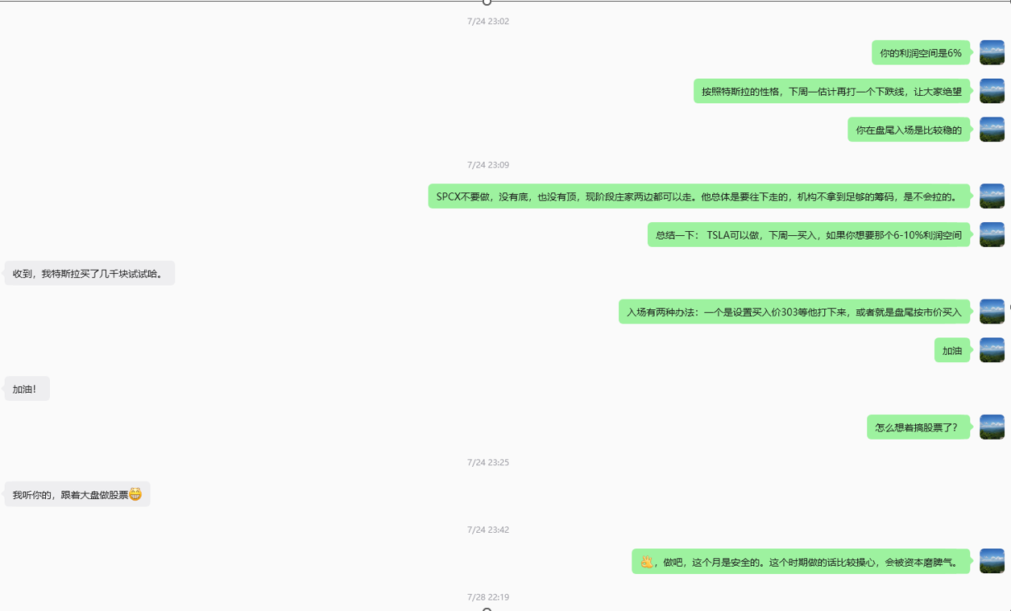
Figure 5. Original timestamped TSLA chat evidence (part 2).

4. ON Semiconductor - Post-Drop Caution Call
Timestamp: 2026-06-26, 20:12
Asset: ON Semiconductor (ON)
Context: The other participant noted that ON had fallen about 23% and asked whether the stock was buyable.
Core judgment: Avoid immediate entry. A rebound was possible, but further downside was also considered plausible. For a longer-term position, wait for a recovery to around $120 as confirmation; for a short-term trade, the setup was not attractive.

Conversation between a friend and Me
Friend: “ON is down 23%.”
Friend: “Can I buy the stock?”
Me: “This stock is difficult to judge. I estimate the institutions’ cost basis to be around $50. In 2023, when most stocks were going up, this one was falling. I believe accumulation started in 2025. Based on the positioning, it could be a possible entry, but there are two issues right now, so you need to be very careful.
I think the broader market is going to have a significant decline at some point, possibly after the midterm elections or around the time OpenAI goes public.
In a normal bottoming process, it is unusual for the percentage of profitable positions to fall directly from around 100% to 20% within only a few days. That is something worth being cautious about.”
Me: “The stock may rebound somewhat. It may even fail to rebound in the near term; a more likely possibility is that it continues falling first, creating room for a rebound, and then pulls back again.
If you are thinking about holding it for the long term, I would wait until the price rises back to around $120 — although I think the probability of that is low — to confirm that there is no trap.
For a short-term trade, I don’t think it is worth doing either. I estimate its underlying cost basis to be around $50.”
Outcome: ON closed at approximately $90.65 on June 26, 2026, after falling 23.66% that day from the previous close of $118.74. The stock then rebounded, reaching an intraday high of about $102.64 on July 9, but it never recovered to the $120 confirmation level mentioned in the original conversation. After that rebound, ON weakened again and was trading around $73–74 by early September 2026.
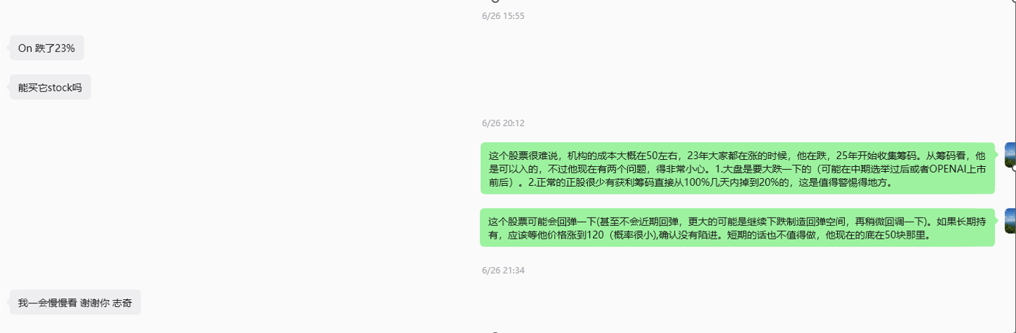
Figure 6. Original timestamped ON chat evidence.

5. BABA / PDD - Cross-Stock Inference from NVDA
Displayed date: 2025-01-26, United States
Platform: Xiaohongshu public post
Signal source: NVDA overnight trading
Post on Xiaohongshu
I took a look at NVDA's overnight session. Could PDD and BABA be about to rise?
Outcome - PDD: Approximately $109 to $133 over the following two weeks (~+22%).
Outcome - BABA: Approximately $89 to $126 over the following three weeks (~+41.6%).
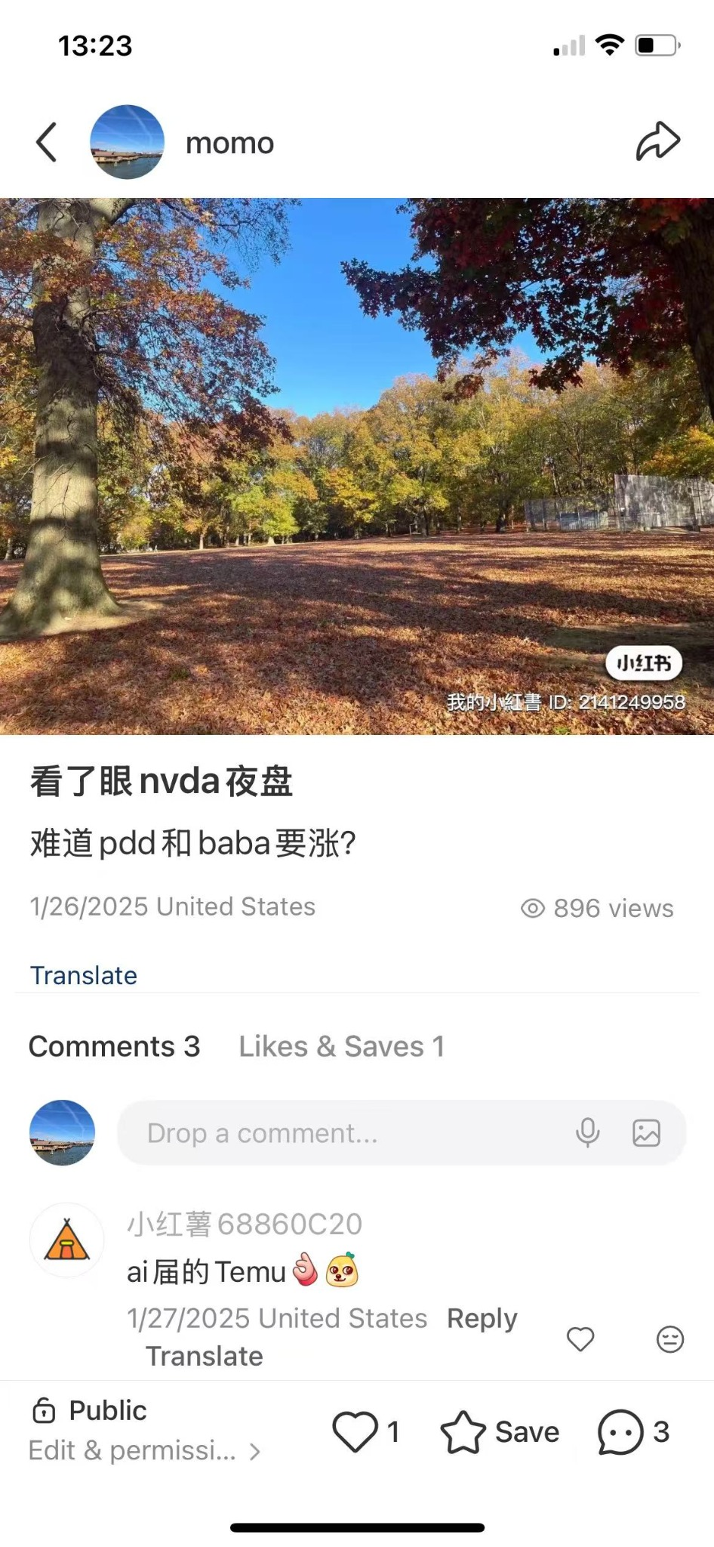
Figure 7. Original public BABA/PDD post dated 2025-01-26.

6. Unverified Personal Recollections
These are retained for personal reference only and should not be presented as timestamp-verified calls.

6.1 PATH - Verbal Recommendation | Mid-June 2026
Recollection: Verbal recommendation made to a friend during an in-person conversation at a playground; friend reportedly entered around $11+.
Outcome: PATH touched $18 recently.

6.2 SNOW - Early Entry / $370 Personal Target | Around 2026-06-01
Recollection: Recommended entering earlier rather than waiting for a deeper June pullback; friend reportedly entered around $270.
Outcome: SNOW hit 380 recently.

6.3 Target (TGT) - ~20% Return View | Xmas 2025
Recollection: During an in-person visit, when asked for a stock recommendation, the view was that TGT was attractive if a roughly 20% return would be satisfactory.
Outcome: Xmas $96 to $160 recently.
6.4 PBF /Iran Geopolitical-Risk Inference – Undocumented Private Intuition
In December 2025, a Two Sigma trader mentioned PBF to me. After reviewing the market action, I had an intuitive view that the stock could continue higher. Based on my own assumptions about the cost structure of oil-related stocks, I felt that greater geopolitical or market turbulence might be necessary to support further upside. This contributed to my private intuition that geopolitical risk involving Iran could increase.

