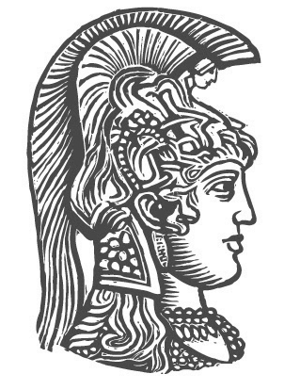
National and Kapodistrian
University of Athens

Department of Informatics and Telecommunications

Integrated system for spatially varying wind flow
and wildfire spread simulation - Evaluation with real data

Zisis M. Tsioumaras, Nikos Bogdos, Elias S. Manolakos (project PI)
{z.tsioumaras, bogdos, eliasm}@di.uoa.gr

Abstract
In this project we investigated the integration of WindNinja (WN), a tool for the modeling and simulation of spatially varying wind flow based on the terrain's topography, to FLogA, a tool for realistic simulation and geo-animation of a wildfire’s spread over Google Earth. The main objective was to allow FlogA, instead of using spatially uniform wind parameters, to take advantage of the spatially varying wind fields (wind direction and speed) obtained from WN. To begin with, we developed a program which visualizes the wind flow results by adjusting accordingly the visualization capabilities of WN in order to best serve the needs of FLogA. In addition, we conducted many wildfire simulation experiments using forest areas of varying wind grid and forest grid resolutions, with a view to assess the execution time overhead imposed by WN in contrast to the expected improvement in the accuracy of FLogA. Finally, we evaluated the integrated system performance using real data from 10 major wildfire cases in Greece (data provided by the National Observatory of Athens). We used 6 different methods to compare the ground truth against the simulation results, which were developed for the purposes of this work. The results of all of these tests indicate a marginal improvement in wildfire simulation accuracy when utilizing WN, but at the expense of a considerable increase in execution time.

Using WindNinja
WindNinja (WN) [1] is a computer program that generates spatially varying wind fields as it simulates the effect of terrain on the uniform wind flow. We chose WindNinja for the purposes of this project because it is free and open source program having an acceptable performance. It also requires a small amount of user input making simulations easy and provides a command line interface (CLI), which renders feasible the integration with FLogA.
We extend WN visualization capabilities by enabling it to display the wind speed using the vector length (Fig 1), apart from just using color. This is useful when simultaneously projecting a wildfire visualization (Fig 2). Also the wind field grid can now be resampled in order to reduce its resolution along with the file size of the visualization. The latter was crucial to smoothly visualize the simulated wind flow in case of a high wind grid resolution.

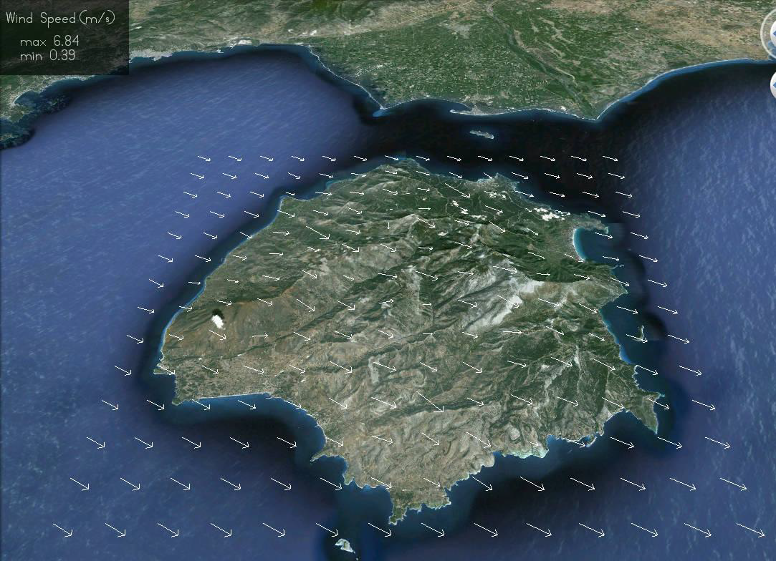

Fig 1. WindNinja visualization showing the wind speed information on the vector length, useful when displaying at the same time a wildfire visualization from FLogA (see Figure 2).

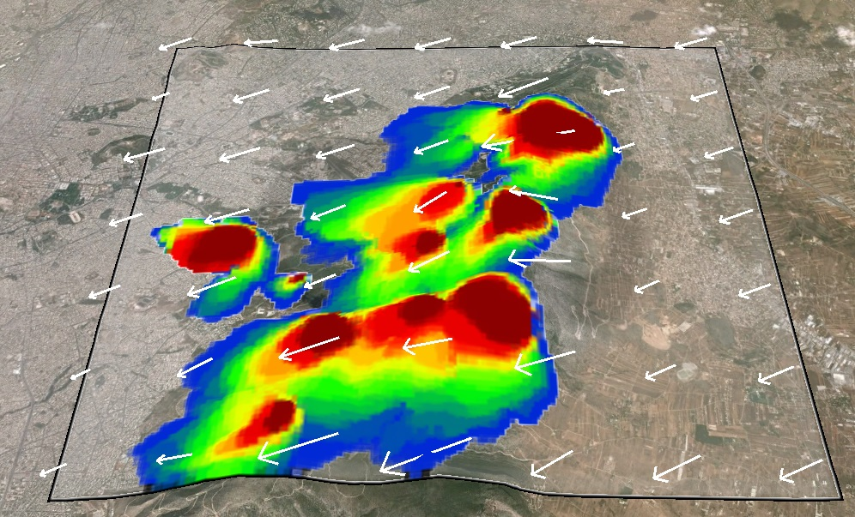

Fig 2. Example of visualization of a FLogA simulation result showing the joint result of the execution of many fire scenarios (color closer to dark red indicates higher burn probability) combined with the WN visualization result.

Execution time vs. Simulation accuracy: Tests using synthetic data
We developed a process to estimate the execution time overhead that the use of WN with varying wind grid resolutions is inducing to the wildfire simulations, while measuring the influence of finer wind field resolutions on the simulation accuracy. We assumed that the maximum accuracy would be obtained when the wind grid resolution and the forest cell grid resolution are equal in size and on this premise we compared this ideal scenario against coarser wind grid resolutions. For example if the forest cell is a square of side x, we execute WN for wind cell of side size x (ideal), 2x, 4x, 8x, 16x, 32x and 64x, thus forming the resolution ratio scenarios of 1-1, 1-2, 1-4 etc. Later, we measure the accuracy of every ratio scenario as:
Accuracy = (#cells ∩) / (#cells U)
Where (#cells ∩) is the amount of the burned forest cells inside the intersection between the ratio scenario 1-x and 1-1, and respectively the (#cells U) is the amount of the union cells. We used the same forest area in three resolutions (500x500 grid with cells of 54x54m, 375x375 grid with cells of 72x72m and 250x250 grid with cells of 108x108m). Also we used 3 wind speed scenarios: 3m/s, 5m/s and 7m/s. Each forest-wind scenario simulation produced a diagram (Fig 3) showing the ratio scenario accuracies along with a table containing the exact as well as aggregate accuracy values. Finally, a diagram was produced which summarizes the information from all simulations (Fig 4). This diagram displays average values for FLogA and WN execution times as well as the accuracy of each simulation group. Based on this diagram we conclude that the 1-4 ratio is the optimal choice, because WN execution time was lower in comparison to FLogA, while the accuracy was kept above 0.75 for all three forest resolutions.

Simulation accuracy evaluation: Tests using real data
Using real hotspot data provided by the National Observatory of Athens (NOA) we evaluated the system's performance based on 10 severe wildfires that occurred in Greece the summer of 2012. NOA data contain time-stamped hotspots-tiles of resolution 4x4km (Fig 5). For the evaluation we developed 6 comparison methods, which were used to assess different aspects of the FLogA performance; i.e. some methods were better on measuring FLogA's under-prediction while others could better detect over-prediction. For every wildfire case we created a diagram, which displays the accuracy against the real data as seen by each comparison method with and without the use of WN. Based on the 10 simulated wildfire cases we concluded that the use of WN effects marginal improvements in simulation accuracy (Fig 6), but at the expense of considerable increase in overall execution times. The average execution time without the use of WN was 5.4 min (with stdev 3.6 min), while with the use of WN was 30.4 min (with stdev 3.6 min).

References

FireLab-WindNinja,http://www.firelab.org/research-projects/hysical-fire/145-windninja
Bogdos, N., Manolakos, E.S., A tool for simulation and geo-animation of wildfires with fuel editing and hotspot monitoring capabilities, Environmental Modelling & Software (2013), http://dx.doi.org/10.1016/j.envsoft.2013.03.009
Zisis M. Tsioumaras, “Integrated system for spatially varying wind flow and wildfire spread simulation - Evaluation with real data”, MSc Thesis, University of Athens, 2014.
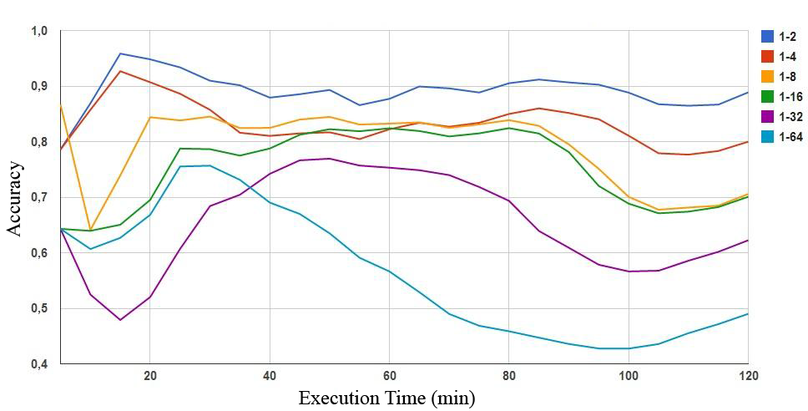
Fig 3. The visual outcome of the simulation accuracy using different combinations of varying wind grid and forest grid resolutions.

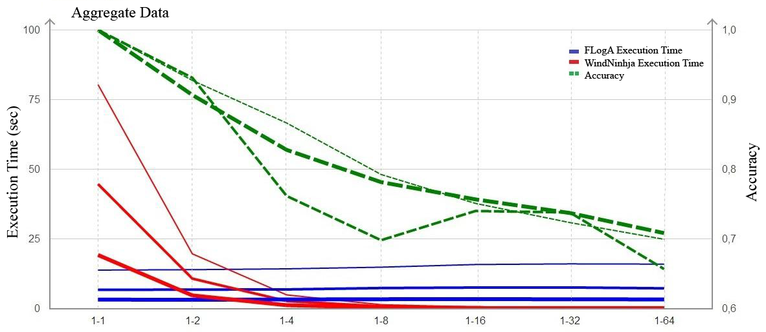
Fig 4. The diagram with aggregate data from all the simulations displays the FLogA and WindNinja execution times along with the accuracy achieved by each simulation group.

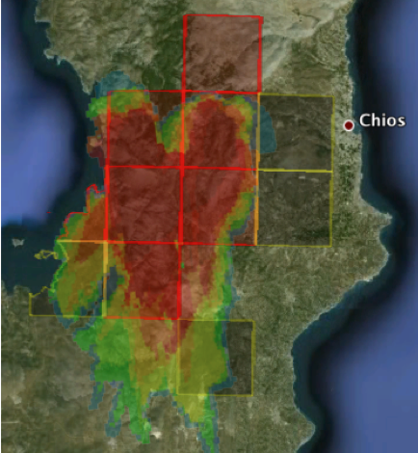
Fig 5. The 180th minute of the 2012 wildfire in Chios, Greece, as measured by the hotspot service of the National Observatory of Athens and predicted by the FLogA wildfire simulator.

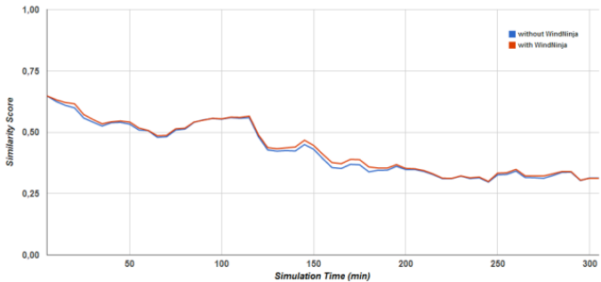
Fig 6. The diagram displays the marginal improvements in the accuracy of the simulation results against the NOA data (see Figure 5) with the use of WindNinja. The results displayed are aggregates obtained from the 10 major wildfire cases of the 2012 Greek summer.

