Lab05

Exercise 1:

Question1

a.

maximum size of the congestion window: 90-100

b.

When the congestion window reaches the maximum value of approximately 90 packets, the TCP flow detects packet loss or congestion. This causes the TCP flow to react by reducing the congestion window size. Specifically, TCP Tahoe, which is being used in this simulation, will reduce the congestion window size to 1 MSS (Maximum Segment Size) and re-enter the slow-start phase. The reason for that is TCP Tahoe uses a conservative approach to congestion control.

c.

Based on the plot, the Congestion window will reduce to 1MSS, and TCP will re-enter the slow start. After congestion window size increases hugely, it will reach threshold, t transitions to congestion avoidance mode, where the congestion window size increases linearly.

Question2:

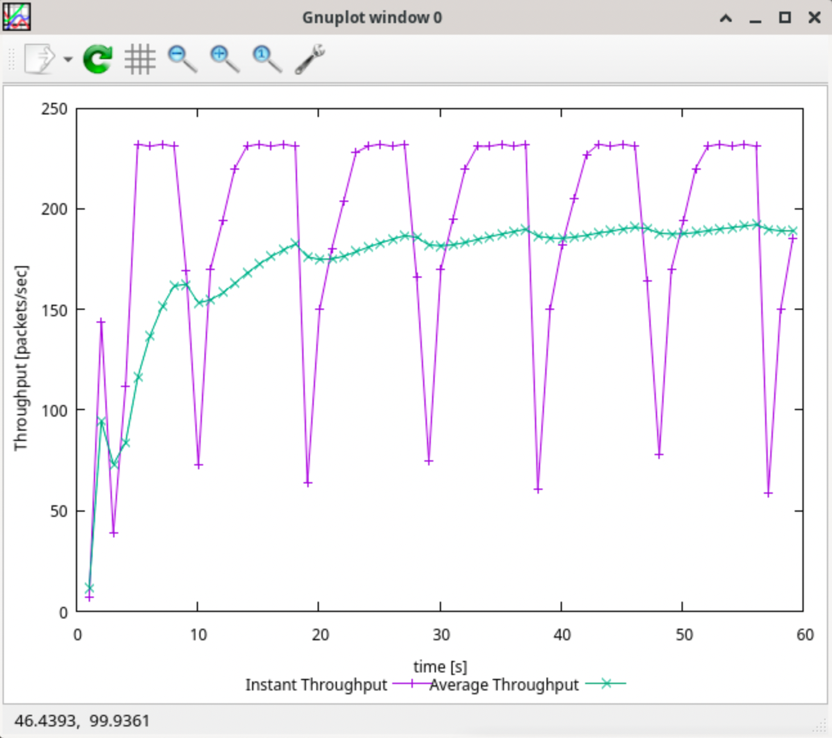

What is the average throughput of TCP in this case? (both in number of packets per second and bps)

Approximately

1.180 packets per seconds

Total packet size: 500 +20 +20 = 540 bytes *8= 4320

2. BPS: 180 packets/sec × 4320 bits/packet = 777600 bits/sec

Question3

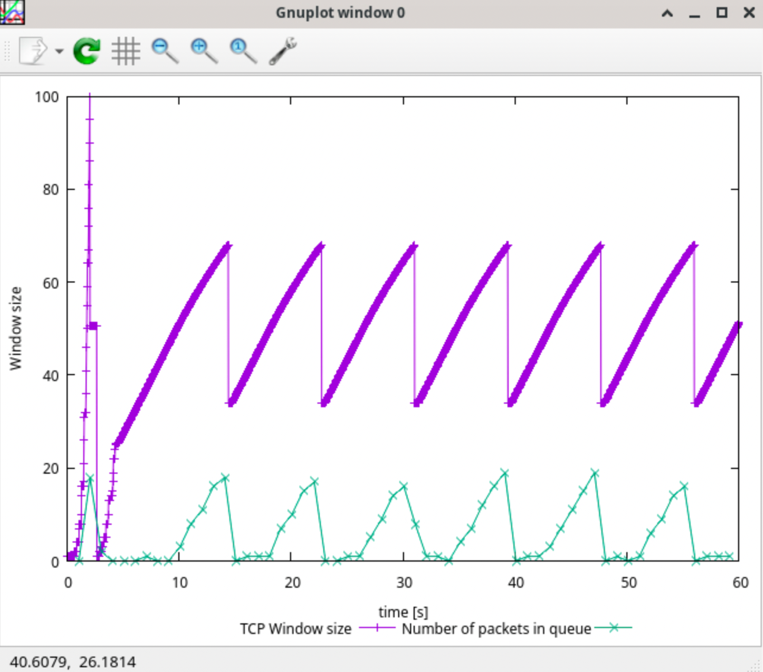

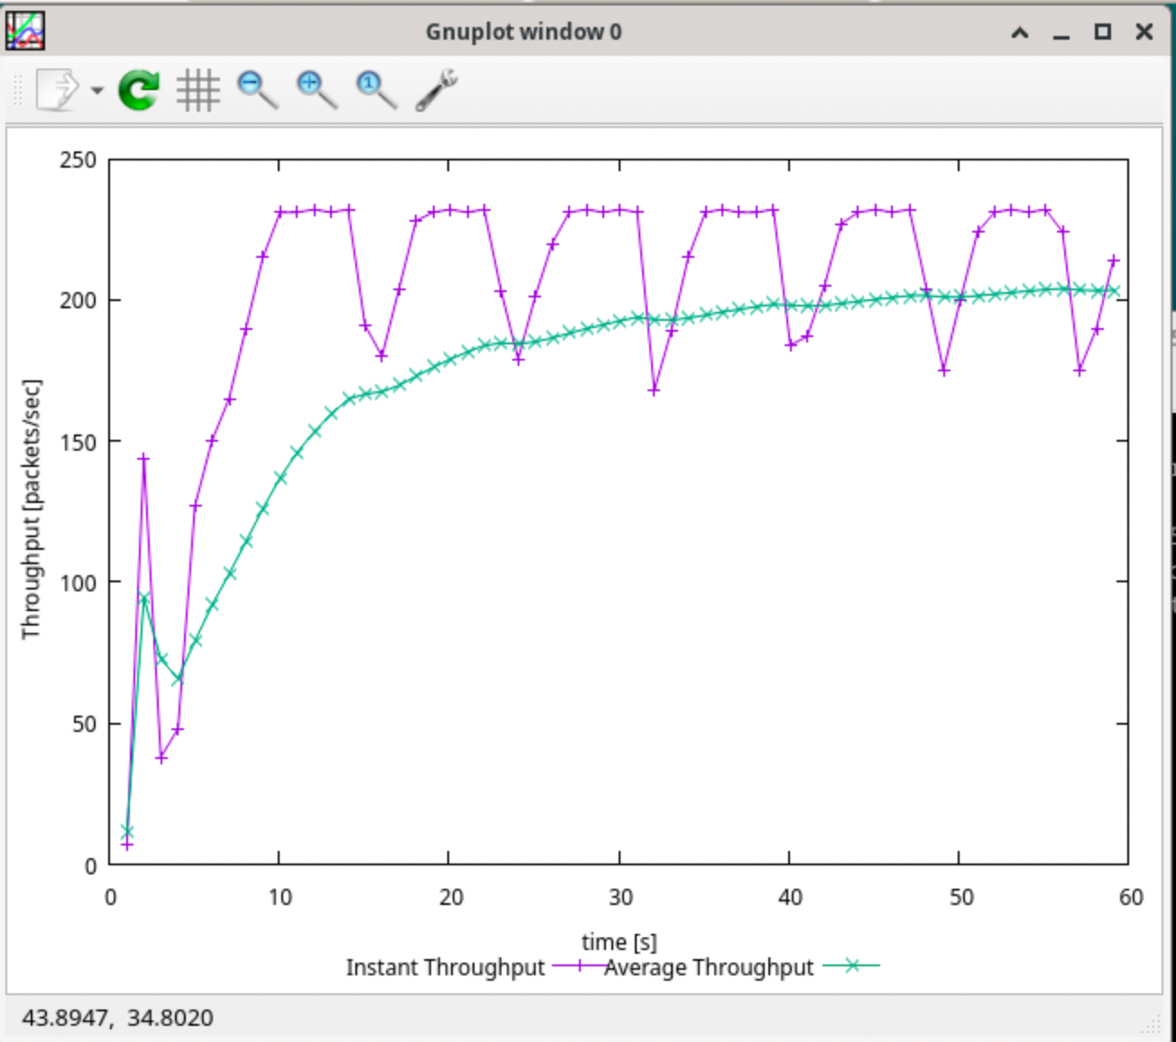

Compare with TCP Tahoe, TCP Reno's congestion window returns to zero fewer times, and growth is smoother because of the sender will cut the window size to 1/2 its current size if it receives three duplicate ACKs. And enter the congestion avoidance phase.

Exercise 2:

1. TCP reduces the congestion window size and transmission speed when it detects network congestion. Perhaps TCP1 is trying to recover lost packets or is affected by congestion on a higher network
2. In the slow start phase, after the window rapidly increases to the maximum value, it will decrease, resulting in sharp fluctuations. It is also possible that TCP2 starts to transmit data, which affects the throughput of TCP1

Exercise 3:

**Question 1:**Which nodes communicate with which other nodes? Which route do the packets follow? Does it change over time?

Node 0 and node 5 have communication.

Node 2 and node 5 have communication.

0-1-4-5

2-3-5

It will not change over time.

**Question 2:**What happens at time 1.0 and time 1.2? Does the route between the communicating nodes change as a result?

During time 1-1.2, the link of node 1 to node 4 is interrupted. The down sign below shows the status of link. the route is unchanged.

Question 3:

Yes, the route is changed during time1-1.2 . when 1-4 is interrupted, the route change to 0-1-2-3-5

Question 4:

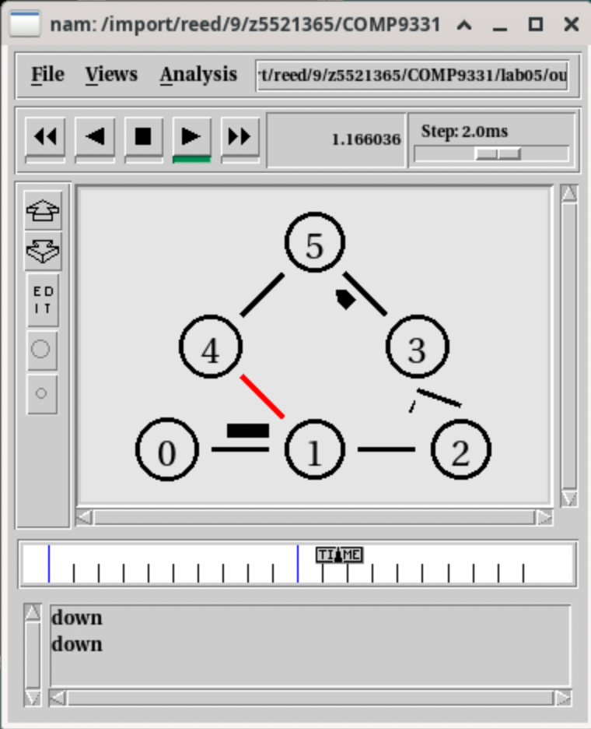

The route change to 0-1-2-3-5

Because route selection can be affected, so that the network avoids high-cost links and chooses a low-cost path. At the meantime , the 1-4 is also interrupted.

Question 5:

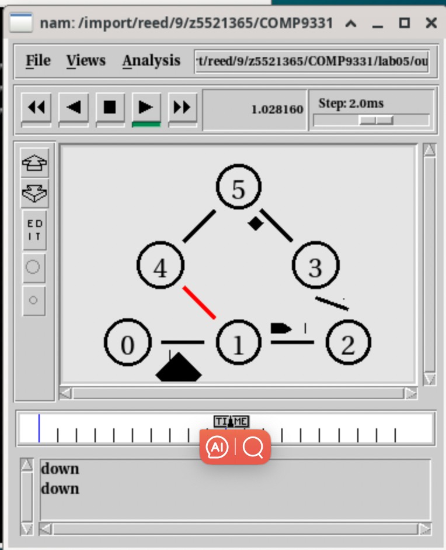

Node set multiPath_ 1 means that enable multiple route

Make route cost means that the path with the lowest cost is taken first.

Because 1-4 is interrupted, packet is lost and the network starts to recalculate the path, choosing other less expensive paths available (0-1-2-3-5).