Lab04

Name: Zixi Hong

Student id: z5521365

1.

IP address of gaia.cs.umass.edu : 128.119.245.12

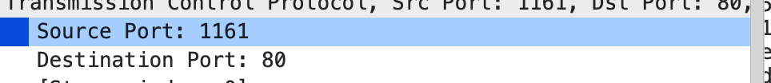

Source port: 1161

Destination port: 80

Client: 192.168.1.102

TCP port from client:1161

2.

sequence number of the TCP segment:232129013



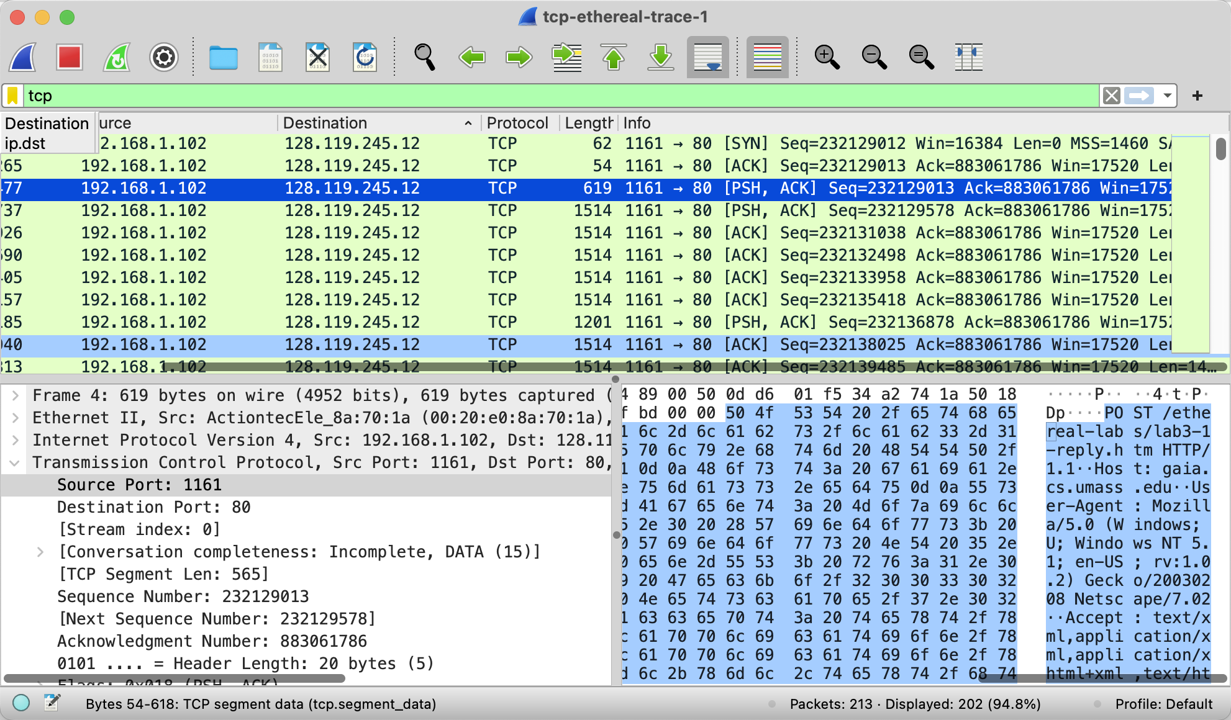

3.

From First segment to last:

Seq: 232129012

Seq: 232129013

Seq: 232129013

Seq: 232129578

Seq: 232131038

Seq:232132498

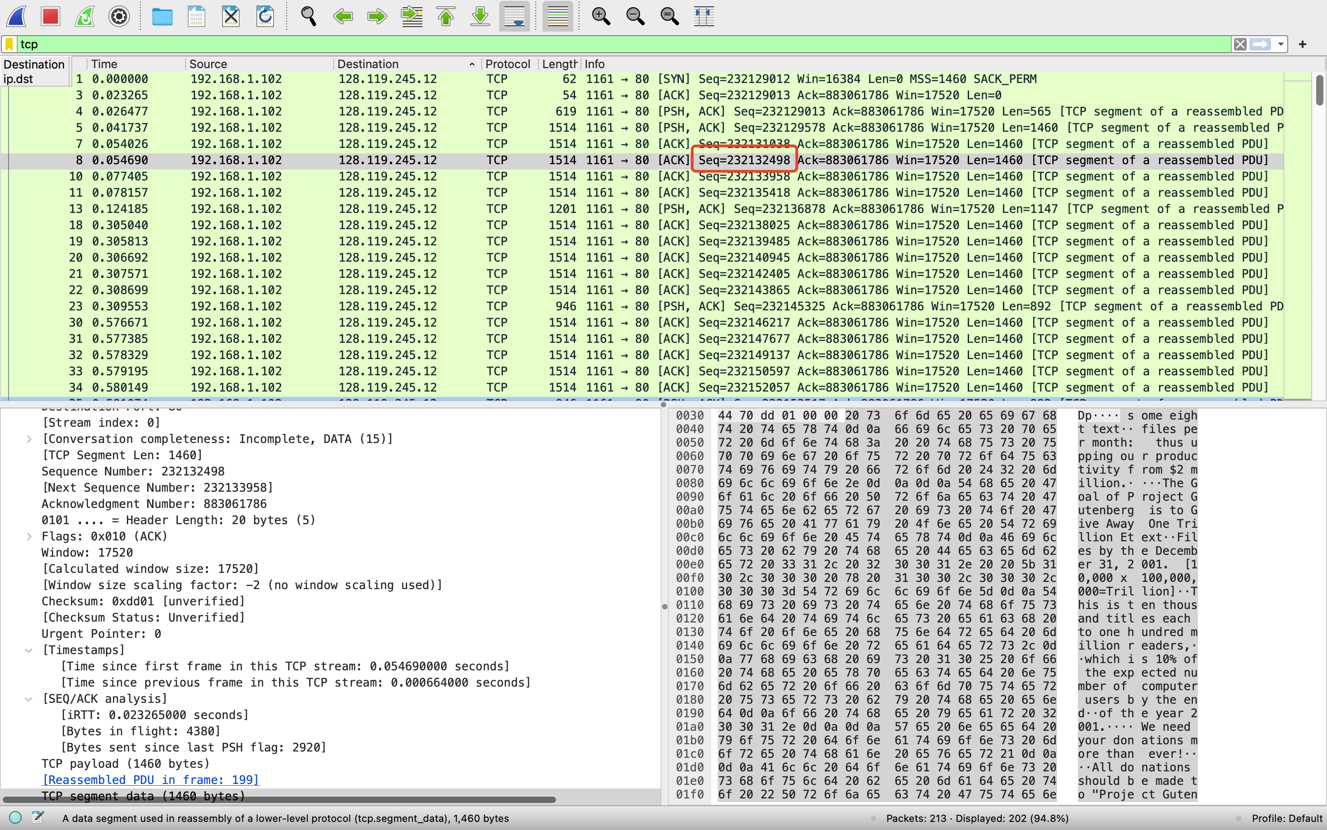

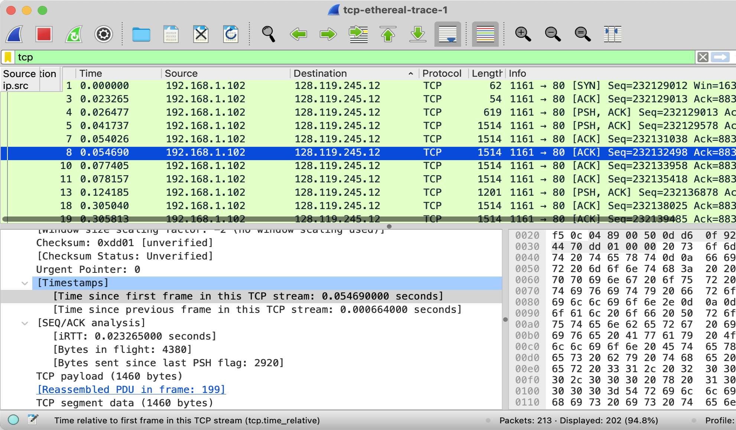



We can observe this from timestamp:

Segment 1:

Seq: 232129012



RTT：0.02326500

EstimatedRTT = 0.023265s



Segment 2:

Seq: 232129013

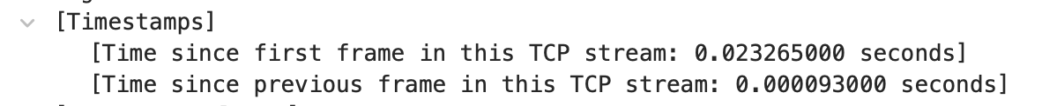

RTT: next sent – this sent = 0.003212

EstimatedRTT=(1−0.125)×0.023265+0.125×0.003212 =0.020760875

Segment 3:

Seq: 232129013

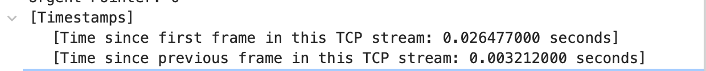

RTT:0.015626

EstimatedRTT=0.020119015625

Segment 4:

Seq: 232129578

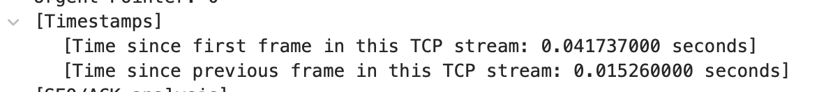

RTT: 0.012289s

EstimatedRTT=0.0191402626953125

Segment 5:

Seq: 232131038

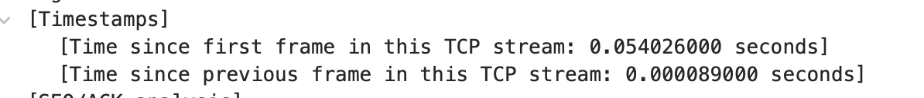

RTT: 0.000664s

EstimatedRTT=0.01683122998046875

Segment 6:

Seq:232132498

RTT: 0.077405 – 0.05469 = 0.022715s

EstimatedRTT=0.017568301982421874

4.

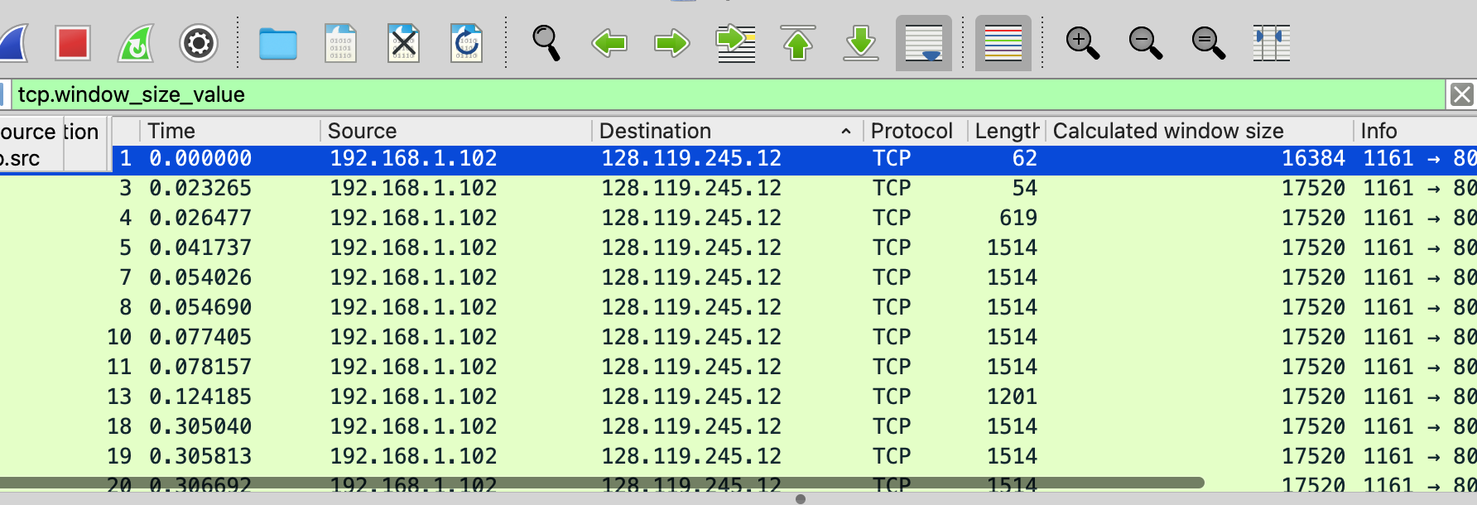

Minimum: 16384

There is no window size down to 0 which mean it doesn’t lack of receiver buffer space .

No , there is no retransmission segments

6.

Normally：Ack=2321314518 - Ack=2321313958 = 560

The amount of data confirmed between other acks is too large, which I can think of as delayed ACK. The diagram below:

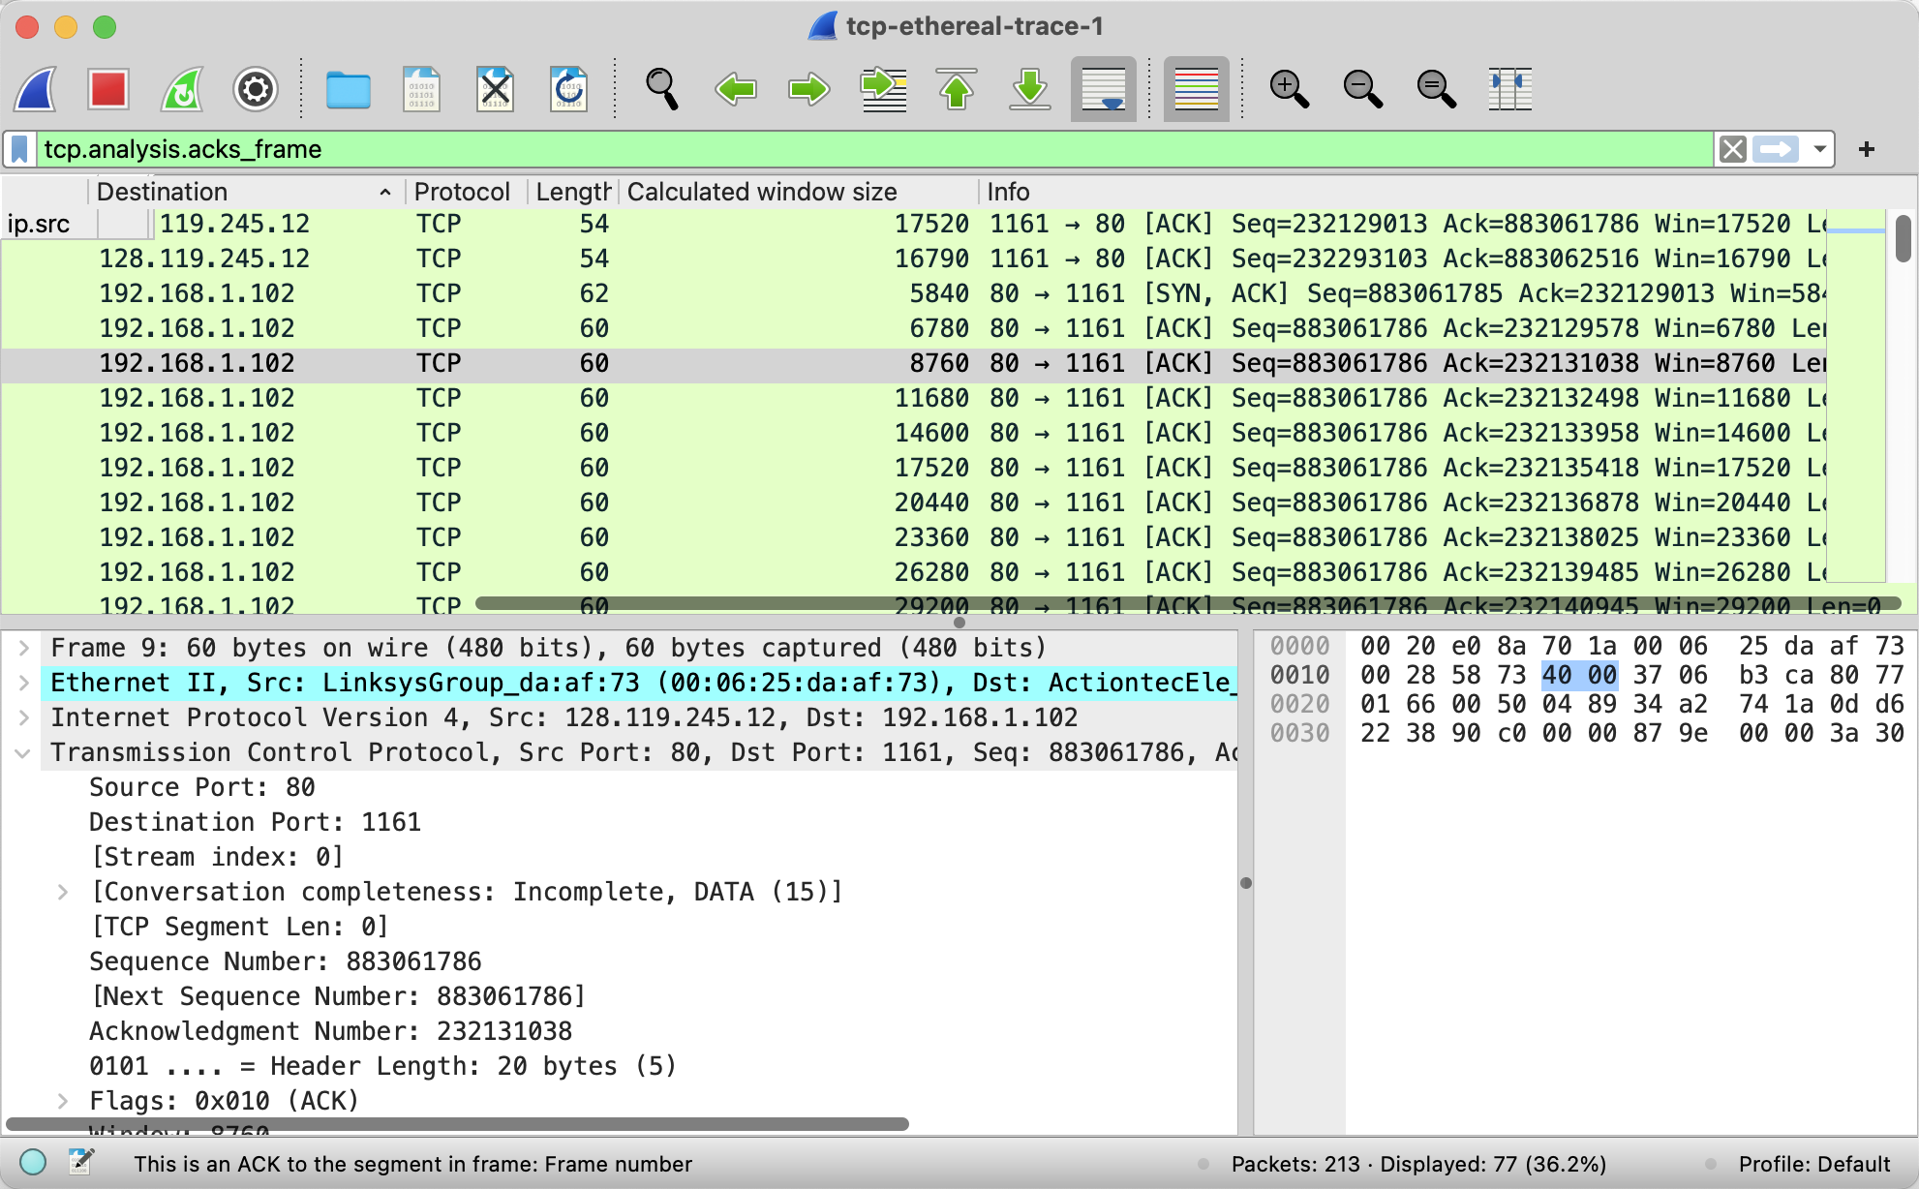

7.

Throughput = Total bytes transferred/connection duration

Question 2:

1. SYN seq:2818463618
2. SYNACK:1247095790. ACK:2818463619, server expect to send next seq number will be ack
3. Seq: 2818463619 ACK: 247095791 there is no data.
4. (1) Active close: The server (2) send a first FIN. (3) 4-segment closure (FIN/ACK/FIN/ACK)
6. **Data transferred from client to server**: 2818463652 - 2818463618 = 34 bytes
7. Data transferred from server to client: 1247095831 - 1247095790 = 41 bytes