**Compiler Construction Lab Mid**

Zia Ur Rahman

Fa20-BCS-082

Q1. Describe functioning of regex C# library, give examples of patterns, separators and anchors etc.

**Ans:**

The System.Text.RegularExpressions namespace in C# provides a powerful framework for working with regular expressions. Regular expressions (regex) are patterns used to match character combinations in strings.

**Functionality of the Regex Class:**

The Regex class provides methods for working with regular expressions in C#. Some of the key methods include:

**IsMatch:**

Checks if a regular expression matches a specified input string.

**Match:**

Searches an input string for a substring that matches a regular expression pattern. Returns the first match found.

**Matches:**

Searches an input string for all occurrences of a substring that matches a regular expression pattern. Returns a collection of matches.

**Replace:**

Replaces all occurrences of a specified regular expression pattern with a specified replacement string.

**Split:**

Splits an input string into an array of substrings based on a regular expression pattern.

**Common Patterns:**

* \d: Matches any digit (0-9).
* \w: Matches any word character (alphanumeric + underscore).
* \s: Matches any whitespace character (spaces, tabs, line breaks).
* . Matches any character except a newline.

**Quantifiers:**

* *: Matches 0 or more occurrences of the preceding pattern.
* +: Matches 1 or more occurrences of the preceding pattern.
* ?: Matches 0 or 1 occurrence of the preceding pattern.

**Character Classes:**

* [abc]: Matches any single character a, b, or c.
* [^abc]: Matches any single character except a, b, or c.
* [a-z]: Matches any lowercase letter.
* [0-9]: Matches any digit.

**Anchors:**

* ^ (Caret): Matches the start of a string.
* $ (Dollar Sign): Matches the end of a string.

**Q2. Output**

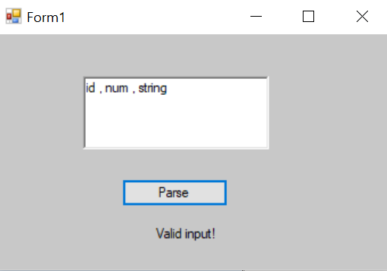

**Q3. Output**

