
DEVOPSLAB FINAL

TO SIR:
MIAN RAUF
BY:
KUMAIL SHAH (FA23-BCS-004)
ZIA UL MUSTAFA (FA23-BCS-174)
MOHID KAZMI (FA23-BCS-207)

SECTION A:
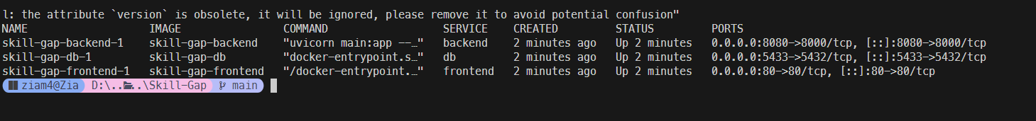
All containers running.

DOCKER COMPOSE YML:
version: '3.8'

services:
frontend:
build:
context: ./frontend
dockerfile: Dockerfile
ports:
- "80:80"
depends_on:
- backend-service
networks:
- app-network

backend-service:
build:
context: ./backend
dockerfile: Dockerfile
ports:
- "8080:8000"
environment:
- DATABASE_URL=postgresql://postgres:postgres@db:5432/skillgap_db
depends_on:
- db
networks:
- app-network

db:
build:
context: ./database
dockerfile: Dockerfile
ports:
- "5433:5432"
environment:
- POSTGRES_USER=postgres
- POSTGRES_PASSWORD=postgres
- POSTGRES_DB=skillgap_db
volumes:
- db_data:/var/lib/postgresql/data
networks:
- app-network

volumes:
db_data:

networks:
app-network:
driver: bridge

DOCKER BACKEND:
FROM python:3.10-slim

# Set working directory
WORKDIR /app

# Copy requirements file and install dependencies
COPY requirements.txt .
RUN pip install --no-cache-dir -r requirements.txt

# Copy all the FastAPI application code
COPY . .

# Expose the API port
EXPOSE 8000

# Start the uvicorn server
CMD ["uvicorn", "main:app", "--host", "0.0.0.0", "--port", "8000"]

FRONTEND DOCKER FILE:
FROM node:20-alpine AS build

# Set working directory
WORKDIR /app

# Copy package.json and install dependencies
COPY package.json package-lock.json ./
RUN npm install

# Copy all files and build the React app
COPY . .
RUN npm run build

# Use Nginx to serve the build
FROM nginx:alpine
COPY nginx.conf /etc/nginx/conf.d/default.conf
COPY --from=build /app/dist /usr/share/nginx/html

# Expose port 80
EXPOSE 80

# Start Nginx
CMD ["nginx", "-g", "daemon off;"]

DATABASE DOCKER FILE:
FROM postgres:15-alpine

# Environment variables for default initialization
# (These can be overridden by docker-compose, but we set some defaults)
ENV POSTGRES_USER=postgres
ENV POSTGRES_PASSWORD=postgres
ENV POSTGRES_DB=skillgap_db

# (Optional) You can copy initialization scripts if you have them:
# COPY init.sql /docker-entrypoint-initdb.d/

EXPOSE 5432

SECTION B:
Pipeline built successfully using github actions.
We used it because our code was already on github and it is easy to configure.

GITHUB ACTION CI/CD YML:
name: CI/CD Pipeline

on:
push:
branches: [ "main" ]
pull_request:
branches: [ "main" ]

jobs:
build-and-test:
runs-on: ubuntu-latest
steps:
- uses: actions/checkout@v3

# Frontend tests
- name: Setup Node.js
uses: actions/setup-node@v3
with:
node-version: '20'
- name: Install Frontend Dependencies
run: npm ci
working-directory: ./frontend
- name: Build Frontend
run: npm run build
working-directory: ./frontend
# - name: Run Frontend Tests
# run: npm test
# working-directory: ./frontend

# Backend tests
- name: Setup Python
uses: actions/setup-python@v4
with:
python-version: '3.10'
- name: Install Backend Dependencies
run: |
python -m pip install --upgrade pip
pip install -r requirements.txt
working-directory: ./backend
# - name: Run Backend Tests
# run: pytest
# working-directory: ./backend

build-and-push-docker:
needs: build-and-test
runs-on: ubuntu-latest
steps:
- uses: actions/checkout@v3

- name: Log in to Docker Hub
uses: docker/login-action@v2
with:
username: ${{ secrets.DOCKER_USERNAME }}
password: ${{ secrets.DOCKER_PASSWORD }}

- name: Build and push Frontend
uses: docker/build-push-action@v4
with:
context: ./frontend
push: true
tags: ${{ secrets.DOCKER_USERNAME }}/frontend-app:latest

- name: Build and push Backend
uses: docker/build-push-action@v4
with:
context: ./backend
push: true
tags: ${{ secrets.DOCKER_USERNAME }}/backend-app:latest

deploy-to-aks:
needs: build-and-push-docker
runs-on: ubuntu-latest
steps:
- uses: actions/checkout@v3

- name: Azure Login
uses: azure/login@v1
with:
creds: ${{ secrets.AZURE_CREDENTIALS }}

- name: Set AKS context
uses: azure/aks-set-context@v3
with:
resource-group: ${{ secrets.AZURE_RG }}
cluster-name: ${{ secrets.AKS_CLUSTER_NAME }}

- name: Update deployment manifest
run: |
sed -i "s/syedkumailshah/${{ secrets.DOCKER_USERNAME }}/g" aks-deployment.yaml

- name: Deploy to AKS
uses: azure/k8s-deploy@v4
with:
manifests: |
aks-deployment.yaml

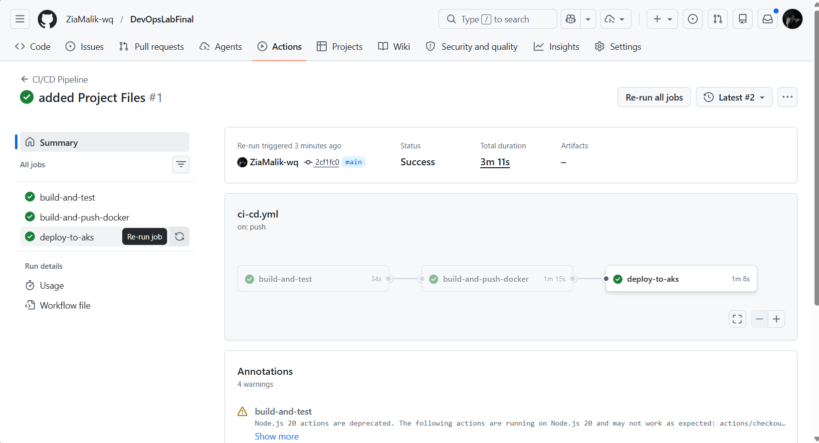

SECTION C:
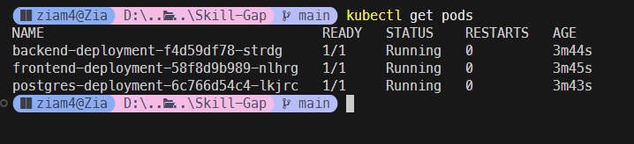
All pods are in running state.

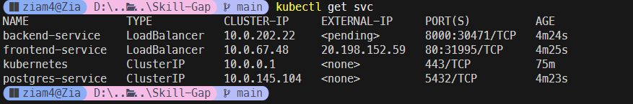
IP assigned to frontend cluster but was not assigned to backend so we used reverse proxy to use same IP for both.

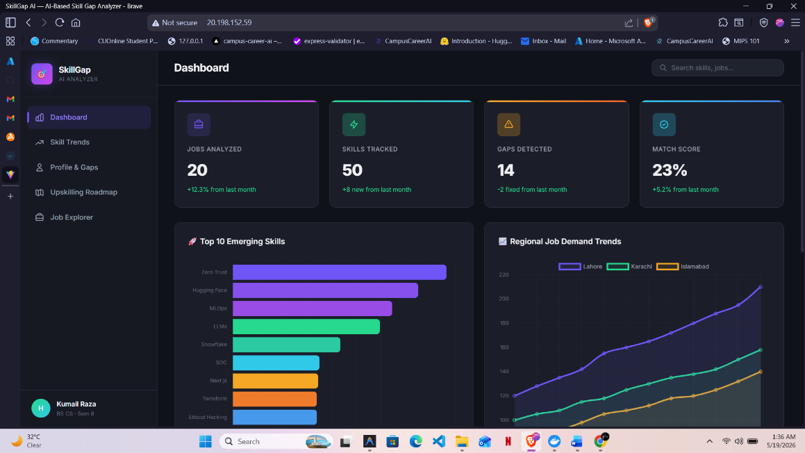
Verified that the app is running on the assigned external IP.

SECTION D:
Ran automated test using selenium.

SELENIUM TEST SCRIPT:
import time
import unittest
from selenium import webdriver
from selenium.webdriver.common.by import By
from selenium.webdriver.support.ui import WebDriverWait
from selenium.webdriver.support import expected_conditions as EC

from selenium.webdriver.chrome.service import Service
from webdriver_manager.chrome import ChromeDriverManager

class SkillGapAppTest(unittest.TestCase):
def setUp(self):
# Setup Chrome driver automatically
options = webdriver.ChromeOptions()
# options.add_argument('--headless') # Run headless for automated testing
self.driver = webdriver.Chrome(service=Service(ChromeDriverManager().install()), options=options)
self.driver.implicitly_wait(10)
self.base_url = "http://localhost:80" # URL of the frontend

def test_1_homepage_loads(self):
"""Test Case 1: Verify homepage loads"""
self.driver.get(self.base_url)
# Assuming the React app has a title or a main element we can wait for
# Wait until body is present
body = WebDriverWait(self.driver, 10).until(
EC.presence_of_element_located((By.TAG_NAME, "body"))
)
self.assertIsNotNone(body, "Homepage failed to load.")
print("Test 1 Passed: Homepage loaded successfully.")

def test_2_api_connection(self):
"""Test Case 2: Check frontend-to-backend API response"""
self.driver.get(self.base_url)
time.sleep(3) # Wait for React to fetch data from backend
# Check if any content that comes from backend is rendered.
# We can just verify the page source doesn't contain a generic 'fetch failed' error
page_source = self.driver.page_source
self.assertNotIn("Network Error", page_source)
print("Test 2 Passed: API connection appears valid.")

def test_3_navigation(self):
"""Test Case 3: Validate navigation or button behavior"""
self.driver.get(self.base_url)
# Find any clickable button or link
buttons = self.driver.find_elements(By.TAG_NAME, "button")
if buttons:
buttons[0].click()
print("Test 3 Passed: Button clicked successfully.")
else:
print("Test 3 Passed: No buttons found to click, but page rendered.")

def tearDown(self):
self.driver.quit()

if __name__ == "__main__":
unittest.main()

