**Mohammad Zia Ul Rahman**

**8341934186,**

[ZIA-UL-RAHMAN.MOHAMMAD@CAPGEMINI.COM](mailto:ZIA-UL-RAHMAN.MOHAMMAD@CAPGEMINI.COM)

**15-9-164, Kaviraj Nagar, Khammam, Pin code -507002**

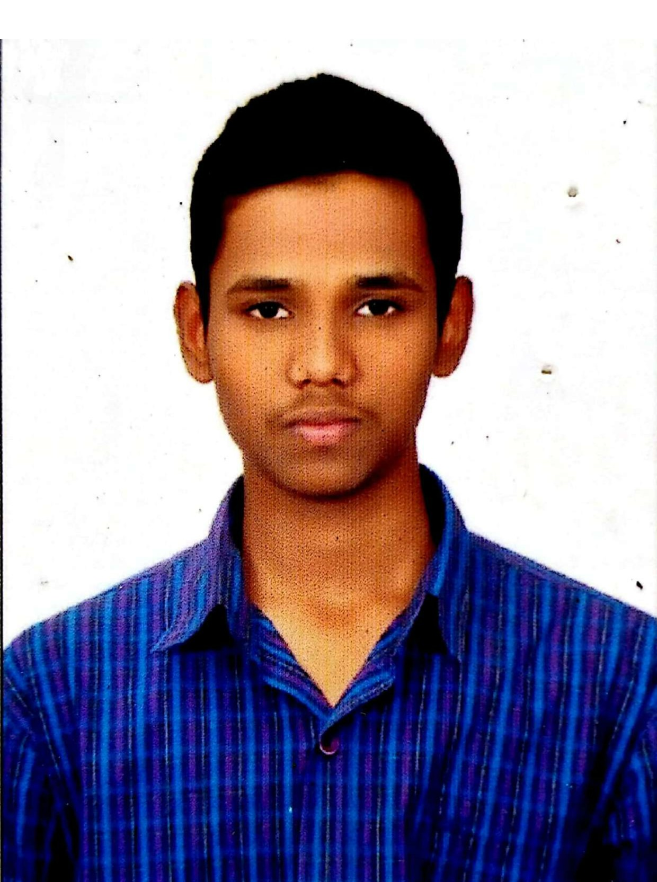

|  |  |
| --- | --- |
| **Title :** | Software Engineer (Analyst), |
| **Location :** | Khammam, Telangana, India |
| **Languages :** | English(fluent), Hindi(fluent), Telugu(fluent) |

# Experience Summary

**CAPGEMINI Technology Service India Limited | 2021 –**

JEEE full stack developing with Angular. With relational database (Postgres) developing application in back-end as well as front-end. Full Stack Java PostgreSQL, HTML, CSS, BOOTSTRAP JAVASCRIPT

**KEY SKILLS:**

* **Functional:** Project Management, Team Building, Team Leader, Strategic/Tactical Planning, Business Analysis and Development, Excellent Communication and Interpretation skills
* **Technical:** Core Java, PostgreSQL, Spring Framework, Git and Git Hub, HTML, CSS, Bootstrap, JavaScript, Angular.

# Experience

JEEE full stack with Angular has been technically trained by the Capgemini company within the three months of period. They involved all the technical business logics. They also trained about the soft skills which is very helpful in upgrading the skills in communication, presentation etc.,

##### 

# Higher Education

* **B-TECH(C.S.E)**
  + - VIJAYA ENGINEERING COLLEGE, KHAMMAM, TELANGANA
    - 2017-2021
* **INTERMIDIATE**
  + - SRI CHAITANYA JUNIOR COLLEGE, KHAMMAM, TELANGANA
    - 2015-2017
* **SSC**
  + - TRIVENI TALENT SCHOOL, KHAMMAM, TELANGANA
    - 2014-2015