Supervised by:
DR/Emad Raouf

Mohamed Amin Sewilam
Reg: 20109043
Contact: 01002984591

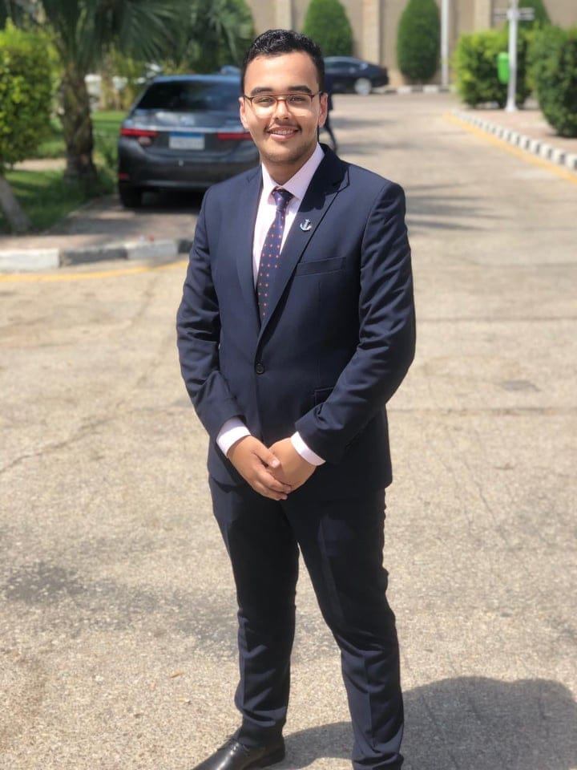

Ziad Hamed Mohamed
Reg: 20100373
Contact: 01203512705

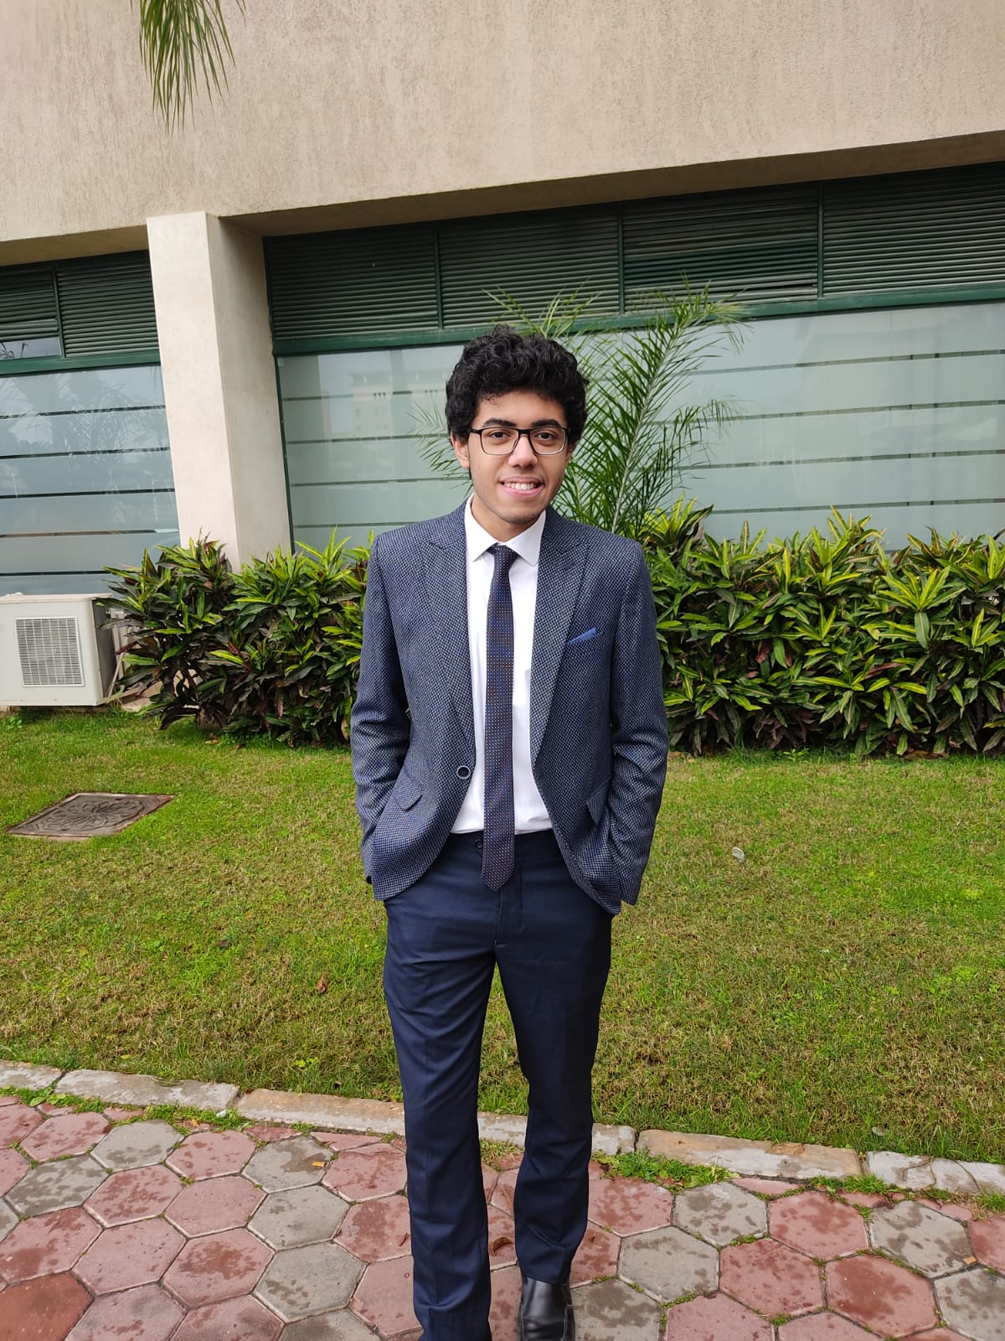

Abdallah Mohamed Hamed 20109594
Reg: 20109594
Contact: 01027583777

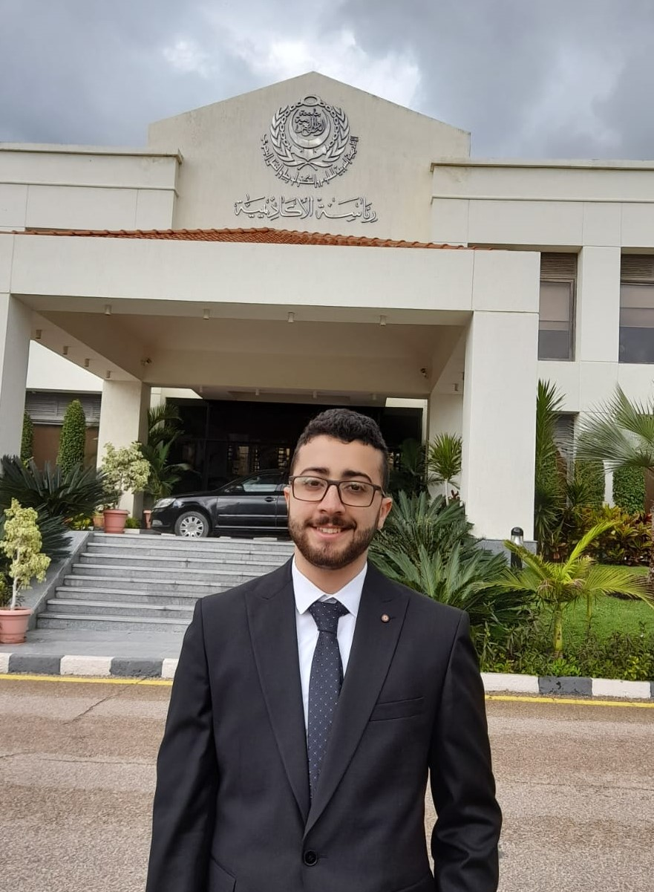

Mohamed Tarek Elsaid
Reg: 20102053
Contact: 01004616424

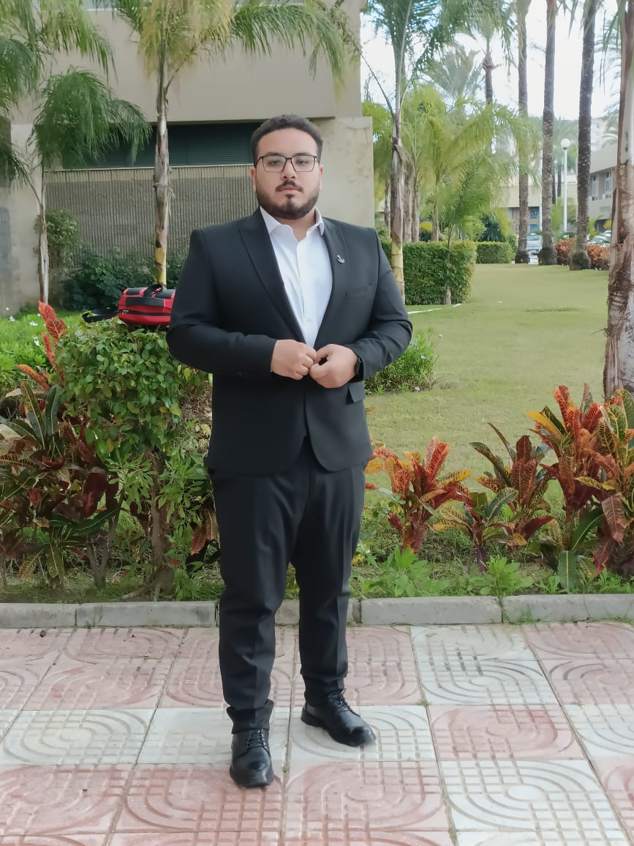

Abdelrahman Kamal
Reg: 20100101
Contact: 01145124472

