

**LAB 0**

**Systolic Array for Applying**

**Matrix Multiplication**

**Submitted to Eng.** **Ahmed Abdelsalam**

**Made by: Ziad Alaa Anis Mohamed Kamal Kassem  
Contact Info:** [**Ziad.Kassem.eng@gmail.com**](mailto:Ziad.Kassem.eng@gmail.com)

[**Linkedin**](https://www.linkedin.com/in/ziad-kassem-887aa1283/)[**Github**](https://github.com/Ziad-1544)

[**Project Repo**](https://github.com/Ziad-1544/Systolic_Array_Paramatrized_Verified)

**Systolic Array Project**

# Intro:

The systolic array is a hardware architecture optimized for matrix multiplication and similar linear algebra computations. It is composed of a two-dimensional grid of simple processing elements (PEs), where each PE performs basic operations such as multiply and accumulate. This structure allows for efficient and parallel data movement and computation, making it ideal for applications like digital signal processing (DSP) and machine learning.

# Design Diagram:

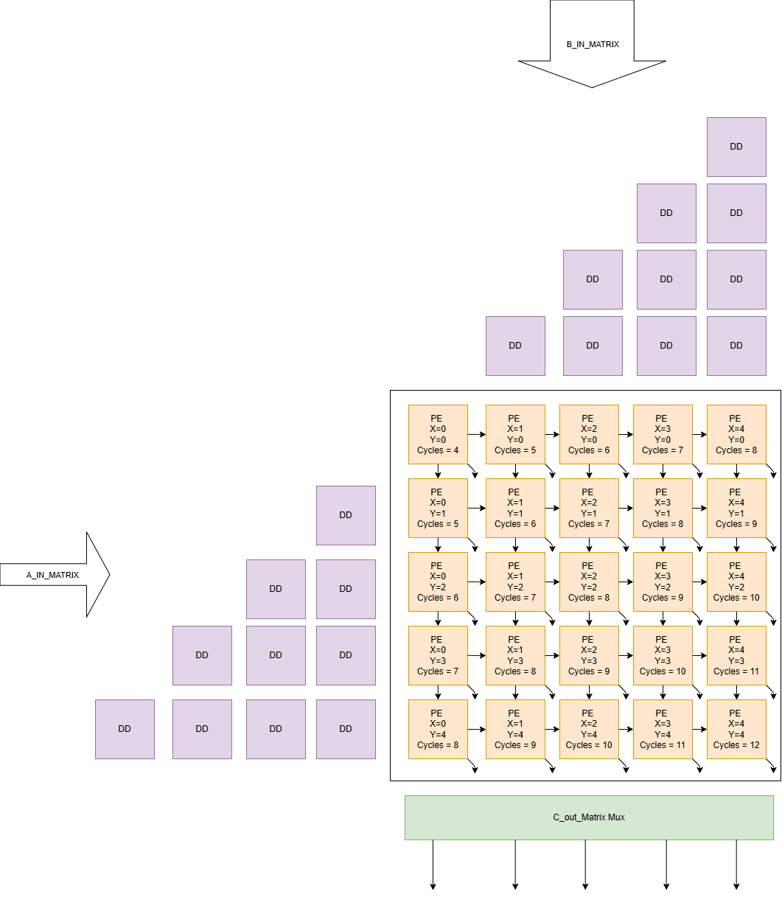

## Data Flow:

**-Matrix A** elements are streamed into the array row-wise from the **left**, and  
**-Matrix B** elements are streamed column-wise from the **top**.

Each PE:

* Receives one element from Matrix A and one from Matrix B.
* Multiplies the two input values.
* Adds the result to its internal accumulator register.
* Passes:
  + The A value to the right neighbor.
  + The B value to the bottom neighbor.

## Computation Steps

At each clock cycle:

1. The first elements of A and B enter the top-left PE (position (0,0)).
2. The PE multiplies these values and stores the result.
3. On subsequent cycles, new A and B elements enter from the left and top edges respectively.
4. Each PE performs a multiply-accumulate operation and shifts data to its neighbors.
5. After (N_SIZE + X_id +Y_id) cycles, each PE will have computed the full value of its corresponding.

Each Processing Element (PE) in the systolic array includes an internal counter that plays a critical role in synchronization and control. The counter is responsible for tracking the computation cycles within the PE. Since matrix multiplication requires summing over (2 * N_SIZE) elements (i.e., performing (N_SIZE) multiply-accumulate operations per PE), the counter keeps track of how many valid data items have passed through the PE. This ensures that the accumulation is performed exactly (N_SIZE) times before producing the final result. The counter typically increments on every clock cycle when valid data is present. Once the counter reaches the value (N_SIZE + X_id +Y_id), it signals that the PE has completed its contribution to the output matrix. At this point, the PE can assert a valid_out signal, indicating that the result stored in its accumulator is ready to be read. Additionally, this counter-based logic helps in stalling or disabling unnecessary operations after the computation is done, optimizing power and performance in hardware implementations.

**Benefits of the Systolic Array**

* **Parallelism:** All PEs work concurrently, enabling high throughput.
* **Data Locality:** No need to store full matrices in memory.
* **Scalability:** Easily expandable for larger matrix sizes.
* **Efficiency:** Suitable for hardware implementations with regular, predictable data flow.

# Design Code:

module systolic_array #(

    parameter N_SIZE = 5 ,

    parameter DATAWIDTH = 16

) (

    input logic clk,rst_n,valid_in, *// Asynchronous Active low*

    input wire signed [DATAWIDTH-1:0] matrix_a_in [0:N_SIZE-1], *//Data Array  [COLOMN][DATA]*

    input wire signed [DATAWIDTH-1:0] matrix_b_in [0:N_SIZE-1], *//Data Array  [COLOMN][DATA]*

    output logic valid_out,

    output logic signed [2*DATAWIDTH-1:0]matrix_c_out[0:N_SIZE-1]

*// Data Array [Each block in last row OUTPUT][DATA]*

);

*//Local Variables:*

logic [DATAWIDTH-1:0] matrix_a_delayed [0:N_SIZE-1][0:N_SIZE-1]; *// [ROW][STAGE][DATA]*

logic [DATAWIDTH-1:0] matrix_b_delayed [0:N_SIZE-1][0:N_SIZE-1]; *// [COLOMN][STAGE][DATA]*

logic [DATAWIDTH-1:0] a_interconnects [0:N_SIZE-1][0:N_SIZE-1]; *// a_in connections [ROW][COLOMN][DATA]*

logic [DATAWIDTH-1:0] b_interconnects [0:N_SIZE-1][0:N_SIZE-1]; *// b_in connections [COLOMN][ROW][DATA]*

logic valid_out_array [N_SIZE-1:0][N_SIZE-1:0];

logic signed [2*DATAWIDTH-1:0] row_c_out [0:N_SIZE-1][0:N_SIZE-1];

*//Generates iterators:*

genvar row_h, col_h;

genvar row_v, col_v;

*//Instantiating Horizontal Flip-Flops:*

generate

    for (row_h = 0; row_h < N_SIZE; row_h++) begin : GEN_ROW_H

        for (col_h = 0; col_h <= row_h; col_h++) begin : GEN_COL_H_A

            if (col_h == 0) begin

                assign matrix_a_delayed[row_h][col_h] = matrix_a_in[row_h];

            end else begin

                D_ff #(.*DATAWIDTH*(DATAWIDTH)) dff_a (

                    .*clk*(clk),

                    .*rst_n*(rst_n),

                    .*d_in*(matrix_a_delayed[row_h][col_h-1]),

                    .*d_out*(matrix_a_delayed[row_h][col_h])

                );

            end

        end

    end

endgenerate

*//Instantiating Vertical Flip-Flops:*

generate

    for (col_v = 0; col_v<N_SIZE ; col_v++ ) begin : GEN_COL_v

        for (row_v =0; row_v<=col_v ;row_v++ ) begin : GEN_ROW_V_B

            if (row_v == 0) begin

                assign matrix_b_delayed[col_v][row_v] = matrix_b_in[col_v];

            end else begin

                D_ff #(.*DATAWIDTH*(DATAWIDTH)) dff_b (

                    .*clk*(clk),

                    .*rst_n*(rst_n),

                    .*d_in*(matrix_b_delayed[col_v][row_v-1]),

                    .*d_out*(matrix_b_delayed[col_v][row_v]));

            end

        end

    end

endgenerate

*//Connecting interconnected to delayed matrix:*

generate

    for (genvar row = 0 ; row<N_SIZE ;row++ ) begin :GEN_ROW_ASSIGN

        assign a_interconnects[row][0] = matrix_a_delayed[row][row];

    end

    for (genvar col = 0 ; col<N_SIZE ;col++ ) begin :GEN_COL_ASSIGN

        assign b_interconnects[col][0] = matrix_b_delayed[col][col];

    end

endgenerate

*//PE Instantiation:*

genvar row_PE, col_PE;

generate

    for (row_PE = 0; row_PE<N_SIZE ; row_PE++ ) begin :GEN_PE_R

        for (col_PE = 0; col_PE<N_SIZE ; col_PE++ ) begin :GEN_PE_C

                PE #(

                .*N_SIZE*(N_SIZE),

                .*DATAWIDTH*(DATAWIDTH),

                .*x_id*(row_PE),

                .*y_id*(col_PE)

                ) pe_inst (

                .*clk*(clk),

                .*rst_n*(rst_n),

                .*valid_in*(valid_in),

                .*a_in*(a_interconnects[row_PE][col_PE]),

                .*b_in*(b_interconnects[col_PE][row_PE]),

                .*valid_out*(valid_out_array[row_PE][col_PE]),

                .*a_out_right*(a_interconnects[row_PE][col_PE+1]),

                .*b_out_down*(b_interconnects[col_PE][row_PE+1]),

                .*c_out*(row_c_out[row_PE][col_PE]));

       end

    end

endgenerate

*// valid_out logic: high when any row's last PE is valid*

always_comb begin

    valid_out = 0;

    for (int row = 0; row < N_SIZE; row++) begin

        if (valid_out_array[row][N_SIZE-1]) begin

            valid_out = 1;

        end

    end

end

*//OUTPUT MUX*

always_comb begin

    matrix_c_out = '{default:0};

    for (int row = 0; row < N_SIZE; row++) begin

        if (valid_out_array[row][N_SIZE-1]) begin

            for (int col = 0; col < N_SIZE; col++) begin

                matrix_c_out[col] = row_c_out[row][col];

            end

        end

    end

end

endmodule

module PE #(

    parameter N_SIZE = 5,

    parameter DATAWIDTH = 16,

    parameter x_id = 0 ,

    parameter y_id = 0

) (

    input logic clk,rst_n,valid_in,

    input logic signed [DATAWIDTH-1:0] a_in,b_in,

    output logic valid_out,

    output logic signed [(DATAWIDTH)-1:0]b_out_down,

    output logic signed [(DATAWIDTH)-1:0]a_out_right,

    output logic signed [(2*DATAWIDTH)-1:0]c_out

);

logic [N_SIZE:0] internal_counter;

logic [(2*DATAWIDTH)-1:0] sum;

logic valid_in_flag_holder;

    always @(posedge clk , negedge rst_n)begin

       if (!rst_n) begin

            internal_counter <= 0;

            sum <= 0;

            valid_in_flag_holder <=0;

            c_out<=0;

       end

       else begin

        valid_out<=0;

        if (valid_in || valid_in_flag_holder) begin

            valid_in_flag_holder<=1;

            if (internal_counter < N_SIZE + x_id + y_id) begin

                internal_counter <= internal_counter + 1;

                if (internal_counter >= x_id +y_id) begin

                    if (internal_counter == N_SIZE + x_id + y_id - 1) begin

                        valid_out <= 1;

                        valid_in_flag_holder <= 0;    internal_counter <= 0;

                        c_out <= sum + (a_in*b_in);

                        sum <= 0;

                    end

                    else begin

                        sum <= sum + (a_in*b_in);

                    end

                    a_out_right <= a_in;   b_out_down <= b_in;

                end

            end

            else begin

            end

        end

       end

    end

endmodule

module D_ff #(

    parameter DATAWIDTH = 16

) (

    input logic clk,rst_n,

    input logic [DATAWIDTH-1:0] d_in,

    output logic [DATAWIDTH-1:0] d_out

);

always @(posedge clk , negedge rst_n) begin

    if(!rst_n) d_out <= 0;

    else d_out <= d_in;

end

endmodule

# Verification Code:

module systolic_array_tb;

    localparam N_SIZE = 5;

    localparam DATAWIDTH = 16;

    logic clk, rst_n, valid_in;

    logic signed [DATAWIDTH-1:0] matrix_a_in [N_SIZE-1:0];

    logic signed [DATAWIDTH-1:0] matrix_b_in [N_SIZE-1:0];

    logic valid_out;

    logic signed [2*DATAWIDTH-1:0] matrix_c_out [N_SIZE-1:0];

*// Instantiate DUT*

    systolic_array #(

        .*N_SIZE*(N_SIZE),

        .*DATAWIDTH*(DATAWIDTH)

    ) dut (

        .*clk*(clk),

        .*rst_n*(rst_n),

        .*valid_in*(valid_in),

        .*matrix_a_in*(matrix_a_in),

        .*matrix_b_in*(matrix_b_in),

        .*valid_out*(valid_out),

        .*matrix_c_out*(matrix_c_out)

    );

*// Clock generation*

    initial begin

        clk=0;

        forever begin

            #1 clk=~clk;

        end

    end

*// Test vectors*

    initial begin

        rst_n = 0;

        valid_in = 0;

        matrix_a_in = '{default:0};

        matrix_b_in = '{default:0};

*repeat*(1) @(negedge clk);

        rst_n = 1;

*// Test Case 1 5*5*

        matrix_a_in = '{1, 2, 3, 4, 5};

        matrix_b_in = '{25, 24, 23, 22, 21};

        valid_in = 1;

*repeat*(1) @(negedge clk);

        matrix_a_in = '{6, 7, 8, 9, 10};

        matrix_b_in = '{20, 19, 18, 17, 16};

*repeat*(1) @(negedge clk);

        matrix_a_in = '{11, 12, 13, 14, 15};

        matrix_b_in = '{15, 14, 13, 12, 11};

*repeat*(1) @(negedge clk);

        matrix_a_in = '{16, 17, 18, 19, 20};

        matrix_b_in = '{10, 9, 8, 7, 6};

*repeat*(1) @(negedge clk);

        matrix_a_in = '{21, 22, 23, 24, 25};

        matrix_b_in = '{5, 4, 3, 2, 1};

*repeat*(1) @(negedge clk);

        valid_in = 0;

*repeat*(13) @(negedge clk);

*$display*("Test 1 should be done");

*$stop*;

*//=================================================================*

*// Test Case 2 5*5*

        matrix_a_in = '{5, 4, 3, 2, 1};

        matrix_b_in = '{1, 1, 1, 1, 1};

        valid_in = 1;

*repeat*(1) @(negedge clk);

        matrix_a_in = '{10, 9, 8, 7, 6};

        matrix_b_in = '{2, 2, 2, 2, 2};

*repeat*(1) @(negedge clk);

        matrix_a_in = '{15, 14, 13, 12, 11};

        matrix_b_in = '{3, 3, 3, 3, 3};

*repeat*(1) @(negedge clk);

        matrix_a_in = '{20, 19, 18, 17, 16};

        matrix_b_in = '{4, 4, 4, 4, 4};

*repeat*(1) @(negedge clk);

        matrix_a_in = '{25, 24, 23, 22, 21};

        matrix_b_in = '{5, 5, 5, 5, 5};

*repeat*(1) @(negedge clk);

        valid_in = 0;

*repeat*(13) @(negedge clk);

*$display*("Test 2 should be done");

*$stop*;

*//===============================================================*

*// Test Case 3 5*5*

        matrix_a_in = '{1, 3, 5, 7, 9};

        matrix_b_in = '{5, 4, 3, 2, 1};

        valid_in = 1;

*repeat*(1) @(negedge clk);

        matrix_a_in = '{2, 4, 6, 8, 10};

        matrix_b_in = '{10, 9, 8, 7, 6};

*repeat*(1) @(negedge clk);

        matrix_a_in = '{11, 13, 15, 17, 19};

        matrix_b_in = '{15, 14, 13, 12, 11};

*repeat*(1) @(negedge clk);

        matrix_a_in = '{12, 14, 16, 18, 20};

        matrix_b_in = '{20, 19, 18, 17, 16};

*repeat*(1) @(negedge clk);

        matrix_a_in = '{21, 22, 23, 24, 25};

        matrix_b_in = '{25, 24, 23, 22, 21};

*repeat*(1) @(negedge clk);

        valid_in = 0;

*repeat*(13) @(negedge clk);

*$display*("Test 3 should be done");

*$stop*;

*//===============================================================*

*// Test Case 4 5*5*

        matrix_a_in = '{1, 0, 1, 0, 1};

        matrix_b_in = '{1, 2, 3, 4, 5};

        valid_in = 1;

*repeat*(1) @(negedge clk);

        matrix_a_in = '{0, 1, 0, 1, 0};

        matrix_b_in = '{5, 4, 3, 2, 1};

*repeat*(1) @(negedge clk);

        matrix_a_in = '{1, 1, 1, 1, 1};

        matrix_b_in = '{1, 2, 3, 4, 5};

*repeat*(1) @(negedge clk);

        matrix_a_in = '{2, 2, 2, 2, 2};

        matrix_b_in = '{5, 4, 3, 2, 1};

*repeat*(1) @(negedge clk);

        matrix_a_in = '{3, 3, 3, 3, 3};

        matrix_b_in = '{1, 2, 3, 4, 5};

*repeat*(1) @(negedge clk);

        valid_in = 0;

*repeat*(13) @(negedge clk);

*$display*("Test 4 should be done");

*$stop*;

*//===============================================================*

*// Test Case 5 5*5*

        matrix_a_in = '{1, 1, 1, 1, 1};

        matrix_b_in = '{1, 2, 3, 4, 5};

        valid_in = 1;

*repeat*(1) @(negedge clk);

        matrix_a_in = '{2, 2, 2, 2, 2};

        matrix_b_in = '{6, 7, 8, 9, 10};

*repeat*(1) @(negedge clk);

        matrix_a_in = '{3, 3, 3, 3, 3};

        matrix_b_in = '{11, 12, 13, 14, 15};

*repeat*(1) @(negedge clk);

        matrix_a_in = '{4, 4, 4, 4, 4};

        matrix_b_in = '{16, 17, 18, 19, 20};

*repeat*(1) @(negedge clk);

        matrix_a_in = '{5, 5, 5, 5, 5};

        matrix_b_in = '{21, 22, 23, 24, 25};

*repeat*(1) @(negedge clk);

        valid_in = 0;

*repeat*(13) @(negedge clk);

*$display*("Test 5 should be done");

*$stop*;

        end

endmodule

# Simulation Output (Questasim):

I used Matlab as a golden model to compare output validation & correctness:

Each snippet Is integrated with Matlab output of same test case:

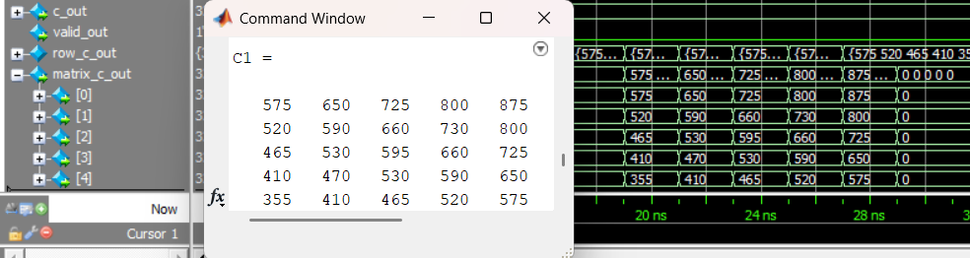*Case 1:*

*Case 2:*

*Case 3:*

*Case 4:*

*Case 5:*

# Vivado Output:

FPGA USED:

## Constraint File for Timing Analysis:

*## Clock signal*

*set_property* -dict { PACKAGE_PIN W5   IOSTANDARD LVCMOS33 } [*get_ports* clk]

*create_clock* -add -name sys_clk_pin -period 10.00 -waveform {0 5} [*get_ports* clk]

## Elaborated RLT Schematic:

## Synthesis :

Power Report:

