
Cairo University
Faculty of Computers and Information

CS251
Software Engineering I
Educational Entertainment Website
Software Requirements Specifications
Names:

Team
ID | Name | Email
20140377 | Omar abdulaziz saeed | omer.alqubati@gmail.com | leader
20170375 | Hameed Mohammed Abdullah | Hameed203083@gmail.com
20140367 | Asseel Ahmed mohmed | asseel7723@gmail.com
20140339 | Wafaa samir ahmed alahmer | fofoalah@gmail.com 20140339
20140341 | Ziad amer al-tahhan | ziadaamer 9@gmail.com

Document Purpose and Audience
Document:
The description of what the software does and how it is intended to operate.
Also it is used as an agreement on what the software will do.
The Audiences:
The Audiences are the ones involved in the production of that software:
End users, customers, product managers, project managers,
Software engineers, designers, developers, and testers.

Introduction

Software Purpose
This platform will help students to understand basic educational concepts while playing simple games, created by teachers

Software Scope
*Web Application software
*Serves as platform for teachers to upload their games on it
*Teachers upload a game to be from a specific category
*Teachers also manage the games they made
*Teachers respond to comments made by students
*Students can play the games made by teachers
*Students can comment and rate those games.
*Students can choose games based on their categories

Requirements

Functional Requirements
1- A teacher must be able to Add more than one game which is then added to his list <**>via the system.
2- Each game a teacher adds, targets a certain level.
3- A teacher should add a description and instruction for the game he added or the process is rejected.
4- A teacher can remove any game from his games list which in turn all the students who are in that game will be returned to the home page.
5- A teacher can upgrade any game from his games list.
6- A teacher must be able to check feedbacks from his games list and reply to students comments.
7- A student must be able to play games.
8- A student can give his feedback to games that he already has played.
9- A student has the opportunity to see the description of a game.
10- The system should save the level in which a student has stopped.
11- After the student finishes playing his his level experience bar is increased.
12- When the level bar is full the student is transferred to the next level.

Non Functional Requirements
 | Details
Performance | 1- The system will be respond to the end user in not less than two seconds from the time of the request submittal, but it will take more time when large operations are done like add new game or delete existing one.  2- 1000 student should be able to open the website at the same time.
Security Requirement: | 1- The system uses a form of protection, a user name and password for each user, such that the user will be distinguished a student or teacher.
Reliability Requirement : | The system has to be 100% reliable, because it's a teaching tool for studying the basic principles of some science fields as there should be no games which are not educational.
Availability Requirement: | The system will be available all the time for the end users, and will be operational 24 hours a day and 7 days a week.
Usability Requirement: | The system uses a web browser as an interface. Since all users are familiar with the general usage of browsers, no special training is required.

System Models

Use Case Model
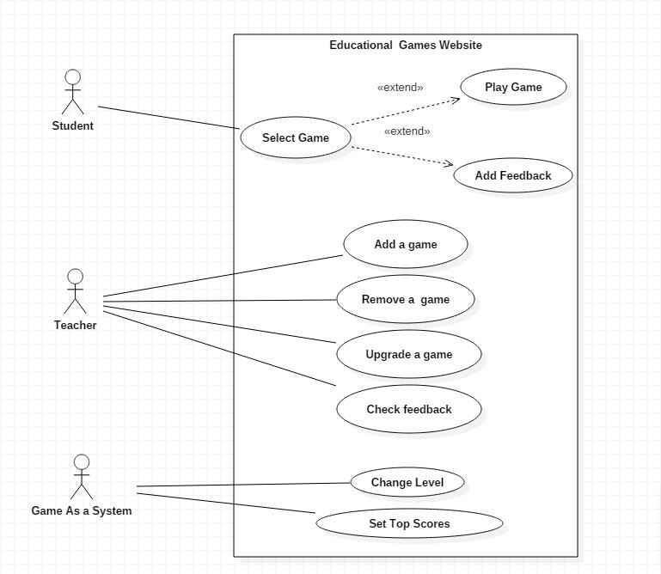

Use Case Tables
Use Case ID: | 1
Use Case Name: | Select Game
Actors: | Student
Pre-conditions: | 1-Logged in  2-Select certain game
Post-conditions: | 1-Start to play the game.  2-Add feedback to the game.
Flow of events: | User Action | System Action
Flow of events: | 1- Student log in.
Flow of events: |  | 2- System Displays all the games
Flow of events: | 3- Student choose the game
Flow of events: |  | 4- System Displays information of game.
 | 5- Student will choose either to play or add a feedback.
Exceptions: | User Action | System Action
Exceptions: | No exception
Includes:

Use Case ID: | 2
Use Case Name: | Play game
Actors: | Student
Pre-conditions: | 1- Student selects a game.  2- Student's level fits the game's level.
Post-conditions: | 1- Lose the game.  2- End of the game's Level.
Flow of events: | User Action | System Action
Flow of events: | 1-Student Press "start play button"
Flow of events: |  | 2- System Load the game.
Flow of events: | 3- Student Choose whether to start new game or continue.
Flow of events: | 4- Student Start playing the game.
Flow of events: |  | 5- After finishing a level. The system saves the current level as played level.
Exceptions: | User Action | System Action
Exceptions: | No Exceptions.
Includes:
Notes and Issues:

Use Case ID: | 3
Use Case Name: | Add Feedback
Actors: | Student
Pre-conditions: | 1- Student selects a game.  2- Student already played the game.
Post-conditions: | 1-Uploading the feedback.
Flow of events: | User Action | System Action
Flow of events: | 1-Student selects a certain game.
Flow of events: | 1-Student Press the "Add feedback button".
Flow of events: |  | 2- System Prints the ways of submitting the feedback.
Flow of events: | 3- Student Choose a way of submitting the feedback.
Flow of events: |  | 4- System Displays average rate and the comments.
Flow of events: | 5- Student Adds his comment or gives a rate.
Flow of events: | 6- Student submits the feedback
Flow of events: |  | 5- System updates and re-calculates the new average.
Exceptions: | User Action | System Action
Exceptions: | 1-Student press Add feedback and he didn't play the game before.
 |  | 2-System prints error.
Use Case ID: | 4
Use Case Name: | Add a game
Actors: | Teacher
Pre-conditions: | 1- Logged in account as a teacher.
Post-conditions: | 1- Game finished uploading.
Flow of events: | User Action | System Action
Flow of events: | 1- Teacher Choose name and icon of the game and its category.
Flow of events: |  | 2- System verifies the name of the game.
Flow of events: | 3- Teacher adds description of the game.
Flow of events: | 4-Teacher uploads the game file and its instruction.
Flow of events: |  | 5- System adds the game to teacher's list.
 |  | 6- System Displays the new game in the home page.
Exceptions: | User Action | System Action
Exceptions: | 1- Teacher Chooses name for the game and the name already exists.
Exceptions: |  | 2- System rejects the addition process.
Use Case ID: | 5
Use Case Name: | Remove a game
Actors: | Teacher
Pre-conditions: | 1- The teacher owns the game.
Post-conditions: | 1- The game is deleted.
Flow of events: | User Action | System Action
Flow of events: | 1- Teacher enters the list of the games that he uploaded.
Flow of events: | 2- select a game to be removed
Flow of events: |  | 3- System removes the game from the home page and teachers list.
Exceptions: | User Action | System Action
Exceptions: | 1- Teacher removes the game while there are students playing it.
Exceptions: |  | 2-System directly returns Students to the home page.
Includes:
Notes and Issues:

Use Case ID: | 6
Use Case Name: | Upgrade a game.
Actors: | Teacher
Pre-conditions: | 1- The teacher owns the game.
Post-conditions: | 1- The new version of the game is added.
Flow of events: | User Action | System Action
Flow of events: | 1- Teacher enters the list of the game that he uploaded.
Flow of events: | 2- Teacher Select a game to be updated.
Flow of events: | 3- Teacher removes and add the new version.
Flow of events: |  | 4- System adds the game to home page and teachers list again.
Exceptions: | User Action | System Action
Exceptions: | 1- Teacher upgrading the game while there are students playing it.
Exceptions: |  | 2-System directly returns Students to the home page.
Includes:
Use Case ID: | 7
Use Case Name: | Check feedback.
Actors: | Teacher
Pre-conditions: | The game developed by this teacher.
Post-conditions: | Finish all feedback and reply to the students comments .
Flow of events: | User Action | System Action
Flow of events: | 1- Teacher Enters the game list he added.
Flow of events: | 2- Teacher Select a game to check its feedbacks.
Flow of events: |  | 3-System opens the games feedback.
Flow of events: | 4- Teacher responds to the students comment.
 |  | 5-System uploads the replied message to the students comment.
Exceptions: | User Action | System Action
Exceptions: | No exception.
Includes:
Notes and Issues:

Use Case ID: | 8
Use Case Name: | Change level.
Actors: | Game as system.
Pre-conditions: | 1- Student succeeds in a game given in his level.
Post-conditions: | 1- The Level experience bar of the Student being filled.
Flow of events: | User Action | System Action
Flow of events: | 1- After the student finish playing, the score is calculated.
Flow of events: | 2- The students experience bar gets increased.
Flow of events: |  | 3- System displays the new bar.
Exceptions: | User Action | System Action
Exceptions: | No exception.

Use Case ID: | 9
Use Case Name: | Choose top score players.
Actors: | Game as system.
Pre-conditions: | 1- Student finishes playing a game.
Post-conditions: | 1- Top score list is updated.
Flow of events: | User Action | System Action
Flow of events: | 1- Game as a system saves the score of the player.
Flow of events: | 2- Add the score and the students name to the top score players.
Flow of events: | 3- Sort the players depending on the score and choose the best ten.
Flow of events: |  | 4- System displays the top 10 players.
Exceptions: | User Action | System Action
Exceptions: | No exception

Ownership Report

Item | Owners

Policy Regarding Plagiarism:

Students have collective ownership and responsibility of their project. Any violation of academic honesty will have severe consequences and punishment for ALL team members.
- تشجع الكلية على مناقشة الأفكار و تبادل المعلومات و مناقشات الطلاب حيث يعتبر هذا جوهريا لعملية تعليمية سليمة
- ساعد زملاءك على قدر ما تستطيع و حل لهم مشاكلهم فى الكود و لكن تبادل الحلول غير مقبول و يعتبر غشا.
- أى حل يتشابه مع أى حل آخر بدرجة تقطع بأنهما منقولان من نفس المصدر سيعتبر أن صاحبيهما قد قاما بالغش.
- قد توجد على النت برامج مشابهة لما نكتبه هنا أى نسخ من على النت يعتبر غشا يحاسب عليه صاحبه.
- إذا لم تكن متأكدا أن فعلا ما يعد غشا فلتسأل المعيد أو أستاذ المادة.
- فى حالة ثبوت الغش سيأخذ الطالب سالب درجة المسألة ، و فى حالة تكرار الغش سيرسب الطالب فى المقرر.

