TOPIC

Database systems

By:

|  |  |  |  |
| --- | --- | --- | --- |
| B.N | Edu.Email | Name |  |
| 370 | Zeyad195409@feng.by.edu.eg | زياد علاء محمد محمود ضيف | 1 |

Github.link: <https://github.com/Ziad-Alaa/index.html>

Github bage: <https://ziad-alaa.github.io/index.html/>.

Application brief

Database Management System allows a person to organize, store, and retrieve data from a computer. It is a way of communicating with a computer’s “stored memory.” In the very early years of computers, “punch cards” were used for input, output, and data storage. Punch cards offered a fast way to enter data, and to retrieve it. Herman Hollerith is given credit for adapting the punch cards used for weaving looms to act as the memory for a mechanical tabulating machine, in 1890. Much later, databases came along

Screenshots: 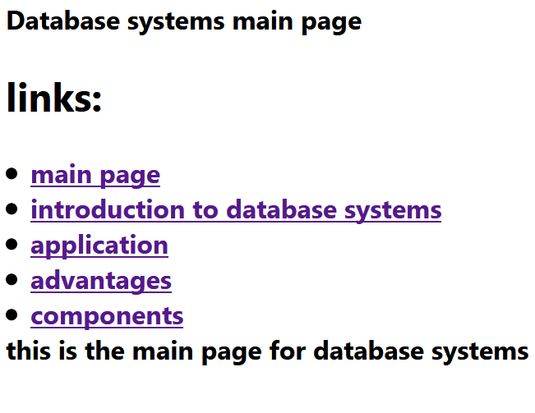

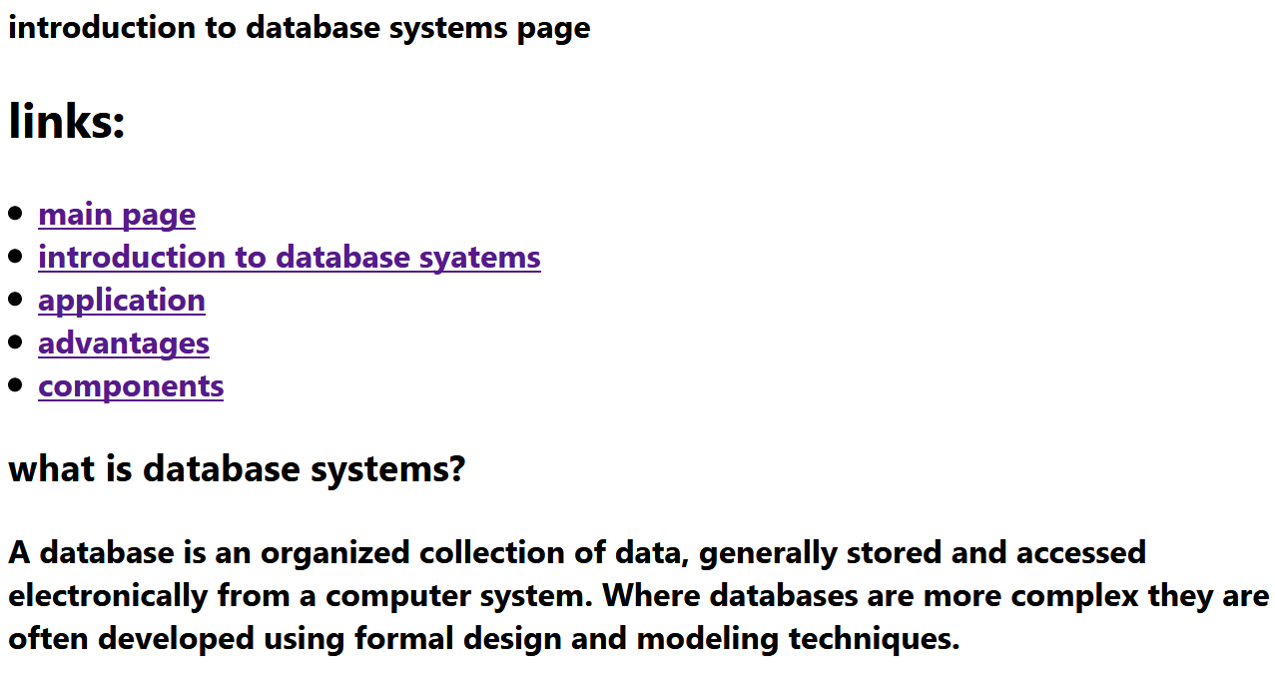

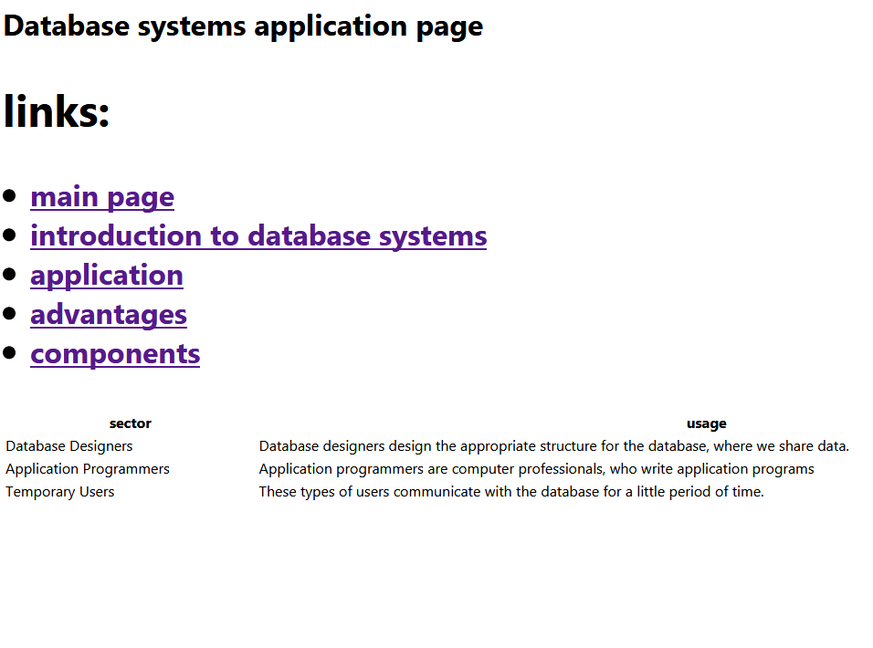Database systems anvantages page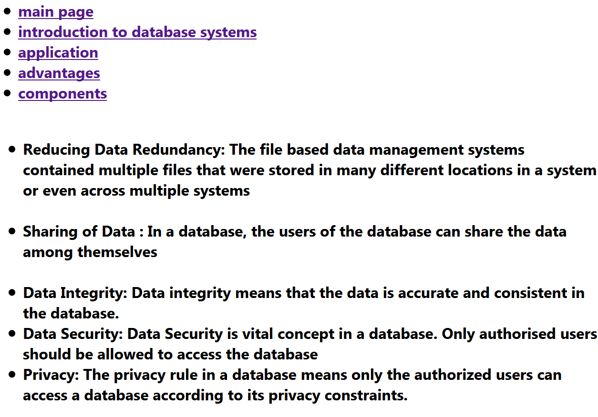

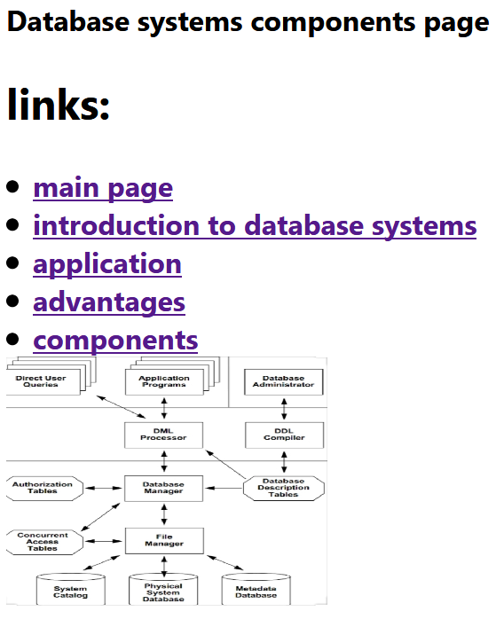

Source code

Database systems main page

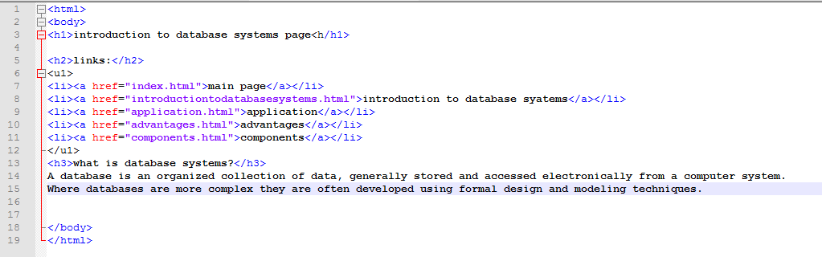

Introduction to data base systems



Database systems application page

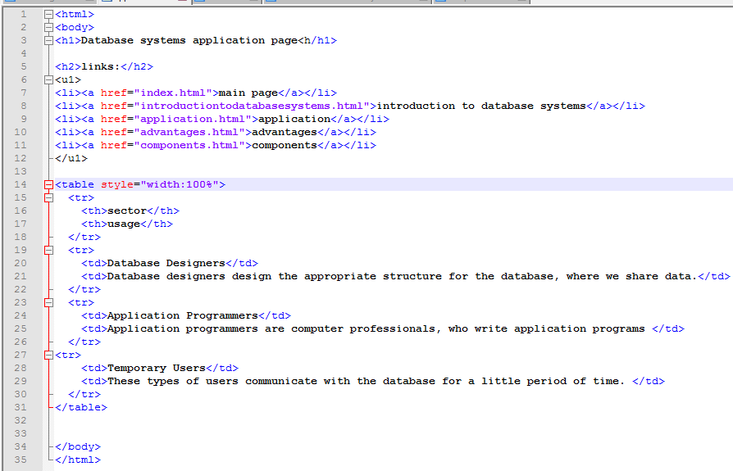

Database systems advantages page

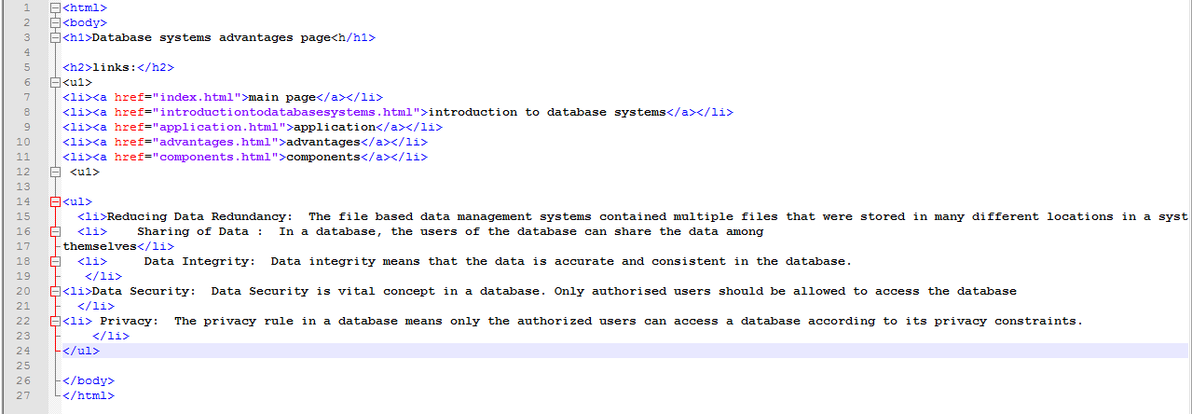

Database systems components page

