CommTheory
Lab Assignment 1

Nadine Ahmed Abd El Aziz 43-4385
Ziad Mohamed Ayman 43-4384

- Original signal:

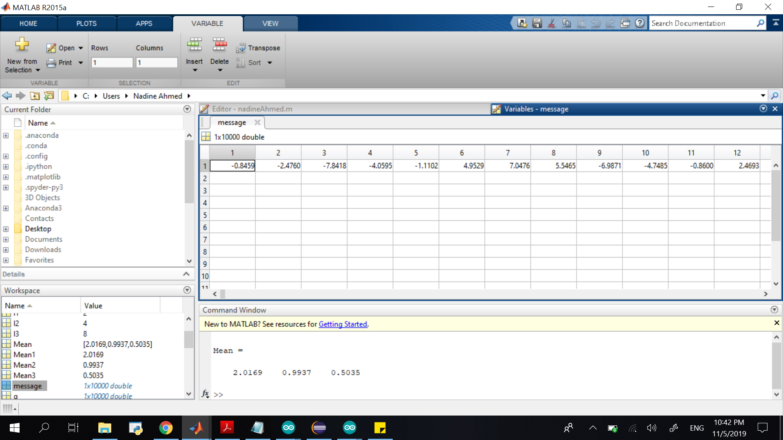

For Level 2 :
1-Quantized message :
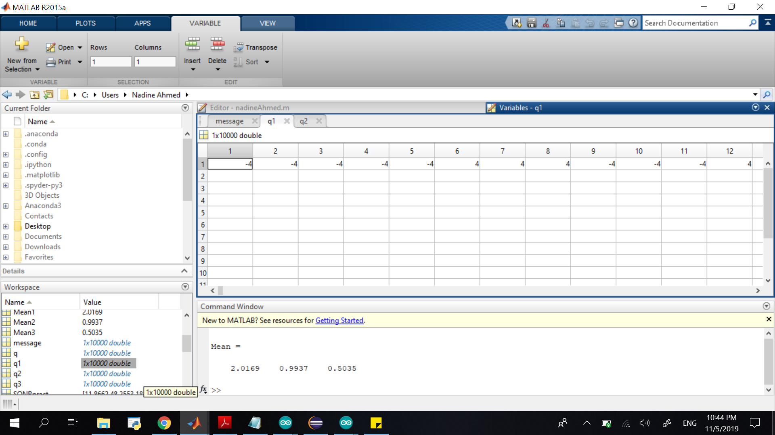

Mean : 2.0169
Theoratical Variance : 5.3333
Practical Variance : 5.3935
Theoratical SQNR : 12
Practical SQNR : 11.8662

For Level 4 :
1-Quantized Message
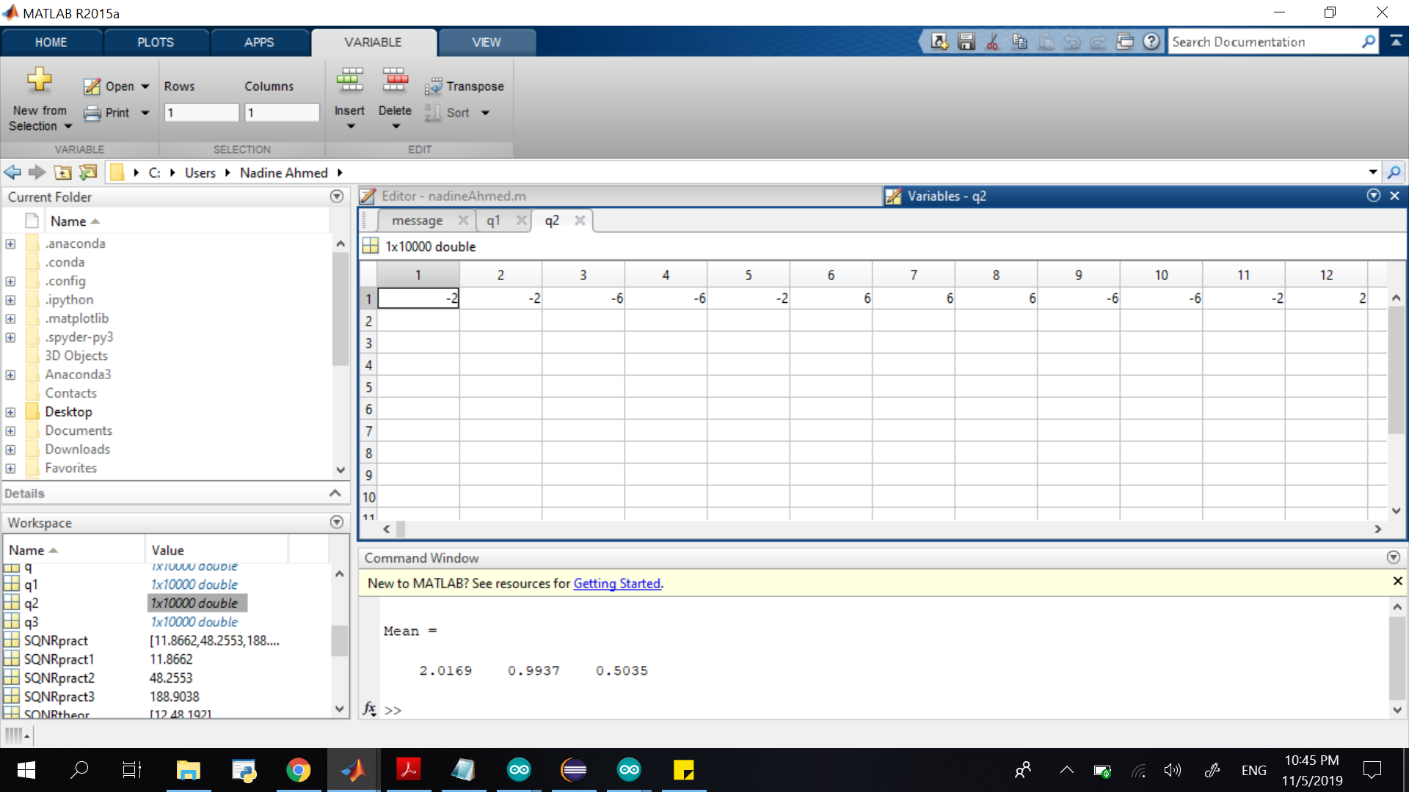

Mean : 0.9937
Theoratical Variance : 1.3333
Practical Variance : 1.3263
Theoratical SQNR : 48
Practical SQNR : 48.2553

For Level 8 :
1-Quantized Message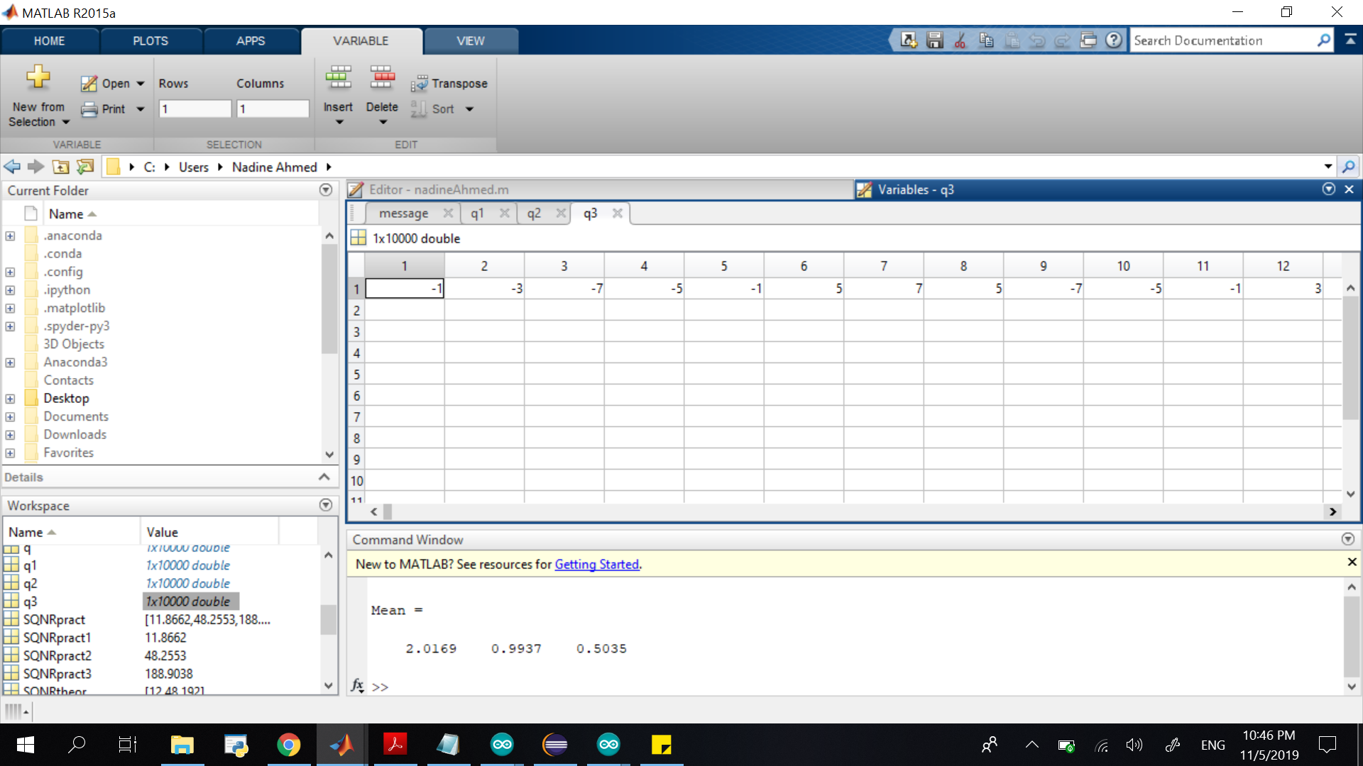

Mean : 0.5035
Theoratical Variance : 0.3333
Practical Variance : 0.3388
Theoratical SQNR : 192
Practical SQNR : 188.9038

Mean VS Number of Levels:
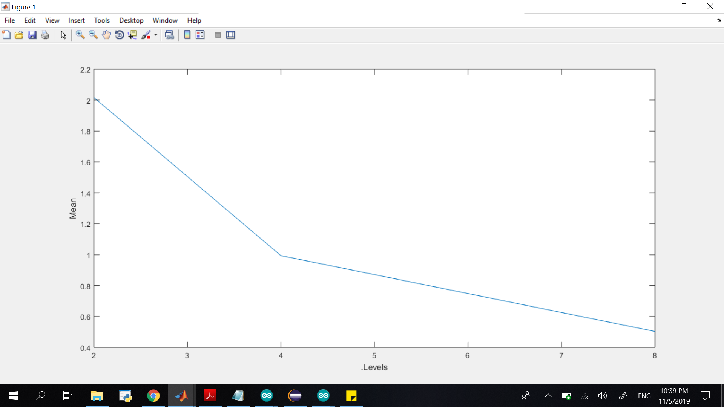
As the number of quantizations levels increase the mean value of the quantized signal decrease.

Variance VS Number of Levels:
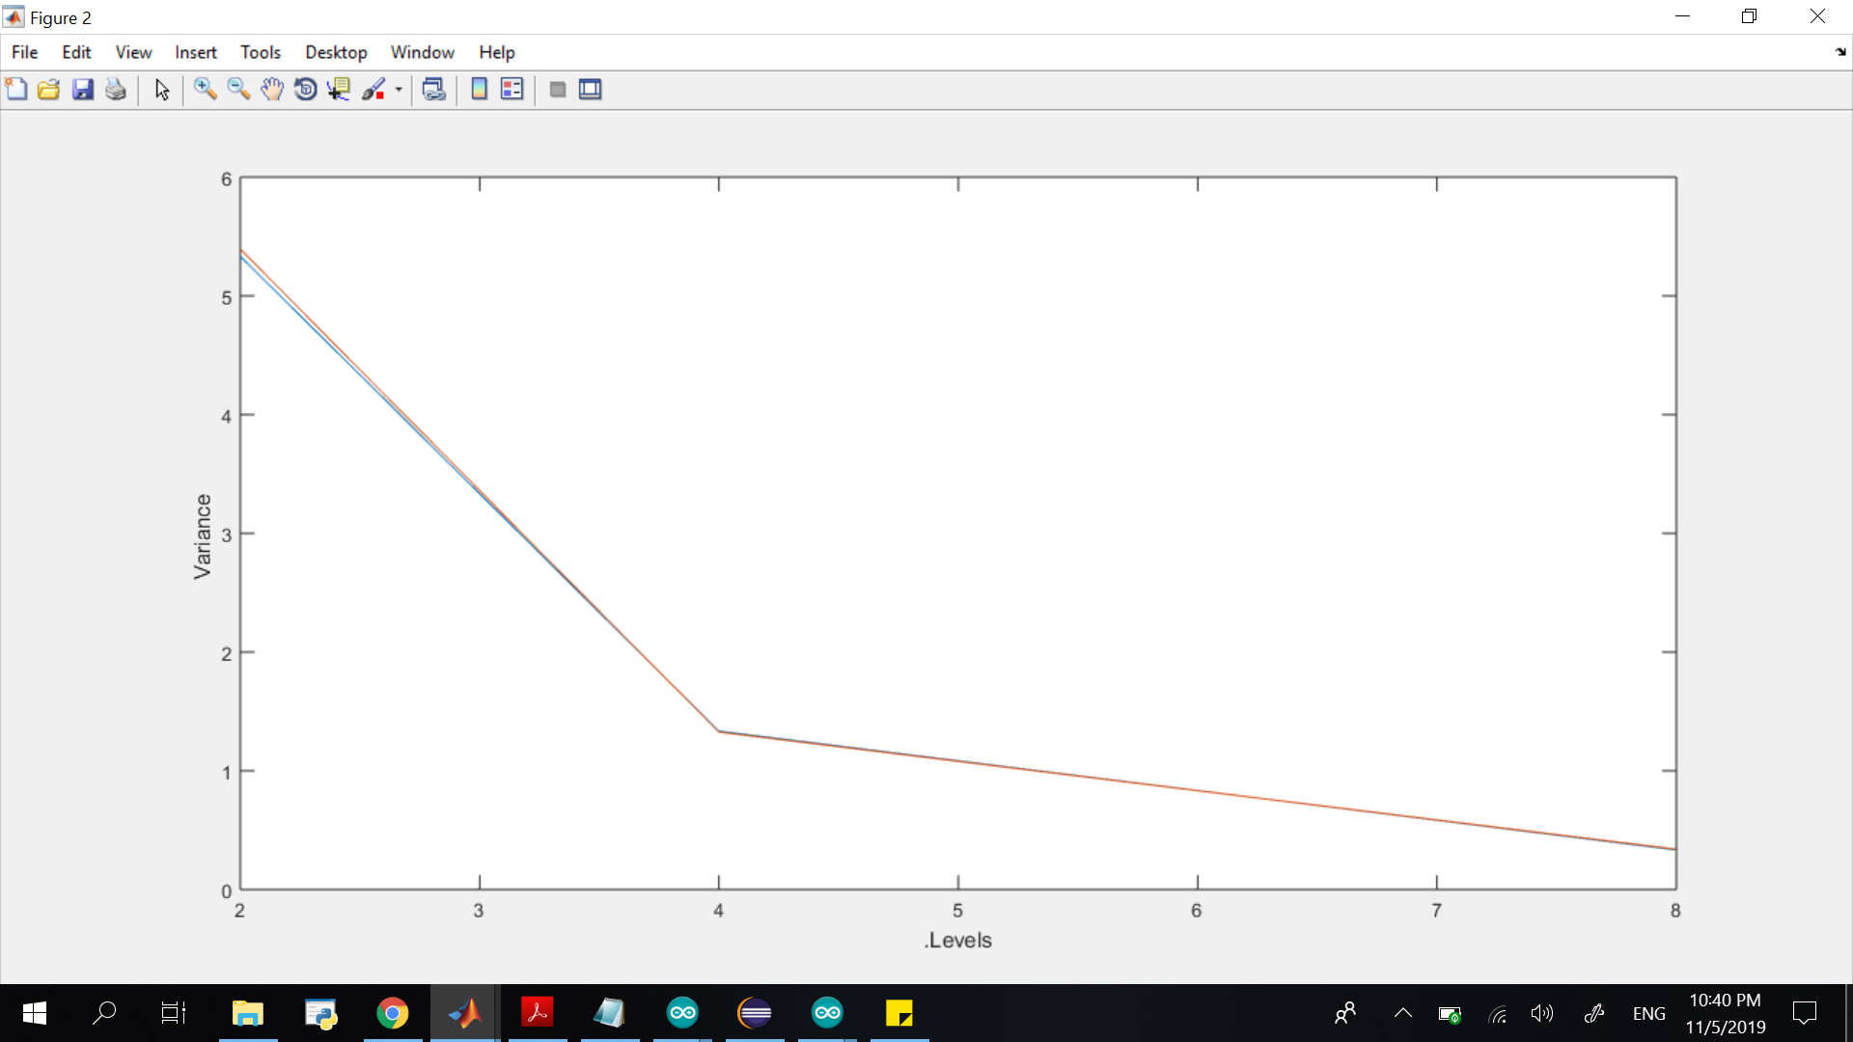
As the number of quantizations levels increase the theoretical and practical variance value of the quantized signal decrease.

SQNR VS Number of Levels:
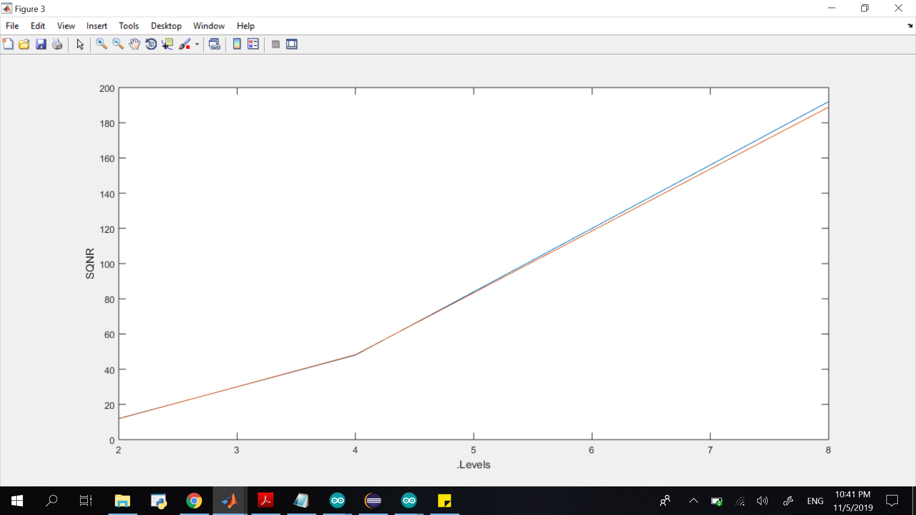
As the number of quantizations levels increase the mean value of the quantized signal increase.

Copy of the Code :
