|  |
| --- |
| Ziad Tarek Mohamed Essa  4169 |

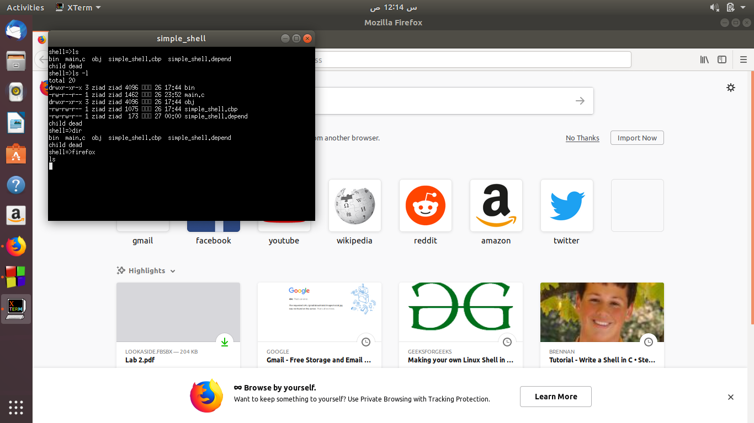

In this pic. It shows the wait which means the child won’t die except after the process is finished.

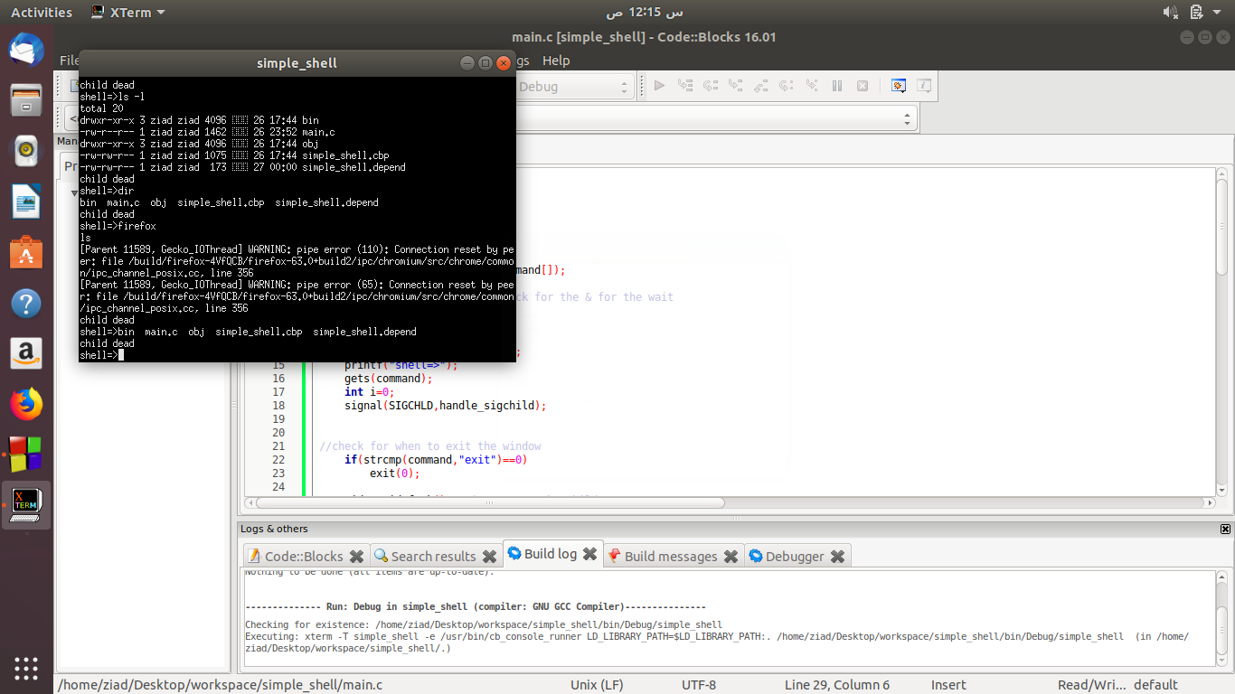

In this pic. The has died and it executed the commands that have been waiting .

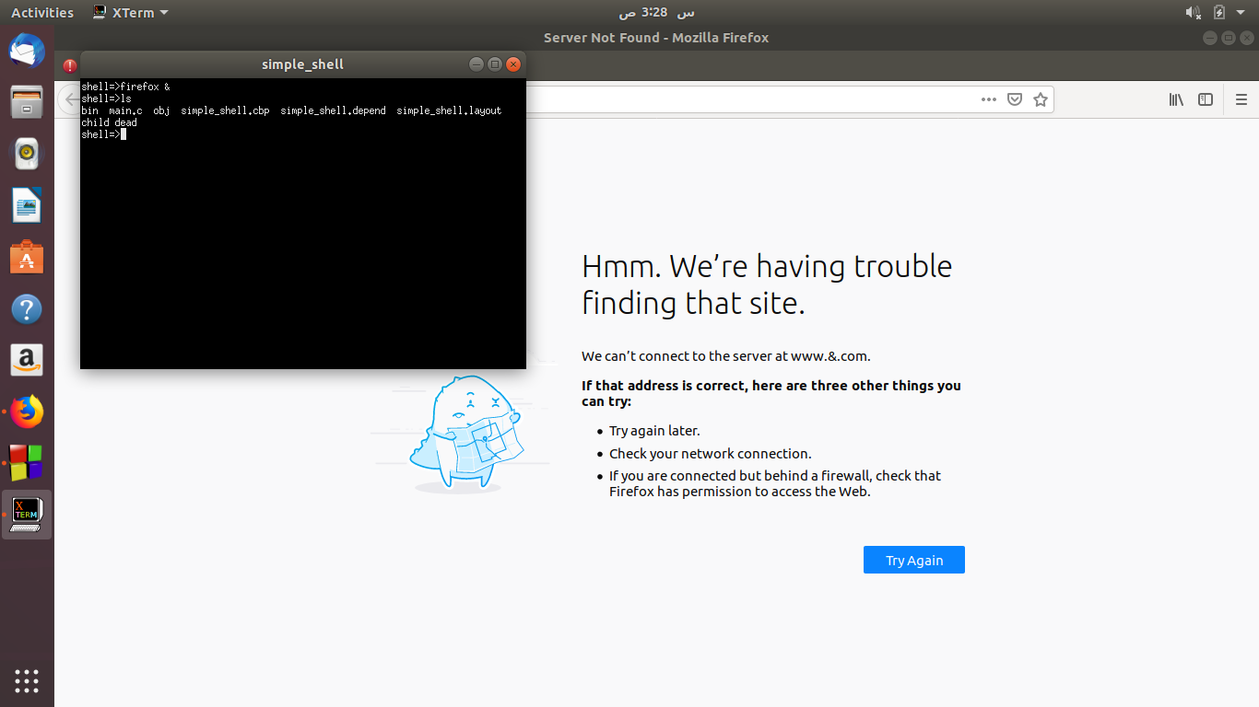

In this pic. It shows the & process which works in parallel with other commands .

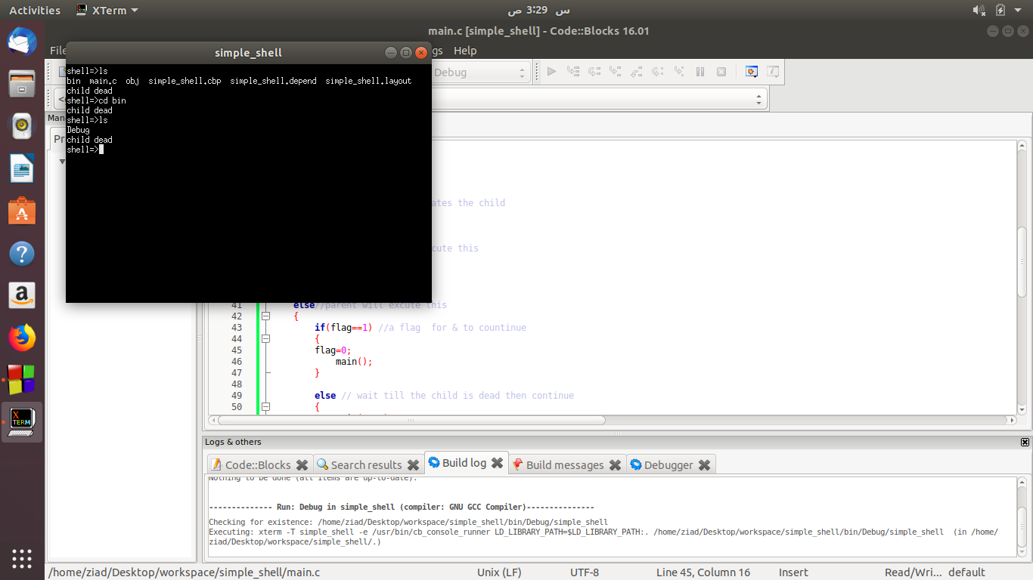

In this pic. It shows how it changed directories simple shell to bin.