UART & USB Emulator

***A report submitted in fulfillment of the requirements for the ELC3030 project***

***NOVEMBER 2021***

**1**  **Protocol**

**1.1** **USB Protocol**

**Universal Synchronous Bus (USB) Transmission Protocol :**

|  |
| --- |
| **SYNC** |
| **Packet ID** |
| **Address Field** |
| **Data Payload** |
| **End of Bits** |

**1.2** **UART Protocol**  
**Universal Asynchronous Transmitter Receiver Protocol :**

|  |
| --- |
| **Start Bit** |
| **Data (7 / 8 bits)** |
| **Parity (even / odd)** |
| **Stop Bit (1/ 2 bits )** |

**2** **Procedure/Output**   
**2.1** **USB Sample PLot**  
**This is USB Packet as NRZI encoded data with differential data**  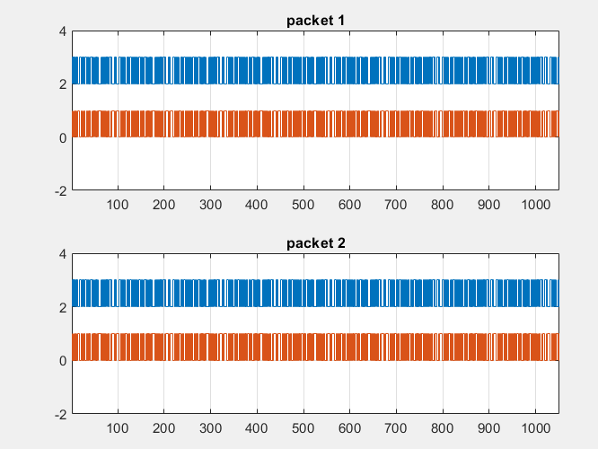

**2.2** **UART Sample Plot**

**This is UART Byte with even parity ,1 stop bit , 7 bytes data**

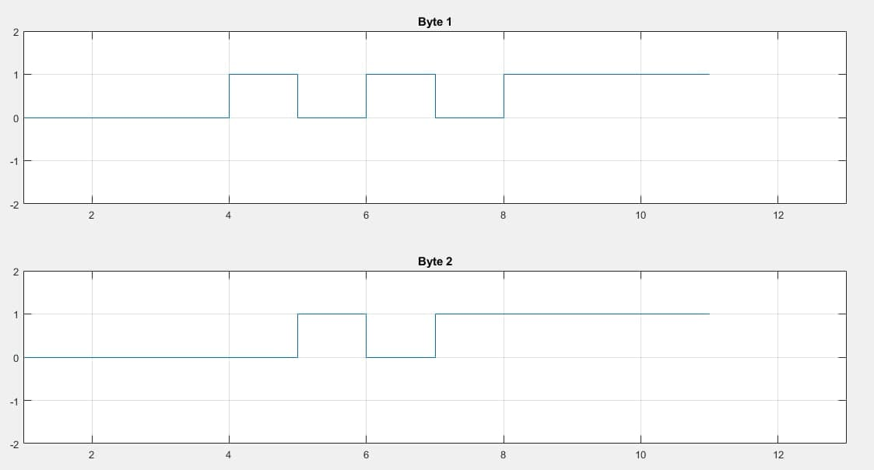

**This is UART Byte with odd parity ,2 stop bit ,8 bytes data**

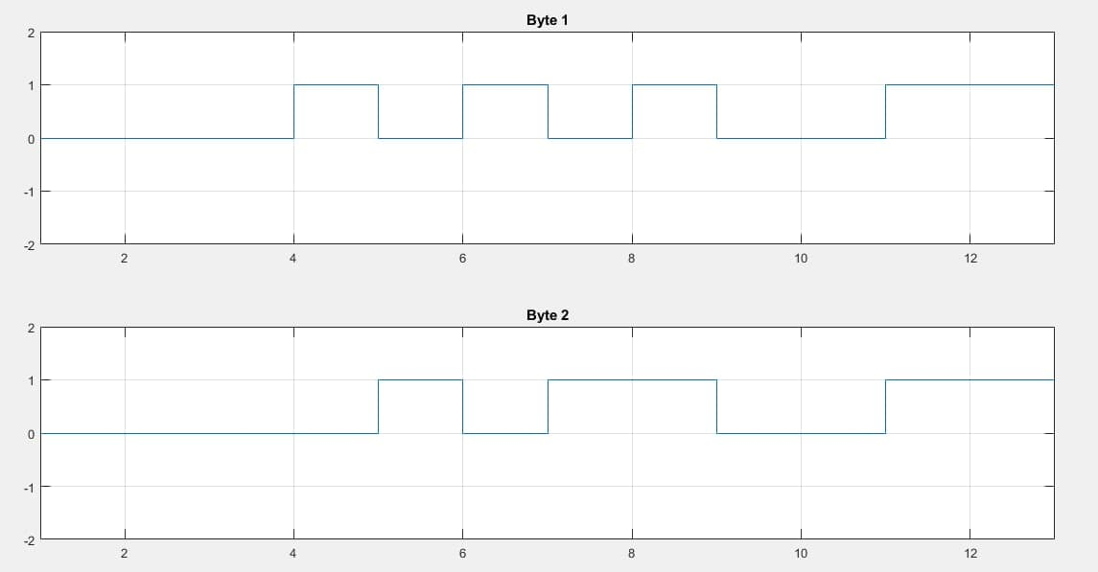

**3** **Plotting Overhead**  **versus File Size**

* In this part we kept doubling the file size over and over with using the original json file configuration and we also could use any size you want WHEATHER increase or decrease and not just a size divisible by 128 .

**3.1**  **USB**  
**3.1.1** **USB Overhead**  
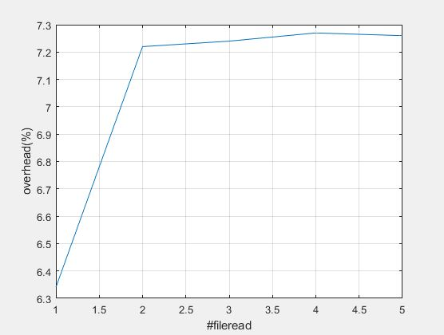

**3.1.2** **USB Transmission Time**  
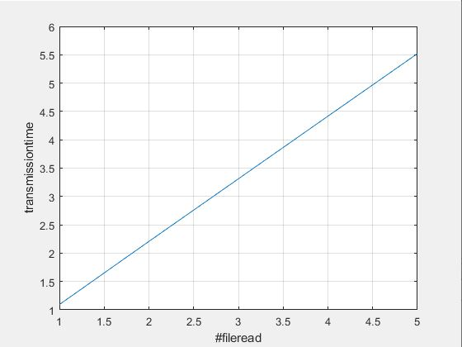

* **Comments**
* Overhead percentage is increases when the size increases as the number of overhead bits might increase each time due to bit stuffing
* Transmission time percentage increases when size increases as no of bits needs to be transmitted increases

**3.2** **UART**  
**3.2.1 UART Overhead And**  **UART Transmission Time**

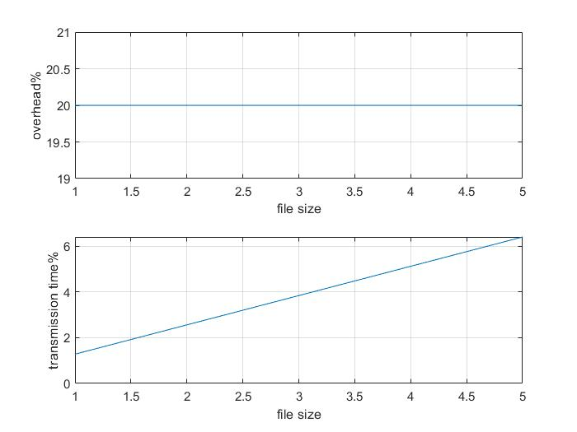

* **Comments**
* Overhead percentage is constant however the size changes as the number of overhead bits remain the same
* Transmission time percentage increases when size increases as no of bits needs to be transmitted increases
* **Note: in order to write in output json file you need to run both USB and UART protocol and not only one in the first time in order to create the file**