Lab 4: Microservices and Cloud-Native Design
Name :Ziad Muhammed
Group : SE2

Docker Compose Running
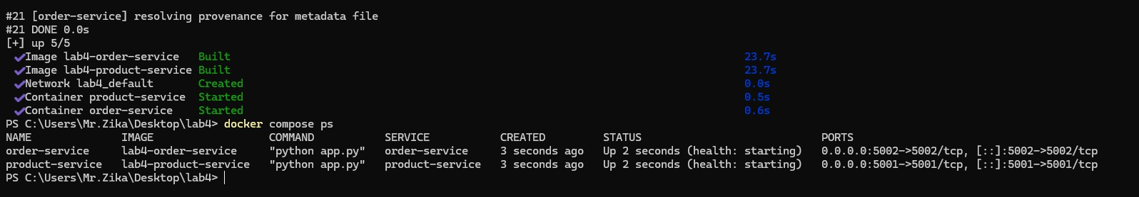
This screenshot shows both product-service and order-service containers successfully built and running using Docker Compose.

Service Logs
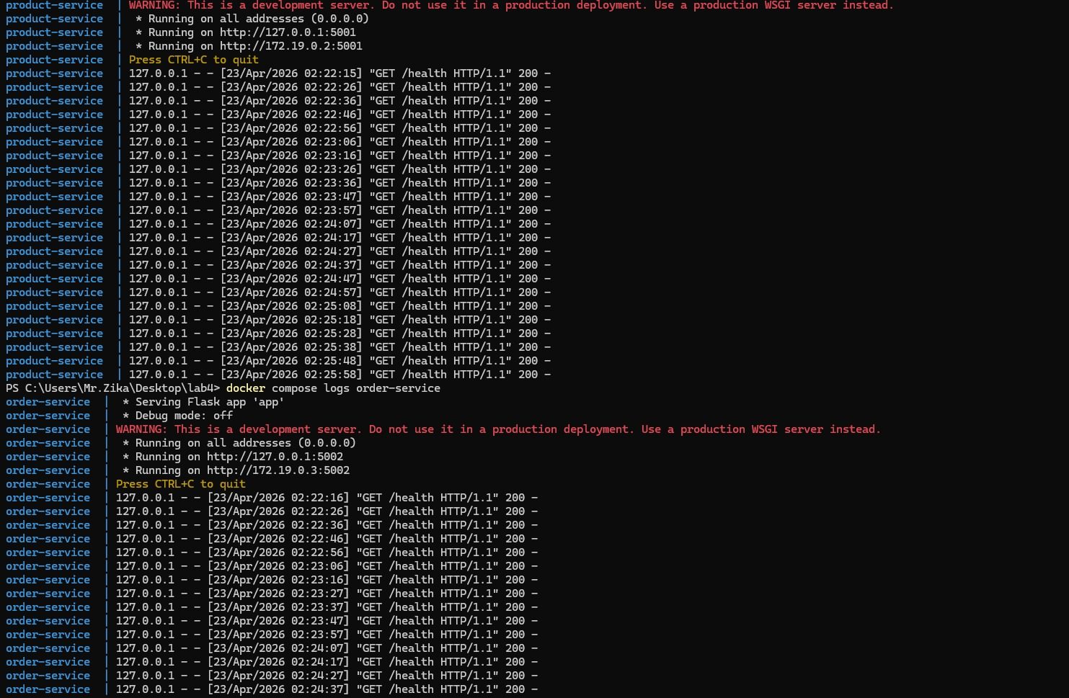
Logs of both services showing continuous health check requests and confirming that both services are active and responding.

Product Service API Testing
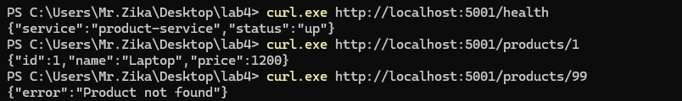
Testing product-service endpoints. Valid product returns correct data, and invalid product returns 'Product not found' error.

Successful Order Creation
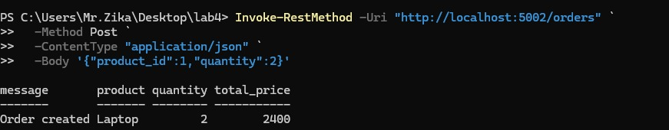
Order-service successfully creates an order after validating product data from product-service.

Failure Simulation
After stopping product-service, order-service returns an error indicating product-service is unavailable.

Part I: Architecture Reflection
1. Benefits of microservices over a monolith:
Microservices allow separation of concerns, independent deployment, and better scalability. Each service focuses on a single responsibility.
2. Complexities introduced:
Service-to-service communication, network failures, and container orchestration increase system complexity compared to a monolithic design.
3. Impact of latency or slow services:
If product-service is slow or unavailable, order-service cannot complete requests, showing tight coupling in synchronous communication.
4. 12-factor principles used:
The system uses environment variables, stateless services, and containerization, aligning with cloud-native design principles.

